Theoretical Chemistry Accounts
(2023) 142:4
https://doi.org/10.1007/s00214-022-02940-3
RESEARCH
New Au(III)‑ and Fe(III)‑based complexes of bio‑pharmacological
interest: DFT and in silico studies
Yassamina Arbia¹ · Soraya Abtouche¹ · Mohamed Dahmane² · Meziane Brahimi¹
Received: 5 October 2022 / Accepted: 30 November 2022
© The Author(s), under exclusive licence to Springer-Verlag GmbH Germany, part of Springer Nature 2022
Abstract
Many researchers have tried to overcome the limitations of clinical Cis-platin, which has led to several generations of
platinum-based drugs that are derived from the Cis-platin matrix with a large number of molecules, but only f ve complexes
have been approved. These include f ve cornerstone drugs in modern platinum-based chemotherapy, namely carboplatin,
oxaliplatin, nedaplatin, heptaplatin and albaloplatin. These latest generations of platinum-based drugs are rather important
in chemotherapy, as they are often involved in the treatment of dif erent types of cancer. Their use remains hampered by
their severe toxicity, resistance to tumor cells, poor oral bioavailability as well as the repair of the resulting adducts, and the
failure of the apoptotic pathways. It is obvious that dif erent strategies are needed. To understand the structural, electronic,
and spectroscopic properties of new Au(III)-based complexes, a theoretical study at the density functional theory is under-
taken in this work using dif erent functional and basis sets. If a correlation is found between the various descriptors and the
anti-cancer activity, it would probably indicate a better solution to substitute Au(III) with Fe(III), which is commonly used
in the manufacturing of drugs, for its attractive cost.
Keywords New Au(III) and Fe(III) complexes · DFT and ADMET studies · Spectroscopic properties · anti-cancer activity
1 Introduction
by Rosenberg in 1965, meanwhile a simple experiment in
bacteriology, which was to study the ef ect of an electric
f eld using platinum electrodes on cell division of E.coli
(Escherichia coli); the unexpected results of this experi-
ment have been ground-breaking for modern-day cancer
treatment. Rosenberg noticed that the bacterial cell division
had stopped although bacterial cell growth continued into
long strands [14]. These results were the starting point for
other research.
Modern medicinal chemistry involves the development of
new metal-based drugs [1–10]; these latter complexes have
several applications, and they are mainly used in the treat-
ment of cancers [11]. Complex platinum compounds (II)
represent a critical class of drugs for cancer control [12,
13]. Among them, we f nd that Cis-platin is regarded as
the benchmark in its class of organometallic complexes.
Its discovery as an anti-cancer agent was made by chance
Cis-platin was produced for the f rst time in 1845 by
Michele Peyrone [15]; hence, its f rst name was "Peyrone's
chloride"; it was tested on rats in 1969 [16]. Clinical tests
carried out in 1971, on Cis-platin, showed that it had sig-
nif cant anti-cancer activity. In 1978, it was approved as a
treatment for several types of cancer [17], mainly cancers
involving the testicles, ovaries, lungs, head, and neck [18,
19].
This work is dedicated to the memory of Mohamed Lamine
Abdelatif.
* Meziane Brahimi
mez_brahimi@yahoo.fr
1
2
Laboratoire de Physico Chimie Théorique Et Chimie
Informatique (LPCTCI), Faculté de Chimie, Université
Des Sciences Et de La Technologie Houari Boumediene
(USTHB), BP 32 El-Alia, 16111 Algiers, Algeria
This anti-cancer activity is dose-dependent because of
the adverse gastrointestinal, otological, neurological, and
nephrological side ef ects [20]. The main target of plati-
num (II) salts is DNA [21, 22]. Thus, once in the organism,
they hydrolyze to give hydroxide derivatives in an aqueous
medium. This allows them to bind to DNA by the formation
Laboratoire de Chromatographie, Faculté de Chimie,
Université Des Sciences Et de La Technologie Houari
Boumediene(USTHB), BP 32 El-Alia, 16111 Algiers,
Algeria
1 3

4
Page 2 of 15
Theoretical Chemistry Accounts
(2023) 142:4
of cross-linked covalent bonds between complementary
strands of DNA [23, 25] by a stereoselective mechanism of
purine bases involving the donor site (nitrogen) of guanine
[25–28]. The product is stabilized by hydrogen bonding [29]
with proton release [30], which leads to the reaction prod-
ucts that induce cell death processes, hence the cytotoxic
ef ect of the drug [31]. Unfortunately, the ef ectiveness of
the Cis-platin is limited because of its toxicity, which is due
to the ability of platinum ions to bind with proteins, and to
the resistance of tumor cells to treatment; these tumor cells
may have intrinsic resistance or acquired resistance [32–36].
Many researchers have devoted their ef orts to overcoming
the limitations of clinical Cis-platin, which has led to sev-
eral generations of drugs derived from the Cis-platin matrix
with a signif cant number of molecules [37–39]; however,
only f ve of them have been approved as anti-cancer agents,
namely carboplatin, oxaliplatin, nedaplatin, heptaplatin and
albaloplatin [40–43]. These derivatives, remaining indis-
pensable in modern-day cancer treatment, are used to treat
several types of cancer. Nevertheless, they possess severe
toxicity with tumor cell resistance, low oral bioavailability,
and failure of apoptotic pathways [44, 45]. Dif erent path-
ways employing new approaches to the synthesis of new
organometallic complexes, similar to platinum complexes
[46–53], involving transition atoms as complexing agents
such as gold, copper, cobalt, iron, and others [54–57] have
been developed over the past few decades. Au (I/III) coor-
dination complexes have known a great development due to
the fact that gold has a strong capacity to complex with many
ligands, like platinum [58–66]. The gold atom has several
possible oxidation states ranging from (I to V), but only the
states (I) and (III) are used in the pharmaceutical industry
[67]. The choice of ligands inf uences the stability, overall
pharmacodynamic prof le, and biopharmaceutical activity
of the resulting complexes [68].
To better understand the structural, electronic, and
spectroscopic properties of new Au(III)-based complexes,
synthesized in 2017 [82], a theoretical study at the density
functional theory (DFT) level was performed using dif-
ferent functional with various basis sets. Moreover, iron
is a much less toxic element and is involved in several
living mechanisms, so if the theoretical study of gold com-
plexes leads to a good understanding and correlation of
the various descriptors and their anticancer activity, we
may also extrapolate this concordance for the suggestion
of creating newer, safer anti-cancer solutions with Fe(III)
instead of Au(III), as Fe(III) is commonly used in drug
manufacturing.
2 Computational strategies
DFT [83] calculations of these complexes of Au(III) and
Fe(III) have been carried out with the hybrid density func-
tional B3LYP with the 6–311 + G** basis sets for the H, N,
O, S, Cl, and Fe atoms and a LANL2DZ pseudo-potential
for Pt, Au. All calculations are performed with the Gauss-
ian09 programs [84]. To build the complex, geometries of
the organic molecules are optimized separately. Harmonic
frequencies are calculated to ensure that stable complexes
are obtained in absolute minima energy without imagi-
nary frequency and the IR and NMR (¹H and ¹³C) spectra
are obtained at the same theoretical levels. All values are
scaled by a constant factor of 0.98, for the IR frequencies
[85]. Energy gaps, OM frontiers, and electronic density
are obtained at the same level of theory.
For each complex, we have modeled at the DFT, NMR
proton spectrum (¹H NMR), and the carbon ones (¹³C
NMR). The solvents were chosen in agreement with the
experiment [82] for the series of Au(III) complexes by
applying the CPCM model [86]. For comparison purposes,
the same solvents are used in the Fe(III) complexes stud-
ies. The ¹H-NMR spectra of the M1 and M2 complexes
(M = Au and Fe) were obtained, respectively, in dichlo-
romethane (CH Cl ) and chloroform (CHCl ) whereas the
Several organometallic complexes, synthesized recently,
have shown promise in vitro activity. The passage to perform
in vivo tests is often very expensive, and in addition to this,
the majority of new complexes lose their activity, which
does not allow them to reach clinical trials. Modeling is, in
this context, of paramount importance to better understand
their activity and to be able to choose the most relevant ones
[69–71] before carrying out in vivo tests.
2
2
3
other spectra are obtained in the DMSO solvent. It is the
same for the ¹³C-NMR spectra, which are obtained with
tetra methyl silane (TMS) as the internal standard. The
absolute chemical isotropic shielding was calculated using
the GIAO (gauge-independent atomic orbital) method
[87].
Au(I/III) complexes have better cytotoxic properties than
cis-platin [72–77] whereby Au(I) selectively targets tumor
cells more than healthy cells thanks to its af nity to thiol and
selenol groups of cysteine and selenocysteine, respectively
[69, 70]. On the other hand, Au (III) has a d⁸ conf guration,
which gives it an iso-structural and iso-electronic character
rather than Pt (II) [78, 79]. However, the Au (III) complexes
have more active anticancer activity than those based on Au
(I), which can be explained by the reduction of Au (III) in
Au (I) [71, 80, 81].
The in silico ADME/Tox study is very useful for pre-
dicting the pharmacological properties of candidate mol-
ecules to be a drug. The pkCSM-pharmacokinetics tool [88]
(http://biosig.unimelb.edu.au/pkcsm/) is used to describe the
absorption, distribution, metabolism, excretion, and toxicity
of our complexes.
1 3

Theoretical Chemistry Accounts
(2023) 142:4
Page 3 of 15
4
3 Results and discussion
3.1 Cis‑Platin studies
smaller than that obtained by X-ray dif raction and there is
an increase of the N–Pt–N and Cl–Pt–Cl angle.
3.1.2 IR spectrum
3.1.1 Geometrical parameters
The IR (scaled by 0.98 [85]) and Raman spectra were car-
ried out at the DFT levels with the 6–311+G ** basis sets
for H, Cl, and N as depicted in Fig. 1 where the calcu-
lated and experimental results [91] are plotted. The same
trend is obtained with the squared correlation coef cient
This work will f rst focus on a theoretical study of Cis-
platin at the DFT level using the functional B3LYP with
the 6-311G ** basis sets for the H, N, and Cl atoms and
the pseudo-potential LANL2DZ basis for the platinum atom
(Pt). This step is performed to validate the choice of the
appropriate method. The optimized geometrical parameters
(bond lengths, valence, and dihedral angles) are depicted
in Table 1. The square planar geometry, of lower energy, is
thermodynamically the most stable. In this conformation,
the Pt–N and Pt–Cl bonds are equal to 2.120 Ǻ and 2.350
Ǻ, respectively, which is in agreement with the theoretical
data of the literature [89]. Theoretical calculations overesti-
mate the Pt–N and Pt–Cl bond lengths by 0.12 and 0.019 Å,
respectively, compared to the experimental results obtained
by X-ray diffraction on Cis-platin [90]. The results, in
Table 1, show that the theoretical angles N–Pt–N, Cl–Pt–Cl
are overestimated by 11.3 and 3.3 degrees, respectively,
whereas the N–Pt–Cl angle is underestimated by 7.0 degrees
[90]. This dif erence can be explained by the formation of
inter and/or intramolecular hydrogen bonds of the NH …
Cl type and by the steric ef ects between dif erent groups of
the same molecule or between interacting Cis-platin mol-
ecules. In isolated Cis-platin molecules, the intramolecu-
lar hydrogen bond NH … Cl would bring the NH3 and Cl
groups together; hence, the calculated angle (N-Pt-Cl) is
(R
² = 0.998) for the Raman spectrum. Consequently, it is
Fig. 1 Theoretical IR frequencies vs. experimental ones
Table 1 Geometrical parameters of Cis-platin optimized at B3LYP/Gen, with LANL2DZ as the basis for Pt and 6-311G** for all other atoms
Parameters
Cis-Platin
Bond lengths in Ǻ
Theoretical
Experi-
mental
[90]
Pt-Cl
Pt–N
2.350
2.120
2.331
2.000
Valence angles in degrees
Cl–Pt–Cl
N-Pt–N
N-Pt-Cl
95.2
98.3
83.3
91.9
87.0
90.3
Dihedral angles in degrees
Theoretical
H -N -Pt-Cl
0.002
0.055
0.033
0.002
10
4
2
3
2
3
H -N -Pt-Cl
10
4
H -N -Pt-Cl
11
5
H -N -Pt-Cl
11
5
1 3
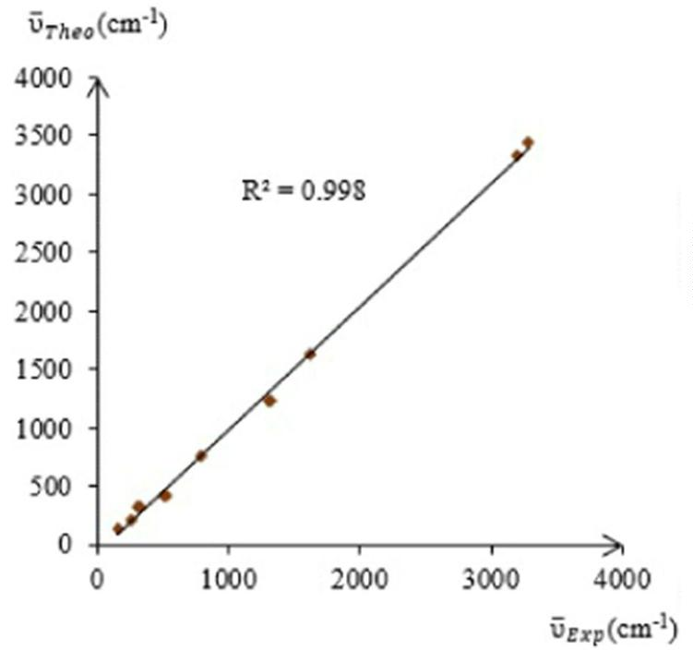

4
Page 4 of 15
Theoretical Chemistry Accounts
(2023) 142:4
possible to validate the calculation method for the dif er-
ent Au complexes, especially since these results are in good
agreement with those of the literature [89–91].
square planar geometry with dihedral angles close to zero
in the Au1, Au2, and Au4 complexes and a slight f atness
deviation to the order of 10 degrees in the Au3a and Au3b
complexes, which is due to the steric ef ects of the sub-
stitution at the 8-quinoline group. The results are in good
agreement with the experimental ones.
3.2 Au(III) and Fe(III) complexes
3.2.1 Geometrical parameters
On the other hand, in the Fe(III) series complexes, we
notice, according to Table S2-b, that the two bonds Fe-Cl
1
Figure 2 shows the complexes to be studied in this work. We
will f rst explain the ef ect of the substitution in position 8
of the quinoline fragment on the stability and the reactivity
of the complexes. We will then examine the substitution of
Au by Fe. The results obtained will be compared with those
obtained for Cis-platin at the same theoretical level.
Fe(III) complexes can adopt two dif erent geometries
according to their spin and multiplicity state, namely a tetra-
hedral geometry with high spin (S= 5/2) conf guration, and
a square-planar geometry with low spin (S= 1/2) state. Both
possibilities have been investigated and their thermodynamic
stability has been compared. The complexes with the tet-
rahedral geometry are the most thermodynamically stable.
The geometric parameters of the Au(III) and Fe(III) com-
plexes, as obtained at the B3LYP/Gen (with LANL2DZas
the basis for Pt and Au and 6-311G** for all other atoms),
are shown in supplementary materials (Tables S1-a and b),
respectively.
and Fe–Cl have the same exact lengths: 2.189, 2.145, and
2
2.196 Å, respectively, in the Fe1, Fe2, and Fe4 complexes.
Unlike the Fe3a complex, whose Fe–Cl bond increased
1
slightly (2.204 Å) with the Fe–Cl bond having recorded
2
a length of 2.193 Å, for the Fe3b complex, the Fe–Cl
1
bond was recorded at 2.197 Å, and the Fe–Cl bond was
2
of the order of 2.210 Å. The variation of the M–Cl length
could be justif ed by the steric ef ects. Another peculiarity
that has been noticed in the Fe3a and Fe3b complexes is
the position of the substitution of the sulfonyl groups; the
mesyl (methylsulfonyl) group in the 8-quinoline position
in the Fe3a complex is located in the upper part of the
complex as well as the tosyl group in the Fe3b complex,
which is located below the coordination plane of the com-
plex. Unlike their Au(III)-based analogs, the set of valence
and torsion angles around the Fe(III) metallic center indi-
cate that all of the complexes have a tetrahedral geometry
where the valence angles are close to 109.5 degrees (sp³
hybridization). The torsion angles are zero for the angles
involving the quinoline bonds with the exception of the
Fe3a and Fe3b complexes, which show a slight deforma-
tion that can be considered negligible. This indicates that
the two bonds (Fe-N ) and (Fe–X) with 8-quinoline are
The Au-Cl bond length is more elongated than the
2
Au-Cl lengths (see table S1-a). For the Au1 complex, the
1
shortest Au-Cl (Au-Cl ) bond length is equal to 2.328
1
2
(2.352 Å); the longest bond length is found in the Au4
complex with a value of 2.347 (2.416 Å). The Au–O bond
length, equal to 2.062 Å in the Au1 complex, is shorter
than the Au–N bond equal to 2.091 Å and 2.086 Å in the
Au3a and Au3b complexes, respectively. In the Au2, it is
2.135 Å whereas the Au–S bond is equal to 2.376 Å in the
Au4 complex. The latter is the most elongated, because
of the atomic radius of sulfur. The f ve complexes have a
1
in the same plane, on the other hand, the two chlorines
are outside of the plane with the quinoline group, which
corresponds to tetrahedral geometry. The shortest M–Cl,
MO, MN, and MS lengths are observed for the Fe(III)
complexes. These results are due to the dif erence in the
atomic and Van der Waals radii of Au (1.79; 2.13) and Fe
(1.72; 1.89) [92].
Fig. 2 MX complexes with
(M=Au(III) and Fe(III) and
X=O (1), NH (2), N–SO Me
2
2
(3a), N–SO Tol (3b), and S (4)
2
1 3
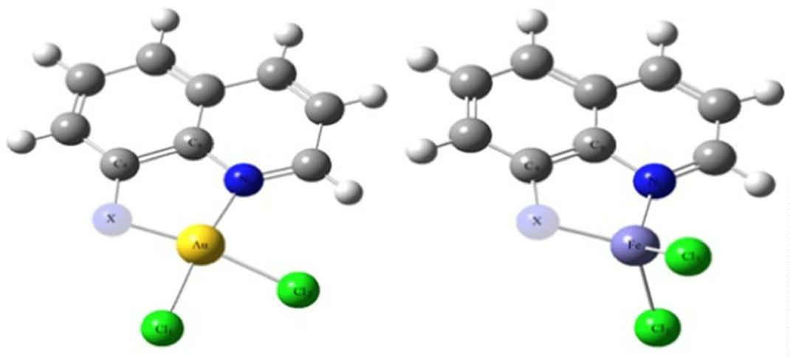

Theoretical Chemistry Accounts
(2023) 142:4
Page 5 of 15
4
3.2.2 NMR spectrum
¹H-NMR chemical shifts are reported in Table S2-a and
¹³C-NMR shifts in Table S2-b. The theoretical and experi-
mental values are in the same regions for the Au(III)-based
complexes. This allows us to assume that it will be the same
for the complexes based on Fe(III), for which we have no
experimental data.
The experimental (δ ) and theoretical (δ ) chemical
exp
theo
shifts are summarized in Tables S2-a and S2-b for ¹H-NMR
and ¹³C-NMR, respectively.
The experimental chemical shifts of the proton (see
Table S2-a) indicate the presence of six characteristic sig-
nals of the protons carried by quinoline, which are located
in the intervals of: [7.31–9.14], [6.50–9.37], and [7.76–9.90]
ppm, respectively, for the Au1, Au2, and Au4 complexes
[82]. The calculated chemical shifts are in the intervals
[6.93–9.21], [5.58–9.58], and [7.65–9.98] ppm. The proton
chemical shifts for the Fe(III) complexes are found in the
ranges [6.60–8.99], [5.45–9.27], and [7.59–9.22], respec-
tively, in the Fe1, Fe2, and Fe4 complexes. These displace-
ments are due to the resonance of chemically non-equivalent
nuclei. The experimental spectrum of the Au3a complex is
characterized by the presence of a triplet at approximately
3.52 ppm, which corresponds to the CH protons of the mesyl
3.2.3 Electrochemistry
The molecular structures of the neutral complexes (oxi-
dized forms) and their reduced forms are optimized with
a frequency calculation to conf rm the energy minima. The
reduction potential was calculated from the solvation-free
energies. The latter was obtained by implicitly using the
CPCM solvation model [86] with dichloromethane as a sol-
vent in accordance with the experiment. The free energies
in the gas state and the solvated state of each species were
evaluated at 298.15 K and under a pressure of 1 atm. We
calculated the absolute reduction potential for each complex
using the Born-Haber thermodynamic cycle, given in Fig. 3,
which links the dif erent electron transfer processes in the
gas and solvated phases.
3
group. The electronic cloud of the last mesyl group is denser
because of its electro-attractive character compared to the
quinoline nucleus. Consequently, a strongly shielded ef ect
is observed. The corresponding theoretical mean value is
3.24 ppm for the Au3a complex, and it is 3.37 ppm for the
Fe3a complex. On the experimental spectrum of the Au3b
complex, three types of aromatic protons appear. They cor-
respond to those of toluene in the tosyl group in the 8-qui-
noline position with a chemical shift of 7.67 ppm for the
protons in the ortho position, 7.27 ppm for the protons in the
meta position, and a shift of 2.29 ppm for the protons of the
CH group [82]. The calculated values are not very far from
According to Nernst's relation:
0∕abs
_{= −ΔG}⁰_{sol}(RedOx)∕nF
(1)
(2)
E
Ox∕Red
0
Ox∕Red
0∕abs
E
= E
^{− E}Ag∕AgCl
Ox∕Red
with:
E
^{0∕abs} : is the absolute standard redox potential of the
3
Ox∕Red
the experimental values, but they are overestimated by shift
dif erences of 0.86, 0.40, and 0.25 ppm, respectively. For
the Fe3b complex, the same shifts are observed around 7.67,
8.30, and 2.48 ppm. A doublet at 6.50 ppm, corresponding
to the protons of the –NH group in the 8-quinoline position
couple Ox/Red
ΔG_{0sol}(Ox): the standard solvation energy of the oxidized
species
ΔG_{0sol}(Red): the standard solvation energy of the reduced
species
2
appears on the experimental spectrum of the Au2 complex,
and the calculated value is underestimated by 0.72 ppm. The
same calculation on the Fe2 complex leads to a chemical
shift of the order of 5.45 ppm. Experimental and theoretical
ΔG (RedOx): the standard free energy of the gas phase
0
g
reduction
ΔG₀ (RedOx): the Gibbs free energy associated with the
sol
reduction of complexes in solution
Fig. 3 Born-Haber cycle
1 3
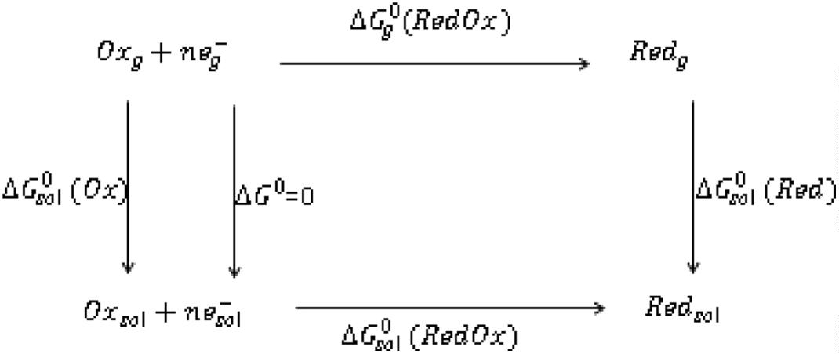

4
Page 6 of 15
Theoretical Chemistry Accounts
(2023) 142:4
Table 2 The Gibbs free energies associated with the reduction (in
kcal.mol⁻¹); the absolute reduction potential ((abs) in V) obtained
at the DFT/B3LYP/GEN level (6–311+g** for all atoms and
LANL2DZ for Au) as well as the experimental
^{reduction potentials (in V).E}exp
ΔG⁰ _{(RedOx)E}0∕abs
sol
Ox∕Red
Complexes
ΔG⁰_{sol}(RedOx)^{(kcal.mol−1)}
E_{exp}(V)
E^{0∕abs}
(V)
Ox∕Red
Au1
Protonated Au2
Deprotonated Au2
Au3a
Au3b
Au4
Fe1
Protonated Fe2
Deprotonated Fe2
Fe3a
Fe3b
Fe4
−221.4
−248.5
−214.7
−220.4
−220.1
−215.5
−627.7
−627.8
−627.7
−627.7
−627.7
−627.7
4.801
+0.175
−0.170
−0.170
+0.125
0.095
−0.115
–
–
–
–
–
–
5.388
4.656
4.781
4.773
4.674
3.495
4.340
3.296
3.716
3.705
3.598
Fig. 4 Charged, and deproto-
nated Au2 complexes
Fig. 5 Theoretical absolute potential vs. experimental ones
1 3
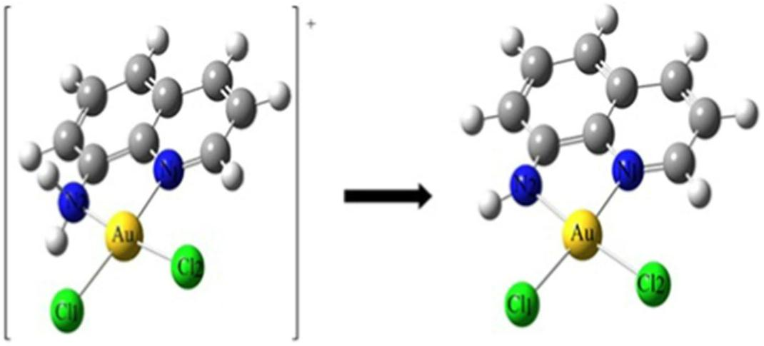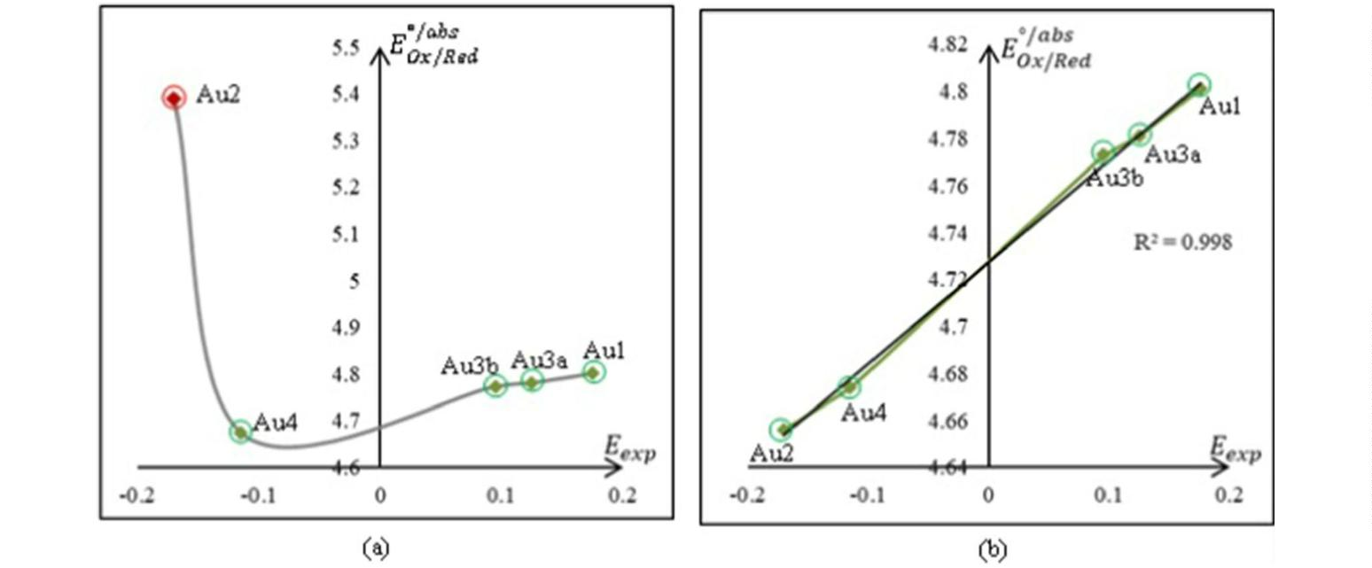

Theoretical Chemistry Accounts
(2023) 142:4
Page 7 of 15
4
n: is the number of electrons involved during the reduc-
tion process
using density functional theory-based molecular dynamics
[93] and standard hydrogen electrode (SHE) developed by
Cheng, Sulpizi, and Sprik in water solution [94]. If this is
considered, the two Au2 and Au4 complexes will have a
negative redox potential, and the rest of the complexes will
have a positive redox potential.
F: is Faraday's constant where F=23.06 kcal mol⁻¹ V⁻¹.
The results are reported in Table 2.
To calculate the reduction potentials, we use, respec-
tively, the Nernst Eq. (1), then Eq. (2) giving the theoreti-
cal standard potential, which must be compared with the
experimental values. As the absolute potential of the refer-
These results, in agreement with the experiment [82], are
due to the stabilization of the metal center by the nature of
the ligand in position 8 of the quinoline. Donating power
of the –NH group decreases due to the substitution of the
hydrogen atom by attractor groups in the M3a and M3b com-
plexes (M= Au and Fe). This leads to instability (decrease
in the quantity of M(III) in favor of M(I)) of the metal
center, which results in increasing the calculated absolute
redox potential (4.781 V for Au3a) and (4.773 V for Au3b)
whereas, for the Au2 complex, we have 4.659 V. Due to
the aforementioned proposed potential value of the refer-
ence electrode (Ag/AgCl) in dichloromethane (4.727 V),
the oxidation–reduction potentials of the three respective
complexes Au3a, Au3b, and Au2 calculated (experimental)
are + 0.054 (0.125) V, + 0.046 (0.095) V and – 0.068 (−0.17)
V. These results lead to a good correlation between the cal-
culated and experimental values (see Fig. 4a and Fig. 6).
The results given in Table 2 for the complexes based on
Fe(III)show that the values in this series are more stable
than those based on Au(III), as they have a more accentuated
stability for the complexes Fe2 and Fe1.The latter are more
resistant to redox reactions with theoretical absolute poten-
tials of 3.296 V and 3.495 V, respectively, unlike the other
complexes in the same series. The substitution of the amino
group by sulfonamide in the Fe3a and Fe3b complexes gives
the highest theoretical absolute potential values of the series
(3.716, and 3.705 V, respectively) due to the decreasing of
the donating power of the amino group. The metal centers
of both series gain maximum stability with an amino group
at the 8-position of the quinoline.
ence electrode,E
is not available in the literature, to
Ag∕AgCl
evaluate it, we plot the curve giving the calculated values vs.
Experimental ones (see Fig. 5a).
In this step, we f nd that the value of the absolute poten-
tial of the Au2 complex (with a –NH group in position 8
2
of the quinoline) proposed by Antonio Sanchez et al. (see
Fig. 4) is 5.388 V. The dif erence between this value and
those of the other complexes is high (see Fig. 5a).
If, instead, the Au2 complex is considered to be depro-
tonated (–NH in the 8 position of the quinoline instead of
–NH ), the theoretical potential becomes 4.656 V. This
2
result leads to a good correlation between the calculated and
experimental values with a squared correlation coef cient
equal to 0.998 (see Fig. 5b and 6).
The regression equation given in Fig. 5b is:
0∕abs
(3)
E
= 0.433E_{exp} + 4.727 (V)
Ox∕Red
where the y-intercept (4.727 V) represents the absolute
potential of the reference electrode E
.
Ag∕AgCl
The results analysis of Table 2 shows that the type of
ligand and its arrangement af ect the energy levels of the
valence electrons and therefore the redox potential of the
complex.
This allows us to propose, for the f rst time, a value of
4.727 V for the potential of the reference electrode (Ag/
AgCl) in dichloromethane. A dif erence of 0.28 V was found
compared to the value given by a computational scheme
Fig. 6 Experimental and calcu-
lated Reduction potentials
1 3
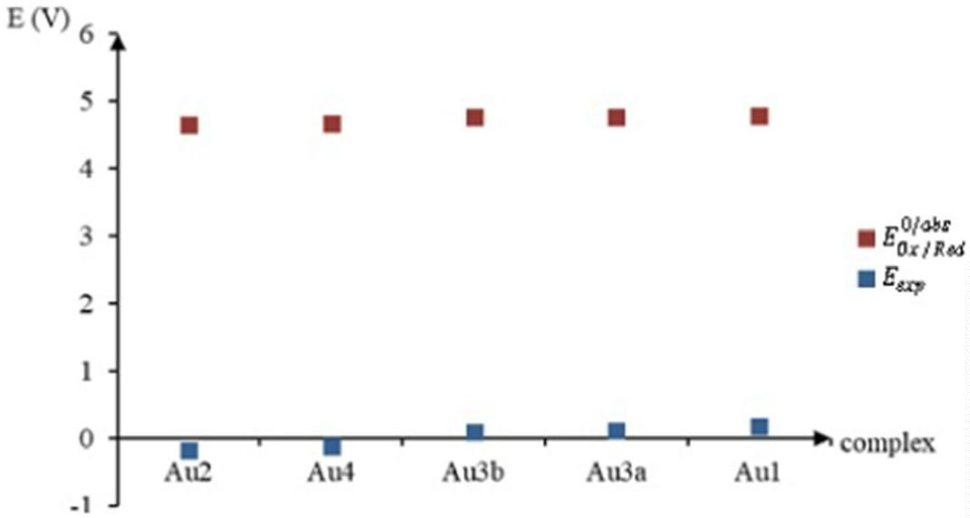

4
Page 8 of 15
Theoretical Chemistry Accounts
(2023) 142:4
Table 3 The complexation
energies (kcal.mol⁻¹) of the
complexes obtained at the DFT
level
Table 4 The intramolecular
Complexes
^{E}_{comp}(kcal.mol⁻¹)
Complexes
^{E}_{disp}(kcal.mol⁻¹)
dispersion energies (kcal.mol⁻¹)
of the complexes obtained at the
DFT/ωB97XD level
Cis-Platin
Au1
Au2
Au3a
Au3b
Au4
Fe1
Fe2
Fe3a
Fe3b
Fe4
−724.7
−1429.3
−1490.6
1420.6
−1419.5
−1445.4
−1300.1
−1313.1
−1288.6
−1291.1
−1298.1
Cis-Platin
Au1
Au2
Au3a
Au3b
Au4
Fe1
Fe2
Fe3a
Fe3b
Fe4
− 3.1
− 9.5
−10.4
−15.5
−20.6
− 9.7
− 8.5
− 9.3
−14.1
−19.7
− 8.9
3.2.4 Complexation energy
stability to the M(III)-based complexes. A slight variation
of this is observed for the Fe(III) complexes when the sub-
stituents at the 8-position of the quinoline are changed. This
dif erence does not exceed 25 kcal mol⁻¹, whereas in the
case of the complexes based on Au(III), it is of the order of
71 kcal mol⁻¹.
The complexation energies of the studied compounds were
calculated from the optimized geometries using the follow-
ing equation:
n

i=1
(4)
E_{comp} = E_{T} −
E_{i}
3.2.5 Dispersion energy
where E
: The electronic energy of complexation; E :
T
DFT-D methods [95–98] take into account the dispersion
[99, 100]. These methods are widely used in the study of
non-covalent interactions. In this part of the work, we have
considered a corrected hybrid density functional based on
the GGA and Becke exchange functions. Table 4 demon-
strates that the dispersion energies are higher, in absolute
value, for the complexes of the two series compared to that
comp
The total electronic energy of the system; E : The electron
i
energy of ligand (i) is optimized in the isolated state at the
same theoretical level. The results (kcal mol⁻¹) are reported
in Table 3 and schematized in Fig. 7:
The complexation energy of the two M(III) series
(M = Au, and Fe) is two times lower than that of Cis-platin at
the same theoretical level. This gives greater thermodynamic
Fig. 7 Complexation energy
obtained at DFT level
1 3
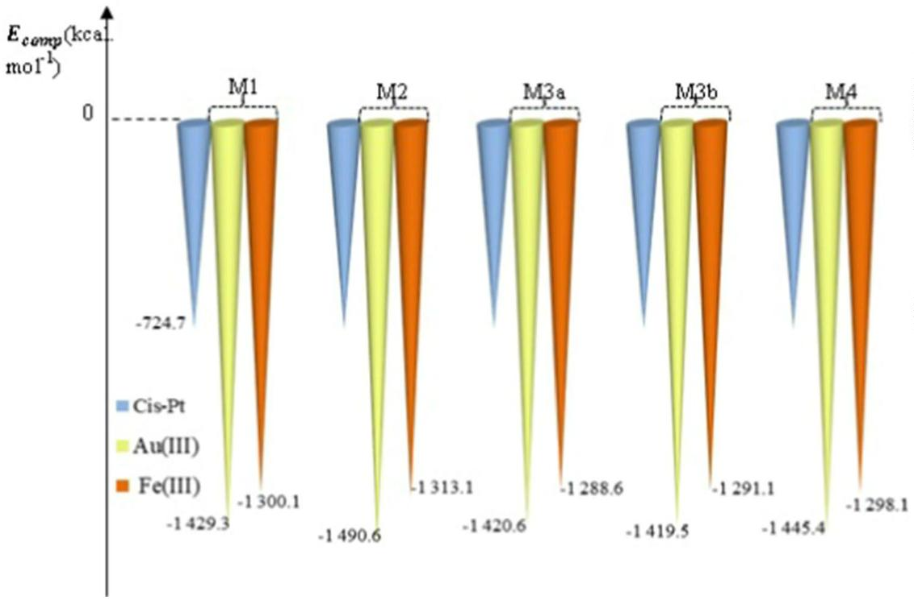

Theoretical Chemistry Accounts
(2023) 142:4
Page 9 of 15
4
Table 5
HOMO, LUMO, and Gap (|E_{HOMO}-E_{LUMO}|) energies (in eV)
reactions might be more dif cult on the Fe(III) complexes.
These results conf rm the conclusions of the electrochem-
istry section (see paragraph 3.2.3).
Complexes
E_{HOMO}
E_{LUMO}
Gap
Cis-Platin
Au1
Au2
Au3a
Au3b
Au4
Fe1
Fe2
Fe3a
Fe3b
Fe4
−6.364
−6.599
−6.144
−6.780
−6.631
−6.532
−6.560
−6.101
−6.621
−6.456
−6.406
−2.006
−4.331
−3.834
−4.192
−4.120
−4.112
−2.875
−2.737
−2.814
−2.690
−3.033
4.358
2.268
2.310
2.588
2.511
2.420
3.703
3.364
3.807
3.766
3.373
3.2.7 Global reactivity descriptors within the conceptual
DFT framework
Global reactivity descriptors [103–109] are calculated
within the framework of the density functional theory.
Among these descriptors are the chemical potential (μ),
which quantif es the electron-withdrawing power of a mol-
ecule, the chemical hardness (η), which tells us about the
resistance of a molecular system to electron transfer, and
whether it is a gain or a loss, and the electrophilicity index
(ω), which measures the ability of a molecule to receive
electrons, and the f exibility (). These quantities of the
global reactivity descriptors are def ned, respectively, by
the relations given below:
of Cis-platin. We note that the dispersion energies of the
Au(III)-based complexes are slightly higher.
Among all the complexes, those containing the amino
group have the highest dispersion energies. Furthermore, the
more the amino group is branched, the greater the dispersion
energy (in absolute value), which results in greater stability.
²
1
1_{; = −;}
; =
= − (EI + AE); = (EI − AE); =
2
2

(5)
where EI is the ionization energies, and AE is the electron
af nity. These are calculated without Koopmans’ approxi-
mation [110]. EI is calculated as the energy difference
between the neutral and ionized complexes, and AE is the
energy dif erence between the neutral and ionized complexes
with (N+ 1) electrons. A good electrophile is characterized
by a low value of chemical potential (μ) and a high value of
electrophilicity index (ω). All the calculated descriptors are
gathered in Table 6.
3.2.6 The frontier molecular orbitals (FMO)
The highest occupied molecular orbital (HOMO) describes
the molecule's ability to donate an electron, and the low-
est empty molecular orbital (LUMO) def nes the molecule's
ability to accept an electron [101, 102]. The optimized
geometries without symmetry constraints conduce to the
HOMO, LUMO, and Gap energies are given in Table 5 and
schematized in Fig. 8a, and b.
The M3a complexes (M = Au, Fe) have the lowest
HOMO with an energy of −6.78 eV for the Au(III)-based
complex and an energy of −6.62 eV for the Fe(III)-based
complex. On the other hand, the highest LUMO was
obtained in the Au2 complex with energy of −3.83 eV
and in the Fe3b complex with energy of −2.69 eV. Overall,
Cis-platin has the highest energy gap (4.36 eV). There-
fore, our new complexes are more reactive compared to
the Cis–platin. The FMOs (see Fig. 8a, and b) show that
the LUMO in Cis-platin and in the Au(III) complexes are
localized to the metal site and to the ligands. Whereas in
Fe(III) complexes, The LUMO is localized on the qui-
noline level without involving the metal ion and the two
Cl atoms. In the Au(III) and Fe(III) series, the HOMO is
mainly localized throughout the structure. In Cis-platin,
the HOMO is localized on its metallic center as well as
on the two Cl atoms. Complexes based on Fe(III) have
the largest energy gaps compared to complexes based on
Au(III), and since the LUMO is partially localized on the
metallic center, this explains the instability of the Au(III)
complexes in the biological medium. Therefore, reduction
According to the calculated descriptors (see Table 6), the
complexes of both series are more reactive than Cis-platin.
This latter has the highest gap and chemical hardness (η)
of 4.358 eV, which ref ects a more remarkable resistance
to electron transfer compared to the other complexes. The
molecules studied are both nucleophiles (Nu =−EI) and
good electrophiles (ω). As nucleic bases are nucleophilic
molecules, the studied complexes can be good candidates
to replace Cis-platin, namely the M3a and M3b complexes
(M = Au, Fe) due to their electrophilic character.
3.2.8 Molecular electrostatic potential (MEP)
The reaction prof le of a molecule can be predicted by ana-
lyzing its molecular electrostatic potential [111]. One of the
pieces of information that we can extract from a molecule’s
surface is the type of attack site (electrophilic or nucleo-
philic). Indeed, there are essentially two types of regions
[112], the blue-colored region represents the sites likely to
undergo a nucleophilic attack (sites def cient in electrons),
1 3

4
Page 10 of 15
Theoretical Chemistry Accounts
(2023) 142:4
Fig. 8 Frontier molecular orbital (FMO). a Cis-Platin and Au(III) complexes. b Cis-Platin and Fe(III) complexes
and the red colored region represents the sites likely to be
attacked by electrophiles (sites rich in electrons). Using
Gaussian 09, we generated the molecular electrostatic poten-
tial (MEP). The results are depicted in Fig. 9a, and b.
In all of the complexes, the negative regions are mainly
located on the two Cl atoms and extend to cover the 8-qui-
noline oxygen atom in the M1 complexes, the sulfur in M4,
and the sulfonyl groups in M3a and M3b (M= Au and Fe).
These last two complexes, namely M3a and M3b, represent
more electron-rich regions. The two -NH3 groups of Cis-
platin are more electrophilic than quinoline.
1 3
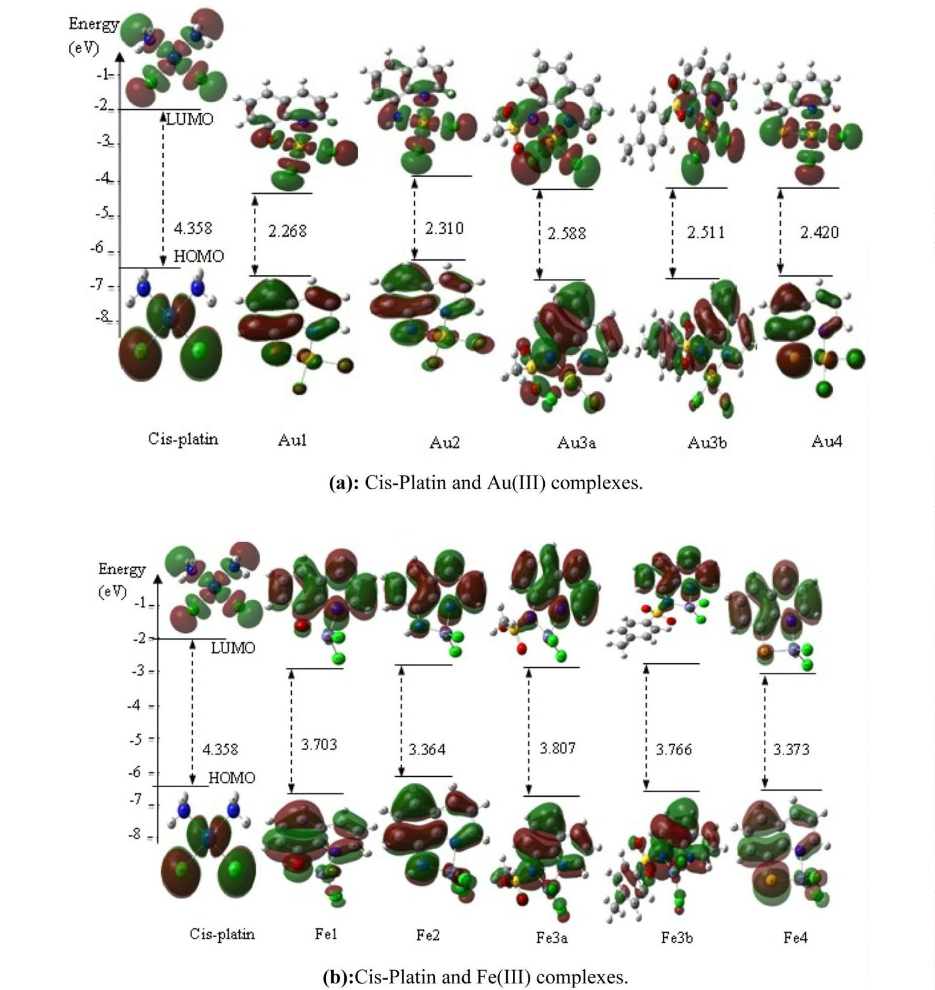

Theoretical Chemistry Accounts
(2023) 142:4
Page 11 of 15
4
Table 6 Global reactivity
Complexes
Descriptors
μ
descriptors in eV
η
ω

χ
Nu
Cis-Platinum
−4.898
4.358
2.752
0.229
4.898
−8.378
Au1
−5.663
2.268
7.070
0.441
5.663
−7.963
Fe1
−5.533
3.703
4.134
0.270
5.533
−7.882
Au2
Fe2
−5.222
−5.191
2.310
3.364
5.902
4.005
0.433
0.297
5.222
5.191
−7.491
−7.380
Au3a
−5.600
2.588
6.059
0.386
5,600
−7.825
Fe3a
−5.595
3.807
4.111
0.263
5.595
−7.792
Au3b
Fe3b
−5.470
−5.424
2.511
3.766
5.958
3.906
0.398
0.266
5.470
5.424
−7.560
−7.524
Au4
−5.520
2.420
6.296
0.413
5.520
−8.002
Be4
−5.502
3.373
4.487
0.296
5.502
−7.781
Fig. 9 Molecular electrostatic
potential (MEP). a Cis-Platin
and Au(III) complexes. b Cis-
Platin and Fe(III) complexes
3.3 ADME/Tox properties
with very high intestinal absorption percentages of 95.24%
for Au3b and 95.20% for Fe3b, respectively. Lower intestinal
absorption (90.65%) for Au2 and (90.62%) for Fe2 were also
obtained. Finally, the intestinal absorption of Cis-platin was
estimated to be 92.60% (Scheme 2).
The in silico study of the ADME properties led to the results
shown in Tables S3-a, b, and c and Schemes 1 and 2. The
absorption of the compounds studied was predicted by
human intestinal absorption (%HIA) and Caco-2 perme-
ability [113, 114]. All the studied complexes presented a
high permeability to CaCo-2, which is manifested by log
(Papp) values greater than 1 (Scheme 1). The M3b com-
plexes (M = Au, Fe) have a value less than 0.8 (Table S3-a)
Table S3-a shows that only Cis-platin, Au1, and Fe1
can be substrates for P-glycoprotein ( +) without any
inhibitory ef ect on the two P-glycoprotein I/II(−) vari-
ants. One of the most remarkable results is that the Au3b
and Fe3b complexes are the only ones with an ability to
1 3
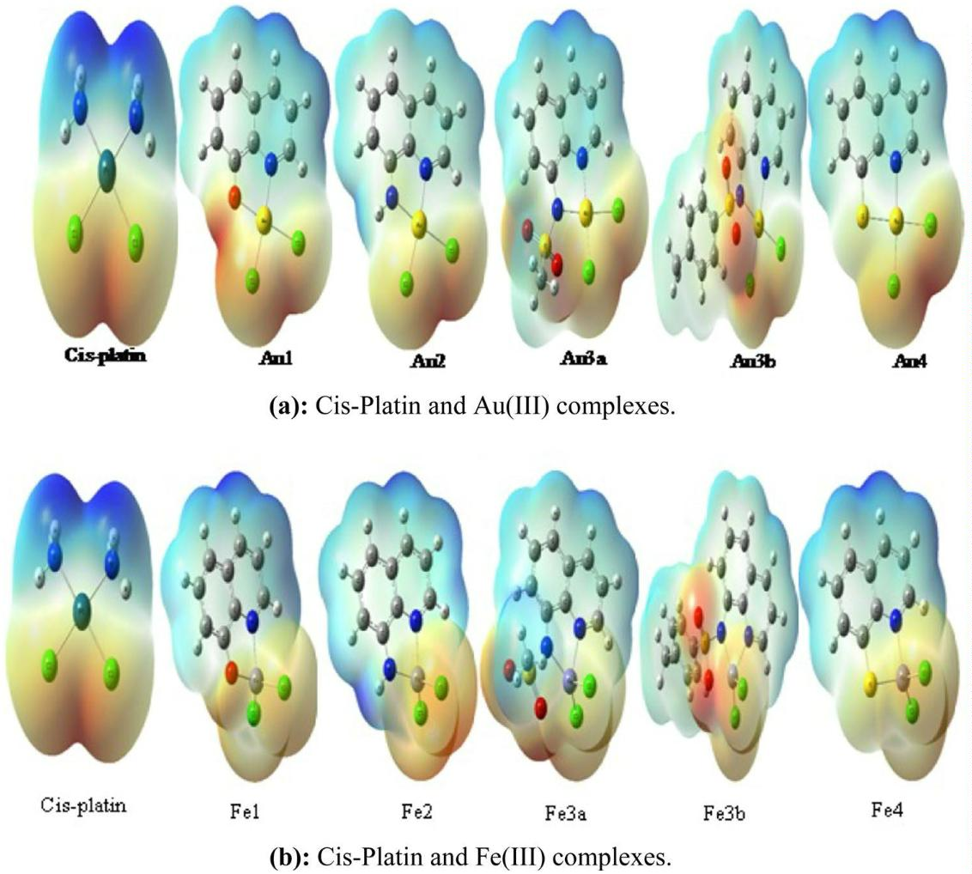

4
Page 12 of 15
Theoretical Chemistry Accounts
(2023) 142:4
Scheme 1 Histogram of perme-
ability (Caco-2)
Scheme 2 Histogram of intesti-
nal absorption (%HIA)
inhibit P-glycoprotein I and II ( +) without being at the
same time a substrate for P-glycoprotein (−), which could
have the ef ect of increasing their bioavailability, hence a
more ef ective anti-cancer activity. Analysis of the volume
of distribution (log VDss) [115] (see Table S3-a) shows
that all of the complexes exhibit a larger distribution
(0.413–0.631) in relation to that of Cis-platin’s (0.302)
except for the Au3a (0.011) and Fe3a (0.010) complexes.
A value of log(VDss) greater than 0.45 is considered rela-
tively high; therefore, a molecule with a high log(VDss)
will have a longer half-life. The study of permeability
at the blood–brain barrier (BBBP) is described by the
log(BB) and that of the Central Nervous System (CNS)
by the log(PS) [116, 117]. According to their values (see
Table S3-a), all of the complexes should be able to eas-
ily cross the BBB and to even be able to enter the CNS
(with a value of log(BB) > 0.3, the drug can easily cross
the blood–brain barrier and with a value of log(PS) > −2,
the drug can penetrate the CNS). According to the results
obtained in Table S3-b, we f nd that all of the complexes
in both series inhibit the CYP1A2 ( +) isoform except for
Cis-platin (−). CYP2D6 is only inhibited by the M3a com-
plexes (M= Au, Fe) (−). On the other hand, the CYP2C19
iso-form is inhibited only by the M4( +) complexes.
CYP2C9 and CYP3A4 are not inhibited by any complex
(−). Complexes with a nitrogen moiety at the 8-quino-
line position (M2, M3a, and M3b) are the only candidates
that have been predicted as a substrate for CYP3A4 ( +);
therefore, they can be metabolized in the liver with little
or no hepatotoxicity. Cis-platin was not predicted to be
either an inhibitor or a substrate of CYP450. Excretion
was predicted and are reported in Table S3-b, using the
1 3
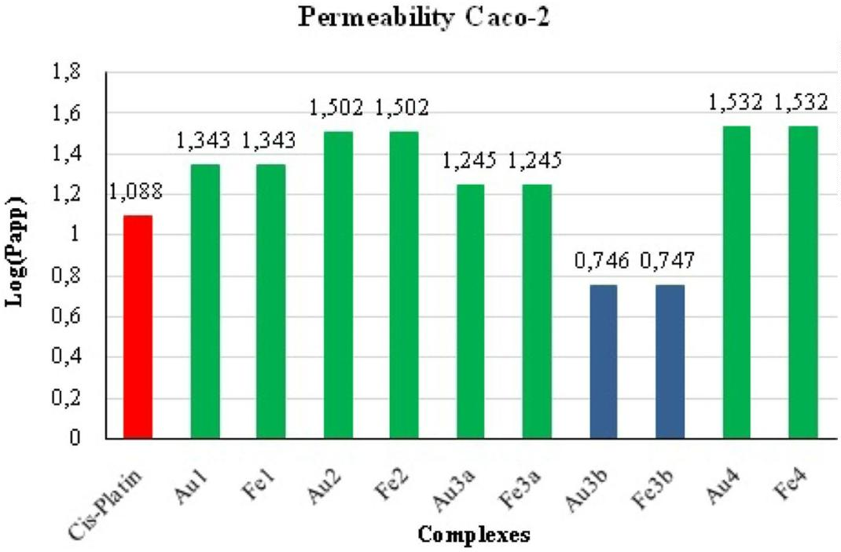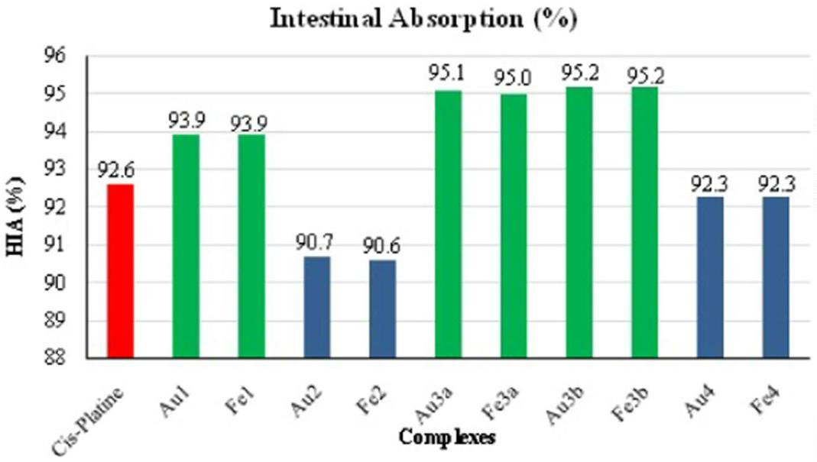

Theoretical Chemistry Accounts
(2023) 142:4
Page 13 of 15
4
total clearance (log(CL )) resulting from a combination
of 4.727 V for the potential of the reference electrode (Ag/
AgCl) in dichloromethane. Finally, the new complexes are
less toxic and appear to be better anti-cancer drug candidates
than Cis-platin.
tot
of hepatic and renal clearance. Only the M3a and M3b
complexes seem to be eliminated via the kidneys where
they were predicted to be substrates for the OCT2 protein
( +). While the other complexes are eliminated by other
means, namely sweat, bile, or other (−). Predicted val-
ues for total clearance, log(CL ), range from −0.099 to
Supplementary Information The online version contains supplemen-
tary material available at https://doi.org/10.1007/s00214-022-02940-3.
tot
1.187 ml.min⁻¹.kg⁻¹, which are lower than the predicted
values of Cis-platin (see Table S3-b). According to the
toxicological properties obtained at the pkCSM level
(see Table S3-c), all the molecules treated in this analysis
showed no ability to cause allergic contact dermatitis. It
was also observed that none of the complexes presented a
mutagenic potential, except for the M2 complexes (Ames
toxicity positive). Only the M3a complexes are predicted
to be hepatotoxic ( +). Inhibition of hERG (human ether
a gogo-reelated gene) potassium channels leads to heart
rhythm disturbances [118]. None of the complexes exhib-
ited an inhibitory effect toward hERG (I/II) (−). The
predicted LD50 lethal doses are 2.876 mol kg⁻¹ for Cis-
platin and are included in the interval [3.103–3.513] mol
kg⁻¹ (Fe3a) for all of the complexes studied. Similarly,
the oral rat chronic toxicity (LOAEL) of the complexes
[0.657–1.239] is greater than that of Cis-platin (0.428).
It appears from this that the new complexes are less toxic
than Cis-platin.
Author contributions "AY carried out all theoretical calculations with
Gaussian09.AY, SA and MB wrote the main manuscript text and MD
prepared the spectrocopique discussions. All authors reviewed the
manuscript."
Funding This research received no specif c grant from any funding
agency in the public, commercial, or not-for-prof t sectors.
Declarations
Conflict of interest The authors declare no conf ict of interests.
References
1. Vaidya SP, Gadre S, Kamisetti RT, Patra M (2022). Bios Rep.
https://doi.org/10.1042/BSR20212160
2. Dorcier CS, DorcierScolaroDyson ACPJ (2005) Appl Organomet
Chem 19:1–10. https://doi.org/10.1002/aoc.725
3. Dyson PJ, Sava G (2006) Dalt Trans 16:1929–1933. https://doi.
org/10.1039/B601840H
4. Hannon MJ (2007) Pure Appl Chem 79:2243–2261. https://doi.
org/10.1351/pac200779122243
5. Benjamin Garbutcheon-Singh K, Grant MP, Harper BW et al
(2011) Curr Top Med Chem 11:521–542. https://doi.org/10.
2174/156802611794785226
4 Conclusion
6. Medici S, Peana M, Nurchi VM, Lachowicz JI, Crisponi G,
Zoroddu MA (2015) Coordination Chemistry Reviews. Else-
vier BV. 284: 329–350, https://doi.org/10.1016/j.ccr.2014.08.
002
From the results, particularly those presented in the elec-
trochemistry section, we can f nally explain the instability
of Au(III)-based complexes in the biological environment
because they tend to undergo reduction reactions. The Au1
complex has the highest electrophilic character followed by
the Au3a complex and lastly the Au2 complex. Similarly,
the highest reduction potential was obtained for the Au1
complex, and the lowest potential was obtained for the Au2
complex.
7. Trudu F, Amato F, Vaňhara P, Pivetta T, Peña-Méndez EM,
Havel J (2015) J Appl Biomed 13:79–103. https://doi.org/10.
1016/j.jab.2015.03.003
8. Cirri D, Pratesi A, Marzo T, Messori L (2021) Drug Discov
16:39–46. https://doi.org/10.1080/17460441.2020.1819236
9. Nguyen Ch, Toubia I, Diring S et al (2022) Dalt Trans 50:4583–
4592. https://doi.org/10.1039/D0DT03792C
10. Keller S, Ong YC, Lin Y, Cariou K, Gasser G (2020) J Orga-
nomet Chem 906:121059. https://doi.org/10.1016/j.jorganchem.
2019.121059
FMO theory and the global reactivity descriptors show
that the new complexes based on Au(III) and Fe(III) are
more reactive than Cis-platin. The ADME/Tox properties
go in the same direction, namely that the complexes studied
are better drug candidates than Cis-platin.
11. Kostova I, Balkansky S (2013) Curr Med Chem 20:4508–4539.
https://doi.org/10.2174/09298673113206660288
12. Martinčič A, Cemazar M, Sersa G, Kovač V, Milačič R, Ščančar
J (2013) Talanta 116:141–148. https://doi.org/10.1016/j.talanta.
2013.05.016
The two complexes M3a and M3b have regions that are
richer in electrons and are therefore more reactive. The
two –NH groups in Cis-platin have a more electrophilic
13. Chatelut E (2011) Bull Cancer 98:1253–1261. https://doi.org/10.
1684/bdc.2011.1464
14. Rosenberg B, Van Camp L, Krigas T(1965) Nature Publishing
Group, Nature, 205:698–699, https://doi.org/10.1038/205698a0
15. von Sommaruga E, Reichardt E (1877) Ber Dtsch Chem Ges
10:432–434. https://doi.org/10.1002/cber.187701001122
16. Rosenberg B, Van Camp L, Trosko JE, Mansour VH (1969) Plati-
num compounds: a new class of potent antitumor agents. Nature
222:385–386. https://doi.org/10.1038/222385a0
3
character compared to quinoline. On the other hand, the
complexes which contain the amino group have the high-
est dispersion energies. This is true even more so when the
amino group is branched, which results in even greater sta-
bility. This work allows us to propose theoretically a value
1 3

4
Page 14 of 15
Theoretical Chemistry Accounts
(2023) 142:4
17. Lippert B (1999) Cisplatin: chemistry and biochemistry of a lead-
ing anticancer drug. 1–563, https://doi.org/10.1002/9783906390
420.
45. Johnstone TC, Pil PM, Lippard SJ (2015) Reference Module
Biomed Sci https://doi.org/10.1016/B978-0-12-801238-3.
98740-3
18. Kelland L (2007) Nat Rev Cancer 7:573–584. https://doi.org/10.
1038/nrc2167
46. Łakomska I, Fandzloch M, Muzioł T, Lis T, Jezierska J (2013)
Dalton Trans 42:6219–6226. https://doi.org/10.1039/C2DT3
2216A
19. Jung Y, Lippard SJ (2007) Chem Rev 107:1387–1407. https://
doi.org/10.1021/cr068207j
47. Matesanz AI, Leitao I, Souza P (2013) J Inorg Biochem
125:26–31. https://doi.org/10.1016/j.jinorgbio.2013.04.005
48. Smoleński P, Jaros SW, Pettinari C, Lupidi G, Quassinti L et al
(2013) Dalton Trans 42:6572–6581. https://doi.org/10.1039/
C3DT33026E
20. Rabik CA, Dolan ME (2007) Cancer Treat Rev 33:9–23. https://
doi.org/10.1016/j.ctrv.2006.09.006
21. Pinto A, Lippard SJ (1985) Biochem et Biophysca Acta (BBA)
780:167–180. https://doi.org/10.1016/0304-419X(85)90001-0
22. Komeda S (2011) Metallomics 3:650–655. https://doi.org/10.
1039/C1MT00012H
49. Ott I, Gust R (2007) Archiv der Pharmazie (Weinheim)
340:117–126. https://doi.org/10.1002/ardp.200600151
50. Meggers E (2007) Curr Opin Chem Biol 11:287–292. https://
doi.org/10.1016/j.cbpa.2007.05.013
23. Chu G (1994) J Biol Chem 269:787–790. https://doi.org/10.1016/
S0021-9258(17)42175-2
24. Reedijk J (1996). Nature. https://doi.org/10.1039/CC99600008
01
51. Nikolić S, Opsenica DM, Filipović V et al (2015) Organome-
tallics 34:3464–3473. https://doi.org/10.1021/acs.organomet.
5b00041
25. Stone PJ, Kelman AD, Sinex FM (1974) Nature 251:736–737.
https://doi.org/10.1038/251736a0
52. Ronconi L, Pizarro AM, McQuitty R, Sadler PJ (2007) Coord
Chem Rev 251:1633–1648. https://doi.org/10.1002/chem.
201002792
26. Brabec V, Balcarova Z (1993) Eur J Biochem 216:183–187.
https://doi.org/10.1111/j.1432-1033.1993.tb18131.x
27. Bertini I, Gray HB, Lippard SJ and Valentine JS (2014) Bioinor-
ganic Chemistry (eds), 455–503. University Science Books, Mill
Valley, California.
53. Bruijnincx PCA, Sadler PJ (2008) Curr Opin Chem Biol
12:197–206. https://doi.org/10.1016/j.cbpa.2007.11.013
54. Clarke MJ, Zhu F, Frasca DR (1999) Chem Rev 99(2511–
2533):1999. https://doi.org/10.1021/cr9804238
55. Eastman A (1987) Chem Biol Interact 61:241–248. https://doi.
org/10.1016/0009-2797(87)90004-4
28. Ushay HM, Tullius TD, Lippard SJ (1981) Biochemistry
20:3744–3748. https://doi.org/10.1021/bi00516a012
29. Hadi S, Appleton TG (2009) Pol J Chem 83:437–443
30. Macquet JP, Theophanides T (1975) Biopolymers 14:781–799.
https://doi.org/10.1002/bip.1975.360140409
56. Evangelou AM (2002) Crit Rev Oncol Hematol 42:249–265.
https://doi.org/10.1016/S1040-8428(01)00221-9
57. Kostova I (2012) Anti-Cancer Agents Med Chem 9:827–842.
https://doi.org/10.2174/187152009789124646
31. Hadi S, Appleton TG (2010) Russ J Inorg Chem 55:223–228.
https://doi.org/10.1134/S0036023610020142
32. Galanski M, Jakupec MA, Keppler BK (2005) Current Med
Chem 12:2075–2094. https://doi.org/10.2174/0929867054
637626
58. Rana BK, Nandy A, Bertolasi V, Bielawski W, Saha KD et al
(2014) Organometallics 33:2544–2548. https://doi.org/10.1021/
om500118x
33. Wang D, Lippard SJ (2005) Nat Rev Drug Discov 4:307–320.
https://doi.org/10.1038/nrd1691
59. Bertrand B, Stefan L, Pirrotta M, Monchaud D, Bodioà W et al
(2014) Inorg Chem 53(2296–2303):2014. https://doi.org/10.
1021/ic403011h
34. Rosenberg B (1977) Noble metal complexes in cancer chemo-
therapy. Adv Exp Med Biol 91:129–150. https://doi.org/10.
1007/978-1-4684-0796-9_10
60. Frezza M, Hindo S, Chen D, Davenport A, Schmitt S et al (2010)
Curr Pharma Des 16:1813–1825. https://doi.org/10.2174/13816
1210791209009
35. Gómez-Ruiz S, Maksimović-Ivanić D, Mijatović S,
Kaluderović GN (2012). Bioinorga Chem Appl, Special Issue
Metals Med. https://doi.org/10.1155/2012/140284
36. Kaluderovic NG, Paschke R (2011) Curr Med Chem 18:4738–
4752. https://doi.org/10.2174/092986711797535308
37. Wheate NJ, Walker S, Craig GE, Oun R (2010) Dalton Trans
39:8113–8127. https://doi.org/10.1039/C0DT00292E
38. Dhar S, Kolishetti N, Lippard SJ, Farokhzad OC (2011) Proc
Natl Acad Sci USA 108:1850–1855. https://doi.org/10.1038/
scibx.2011.162
61. Milacic V, Fregona D, Dou Q P (2008) Histol Histopathol, 23:
101–108, https://doi.org/10.14670/HH-23.101.
62. Bindoli A, Rigobello MP, Scutari G, Gabbiani C, Casini A et al
(2009) Coord Chem Rev 253:1692–1707. https://doi.org/10.
1016/j.ccr.2009.02.026
63. Lakkakula JR, Krause RWM, Divakaran D, Barrage S, Srivastava
R (2021) J Mol Liquids 341:117262. https://doi.org/10.1016/j.
molliq.2021.117262
64. Yang Z, Jiang G, Xu Z, Zhao S, Liu W (2020) Coord Chem Rev
423:213492. https://doi.org/10.1016/j.ccr.2020.213492
65. Singh N, Sharma R, Bharti R (2021) MaterialsToday: Proc
https://doi.org/10.1016/j.matpr.2021.04.270
39. Wang X, Guo Z (2011). Bioinorg Med Chem. https://doi.org/
10.1002/9783527633104
40. Neidle S, Ismail IM, Sadler PJ (1980) J Inorg Biochem 13:205–
212. https://doi.org/10.1016/S0162-0134(00)80069-0
41. Kawai Y, Taniuchi S, Okahara S, Nakamura M, Gemba M
(2005) Biol Pharm Bull 28:1385–1388. https://doi.org/10.
1248/bpb.28.1385
66. Posssato B, Dalmolin LF, Periera LM et al (2021). Eur J Pharm
Sci. https://doi.org/10.1016/j.ejps.2021.105834
67. Shaw CF (1999) Chem Rev 99:2589–2600. https://doi.org/10.
1021/cr980431o
42. Voegeli R, Gunther E, Aulenbacher P, Engel J. hilgard P (1992)
Drugs Future, 17: 883–886, https://doi.org/10.1358/dof.1992.
017.10.183955
68. Beraldo H, Gambino D (2005) Mini-Rev Med Chem 4:31–39.
https://doi.org/10.2174/1389557043487484
69. Bertrand B, Casini A (2014) Dalton Trans 43:4209–4219. https://
doi.org/10.1039/C3DT52524D
43. Lee JW, Park JK, Lee SH, Kim SY, Cho YB, Kuh HJ (2006)
Anticancer Drugs 17:377–384. https://doi.org/10.1097/01.cad.
0000205033.08838.c7
70. Glišić BD, Dhuran MI (2014) J Chem Soc Dalton Trans 43:5950–
5969. https://doi.org/10.1039/C4DT00022F
44. Johnstone TC, Suntharalingam K, Lippard SJ (2016) Chem Rev
116:3436–3486. https://doi.org/10.1021/acs.chemrev.5b00597
71. Zou T, Lum CT, Lok CN, Zhang JJ, Che CM (2015) Chem Soc
Rev 44:8786–8801. https://doi.org/10.1039/C5CS00132C
72. Köster SD, Alborzinia H, Can S, Kitanovic I, Wölf S et al (2012)
Chem Sci 3:2062–2072. https://doi.org/10.1039/C2SC01127A
1 3

Theoretical Chemistry Accounts
(2023) 142:4
Page 15 of 15
4
73. Zou T, Lum CT, Chui SSY, Che CM (2013) Angew Chem–Int
Ed 52:2930–2933. https://doi.org/10.1002/anie.201209787
74. Che CM, Sun RWY (2011) Chem Commun 47:9554–9560.
https://doi.org/10.1039/c1cc10860c
95. Grimme S (2004) J Comput Chem 25:1463–1473. https://doi.
org/10.1002/jcc.20078
96. Grimme S, Antony J, Schwabe T, Mück-Lichtenfeld C (2007)
Org Biomol Chem 5:741–758. https://doi.org/10.1039/B6153
19B
75. Gurba A, Taciak P, Sacharczuk M, Mlynarczuk-Bialy I, Bujalska-
Zadrożny M et al (2022) Int J Mol Sci 23(2):724. https://doi.org/
10.3390/ijms23020724
97. Krishtal A, Van Alsenoy C, Geerlings P (2014) J Chem Phys
140:184105. https://doi.org/10.1063/1.4873133
76. Frik M, Fernández-Gallardo J, Gonzalo O, Mangas-Sanjuan V,
Gonzalez-Alvárez M et al (2015) J Med Chem 58:5825–5841.
https://doi.org/10.1021/acs.jmedchem.5b00427
98. Sato T, Nakai H (2010) J Chem Phys 133:194101. https://doi.
org/10.1063/1.3503040
99. Kassel LS (1936) J Chem Phys 4:276–282. https://doi.org/10.
1063/1.1749835
77. Cisnetti F, Gautier A (2013) Angew Chem–Int Ed 52:11976–
11978. https://doi.org/10.1002/anie.201306682
100. Jurečka P, Černý J, Hobza P, Salahub DR (2007) J Comput Chem
28:555–569. https://doi.org/10.1002/jcc.20570
78. Tiekink ERT (2002) Crit Rev Oncol Hematol 42:225–248.
https://doi.org/10.1016/S1040-8428(01)00216-5
101. Allab Y, Chikhi S, Zaater S, Brahimi M, Djebbar S (2020) Inorg
Chim Acta 504:119436. https://doi.org/10.1016/j.ica.2020.
119436
79. Liu W, Gust R (2016) Coord Chem Rev 329:191–213. https://
doi.org/10.1016/j.ccr.2016.09.004
80. Parish RV (1999) Met-Based Drugs 6:271–276. https://doi.org/
10.1155/MBD.1999.271
102. Mansour AM (2013) Inorg Chim Acta 394:436–445. https://doi.
org/10.1016/j.ica.2012.08.025
81. Yeo CI, Ooi KK, Tiekink ERT (2018) Molecules 23:14–23.
https://doi.org/10.3390/molecules23061410
103. Morrison C (1992) J Chem Phys 96:3718–3722. https://doi.org/
10.1063/1.461875
82. Casado-Sánchez A, Martín-Santos C, PadrónMas-BallesteNa-
varro-Ranninger JMRC et al (2017) J Inorg Biochem 174:111–
118. https://doi.org/10.1016/j.jinorgbio.2017.06.004
83. Parr RG (1980). Horizons Quantum Chem. https://doi.org/10.
1007/978-94-009-9027-2_2
104. Geerlings P, De Proft F, Langenaeker W (2003) Chem Rev
103:1793–1873. https://doi.org/10.1021/cr990029p
105. Itskowitz P, Berkowitz ML (1997) J; Phys Chem A 101:5687–
5691. https://doi.org/10.1021/jp963962u
106. Pearson RG (2005) J Chem Sci 117:369–377. https://doi.org/10.
1007/BF02708340
84. Frisch MJ, Trucks GW, Schlegel HB, Scuseria GE, Robb MA,
Cheeseman JR, Scalmani G, Barone V, Mennucci B, Petersson
GA, Nakatsuji H, Caricato M, Li X. Hratchian HP, Izmaylov AF,
Bloino J, Zheng G, Sonnenberg JL. Hada M, Ehara M, Toyota
K, Fukuda R, Hasegawa J, Ishida M, Nakajima Thonda Y, Kitao
O, Nakai H, Vreven T, Montgomery JA Jr, Peralta JE, Ogliaro
F, Bearpark Mheyd JJ, Brothers E, Kudin KN, Staroverov VN,
Kobayashi R, Normand J, Raghavachari K, Rendell A, Burant JC,
Iyengar SS, Tomasi J, Cossi M, Rega N, Millam JM, Klene M,
Knox JE, Cross JB, Bakken V, Adamo C, Jaramillo J, Gomperts
R, Stratmann RE, Yazyev O, Austin AJ, Cammi R, Pomelli C,
Ochterski JW, Martin RL, Morokuma K, Zakrzewski VG, Voth
GA, Salvador P, Dannenberg JJ, Dapprich S, Daniels AD, Farkas
Ö, Foresman JB, Ortiz JV, Cioslowski J, Fox DJ, (2009) Gaussian
09, revision D01.Gaussian, Inc., Wallingford.
107. Parr RG, Szentpály LV, Liu S (1999) J Am Chem Soc 121:1922–
1924. https://doi.org/10.1021/ja983494x
108. Yang W, Parr RG (1985) Proc Natl Acad Sci USA 82:6723–6726.
https://doi.org/10.1073/pnas.82.20.6723
109. Chermette H (1999) J Comp Chem 20:129–154. https://doi.
org/10.1002/(SICI)1096-987X(19990115)20:1%3c129::AID-
JCC13%3e3.0.CO;2-A
110. Koopmans T (1934) Physica 1:104–113. https://doi.org/10.1016/
S0031-8914(34)90011-2
111. Weiner PK, Langridge R, Blaney JM, Kollman PA (1982) Proc
Natl Acad Sci USA 79:3754–3758. https://doi.org/10.1073/pnas.
79.12.3754
112. Politzer P, Laurence PR, Jayasuriya K (1985) Environ Health
Perspect 61:191–202. https://doi.org/10.1289/ehp.8561191
113. Dahlgren D, Lennernäs H (2019) Pharmaceuticals 11:411.
https://doi.org/10.3390/pharmaceutics11080411
114. Meunier V, Bourrié M, Berger Y, Fabre G (1995) Cell Biol Toxi-
col 11:187–194. https://doi.org/10.1007/BF00756522
115. Toutain PL, Bousquet-Mélou A (2004) J Vet Pharmacol Ther
27:441–453. https://doi.org/10.1111/j.1365-2885.2004.00602.x
116. Hitchcock SA, Pennington LD (2006) J Med Chem 49:7559–
7583. https://doi.org/10.1021/jm060642i
85. Brahimi M, Belmiloud Y, Khef ache D (2006) J Mol Struct
(Thoechem) 759:1–10. https://doi.org/10.1016/j.theochem.2005.
10.017
86. Barone V, Cossi M (1998) J Phys Chem A 102:1995–2001.
https://doi.org/10.1021/jp9716997
87. Wolinski K, Hinton JF, Pulay P (1990) J Am Chem Soc
112:8251–8260. https://doi.org/10.1021/ja00179a005
88. Pires DEV, Blundell TL, Ascher DB (2015) J Med Chem
58:4066–4072. https://doi.org/10.1021/acs.jmedchem.5b00104
89. Malik M, Michalska D (2014) Spectrochimica Acta–Part A: Mol
Biomol Spectroscopy 125:431–439. https://doi.org/10.1016/j.saa.
2014.01.107
117. Pardridge WM (2004) Drug Discov Today 9:392–393. https://
doi.org/10.1016/s1359-6446(04)03065-x
118. Rampe D, Roy ML, Dennis A, Brown AM (1997) FEBS Lett
417:28–32. https://doi.org/10.1016/S0014-5793(97)01249-0
90. Milburn GHW, Truter MR (1966). J Chem Soc A: Inorg Phys,
Theor. https://doi.org/10.1039/J19660001609
Publisher's Note Springer Nature remains neutral with regard to
91. Torres M, Khan S, Duplanty M, Lozano HC, Morris TJ et al
(2018) J Phys Chem A 122:6934–6952. https://doi.org/10.1021/
acs.jpca.8b04023
jurisdictional claims in published maps and institutional af liations.
Springer Nature or its licensor (e.g. a society or other partner) holds
exclusive rights to this article under a publishing agreement with the
author(s) or other rightsholder(s); author self-archiving of the accepted
manuscript version of this article is solely governed by the terms of
such publishing agreement and applicable law.
92. Batsanov SS (2001) Inorg Mater 37:871–885. https://doi.org/10.
1023/A:1011625728803
93. Yang XH, Cuesta A, Cheng J (2019) J Phys Chem B 123:10224–
10232. https://doi.org/10.1021/acs.jpcb.9b06650
94. Cheng J, Sulpizi M, Sprik M (2009) J Chem Phys 131:154504.
https://doi.org/10.1063/1.3250438
1 3

