# GET YOUR PASSPASS CARD ONLINE

This is a nice option if you are still home and already have a housing proof in France. The card will be sent to your French address **within 15 days** (so you must make sure you fill in the right details).

* HOW TO APPPLY ONLINE

To purchase your personal PassPass card and get your monthly subscription, click [here](https://www.ilevia.fr/fr/connexion?back=my-account) and follow the steps below.

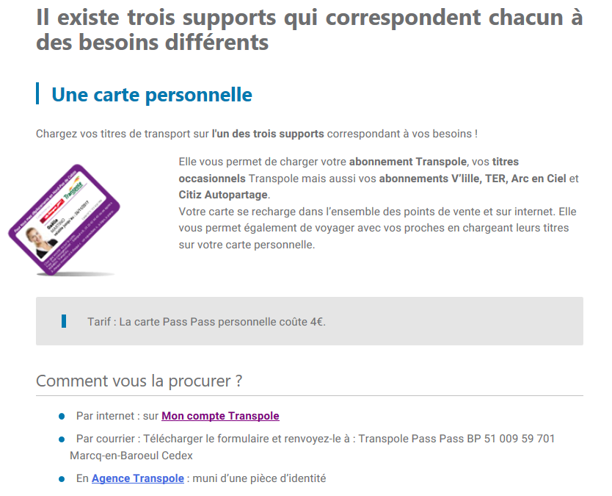

**Click here**

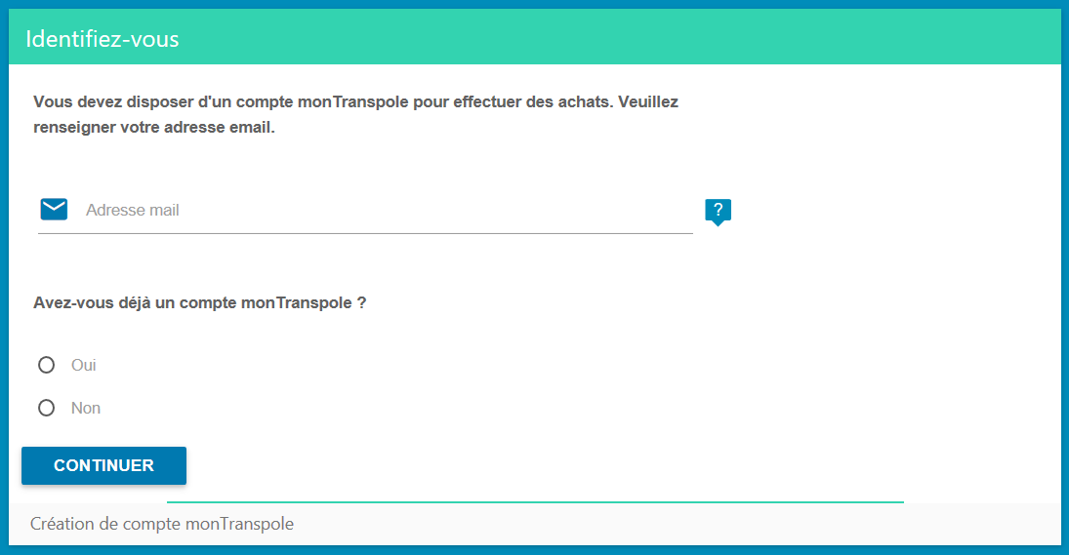

**Enter your email address**

**Tick the “Non” box**

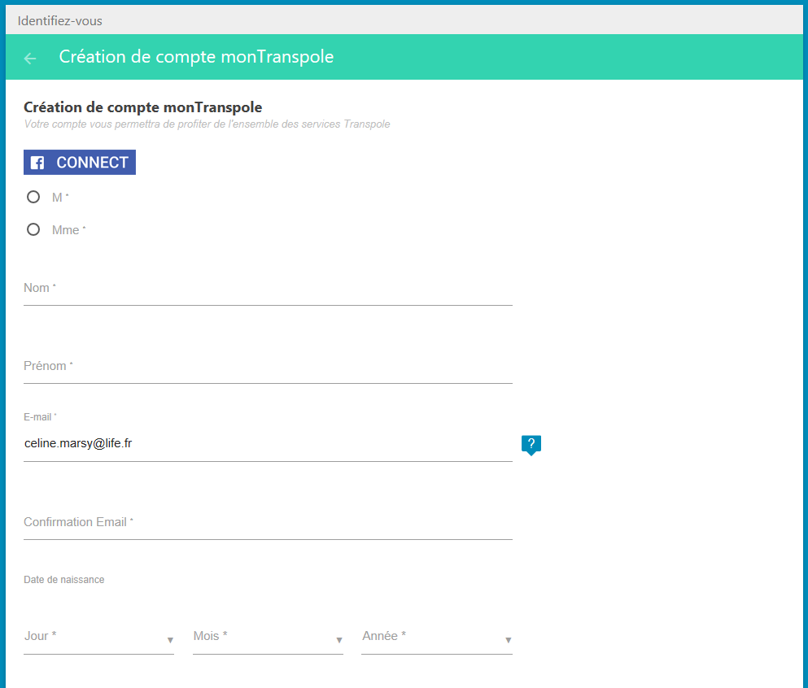

**Mr (***M***) / Mrs (***Mme***)**

**Family name**

**First name**

**Email address**

**Email address again**

**Birthdate (DD/MM/YYYY)**

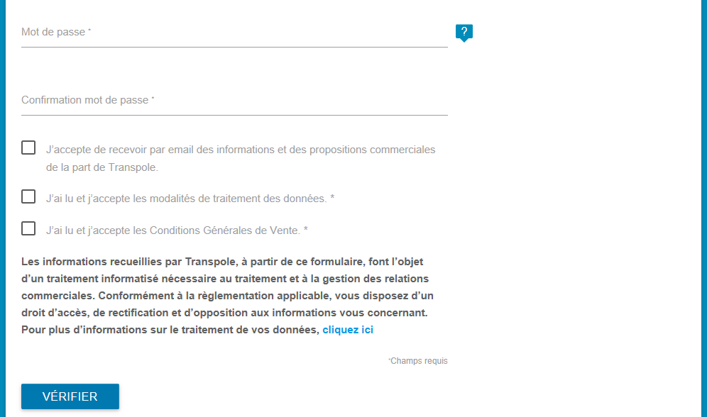

**Password**

**Password again**

**Tick**

Click on the button “VERIFIER”.

The following screen appears:

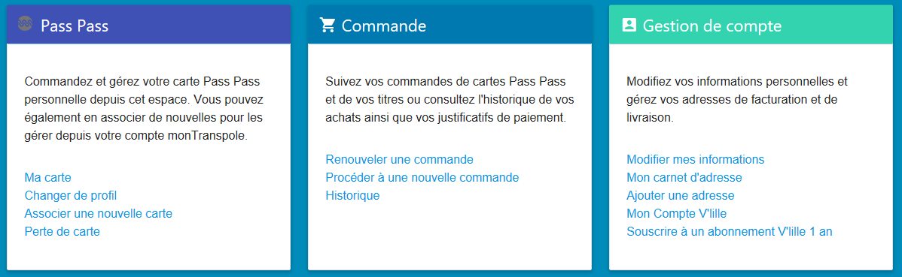

Click on “Procéder à une nouvelle commande”.

You will now have to select the monthly subscription you wish to make.

If you are:

* **25 years old and under**,click on “4 – 25 ans” and “Abonnement mensuel” (€30).
* Une image contenant texte

  Description générée automatiquement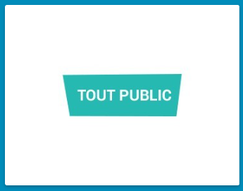**26 years old and over**,click on “Tout public” and “Tout public mensuel” (€60).

After selecting your subscription, the following screen will appear:

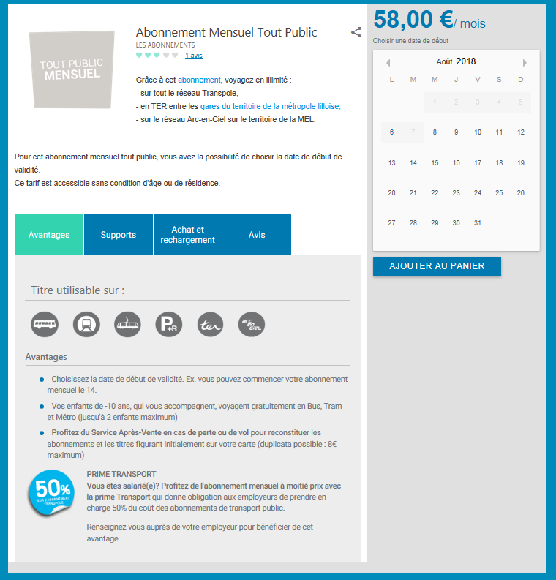

**Select the date you wish to start your subscription on and click on “AJOUTER AU PANIER”.**

**If the chosen date is too close from the day you make this process, the following message will appear:**

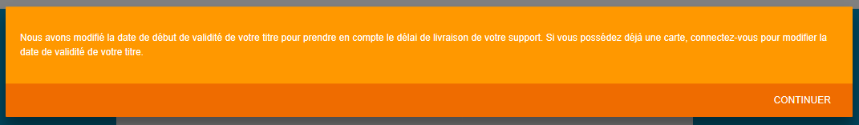

This message means that the start of your monthly subscription was pushed back to take into consideration the delivery time of your PassPass card. Click on “CONTINUER”.

Here is the recap of your purchasing order. Click on “VALIDER”.

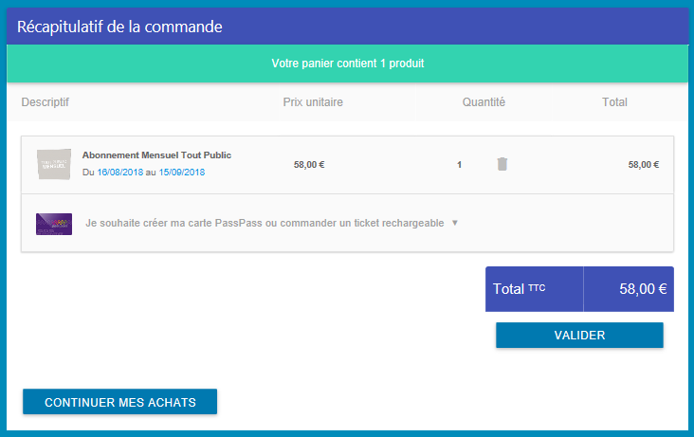

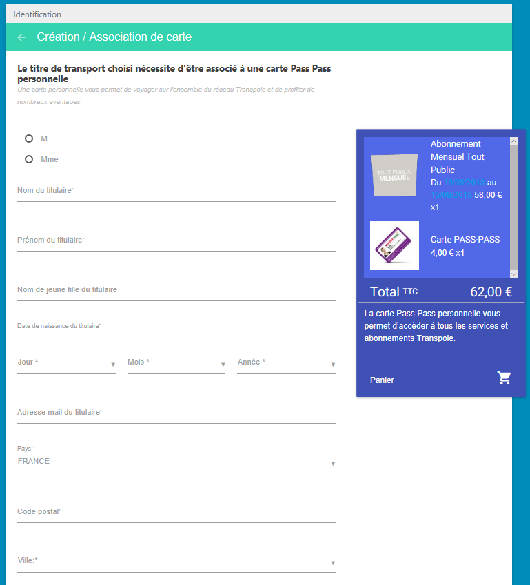

**Mr (***M***) / Mrs (***Mme***)**

**Family name**

**First name**

**Birthdate (DD/MM/YYYY)**



**Email address**

**Country:** *FRANCE*

**Postal code of your residence in France**

**City of your residence in France**

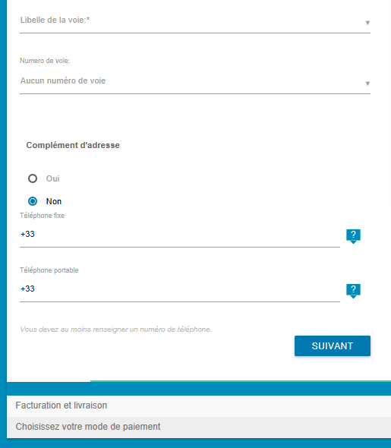

**Street name**

**Street number**

**Tick “Oui” to bring precisions to your address and make sure you will receive your mail in the right mailbox.**

**French mobile phone number**

To bring precisions to your address:

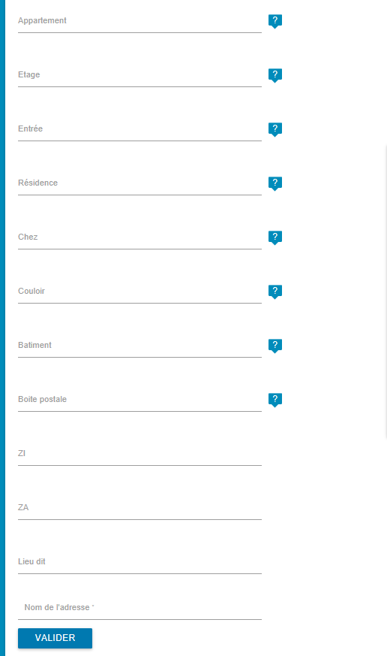

**Apartment number**

**Floor number (if necessary)**

**Residence name**

**Landlord name if it is not your name on the mailbox.**

**Building number**

**(if necessary)**

**Write down** **“**Home**”**

**Q**

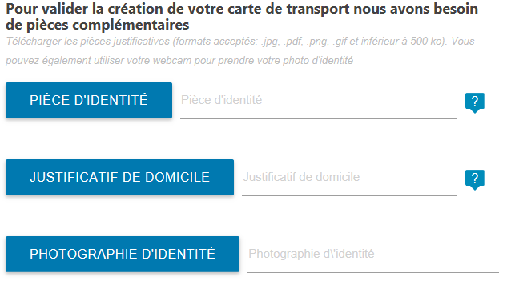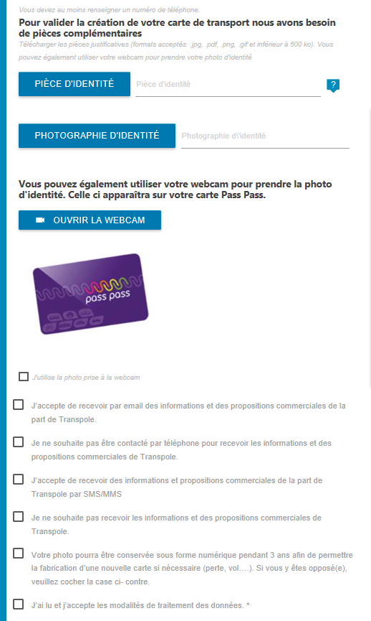

**Upload your passport / ID**

**ID photo (white background)**

**Tick**

**Proof of address (your home insurance certificate is accepted)**

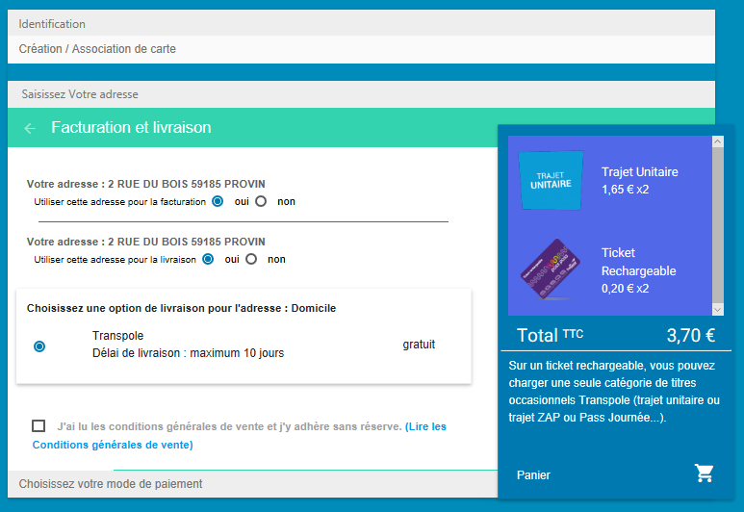

**Tick “***Oui***”**

**Tick “***Oui***” and your Pass Pass card will be sent to your French address.**

**Tick**

Final step: choose your means of payment and proceed!

**Ilevia will process your request within 48 hours. You will receive an email to inform you whether your documents have been accepted or not.**

**It will then take 10 to 15 days for you to receive the Pass Pass card.**