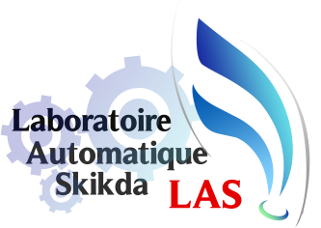

Fourth International Conference On

Technological Advances in Electrical Engineering

May 23-24/2023 Skikda-Algeria
Indexed In: Turkish Journal of Electromechanics and Energy

Phone : +213660372303
E-mail: ictaee2022@univ-skikda.dz
ictaee2022@gmail.com
Sponsored by
Laboratory of Automatic Skikda LAS
Faculty of Technology


Call For Papers
Organized By Automatic Laboratory
University of 20 August 1955 Skikda

Greetings from the General Chair
On behalf of the organizing committee, it is a great pleasure to welcome and invite you to the Third International Conference on Technological Advances in Electrical Engineering (ICTAEE’23) that will be held at the Faculty of Engineering – 20 August 55 Skikda University, on May. 23 – 24 2023. The venue, city of Skikda is the largest city in the East of Algeria, and it is the Economic Capital of East Algeria. This three-day event will provide an opportunity to researchers from Universities, industry, private and public sectors to meet and network with their peers. The technical program comprises well-known plenary speakers, special sessions, panels, oral presentations, posters and exhibitions. Exciting social programs are also planned for the conference attendees.
The Topics Included:
- Control systems
- Signal & Image processing
- Power systems
- Analysis and diagnosis of systems
- Renewable energy
- Modelling and simulation of systems
- Advanced technology of communication
- Embedded Systems

Honorary Chairs
Pr. T. Boufandi
Dr. N. Amouchi
General chair : Pr. A. Lachouri
Important Dates
Full Paper Submission Deadline | Before Apr 20, 2023
Notification of Acceptance | Before May 02, 2023
Registration & Final Paper Submission | Before May 15, 2023
Conference Date | May 23-24, 2023

Conference Scope
The ICTAEE’23: International Conference on Technological Advances in Electrical Engineering aims to bring together leading academic scientists, researchers and research scholars to exchange and share their experiences and research results about all aspects of Electrical Engineering and Technology. It also provides an interdisciplinary forum for researchers, practitioners and educators to present and discuss the most recent innovations, trends, and concerns, practical challenges encountered and the solutions adopted in the field of Electrical Engineering and Technology.

