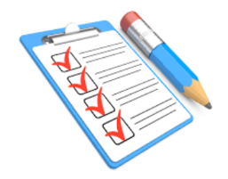
Formalities to be done before reaching EDHEC

Am I ready to reach France?

PASSPORT/VISA
□ I have a valid ID / passport
I am a NON-EU citizens:
□ I got my French student visa
□ I have a scanned copy of my passport and my visa in my email box

TRANSFER
□ I complete the pickup form before December 9th
The campus will be closed from December 24th until January 3rd.

HEALTH INSURANCE
I am a EU citizen:
□ I have a European Health Insurance Card valid for my entire stay in France
I am a NON-EU citizen:
□ I have a private health insurance that covers me for my entire stay in France
For all students
□ VERY IMPORTANT: I send the proof of my health insurance to EDHECWelcome2Lille@edhec.edu

HOUSING
□ I have scheduled my check-in appointment with the residence Manager / my landlord on …………. at ……………….
In student residences, NO check-in during weekends and after 6pm on weekdays.

□ I have taken a home insurance contract and bring a copy to the check-in appointment (for the on-campus student residence
& EGIDE student residence the home insurance is included in the first payment).

TO OPEN A FRENCH BANK ACCOUNT, I NEED:
□ a copy of my passport
□ a copy of my student card or school enrolment letter (available on MyEdhec)
□ a copy of my home contract signed + my home insurance certificate

OTHER DOCUMENTS
□ I bring along my original birth certificate (mother tong) AND the official translation into French (legalized)
□ If I intend to drive in France, I bring an official translation of my driving license

