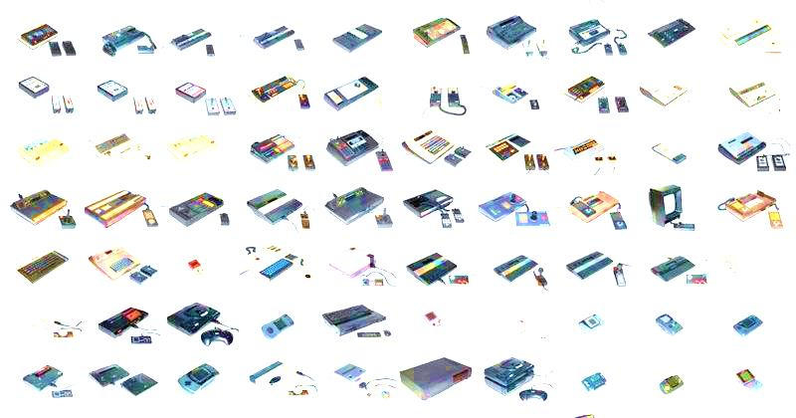
NETTOYAGE CONSOLE
+
PATE THERMIQUE
Xbox/PS4
FAT- SLIM - PRO
3000 DA

