Connector for Temp sensor:

Maxim: MAX31275

I2C comms

Link: https://datasheets.maximintegrated.com/en/ds/MAX31725-MAX31726.pdf

Gnd

Gnd

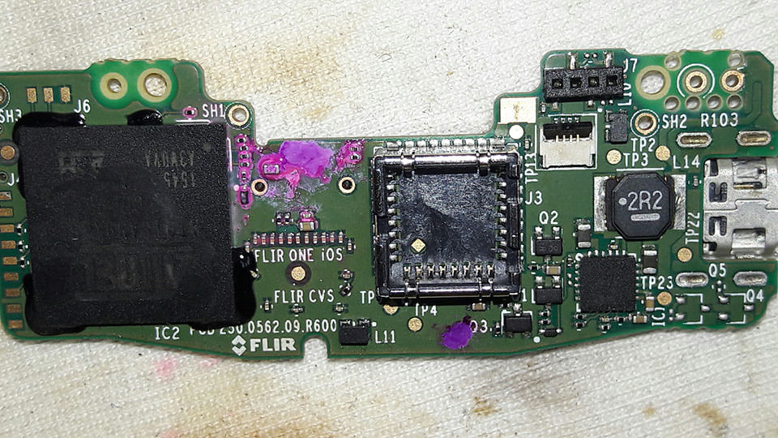

Processor:

Atmel: AT91SAM9X25

Link: http://www.microchip.com/wwwproducts/en/AT91SAM9X25

Charger: USB to battery

TI: bq24295

Link: <http://www.ti.com/product/BQ24295>

I2C comms to Atmel, processor can control charging parameters, for example ‘battery.cfg’

Username: root

Password: indigo

115200, 8n1

Rx, Tx, Gnd

TP23 → battery +ve

USB 2.0 video controller:

Sonix: SN9C270A

Link: http://www.sonix.com.tw/article-en-996-7881

Visible camera:

640x480 VGA

Marking on ribbon cable: Truly: A472F-A1-E TRULY-M

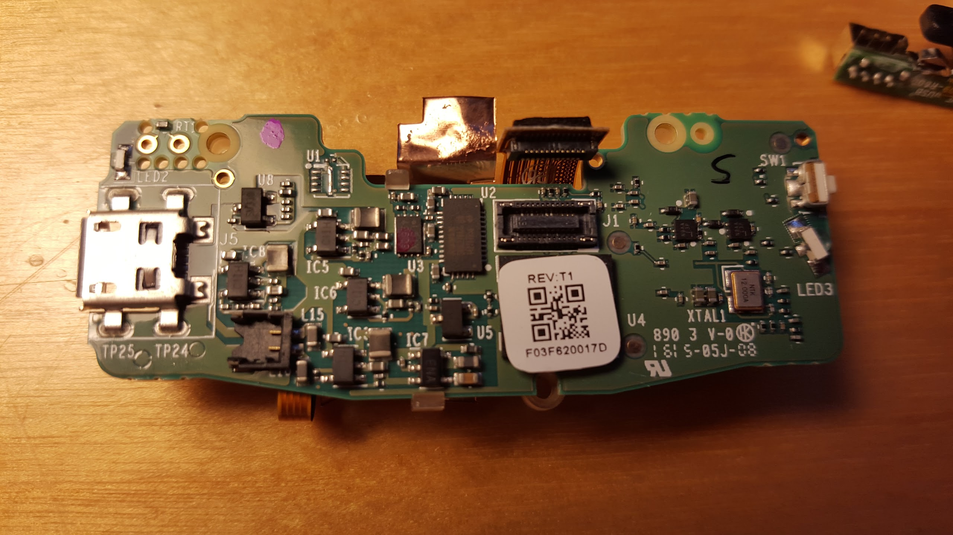

PSU: battery to supplies (step-down convertor)

APsemi: APS1016

SMD marking: C1xx (xx is batch code)

Link: http://www.go-gddq.com/upload/2013-08/temp_13082716459518.pdf

3.1v

1.0v

1.8v

1.18v

1.0v

Gnd

3.3v

2.8v