ETRIER DE FREIN

[https://www.facebook.com/photo.php?fbid=3831594353622168&set=p.3831594353622168&type=3&__cft__[0]=AZUjT3uj-b8tt6n8hzqygXZIbSuvEQ2JDIGtyM0WAZZgYXT4ylZ3DOAQUedChFkAHx-gXZJs6LojM2ZWMgpV9xnGC7K9K-7CcSWSNK4JjLr5I_HvdGZZ7dRE6Gyes403LlRZpw_NnoHPstoXfFFafyfFIY_RmDNY1UMSxck2dBk3xMRVP5iTqNV9NY8E1I8TiD0&__tn__=R]-R](https://www.facebook.com/photo.php?fbid=3831594353622168&set=p.3831594353622168&type=3&__cft__%5b0%5d=AZUjT3uj-b8tt6n8hzqygXZIbSuvEQ2JDIGtyM0WAZZgYXT4ylZ3DOAQUedChFkAHx-gXZJs6LojM2ZWMgpV9xnGC7K9K-7CcSWSNK4JjLr5I_HvdGZZ7dRE6Gyes403LlRZpw_NnoHPstoXfFFafyfFIY_RmDNY1UMSxck2dBk3xMRVP5iTqNV9NY8E1I8TiD0&__tn__=R%5d-R)

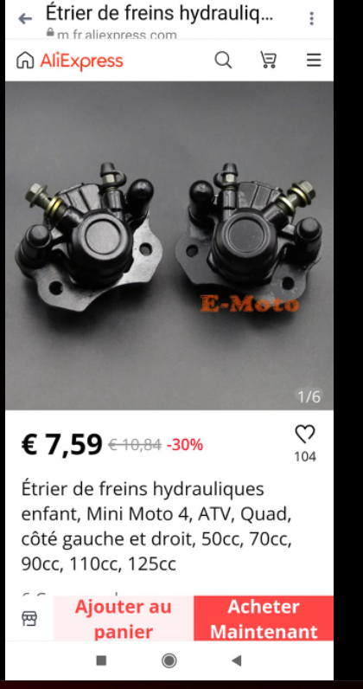

Disque de frein

[https://www.facebook.com/photo.php?fbid=3831594536955483&set=p.3831594536955483&type=3&__cft__[0]=AZUjT3uj-b8tt6n8hzqygXZIbSuvEQ2JDIGtyM0WAZZgYXT4ylZ3DOAQUedChFkAHx-gXZJs6LojM2ZWMgpV9xnGC7K9K-7CcSWSNK4JjLr5I_HvdGZZ7dRE6Gyes403LlRZpw_NnoHPstoXfFFafyfFIY_RmDNY1UMSxck2dBk3xMRVP5iTqNV9NY8E1I8TiD0&__tn__=R]-R](https://www.facebook.com/photo.php?fbid=3831594536955483&set=p.3831594536955483&type=3&__cft__%5b0%5d=AZUjT3uj-b8tt6n8hzqygXZIbSuvEQ2JDIGtyM0WAZZgYXT4ylZ3DOAQUedChFkAHx-gXZJs6LojM2ZWMgpV9xnGC7K9K-7CcSWSNK4JjLr5I_HvdGZZ7dRE6Gyes403LlRZpw_NnoHPstoXfFFafyfFIY_RmDNY1UMSxck2dBk3xMRVP5iTqNV9NY8E1I8TiD0&__tn__=R%5d-R)

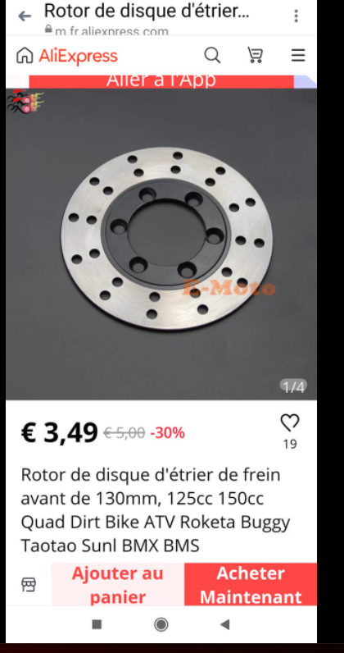

Rotule cremaillere

<https://a.aliexpress.com/_vKHEhd?fbclid=IwAR0ruUqYp4u956CPriehJ52_dY_1THdJpU3s4OqppHFL1RV7hZvq2jBmX8s>

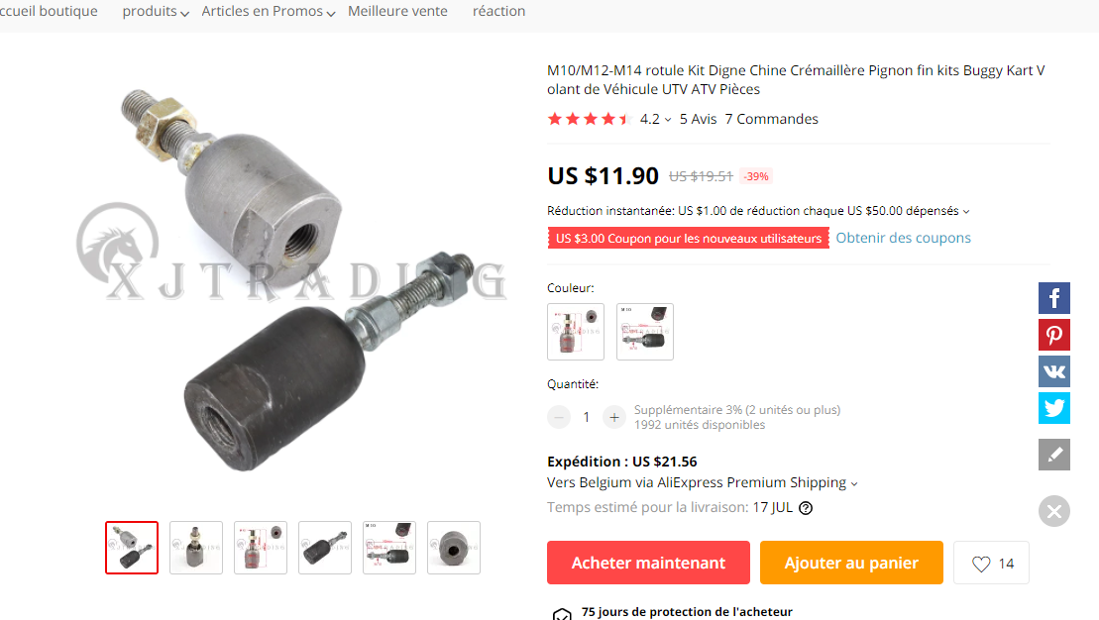

PIGNON 36/14 Assemblés ET PIGNON 27 dents

<https://a.aliexpress.com/_vNYKkj?fbclid=IwAR0P9mahcWOIx5RI0N_-3XIrp1kU-6gUWcV1NmsRuqjtF1XG5JxqDHhQQaA>

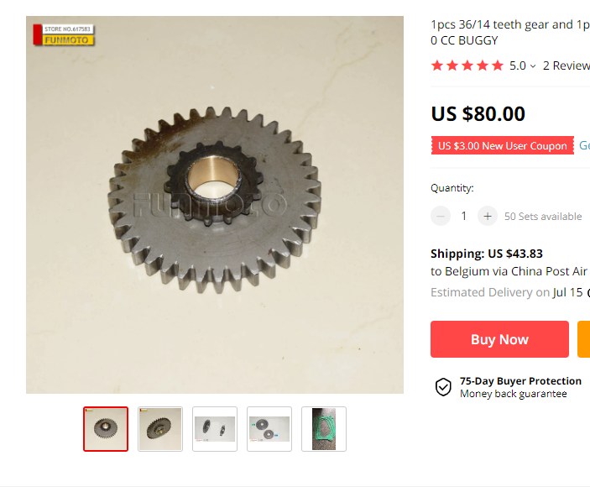

SOUFFLET DE CREMAILLERE

<https://a.aliexpress.com/_uipPA7?fbclid=IwAR0qCuvqbvQcnAZ6xqW-IT_lvXPQUgyWwXr57havqiqP9VKWO8eS9bUv7rQ>

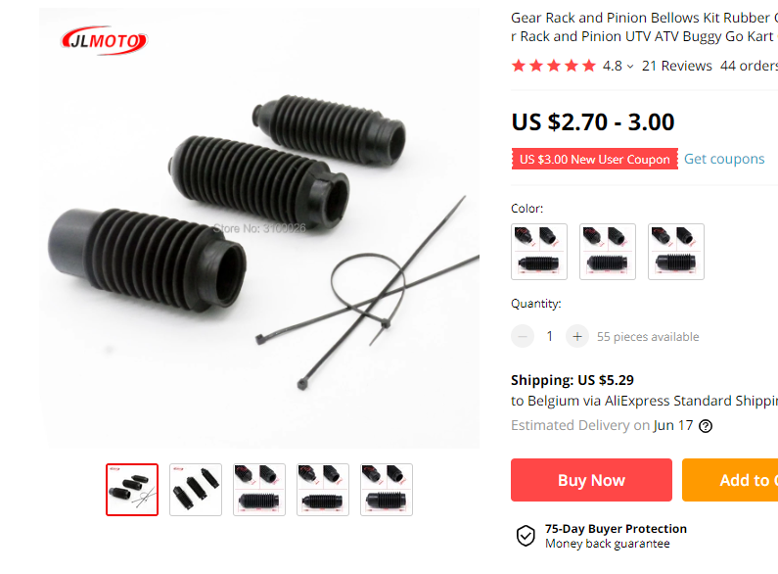

Pour refaire les têtes d'amortisseurs avants

<https://a.aliexpress.com/_v6RWkF?fbclid=IwAR0XbmBo2pogW_yyk7QdKGwMIlOvR0JkHiafeHfY3t8aY4PUHQLz7CufO5E>

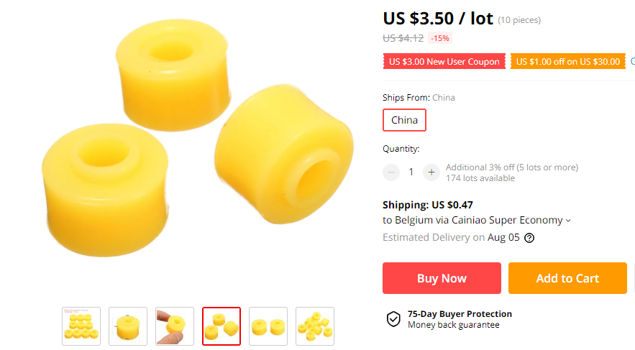

FIXATION BATTERIE

Fixation Batterie

<https://a.aliexpress.com/_uuT67t?fbclid=IwAR1urL3v69fd-NA1BJhH8hsi-1E4Pi30U6nsLXcl8vj2dyJ8ZTFmqLfzKFU>

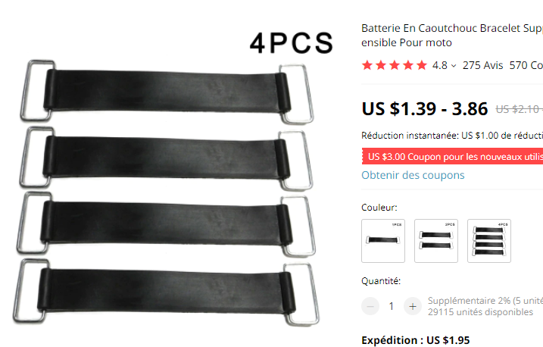

ROTULES

<https://a.aliexpress.com/_vXjuCF?fbclid=IwAR3nw6BdbJXnyiiMJ_byS7s4tYc1f5q783NHU07H1w0BU0YtP4UcopRJG0>

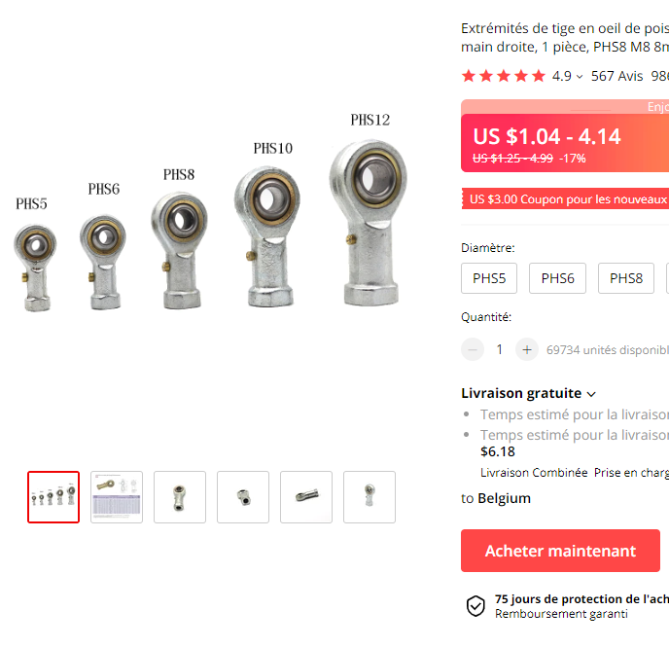

Bouchon vanne de purge

<https://a.aliexpress.com/_vNZ6n1?fbclid=IwAR2rInSQubG5iKGbcnqqhajHS-m_pZUffJB9WbzewPJEffadMBRStTgO5gY>

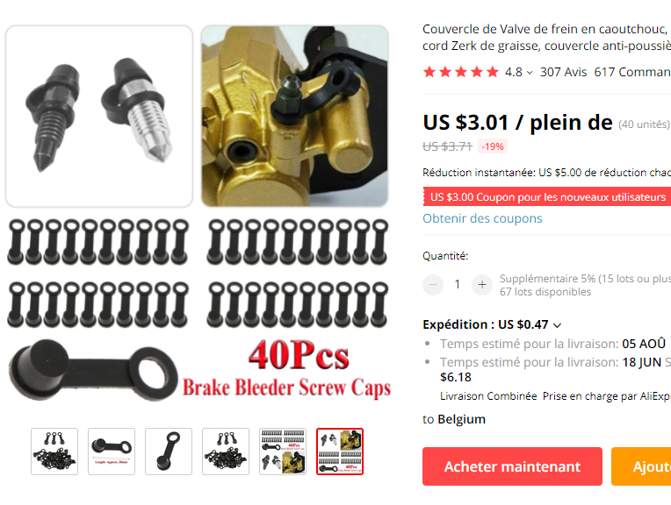

Roulement de colonne de direction

<https://a.aliexpress.com/_u6zTMX?fbclid=IwAR0B5klNLv3633uik7CPNcl77zrbUTKebpNVZNzMSpn6hcXwJ1k2KT91pBI>

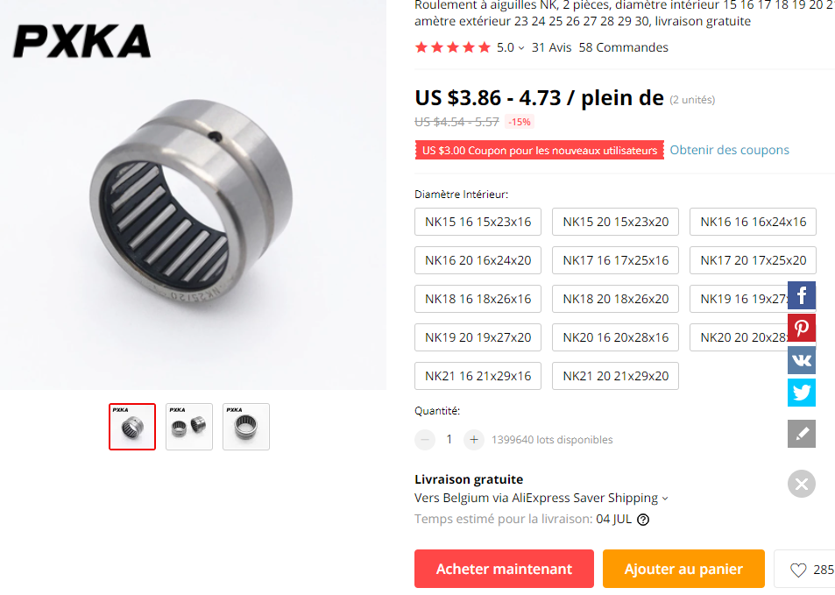

Roulement de moyeu arriere

<https://www.ebay.de/itm/254210960975?fbclid=IwAR1YYqDPKhEims--NEedrQfz9iza95oVyjBhIdXmtfcLdKq8-xK7QTzfu0I>

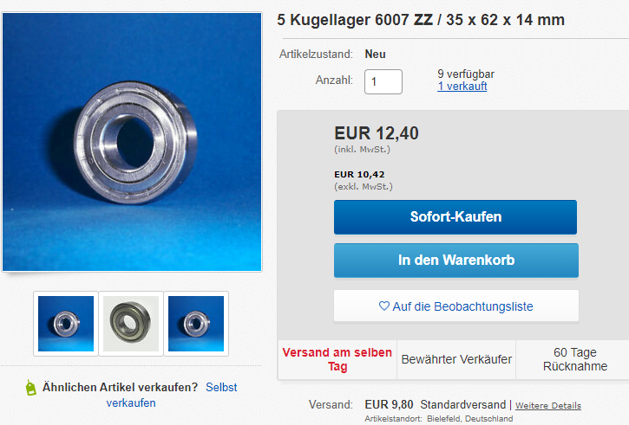

Interrupteur pour moto

<https://a.aliexpress.com/_vrIfXp?fbclid=IwAR1R3FbSvZGn6uymYMET7dvHyax54Bk3YsRreGxxenbU0gjSlaQqDqWrKSk>

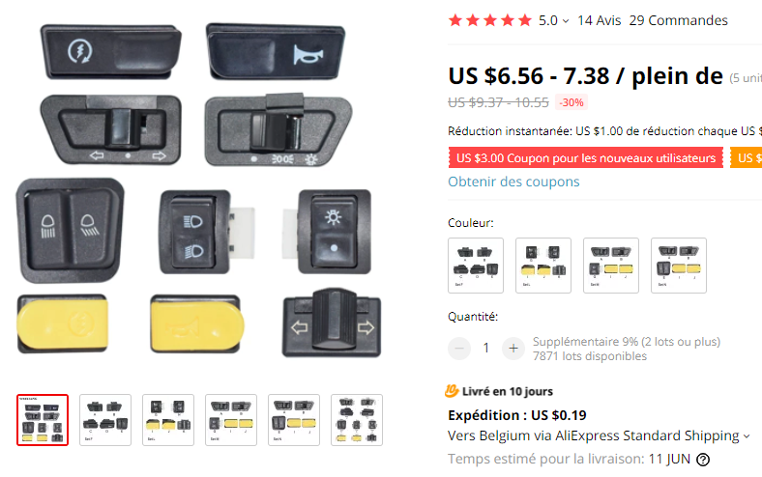

Interrupteur à bascule 2positions

<https://a.aliexpress.com/_vrQp2n?fbclid=IwAR0q7k8FSJF-vYZkG5oCxxJSD9Q3-_Gb8gFSLbQ8yOIbOZBNjHls4PjJKXM>

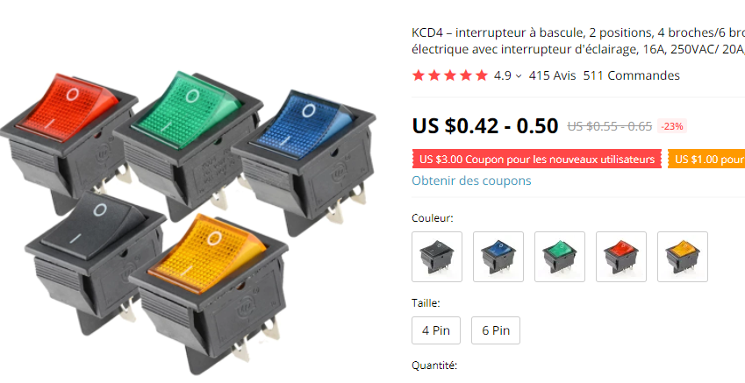

Interrupteur à bascule 3position

[KCD4 1 PIÈCES Interrupteur À Bascule Interrupteur MARCHE ARRÊT SUR 3 Positions 6 équipements Électriques Avec Interrupteur 16A 250VAC/ 20A 125VA | AliExpress](https://fr.aliexpress.com/item/1005001497158726.html?srcSns=sns_Copy&spreadType=socialShare&bizType=ProductDetail&social_params=60056418059&aff_fcid=f6e6efd3d94645988d4c4b1af82d9ab0-1622235641914-04693-_uwyLef&tt=MG&fbclid=IwAR0rtMcS-Z5NMuEDLwH8_wrqSLOLSyr3PiaHOhmi7b7fTHhPE9gVz0eRF-w&aff_fsk=_uwyLef&aff_platform=default&sk=_uwyLef&aff_trace_key=f6e6efd3d94645988d4c4b1af82d9ab0-1622235641914-04693-_uwyLef&shareId=60056418059&businessType=ProductDetail&platform=AE&terminal_id=ba8f631fe75e4ed69fc6d8c7929d8bdd)

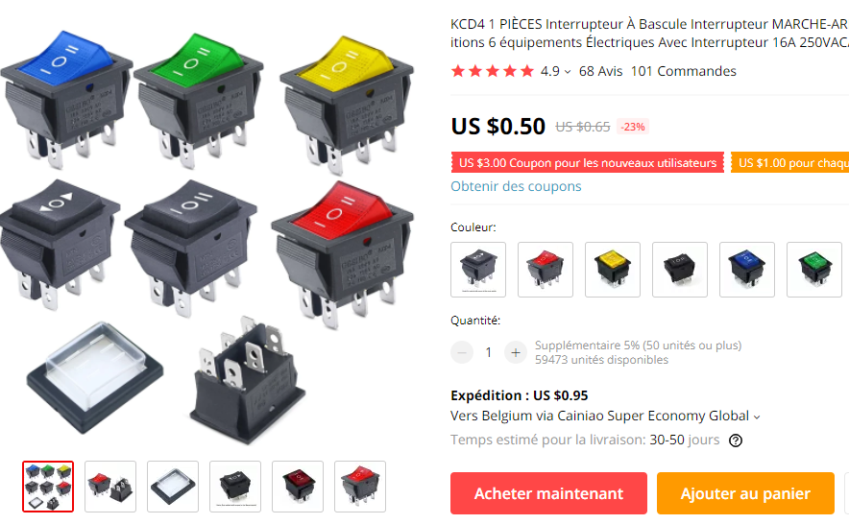

Frein hydraulique

<https://a.aliexpress.com/_v4v4bz?fbclid=IwAR2rksvAwBNxpcxNebcZqG2WtnlJlU-0Ca3e2losSfwJXj6Ndrs1XpMyuf4>

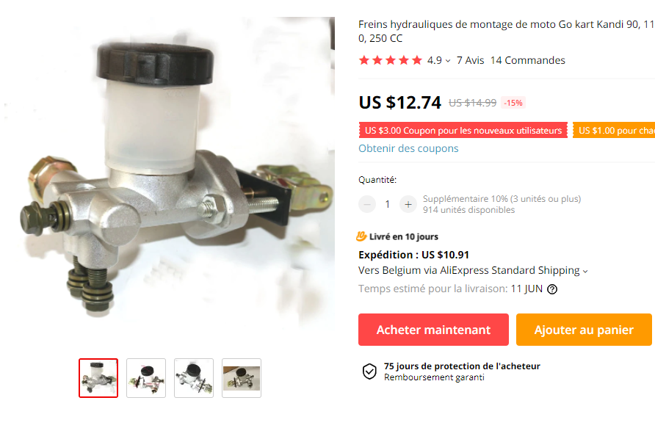

bride de moyeu de roue arrière

<https://a.aliexpress.com/_v1ALZV?fbclid=IwAR0l7sTvTKFsmmJY4HK00gSg-_LKEFwxI5yVgyAeULe0wzFJOQil4X1EKis>

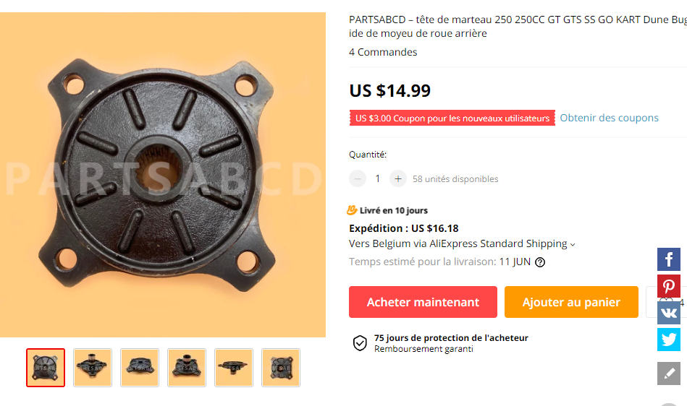

Feu arrière de buggy

<https://www.aliexpress.com/item/32676190982.html?spm=a2g0s.9042311.0.0.374b4c4dIEWrvA&fbclid=IwAR1_Q-Kl1SeYhBXpqSnMwieckJWRQE0aZrJ0xuEIPTrogCsfOrYRL1Q_93I>

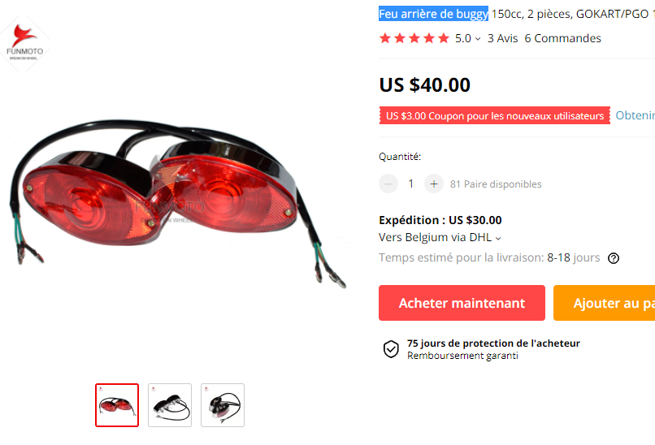

Silencieux d'échappement

<https://www.aliexpress.com/item/4000624730872.html?spm=a2g0s.9042311.0.0.27424c4dVbrHjG&fbclid=IwAR2iU-HauLAZSh3Ir8Dc4e-ArqZ857wsCTSUvDXe3QAc2mTtpmFGAmrhGZU>

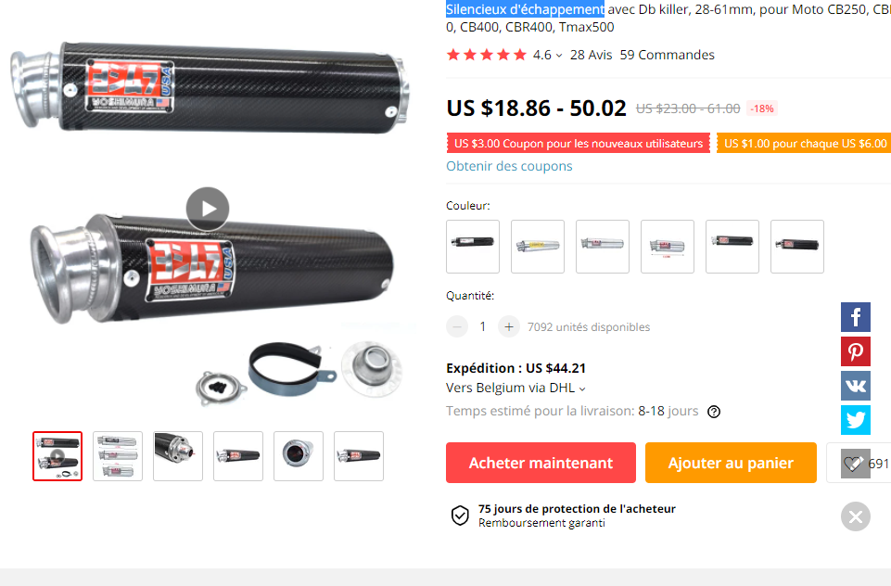

Arbre de transmission arrière

<https://www.aliexpress.com/item/32795359635.html?spm=a2g0s.9042311.0.0.27424c4dB9F5RO&fbclid=IwAR1n2_2c9gRBJIXonom_c2QVHtE0GUxNPkGbg7fNYgkVCLN26fo-ZF3IIAs>

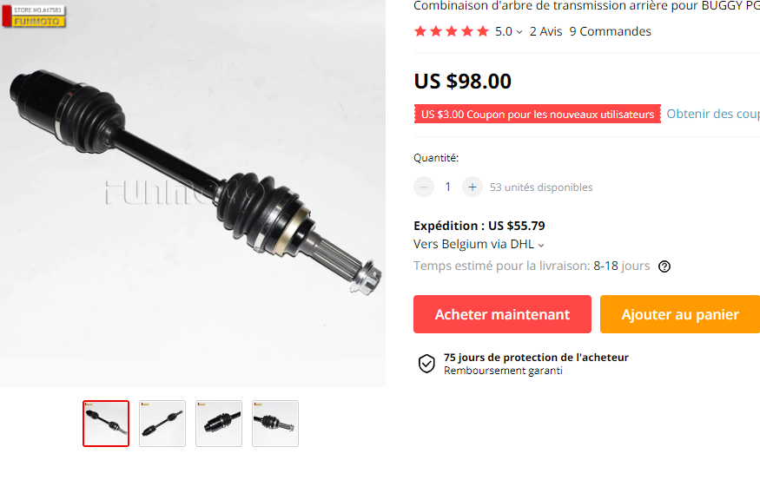

Relais de clignotant électronique réglable CF14 à CF 14K

<https://www.aliexpress.com/item/32978033245.html?spm=a2g0s.9042311.0.0.27424c4dB9F5RO&fbclid=IwAR3IuVOzk61o753vl9JSwVlR5EkDx40cb5nzDUxyJOZA7Y9uPEFD7ZBv8Ak>

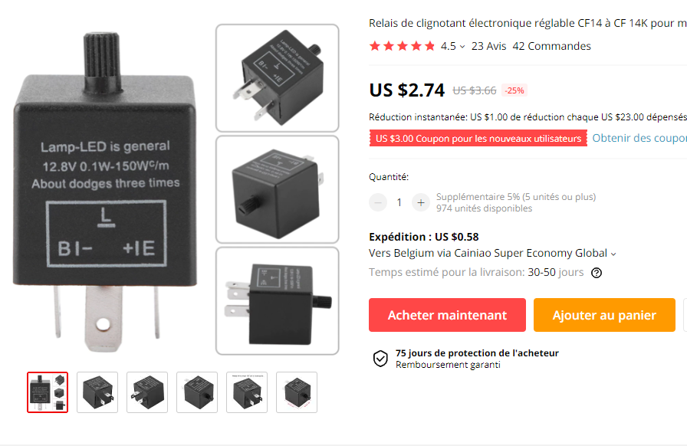

ampoule feu avant

<https://www.aliexpress.com/item/33036009178.html?spm=a2g0s.9042311.0.0.27424c4dM45aXO&fbclid=IwAR0q7k8FSJF-vYZkG5oCxxJSD9Q3-_Gb8gFSLbQ8yOIbOZBNjHls4PjJKXM>

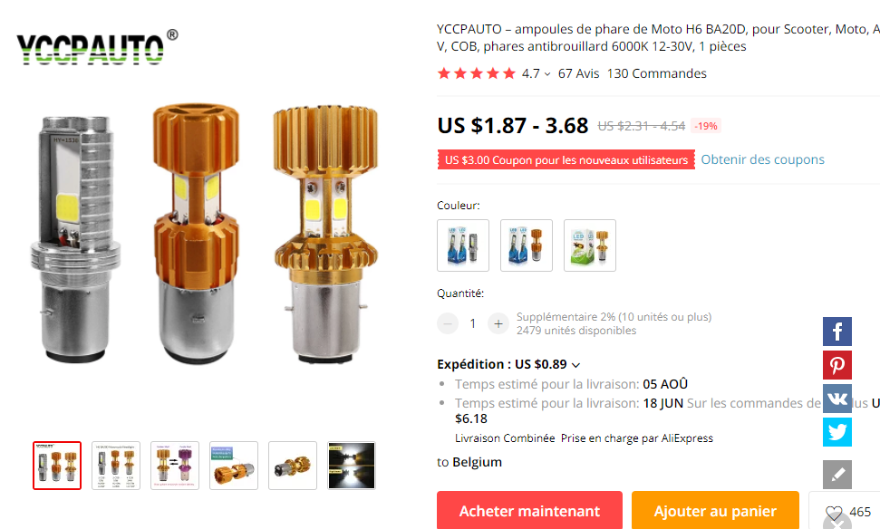

Starter automatique

<https://www.aliexpress.com/item/4000107536301.html?spm=a2g0s.9042311.0.0.27424c4dOYkxSA&fbclid=IwAR2-lokKJ_J2zwOmXOSWMBl-EsnLYDDZgnmVU5LjR_KuYMaGF0N2NB99z1I>

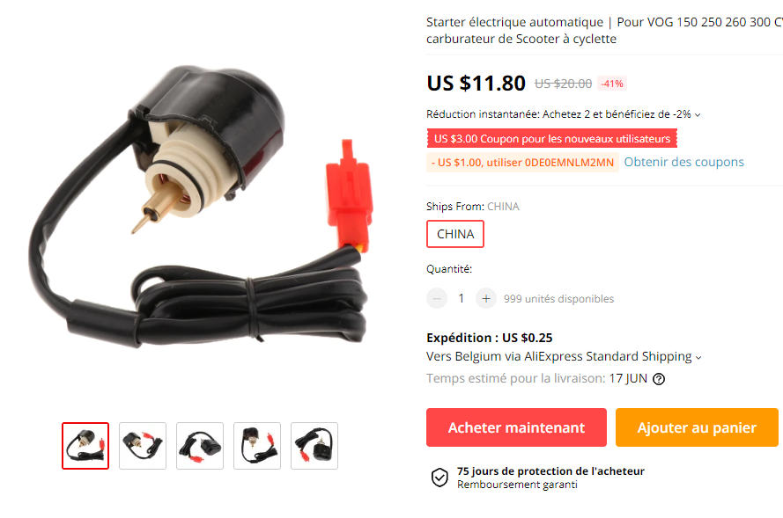

Bouchon radiateur avec jauge

<https://www.aliexpress.com/item/32799772876.html?spm=a2g0s.9042311.0.0.27424c4dwWLMwa&fbclid=IwAR0q7k8FSJF-vYZkG5oCxxJSD9Q3-_Gb8gFSLbQ8yOIbOZBNjHls4PjJKXM>

