- Look at the images and tell what they do
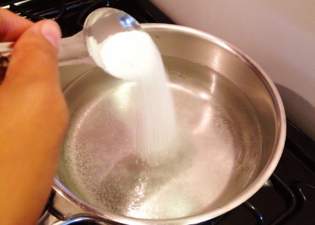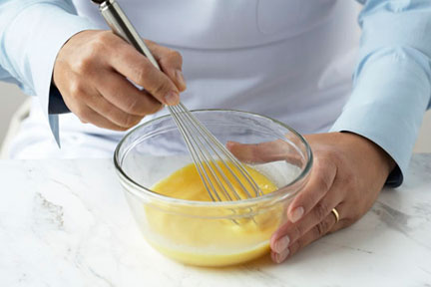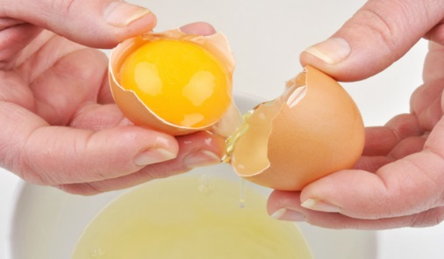
1)She……………………………………. 2)The chef………………………………… 3)The lady………………………………………..
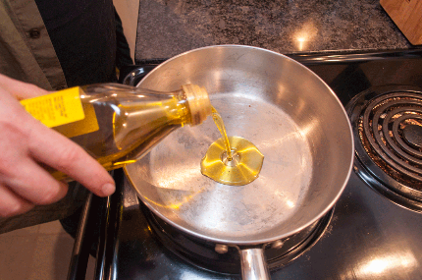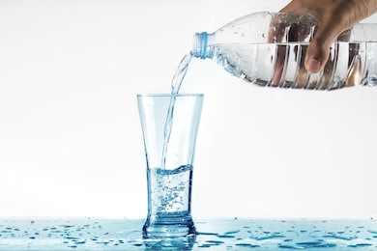
4)He………………………………………. 5)He……………………………………….. 6)The cook………………………………

- Write a text telling how you make mayonnase

