FROM May 21st TO May 25th 2021 -
NAME: Big Bad Convention : Back to Sunnydale

PULLMAN PARIS ROISSY CHARLES DE GAULLE AIRPORT
Roissypôle - Rue de la Haye
CS 10008 - 95935 Roissy CDG Cedex
: +33 1 70 03 82 04 : +33 1 41 33 73 40
Email: h8228-sl@accor.com

Classic single room (per night): 130 € Incl. VAT
Classic double room (per night): 158 € Incl. VAT

Superior single room (per night): 145 € Incl. VAT
Superior double room (per night): 173 € Incl. VAT

City tax: 2,88€ per person and per night

All above rates include breakfast, VAT and service
Breakfast supplement: 28,00€ VAT Included

PLEASE FILL IN THE REGISTER FORM AND SEND IT NO LATER THAN 04/10/2021.
After this date, reservation and price will be subjected to hotel availability.

Name ____________________________________________ Surname ___________________________________________
Company _____________________________________________________________________________________________
Address _______________________________________________________________________________________________
Phone number ____________________________________________ Fax number __________________________________
E-mail ________________________________________________________________________________________________

Room Choice ________ Single Room ________ Twin Room
________ Classic Room ________ Superior Room
Number of people occupying the room
1 2

Arrival & Departure Time

Arrival date and time _________________________ ___ Departure date and time __________________________________
(Check-In from 3:00 PM) (Check-Out before 12:00 AM)
I Authorize the Pullman Paris Roissy Charles de Gaulle Airport to charge the following credit card number
According to the cancellation policy below

Credit card number _________________________________ Expiry date __________

Cardholder name________ ________________________________________ Signature _________________________________

CANCELLATION POLICY

The reservation must be guaranteed with a credit card and a preauthorization of the total amount of the reservation will be block. Otherwise,

the request will be automatically cancelled by the hotel.
- For any cancellation made between 11/13/2020 and 04/21/2021, the hotel will not charge you
- For any cancellation made later than 04/21/2021, the hotel will charge you the total amount of the reservation.
- In case of no show, the whole stay will be charged on your credit card.

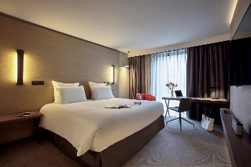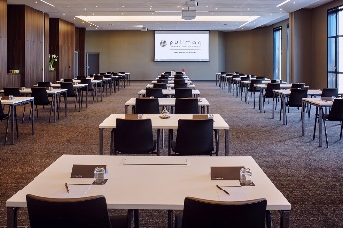

Look around the hotel on the website
http://www.pullmanhotels.com/fr/hotel-8228-pullman-paris-roissy-cdg-airport-opening-october-2015/index.shtml

