Get up 1 :
Exercices de remédiation
sur les unités 1 et 2

U1 | Le cas possessif | p. 1
U1 | To be | p. 3
U1 | Have got | p. 4
U1 | To be and have got | p. 5
U2 | Le présent simple (forme affirmative) | p. 8
U2 | Le présent simple (forme interrogative) | p. 9
U2 | Le présent simple (forme négative) | p. 10

Avec ton livre tu as reçu un petit livret ressource avec le vocabulaire et la grammaire qui allaient être vus cette année.
C’est le moment de l’utiliser
Si tu ne le trouves plus ! Retourne voir la théorie dans ton livre, tout y est !
N’hésite pas à aller sur le site pour les exercices de vocabulaire ainsi que pour les auditions.

Le cas possessif
1 Possessive case or to be? Tick the correct answer.
Coche la bonne réponse.

 | Possessive case | To be
1 Jennifer’s sister has got a guitar. | ………… | …………
2 Her sister’s name’s Iris. | ………… | …………
3 Jennifer and Iris’s rooms are big. | ………… | …………
4 Jack’s her cousin. | ………… | …………
5 Jack’s eight years old. | ………… | …………

2 Tick the correct sentences and correct the wrong ones.
Coche la bonne réponse et corrige si c’est faux.

 | Correct | Corrected version
1 The teacher’s T-shirt is green. | ……… | ……………………………………
2 The children’ books are open. | ……… | ……………………………………
3 The girls’s hair is long. | ……… | ……………………………………
4 The classroom’s tables are round. | ……… | ……………………………………
5 The boy’s shirt° is blue and white. | ……… | ……………………………………
° shirt: chemise

3 Reformulate these sentences using a possessive case if possible.
Reformule avec un cas possessif si c’est possible.

The door of the house. | The toys of the children. | The book of James.
……………………………… | ……………………………… | ………………………………
 | 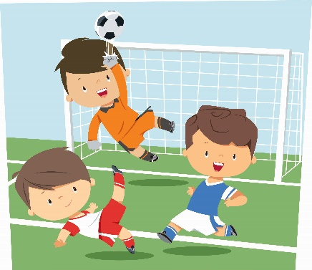
The car of Sue. | The ball of the boys. | The capital of Belgium.
……………………………… | ……………………………… | ………………………………

To be

1 Complete the sentences with the positive (+) or negative form (-) of to be.
Complète avec une forme conjuguée de “to be”. Attention à ce qui t’es demandé (+ ou -)

1 I …Kelly Jackson. (+) | ………
2 My family and I … from the United States. (-) | ………
3 We … from England. (+) | ………
4 My father … forty-two years old. (-) | ………
5 He … forty-five years old. (+) | ………
6 My parents … at home. (-) | ………
7 My mother … a teacher. (+) | ………
8 She … at school. (+) | ………

3 Make questions using to be and answer them.
Formule les questions et réponds-y.

1 you / a boy / ? | ……………………………… | …………………………
2 your parents / married / ? | ……………………………… | …………………………
3 your classroom / big / ? | ……………………………… | …………………………
4 your English teacher / a man / ? | ……………………………… | …………………………
5 you / 28 pupils in your class / ? | ……………………………… | …………………………

Have got

1 Look at the picture and complete the sentences with has got, have got, hasn’t got or haven’t got.
Observe l’image et complète avec la forme adéquate de “have got”.
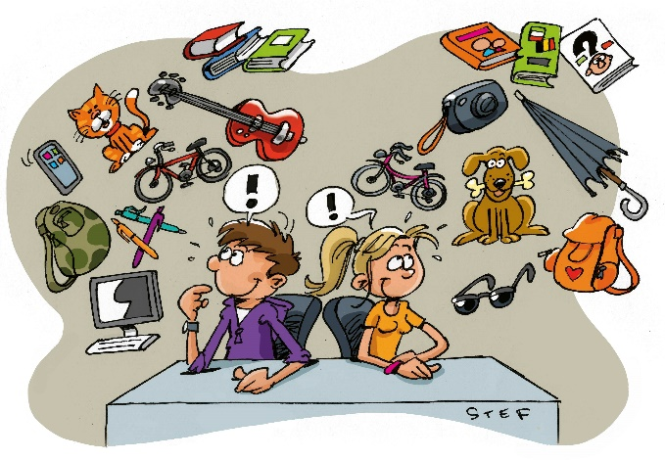
1 Meg … a dog. | …………
2 Fred … sunglasses. | …………
3 Fred … a mobile phone. | …………
4 They … a car. | …………
5 Fred … books. | …………
6 Meg … a guitar. | …………
7 They … a schoolbag. | …………
8 Fred … a camera. | …………
9 Meg … an umbrella. | …………
10 They … a bird. | …………

2 Now ask and answer questions (short answer!!!).
Pose la question et réponds. Toujours par rapport à l’image
Example: Meg / a camera | Has Meg got a camera? | Yes, she has.
1 they / a mobile phone | …………………………………… | …………………………
2 Fred / an umbrella | …………………………………… | …………………………
3 Fred / a computer | …………………………………… | …………………………
4 they / a motorbike | …………………………………… | …………………………
5 Meg / a cat | …………………………………… | …………………………
6 you / a guitar | …………………………………… | …………………………
7 you / a bike | …………………………………… | …………………………

To be / have got

1 Read the sentences. Underline the verb and complete the table.
Lis la phrase. Souligne le verbe et complète le tableau avec des croix là où il faut.

 | To be | Have got | Long form | Short form | Positive form | Negative form | Question
1 I am Jake Blackwell. | …… | …… | …… | …… | ……... | ……... | ……...
2 I’m twelve years old. | …… | …… | …… | …… | ……... | ……... | ……...
3 I haven’t got a brother. | …… | …… | …… | …… | ……... | ……... | ……...
4 I’ve got a sister. | …… | …… | …… | …… | ……... | ……... | ……...
5 She’s sixteen years old. | …… | …… | …… | …… | ……... | ……... | ……...
6 Have you got a sister? | …… | …… | …… | …… | ……... | ……... | ……...
7 My parents are married. | …… | …… | …… | …… | ……... | ……... | ……...
8 Are your parents married? | …… | …… | …… | …… | ……... | ……... | ……...
9 My father isn’t old. | …… | …… | …… | …… | ……... | ……... | ……...
10 We’ve got a house in Blackpool. | …… | …… | …… | …… | ……... | ……... | ……...
11 We haven’t got a dog. | …… | …… | …… | …… | ……... | ……... | ……...
12 Have you got a pet? | …… | …… | …… | …… | ……... | ……... | ……...

2 Complete the sentences with the correct form of to be or have got.
Choisis entre “to be” et “have got” et conjugue.
1 Harry Potter … a wizard. | ……………………
2 His parents … dead. | ……………………
3 He … a cousin called Dudley. | ……………………
4 He … two best friends, Ron and Hermione. | ……………………
5 Hermione … a pure-blood. | ……………………
6 She … any brothers or sisters. | ……………………
7 She … an only child. | ……………………
8 Ron … six brothers and sisters. | ……………………
9 He … in love with Hermione. | ……………………
10 They … the same enemy, Voldemort. | ……………………

Le présent simple (forme affirmative)

1 Underline the correct form of the verb.
Souligne le verbe correctement conjugué.

Welcome to the Smurfs’ village!

- The Smurfs live / lives in a secret village in the forest.
- They speak / speaks a strange language, the “Smurf”.
- Papa Smurf look / looks after all the Smurfs.
- All the Smurfs love / loves Smurfette.
- Gargamel want / wants to catch the Smurfs.
- He always gos / goes in the forest to find their village.
- Papa Smurf studys / studies spells° to fight Gargamel.
° spells: sorts

2 Complete the sentences with the correct form of the verb.
Conjugue le verbe entre parenthèses.

A day in the life of a young football player

1 Every day, I (to get up) … at 6 am to go to the football pitch. | ……………
2 At 7 am, I (to meet) … my coach and my team. | ……………
3 Together we (to train) … for one hour. | ……………
4 Our coach (to give) … a lot of exercises to do. | ……………
5 The training session (to finish) … at 8 am. | ……………
6 After that, we (to dress) … and (to go) … to school. | ……………
7 School (to start) … at 9 am and (to finish) … at 3 pm. | ……………
8 My best friend (to go) … home but I (to play) … football again. | ……………
9 At 7 pm, I (to come) … back home and (to eat) … with my family. | ……………
10 I (to do) … my homework and then (to go) … to sleep at 10 pm. | ……………

Le présent simple (forme interrogative)

1 Circle the correct form of the verb.
Entoure le bon auxiliaire.

- Do / does you have two minutes to answer my questions?
- Where do / does you live?
- How do / does you go to school?
- And how do / does your friends go to school?
- Do / does your father or mother drive you to school?
- Do / does I have time for other questions?
- Does / Do it bother° you?
° bother: ennuyer

2 You are writing to your pen friend. Ask him/her questions.
Tu écris à ton correspondant. Pose-lui des questions en utilisant les mots ci-dessous.

1 you / like chocolate? | ……………………………………………………
2 where / your brother / study? | ……………………………………………………
3 how / you / go to school? | ……………………………………………………
4 what time / you / wake up? | ……………………………………………………
5 your parents / speak French? | ……………………………………………………
6 when / you and your family / go on holiday? | ……………………………………………………
7 you / do sports? | ……………………………………………………

Le présent simple (forme négative)

1 Underline the correct form of the verb.
Souligne la forme correcte du verbe.

- I don’t / doesn’t like grumpy° people.
- My friends and I don’t / doesn’t like Gargamel.
- Gargamel don’t / doesn’t like us.
- Gargamel and his cat don’t / doesn’t catch us very often.
- We don’t / doesn’t live in big houses.
- I don’t / doesn’t like parties.
° grumpy: râleur

2 Look at the pictures and write sentences.
Regarde l’image et formule une phrase négative.

……………………………………………………
……………………………………………………
……………………………………………………
……………………………………………………
3 Complete the text with the correct form of the verbs.
Complète le texte en conjuguant les verbes entre parenthèses.
(attention il y a des formes + et -)

Mary (1 to be) … an American girl. She (2 to live) … in Los Angeles, California, with her family. Her day (3 not - to start) … before 7.30. At that time,  she (4 to get up) …,  (5 to go) … to the bathroom, (6 to have) … a shower,  (7 to brush) … her teeth and (8 to get) … dressed.  She (9 not – to eat) …anything for breakfast.  At 7.45 she (10 to leave) … home and (11 to catch) … the bus to school.  Her sisters (12 to take) … the bus with her. After school, at 4.35, they (13 to go) … to the gym together.  Then they (14 to come) … back home and (15 to do) … their homework. At 7.30, the whole family (16 to eat) … together.  (17 to think – you) … her day is over?  No, because Mary (18 to be) … a very helpful girl, so she (19 to help) … her mother cleaning up everything after dinner.  Then she (20 to watch) … TV for a while.  What (21 to watch – she) …?  Usually a movie.  At about 9.30, she (22 to brush) … her teeth again, (23 to put) … on her pyjamas and (24 to go) … to bed.  Her parents always (25 to kiss) … her goodnight before she (26 to get) … asleep. | 1 ……………  2 ……………  3 ……………  4 ……………  5 ……………  6 ……………  7 ……………  8 ……………  9 ……………  10 ……………  11 ……………  12 ……………  13 ……………  14 ……………  15 ……………  16 ……………  17 ……………  18 ……………  19 ……………  20 ……………  21 ……………  22 ……………  23 ……………  24 ……………  25 ……………  26 ……………

