Extra GRAMMAR EXERCISES – 2nd year

1 To be & have got

1. Choose the correct answer. Choisis la bonne réponse.
I is/are/has got/have got a new friend, Alessia. She is/are/has got/have got my holiday friend. She is/are/has got/have got Italian. Her parents is/are/has got/have got from Florence but they live in Lido di Jesolo. They is/are/has got/have got a house near the beach. That’s where I met her. She invited me to sail because she is/are/has got/have got a small boat.
Alessia loves her country very much. She says Italian people is/are/has got/have got really friendly and Italy is/are/has got/have got a beautiful country. It is/are/has got/have got a lot of wonderful places to visit. The food is/are/has got/have got delicious. She is/are/has got/have got right. Pasta and pizza is/are/has got/have got my favourite dishes.
Dear Jane,  I (1) so excited! We (2) on holiday in Italy. What a beautiful country! The weather (3) sunny and hot. And, I (4) a nice suntan°.  We (5) in a wonderful hotel. It (6) 2 swimming pools and 3 restaurants. I (7) lucky! My sister and I (8) a very big room with TV and Jacuzzi! It (9) amazing. My brother (10) a little bit jealous because his room (11) smaller but he (12) a terrace with sea view. However, he (13) very happy. He plays football on the beach every day. He (14) Italian friends. They (15) very friendly and one of them, Antonio, (16) so handsome. He (17) 15. He (18) tall and thin. He (19) black hair and blue eyes. I think I (20) in love!  I (21) a new friend too. Her name (22) Alessia.  I’ll tell you everything when I come back. I (23) some pictures to show you.  Kisses.  Lucy. | (1) …………………………  (2) …………………………  (3) …………………………  (4) …………………………  (5) …………………………  (6) …………………………  (7) …………………………  (8) …………………………  (9) …………………………  (10) ………………………..  (11) ………………………..  (12) ………………………..  (13) ………………………..  (14) ………………………..  (15) ………………………..  (16) ………………………..  (17) ………………………..  (18) ………………………..  (19) ………………………..  (20) ………………………..  (21) ………………………..  (22) ………………………..  (23) ………………………..
2 Complete this postcard with the correct forms of ‘to be’ or ‘have got’.

3 Write sentences with ‘to be’ or ‘have got’ starting from the following words. Ecris des phrases avec to be ou have got en utilisant les mots ci-dessous.

- Lucy / excited today because she / not / at school. She / on holiday.
………………………………………………………………………………………………………...
- Her parents / not / a car.
………………………………………………………………………………………………………...
- They / plane tickets to go to Italy.
………………………………………………………………………………………………………...
- She / not / a big suitcase.
………………………………………………………………………………………………………...
- They / happy to stay in a hotel.
………………………………………………………………………………………………………...
- Lucy’s friends / not with her.
………………………………………………………………………………………………………...
- But she / her mobile phone.
………………………………………………………………………………………………………...

4 Ask questions about Lucy’s holiday using ‘to be’ or ‘have got’ and complete her answers. Pose des questions à propos des vacances de Lucy en utilisant les verbes to be & have got. Complète les réponses de Lucy.

1 you / a lot of clothes in your suitcase?  …………………………………………………  2 your cousin / with you?  …………………………………………………  3 the hotel / comfortable?  …………………………………………………  4 your room / Wi-Fi?  …………………………………………………  5 you / in a small hotel?  …………………………………………………  6 your sister / her own room?  …………………………………………………  7 you / sunglasses?  ………………………………………………… | 1 No, I …………………………………………  2 No, he ……………………………………….  3 Yes, it ……………………………………….  4 Yes, it ……………………………………….  5 No, I …………………………………………  6 No, she ………………………………………  7 Yes, we ………………………………………

2 Les adverbes de fréquence

1 Choose the correct frequency adverbs. Cross the wrong ones. Choisis le bon adverbe de fréquence, barre ceux qui sont inutiles et/ou mal placés.

- Stuart seems stupid, but he sometimes is sometimes intelligent.
- He often eats often bananas. It’s his favourite fruit.
- He always is always funny. He likes joking.
- He sometimes dances sometimes salsa.
- Stuart usually argues usually with Bob.

2 Look at the table about Bob’s routines and write sentences using the correct frequency adverbs. Observe le tableau au sujet des routines de Bob et écris des phrases en utilisant l’adverbe de fréquence approprié.
- sometimes ✓✓often ✓✓✓ usually ✓✓✓✓always ✗ never

Eat chocolate | Have good ideas | Build things | Be naughty | Play tricks
✓ | ✓✓✓ | ✓✓ | ✗ | ✓✓✓✓

- ………………………………………………………………………………………………………
- ………………………………………………………………………………………………………
- ………………………………………………………………………………………………………
- ………………………………………………………………………………………………………
- ………………………………………………………………………………………………………

3 Answer these questions about your school habits. Réponds aux questions suivantes par rapport à tes routines.

Example: How often do you travel to school by train? | Answer: I rarely go to school by train.
1 How often do you come to school by bike?  2 How often do you take the bus?  3 How often are you late for school?  4 How often do you raise your hand in class?  5 How often do you do your homework? | 1 ………………………………………………  2 ………………………………………………  3 ………………………………………………  4 ………………………………………………  5 ………………………………………………

3 Le cas possessif

1 Match the characters with their favourite items. Use the possessive case. Associe les personnages à leur objet préféré. Utilise le cas possessif pour ta phrase.
cup of coffee - television - newspaper - donut - house - skateboard

Homer ………………………………………………………………………………………………

Bart ………………………………………………………………………………………………………
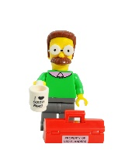

The neighbour……………………………………………………………………………………………
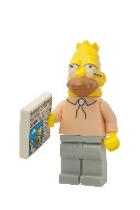

The grandfather…………………………………………………………………………………………...

The Simpsons…………………………………………………………………………………………….

The parents……………………………………………………………………………………………….

2 Rephrase these sentences using the possessive case. Reformule les phrases en utilisant le cas possessif.
1 My friends have a very big house.  2 Annie has a fully equipped kitchen.  3 Tom has a large bedroom.  4 Chris has a new computer.  5 The children have an amazing playroom. | 1 …………… house is very big.  2 …………… kitchen is fully equipped.  3 …………… bedroom is large.  4 …………… computer is new.  5 …………… playroom is amazing.

3 Answer the following questions using the possessive case when it’s possible. Réponds aux questions suivantes en ayant recours au cas possessif lorsque c’est possible.
1 What’s the name of your English teacher?  2 Where is the office of the director?  3 What is the date of the exams?  4 What is the colour of your classroom?  5 What is the job of your father/mother? | 1 ………………………………………………  2 ………………………………………………  3 ………………………………………………  4 ………………………………………………  5 ………………………………………………

4 Les déterminants possessifs

1 Choose the correct possessive adjectives. Choisis le déterminant possessif approprié.

Julia
Sam
Meghan
Mike
Nick

- Me: I’m Sam and these are my / your friends.
- The boys and girls: Your / Their names are Nick, Julia, Mike and Meghan.
- Meghan: Her / my hair is blond. Julia’s hair is black.
- Nick and Mike: They are wearing red clothes because red is his / their favourite colour.
- Mike: His / Her father is my father’s friend.
- Nick and I: My / Our parents are good friends too.
- Me: That’s my / their favourite picture.
- The picture: I love its / her colours and my friends’ faces.
- You: Have you got a picture of your / their friends?

Example: Walt Disney is the creator of Mickey.  1 Disneyland is (the children and parents’) favourite amusement park.  2 The famous roller coaster (of the park) is Space Mountain.  3 The castle (of Sleeping Beauty) is amazing.  4 (The name of the first character) is Mickey.  5 Cinderella is (my sister and I) favourite princess. | Walt Disney is his creator.  1 ………………………………  2 ………………………………  3 ………………………………  4 ………………………………  5 ………………………………
2 Write the correct possessive adjectives. Complète par le bon déterminant possessif.

Teacher: Here is a new pupil. (1) ✍ … name is Tina.  She comes from Mexico. She is in (2) ✍ … school to  learn English.  Mandy: Does she speak English?  Teacher: (3) ✍ … mother tongue is Spanish, but she can speak a little bit of  English.  (4) ✍ … father came to England for (5) ✍ … job.  (6) ✍ … company has an office in England.  They are in Oxford for a year.  Mandy: Where do they live, then?  Teacher: (7) ✍ … new house is here in Oxford.  Mandy: What’s the name of the company?  Teacher: (8) ✍ … name’s ‘Get real’. It’s a software company.  Mandy: That’s cool. Can Tina sit next to me?  Teacher: Yes, Tina you can take a seat next to Mandy.  Where’s (9) ✍ … book, Mandy?  Mandy: It is in (10) ✍ … schoolbag.  Teacher: Can you take it and share it with Tina, please?  Mandy: Yes, of course. | 1 …………  2 …………  3 …………  4 …………  5 …………  6 …………  7 …………  8 …………  9 …………  10 ………..

5 Le présent simple

1 Find and correct the mistakes using your red pen. Trouve les erreurs et corrige-les en rouge.

Allan and Bobby is in a pop group. Allan sing and Bobby plays the guitar. They to give concerts from Friday to Sunday in a club in London. Allan lives in London but Bobby don’t. He come from Liverpool. At the weekend he sleeps in a hotel in the centre of town. They not see each other during the week. You know what? Allan don’t work in the music industry. He is a guide in a museum and usually write songs after work. What about Bobby? Do he work in the music field? He sells music instruments in a famous music shop in Liverpool. But in a few months, their lives will change because they signed a contract with a big producer and they recorded their first album last month.

2 Judith is a fan of the new band. Complete the text with the correct form of the verbs. Judith est fan du nouveau groupe de musique. Complète le texte par une forme verbale.
to know  to work-not  to be  to like  to love  to be  to have  to wear  to look/to seem  to do  to play  to perform  to cost  to want | ✍ … you ✍ … ‘New heroes’?  They ✍ … as firemen.  They ✍ … a band performing in a club in London.  I discovered them last month and now I’m a real fan.  I really ✍ … their music. It’s totally new and positive.  And I ✍ … Allan, the singer too. He  ✍ … so handsome.  ✍ … he ✍ … a rock style?  No, he ✍ ….  He always ✍ … smart clothes: shirts and suits.  He ✍ … like a businessman but he ✍ … so serious.  Bobby is another member. What ✍ … he ✍ …?  He ✍ … the guitar. He’s an excellent musician.  They ✍ … in a club in London.  The ticket ✍ … £20.  ✍ … you ✍ … to come with me next Saturday to watch their show? | ………………………………  ………………………………  ………………………………  ………………………………  ………………………………  ………………………………  ………………………………  ………………………………  ………………………………  ………………………………  ………………………………  ………………………………  ………………………………  ………………………………  ………………………………  ………………………………

3 Jena is a journalist. She is interviewing the band. Write questions using the following words and answers using information from the text in exercise 1. Jenna est une journaliste. Elle interview un groupe de musique. Ecris les questions à l’aide des mots des informations dans l’exercice 1.

Journalist | Allan
Hello boys. Thank you for receiving me. You are working a lot on your first album at the moment, aren’t you? | That’s right!
Can I ask you some questions, Allan? | Yes, sure.
Who/to play the guitar?  …………………………………………………. | ………………………………………………….
When/to sing.  …………………………………………………. | ………………………………………………….
Where/to give concerts?  …………………………………………………. | ………………………………………………….
to live/ in London?  …………………………………………………. | ………………………………………………….
to live/Bobby/in London too?  …………………………………………………. | ………………………………………………….
Where/Bobby/to come from?  …………………………………………………. | ………………………………………………….
What/to do?  …………………………………………………. | ………………………………………………….
Where/Bobby/to work?  …………………………………………………. | ………………………………………………….
What/to do?  …………………………………………………. | ………………………………………………….
Who/to write the songs?  …………………………………………………. | ………………………………………………….
Thank you for your answers. I can’t wait for your album. | You’re welcome.

6 Les auxiliaires de mode

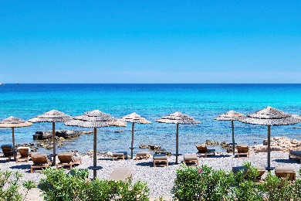
1 Let’s go on holiday! What do the auxiliaries express? Put a cross in the correct column. Partons en vacances ! Qu’expriment les auxiliaires de mode ? Place une croix dans la bonne colonne.

Mum: Amy, you must (1) pack your luggage! We’re leaving tomorrow.
Amy: Mum, you know I can’t (2) do that alone. I have so many things to put in my
luggage. Can (3) I use two bags, please?
Mum: No, you can’t (4). Each passenger can (5) only take one suitcase … but you can (6)
also bring a handbag. You must (7) select your clothes and shoes, Amy.
Amy: I can’t (8) choose between my red shoes and my sports shoes.
Mum: I have an idea! My suitcase isn’t full. I can (9) carry your sports shoes.
Amy: Oh, really! Can (10) you take my T-shirts too?
 | (in)capacité | possibilité | permission | demande | obligation | interdiction
1
2
3
4
5
6
7
8
9
10
2 Express the following ideas using the correct auxiliaries. Exprime les idées suivantes à l’aide du bon auxiliaire. Note seulement l’auxiliaire.
1 Il fait très chaud. Dis à ton petit cousin de boire de l’eau.  2 Par ce beau soleil, tu as envie d’une glace. Demande la permission d’en manger une.  3 Tu as un coup de soleil. Dis à ton ami que tu dois porter un T-shirt.  4 Tu t’es blessé(e) en jouant au beach-volley. Dis à ton ami que tu ne sais pas nager.  5 Il y a un vendeur de délicieux beignets. Demandes-en un. | 1 ……………………  2 ……………………  3 ……………………  4 ……………………  5 ……………………

7 Le pluriel

1 Put the following words in the plural and write them in the correct column. Mets les mots suivants au pluriel et note-les dans la bonne colonne.
tree – witch – lady – knife – boy – child – foot – party – glass – table – shelf – man – cookie – sock – city – wolf – door – book – wife – tooth
+s | +es | +ies | +ves | irregular
2 Fill in the plural forms of the nouns in brackets. Note la forme au pluriel des mots entre parenthèses.

The London Dungeon is one of the scariest (1 a place) … in London. It’s a tourist attraction that tells you all kinds of different (2 a story) … about London’s cruel and scary history.  You learn everything about King Henry VIII who liked beheading° his (3 a wife) … . One of them, Anne Boleyn, had six (4 a finger) … on each hand. The Londoners thought she was a witch. They believed in (5 a witch) …, so she scared people. The attraction also tells you the story of the plague°. A terrible disease that got spread° by rats and (6 a mouse) … . It killed a lot of (7 a man) …, (8 a woman) … and (9 a child) … . During the plague, doctors were the real (10 a hero) … but they often died too. You can also visit the law court: villains and (11 a thief) … were sentenced° here.  You can learn more about Jack the Ripper, a cruel murderer, who killed prostitutes in 1888. It’s one of the biggest (12 a mystery) … because the police never found out who he really was. | 1 ……………………  2 ……………………  3 ……………………  4 ……………………  5 ……………………  6 ……………………  7 ……………………  8 ……………………  9 ……………………  10 ……………………  11 ……………………  12 ……………………

°to behead: décapiter
°the plague: la peste
°to spread: propager
°to sentence: condamner

8 Le présent continu

1 Write down the –ing form of the following verbs and put them in the correct column. Note les formes en -ing des verbes suivants dans la bonne colonne.

to sit – to wait – to do – to play – to watch – to lie - to cut – to come – to drink – to walk – to run – to lose – to travel – to die – to study
+ing | e +ing | +consonant+ing | ie +ying
…………  …………  …………  …………  …………  …………  ………… | …………  …………  …………  …………  …………  …………  ………… | …………  …………  …………  …………  …………  …………  ………… | …………  …………  …………  …………  …………  …………  …………

2. Write questions in the present continuous and answer them with a short answer. Pose des questions au Present Continuous et réponds-y.

1 you / to do / an exercise / ?
……………………………………
2 the sun / to shine / ?
……………………………………
3 your parents / to work / at the moment / ?
……………………………………
4 your teacher / to speak / now / ?
……………………………………
5 the children / to run / in the playground / ?
……………………………………

9 La traduction de « il y a »

1 Look at the picture and choose the correct answer. Observe l’image et choisis la bonne réponse.

1 There is / There isn’t a sofa in front of the windows.
2 There is / There isn’t a lamp in the living room.
3 There are / There aren’t a lot of cushions on the sofa.
4 There are / There aren’t curtains at the windows.
5 There is / There isn’t a TV in the living room.
6 There is / There isn’t a cupboard next to the door.
7 There are / There aren’t picture frames hanging between the windows.

2 Complete the sentences with there is, there are, there isn’t or there aren’t. Complète les phrases par une forme de “il y a / il n’y a pas.
We are ready to watch a game at the Victory Stadium.  1 ✍ … two teams playing tonight. They are close rivals.  2 ✍ … bright lights shining down on the field.  3 ✍ … a rock song playing to get us excited.  4 ✍ … more than 60,000 supporters in the stadium.  5 ✍ … not only men; ✍ … also women watching the game.  6 ✍ … any players on the field yet. They're still in the dressing rooms. | …………  …………  …………  …………  …………  …………

10 Present simple vs present continuous

1 Choose the correct answers to the questions. Choisis la bonne réponse.
1 What do you do?  2 What are you doing?  3 Where do you work?  4 Where are you working?  5 What language do you speak?  6 What language is he speaking?  7 Does his sister play the guitar?  8 Is his brother playing the guitar? | a No, he isn’t. That’s the radio.  b I’m interviewing this man.  c I’m a journalist.  d I’m in London for the moment.  e In a company in Brussels.  f It sounds like Dutch.  g Spanish, I’m from Barcelona.  h No, she doesn’t. She plays the piano.

1 | 2 | 3 | 4 | 5 | 6 | 7 | 8

2 Underline the correct form of the verb. Tick if it is a routine or an action going on now. Souligne la forme verbale correcte. Sélectionne s’il s’agit d’une routine ou d’une action en cours.

 | Routine | Action going on now
1 Every day, school starts / is starting at half past eight.
2 This year, I study / am studying Spanish.
3 I usually have / am having breakfast before going to school.
4 Oh, look at the picture! Lisa doesn’t listen / isn’t listening to the teacher.
5 In that picture, the teacher talks / is talking about Shakespeare. Do you know him?
6 Every Wednesday, I go / am going to football practice.
7 And for the moment, I have / am having drama lessons too.

3 Complete the text with the correct form of the verbs, using the Present Simple or Continuous. Complète le texte par une forme verbale, soit au Present Continuous, soit au Present Simple.
Dear Diary,  Today is my second day of hiking in the Highlands. I’m tired, my legs  ✍ (1. to shake) … and my feet ✍ (2. to bleed) …! But I  ✍ (3. to want) … to continue. Scotland is such a beautiful country! Every day, I ✍ (4. to meet) … different people. They are so nice!  I ✍ (5. to try) … to learn Scots but it’s really different from English. And unfortunately, as you know, I ✍ (6. not to learn) … foreign languages quickly. For the moment I ✍ (7. to travel) … with John, a student from the USA. He is nice but very impatient. He always  ✍ (8. to walk) … ahead of me and ✍ (9. to say) … I’m too slow…  Anyway, now it’s time to sleep! See you tomorrow! ☺ | 1 ………………………  2 ………………………  3 ………………………  4 ………………………  5 ………………………  6 ………………………  7 ………………………  8 ………………………  9 ………………………

11 La forme interrogative

1 Tick the correct questions. Coche la bonne question.
1 Her name’s Judith.
a What's her name? |  | b What's your name? |  | c How’s your name?

2 She’s a doctor.
a What's his job? |  | b What's your job? |  | c What's her job?

3 It’s a stethoscope.
a What's this in English? |  | b What's in English? |  | c What's it English?

4 Yes, she does.
a Has she got children? |  | b Does she like her job? |  | c How is she?

5 She’s from Scotland.
a Where's he from? |  | b Where is she from? |  | c Where does she live?

6 She is visiting a patient.
a What is she doing? |  | b What is he doing? |  | c What does she do?

2 Put the words in the correct order to make questions. Mets les mots dans le bon ordre pour formuler une question.

Your mum is talking to your brother on Skype. What is she asking?
- feeling - how - today - you - are?
………………………………………………………………………...……
- New Zealand - is - how?
………………………………………………………………………………
- you - did - evening - yesterday - do - what?
………………………………………………………………………………
- restaurant - eat - that - well - did - at - you?
………………………………………………………………………………
- are - you - back - when - home - coming?
………………………………………………………………………………
- Christmas - you - come - visit - we - for - and - can?
………………………………………………………………………………
- again - call - you - soon - will?
………………………………………………………………………………

3 There was a theft° in a shop. The police is asking questions to a witness°. You can only hear her answers. Find the questions the police is asking. Un vol a été commis et la police pose des questions à un témoin. Tu peux seulement entendre ses réponses. Trouve les questions que pose la police.

- ……………………………………………………………………………….………………
No, I didn’t see his face.
- ……………………………………………………………………………….………………
Yes, he was tall.
- ……………………………………………………………………………….………………
It happened at 3.15 PM.
- ……………………………………………………………………………….………………
Nothing, I couldn’t move. I was too scared.
- ……………………………………………………………………………….………………
Yes, I’m OK, thanks.
- ……………………………………………………………………………….………………
No, I didn’t hear his voice.
- ……………………………………………………………………………….………………
He went away by car.
°theft: vol
°witness: témoin

12 Le past simple

1 Underline the correct form of the verb. Souligne les formes verbales correctes.
- Last week, I goed / went to London on a school trip.
- We visited / did visit a lot of places.
- My favourite places was / were Madame Tussauds and the Globe Theater.
- At Madame Tussauds I did see / saw my idol, Lady Gaga!
- We visited not / didn’t visit Big Ben because we had not / didn’t have the time.
- Knew you / Did you know that William Shakespeare built / builded the Globe Theater?
- It was / were a great school trip!

2 Put the verbs in brackets in the past simple. Mets les verbes entre parenthèses au Simple Past.
Do you know that man? That’s William Shakespeare. He ✍ (1. to be) … born in Stratford, in England, on 23rd April 1564. ✍ (2. to know) … you that he ✍ (3. to die) … on the same day, 23rd April, fifty-two years later? That’s incredible, isn’t it? Shakespeare ✍ (4. not live) … in Stratford all his life. He ✍ (5. to move) … to London in 1585. In London, he ✍ (6. to work) … as an actor and he ✍ (7. to write) … plays°. People ✍ (8. to love) … his plays and he ✍ (9. to become) … a rich man. He ✍ (10. not stop) … writing until his death. One of his most famous plays is Romeo and Juliet. Do you know them. | 1 ……………………………  2 ……………………………  3 ……………………………  4 ……………………………  5 ……………………………  6 ……………………………  7 ……………………………  8 ……………………………  9 ……………………………  10 ……………………………

3 What did you do or didn’t do during the last summer holiday? Ask questions and write true answers for you. Look at the picture and use the words in the box. Qu’as-tu fait (ou pas) lors de tes dernières grandes vacances ? Pose des questions et écris tes propres réponses. Tu peux utiliser les mots dans le cadre ci-dessous ainsi que les images.

to put on sunscreen – to surf – to play volleyball – to sunbathe – to see dolphins – to build sandcastles – to eat ice cream – to swim – to scuba dive

Example:
1 Did you go to the sea? Yes, I went to the sea. / No, I didn’t go to the sea.
2 ………………………………………………………………………………………
3 ………………………………………………………………………………………
4 ………………………………………………………………………………………
5 ………………………………………………………………………………………
6 ………………………………………………………………………………………
7 ………………………………………………………………………………………
8 ………………………………………………………………………………………
9 ………………………………………………………………………………………
10 ………………………………………………………………………………………
13 L’heure
1 Choose the correct answer. Entoure la bonne réponse.
4.45 | - Quarter to four  - Quarter past four  - Quarter to five
8.25 | - Eight past twenty-five  - Twenty-five past eight  - Twenty-five to nine
6.30 | - Six past half  - Half to seven  - Half past six
11.10 | - Ten past eleven  - Eleven to ten  - Ten to eleven
7.15 | - Fifteen past seven  - Quarter to seven  - Quarter past seven
4.35 | - Thirty-five past four  - Thirty-five to five  - Twenty-five to five

2 What time is it? Write the times in words. Quelle heure est-il ? Note les heures en lettre.
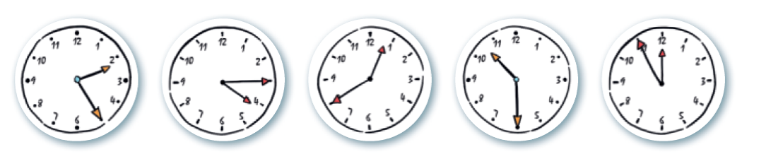

5
4
3
2
1

1 ……………………………………………………………………………………………………
2 …………………………………………………………………………………………………………
3 …………………………………………………………………………………………………………
4 …………………………………………………………………………………………………………
5 …………………………………………………………………………………………………………

3 Look at Yasmin’s timetable and answer the following questions in full letters. Observe l’horaire de Yasmin et réponds aux questions ci-dessous en écrivant les heures en lettre.
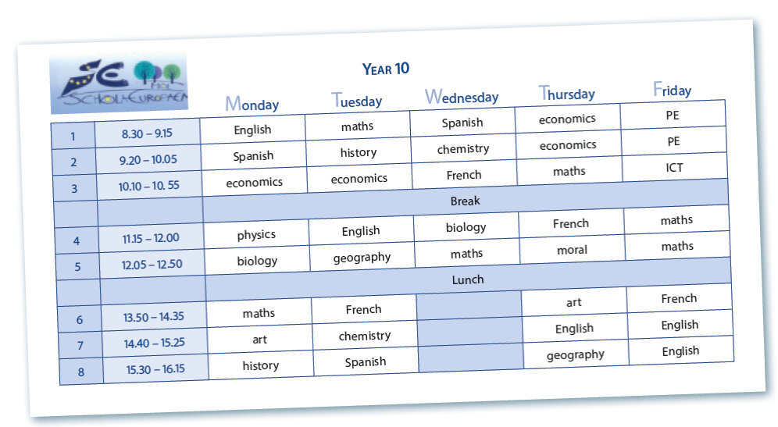
1 What time does Yasmin start school every day?  2 What time does she have English on Tuesday?  3 What time does she finish school on Wednesday?  4 What time does she have a break in the morning?  5 What time does she finish school on Thursday?  6 What time does she have Spanish on Monday?  7 What time does she have French on Friday? | 1 …………………………………..………….  2 …………………………………..………….  3 ………………………………………………  4 ………………………………………………  5 ……………………………………………  6 ……………………………………………  7 ……………………………………………

