REVISIONS 2EME ANNEE

To be / Have got

1 Choose the correct answers.
Choisis les bonnes réponses.

I is/are/has got/have got a new friend, Alessia. She is/are/has got/have got my holiday friend. She is/are/has got/have got Italian. Her parents is/are/has got/have got from Florence but they live in Lido di Jesolo. They is/are/has got/have got a house near the beach. That’s where I met her. She invited me to sail because she is/are/has got/have got a small boat.
Alessia loves her country very much. She says Italian people is/are/has got/have got really friendly and Italy is/are/has got/have got a beautiful country. It is/are/has got/have got a lot of wonderful places to visit. The food is/are/has got/have got delicious. She is/are/has got/have got right. Pasta and pizza is/are/has got/have got my favourite dishes.

2 Complete this postcard with the correct forms of ‘to be’ or ‘have got’.

Dear Jane,  I (1) so excited! We (2) on holiday in Italy. What a beautiful country! The weather (3) sunny and hot. And, I (4) a nice suntan°.  We (5) in a wonderful hotel. It (6) 2 swimming pools and 3 restaurants. I (7) lucky! My sister and I (8) a very big room with TV and Jacuzzi! It (9) amazing. My brother (10) a little bit jealous because his room (11) smaller but he (12) a terrace with sea view. However, he (13) very happy. He plays football on the beach every day. He (14) Italian friends. They (15) very friendly and one of them, Antonio, (16) so handsome. He (17) 15. He (18) tall and thin. He (19) black hair and blue eyes. I think I (20) in love!  I (21) a new friend too. Her name (22) Alessia.  I’ll tell you everything when I come back. I (23) some pictures to show you.  Kisses.  Lucy. | (1) …………………………  (2) …………………………  (3) …………………………  (4) …………………………  (5) …………………………  (6) …………………………  (7) …………………………  (8) …………………………  (9) …………………………  (10) ………………………..  (11) ………………………..  (12) ………………………..  (13) ………………………..  (14) ………………………..  (15) ………………………..  (16) ………………………..  (17) ………………………..  (18) ………………………..  (19) ………………………..  (20) ………………………..  (21) ………………………..  (22) ………………………..  (23) ………………………..
3 Write sentences with ‘to be’ or ‘have got’ starting from the following words:
- Lucy / excited today because she / not / at school. She / on holiday.
……………………………………………………………………………………………
……………………………………………………………………………………………
- Her parents / not / a car.
………………………………………………………………………………………………
- They / plane tickets to go to Italy.
………………………………………………………………………………………………
- She / not / a big suitcase.
………………………………………………………………………………………………
- They / happy to stay in a hotel.
………………………………………………………………………………………………
- Lucy’s friends / not with her.
………………………………………………………………………………………………
- But she / her mobile phone.
…………………………………………………………………………………………………

4 Ask questions about Lucy’s holiday using ‘to be’ or ‘have got’ and complete her answers.
- you / a lot of clothes in your suitcase?
…………………………………………………………………………………….?
No, I ………………………………
- your cousin / with you?
…………………………………………………………………………………….?
No, he ………………………………
- the hotel / comfortable?
…………………………………………………………………………………….?
Yes, it ………………………………
- your room / Wi-Fi?
…………………………………………………………………………………….?
Yes, it ………………………………
- you / in a small hotel?
…………………………………………………………………………………….?
No, I ………………………………
- your sister / her own room?
…………………………………………………………………………………….?
No, she ………………………………
Les déterminants possessifs

1 Choose the correct possessive adjectives.
Choisis les bons déterminants possessifs.

Meghan
Nick
Mike
Julia
Sam

- Me: I’m Sam and these are my / your friends.
- The boys and girls: Your / Their names are Nick, Julia, Mike and Meghan.
- Meghan: Her / my hair is blond. Julia’s hair is black.
- Nick and Mike: They are wearing red clothes because red is his / their favourite colour.
- Mike: His / Her father is my father’s friend.
- Nick and I: My / Our parents are good friends too.
- Me: That’s my / their favourite picture.
- The picture: I love its / her colours and my friends’ faces.
- You: Have you got a picture of your / their friends?

2 Write the correct possessive adjectives.
Ecris le bon déterminant possessif.
Teacher: Here is a new pupil. (1) … name is Tina.  She comes from Mexico. She is in (2) … school to  learn English.  Mandy: Does she speak English?  Teacher: (3) … mother tongue is Spanish, but she can speak a little bit of English.  (4) … father came to England for (5) … job.  (6) … company has an office in England.  They are in Oxford for a year.  Mandy: Where do they live, then?  Teacher: (7) … new house is here in Oxford.  Mandy: What’s the name of the company?  Teacher: (8) … name’s ‘Get real’. It’s a software company.  Mandy: That’s cool. Can Tina sit next to me?  Teacher: Yes, Tina you can take a seat next to Mandy.  Where’s (9) … book, Mandy?  Mandy: It is in (10) … schoolbag.  Teacher: Can you take it and share it with Tina, please?  Mandy: Yes, of course. | 1 …………  2 …………  3 …………  4 …………  5 …………  6 …………  7 …………  8 …………  9 …………  10 ………

3 Use a possessive adjective.
Utilise un determinant possessif.

Example: Walt Disney is the creator of Mickey.  1 Disneyland is (the children and parents’) favourite amusement park.  2 The famous roller coaster (of the park) is Space Mountain.  3 The castle (of Sleeping Beauty) is amazing.  4 (The name of the first character) is Mickey.  5 Cinderella is (my sister and I) favourite princess. | Walt Disney is his creator.  1 ………………………………  2 ………………………………  3 ………………………………  4 ………………………………  5 ………………………………

Le pluriel

1 Put the following words in the plural and write them in the correct column.
Mets les mots suivants au pluriel et écris-les dans la bonne colonne

tree – witch – lady – knife – boy – child – foot – party – glass – table – shelf – man – cookie – sock – city – wolf – door – book – wife – tooth

+s | +es | +ies | +ves | irregular
…………  …………  …………  …………  …………  …………  ………… | …………  …………  …………  …………  …………  …………  ………… | …………  …………  …………  …………  …………  …………  ………… | …………  …………  …………  …………  …………  …………  ………… | …………  …………  …………  …………  …………  …………  …………

2 Fill in the plural forms of the nouns in brackets.
Complète le tableau avec le pluriel des noms entre parenthèses.

The London Dungeon is one of the most scary (1 a place) … in London. It’s a tourist attraction that tells you all kind of different (2 a story) … about London’s cruel and scary history.  You learn all about King Henry VIII who liked beheading° his (3 a wife) … . One of them, Anne Boleyn, had six (4 a finger) … on each hand. The Londoners thought she was a witch. They believed in (5 a witch) …, so she scared people. The attraction also tells you the story of the plague°. A terrible disease that got spread° by rats and (6 a mouse) … . It killed an awful lot of (7 a man) …, (8 a woman) … and (9 a child) … . During the plague, doctors were the real (10 a hero) … but they often died too. You can also visit the law court: villains and (11 a thief) … were sentenced° here.  You can learn more about Jack the Ripper, a cruel murderer, who killed prostitutes in 1888. It’s one of the biggest (12 a mystery) … because the police never found out who he really was. | 1 ……………………  2 ……………………  3 ……………………  4 ……………………  5 ……………………  6 ……………………  7 ……………………  8 ……………………  9 ……………………  10 ……………………  11 ……………………  12 ……………………
°to behead: décapiter
°the plague: la peste
°to spread: propager
°to sentence: condamner
3 Look at the picture and complete the sentences with the following words written in the plural.
Regarde l’image et complète les phrases avec les mots suivants au pluriel.

box – story – pencil - teddy bear – picture frame – cushion – pen – shelf – cupboard - book

This is in my room. I have a single bed with lots of (1) … on it. It is really cosy and I like lying on it to read romantic (2) … . Next to my bed, there are four (3) … where I keep all my (4) … . On the wall, I have many (5) … . On the desk, you can find some (6) … and (7) … . You can’t see them, but on the opposite wall, there are two (8) … with all my (9) … . Yes, I collect them.  I also have two (10) … .  .  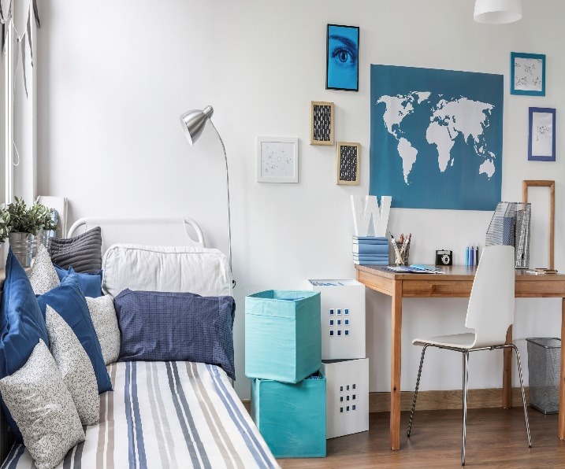 | 1 …………………  2 …………………  3 …………………  4 …………………  5 …………………  6 …………………  7 …………………  8 …………………  9 …………………  10 …………………

