REVIEW
MODULE FOUR

This is John and Anna. They are from London. They are travelling to Paris to spend their summer holidays. Before travelling, John and Anna must prepare for the trip.

ACTIVITY 1 : First, Anna decided to book a hotel room. Complete the dialogue with words from the box. There are 2 extra words :
- Receptionist : Plaza hotel. Good morning. Can I (1) ……………………………… you?
- Anna : My name is Anna Sanders and I would like to (2)……………………………… a room, please.
- Receptionist: you’re welcome, sir. What kind of room would you like?
- Anna : I would like a (3)…………………………………… room.
- Receptionist: may I have your name, please?
- Anna : Mr Anderson.
- Receptionist: Ok, sir. When will you (4)…………………………………………?
- Anna : Saturday afternoon.
- Receptionist: Ok and when will you check out?
- Anna : Monday noon.(5)…………………………. will that cost ?
- Receptionist: that will be 60 €.
- Anna : thank you, madam. See you on Saturday
- Receptionist: see you then. Bye

- cash
- book
- check in
- help
- how much
- shopping
- double

- Find in the dialogue expressions expressing:
- Offering help:…………………………………………………………………………………………..
- Polite request:……………………………………………………………………………………………
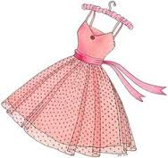
- Taking leave : …………………………………………………………………………………………….
ACTIVITY 2: After booking a hotel room, Anna decided to go shopping for a nice dress to wear in Paris. She went to a nearby clothes shop. Complete the dialogue :
- Shop assistant: Good morning. (1- offering help )………………………………………………………………..?
- Anna : (2- polite request / buy a dress) ………………………………………………………………………………
- Shop assistant: (3- asking about colour)………………………………………………………………………………………. ?
- Anna : I want a pink dress.
- Shop assistant: ah OK madam. (3- asking about size)…………………………………………………………………... ?
- Anna : medium.
- Shop assistant: OK. Here you are. Would you like to try it on ?
- Anna : of course. (4- asking about the place of the fitting room) ………………………………………………….. ?
- Shop assistant: it’s to your left.
- Shop assistant: (after a few minutes ) How was it ?
- Anna : It fits nicely. I will buy it. (5- asking about price)……………………………………………………………………… ?
- Shop assistant: 30 pounds.
- Anna: here you are.
- Shop assistant: just a second madam. I will wrap it for you.

ACTIVITY 3: John went to the bank. Read the dialogue then complete with words from the box. There are 2 extra words:
- Bank employee : Good afternoon, sir . What (must / can / should )¹ I do for you ?
- John : I’d like to (spend / give / cash)² a cheque, please.
- Bank employee: Ok. One thousand pounds . Would you like small or big (coins / notes / pounds)³ ?
- John : (5O-pound / 50 pounds / 50-pounds)⁴ notes will do.
- Bank employee: Just a minute madam. Here you are
- John : thank you. Good bye.
- Bank employee: you’re welcome. Next please.

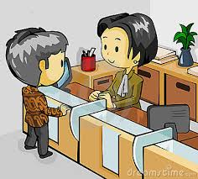

- ACTIVITY 4: After going to the bank, John went to the train station to buy the tickets. Work in pairs and complete the dialogue between a ticket agent and John.
Time | Class |  | Type |  | Number | Price
Saturday / at 8 am | First | Second | Single | Return | 2 | 90 £ / a ticket
- Travel agent : Good morning. ……………………………………………………………………… ?
- John : I’d like to ……………………………………………………………………………………………………
- Travel agent : ……………………………. would you like to travel ?
- John : Saturday at 8 am.
- Travel agent: OK. …………………………………… tickets ?
- John: 2 tickets.
- Travel agent: ………………………………………………………………………………………………………………..
- John: ……………………………………………………………………………………………………………………………….
- Travel agent: ………………………………………………………………………………………………………………..
- John: …………………………. ………………………………………………………………………………………………….
- Travel agent: ………………………………………………………………………………………………………………..
- John: ……………………………………………………………………………………………………………………………….
- Travel agent: …………………………………………………………………………………………………………………

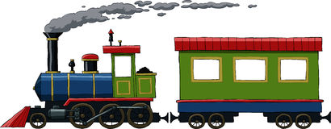

- Pair work: Choose one conversation and enact it in front of the class
- Speakers: Anna / John / a bank employee / a receptionist / a shop assistant / a travel agent
