Mrs yahmadi
Module 5: Entertainment
Lesson 1/ Means of entertainment
- the action of providing or being provided with amusement or enjoyment:"everyone just sits in front of the television for entertainment’’ It means amusement, pleasure, leisure, relaxation, fun, ...
How do people entertain (V) themselves?
There are many entertaining ( adj) activities
watching tv playing video games Practising sport / window shopping
Means of entertainment

cycling Going to
surfing the net movies

hanging around with friends visiting art galleries going to the circus or the zoo

These activities can be practised indoor or outdoor ( That is inside a building or outside it)
Eg/ cycling is an outdoor activity
Now , we read the text p 102 -103 SB and fill in the table p 128 AB
Name | Age | pastime
Kevin | ............ | ..........................................................................
Kelly | ............. | ...................................................................
Sandra | ........ | ...............................................................
Linda | ....... | ....................................................................
King | ........ | ..........................................................................

Let’s learn new expressions
E-books are taking over real books. Books went to the shelf .They are no longer in use.
Kelly and Sandra disagree on where to watch a film cinema or house. Kelly hates the cinema because there are strangers who disturb you with their coughs and cell phones.
Now concentrate on text 4 and 5 and sort out expressions showing uncertainty#

Certainty | uncertainty
I am sure  I am certain  There is no doubt  Undoubtedly  Certainly  I’m positive  I have no doubt  I’m a hundred percent certain | I’m not sure  Perhaps  May be  Probably  I suppose  I doubt it  I ‘m not really sure about it

Now, let’s write
Your English penfriend wants to know how you spend your time during the lockdown.Write him an e-mail to tell him about your entertaining activities at home.
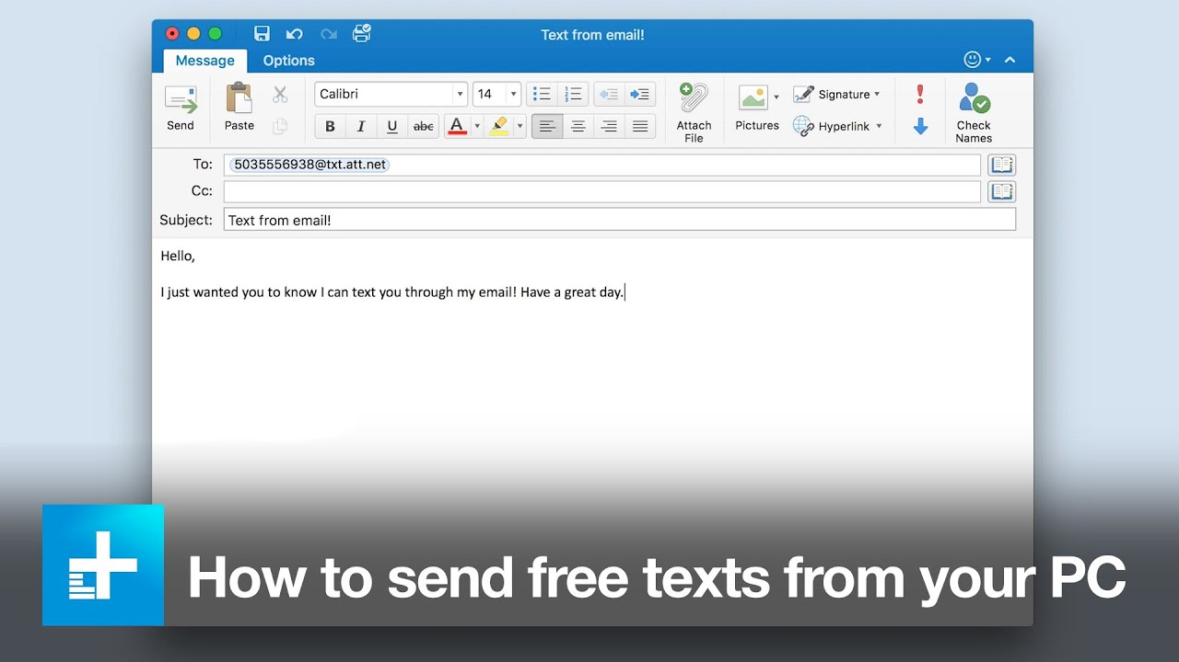
Dear jane,
How are you ? At home , I guess.
In your last e-mail , you asked about how spend my time during the lockdown period.
Well, as all teenagers. I feel bored spending endless times at home but I try to entertain myself a bit. I spend most of my time texting to my friends or chatting with them. I also watch films or videos. I sometimes help my mum with housework but as you know that’s not my cup of tea. In the afternoon , I do some exercising in the garden in a desperate try to keep fit.
After dinner, I sit a little with my family and watch the news, then I go back to my room to follow my favourite stars on instagram.
That is all I have to say . I feel really bored and don’t know when this nightmare will end

