PAT PATROUILLE

ROCKY

PAT PATROUILLE

MARCUS

PAT PATROUILLE

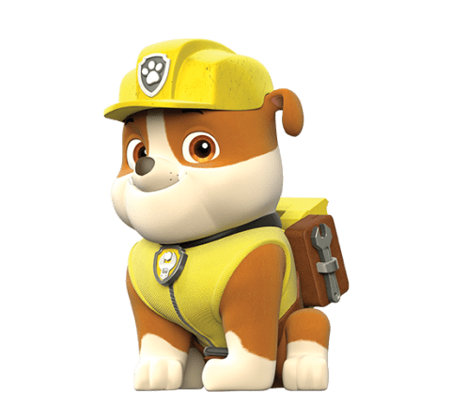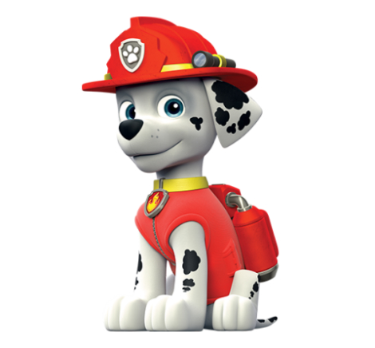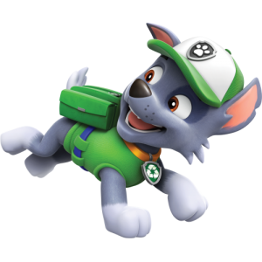

RUBEN

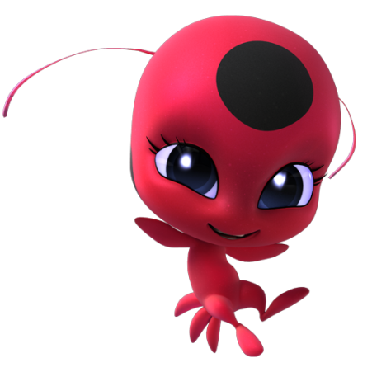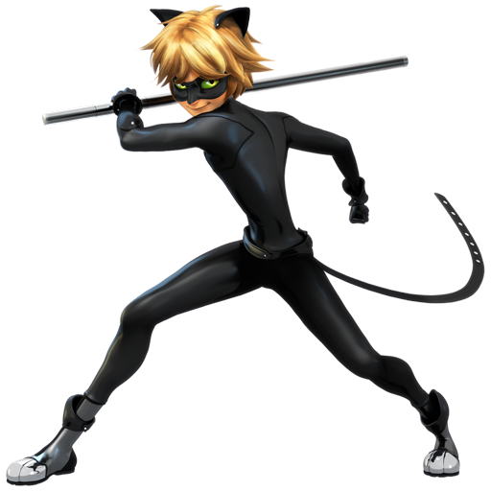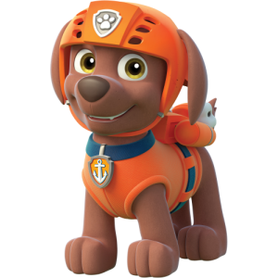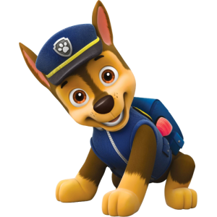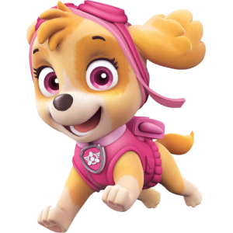

MIRACULOUS

TIKKI

MIRACULOUS

CHAT NOIR

MIRACULOUS

LADYBUG

PAT PATROUILLE

CHASE

PAT PATROUILLE

ZUMA

PAT PATROUILLE

STELLA

MIRACULOUS

LUKA

ALYA

MIRACULOUS

MIRACULOUS

PLAGG

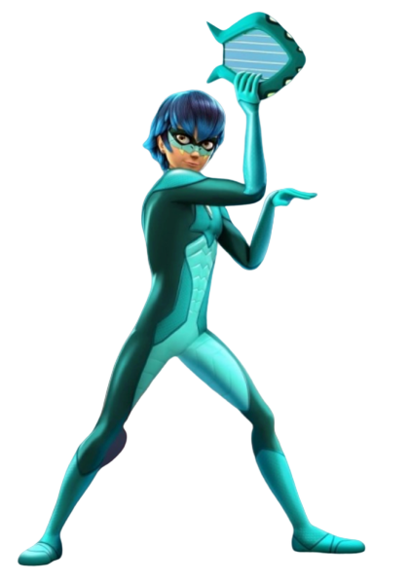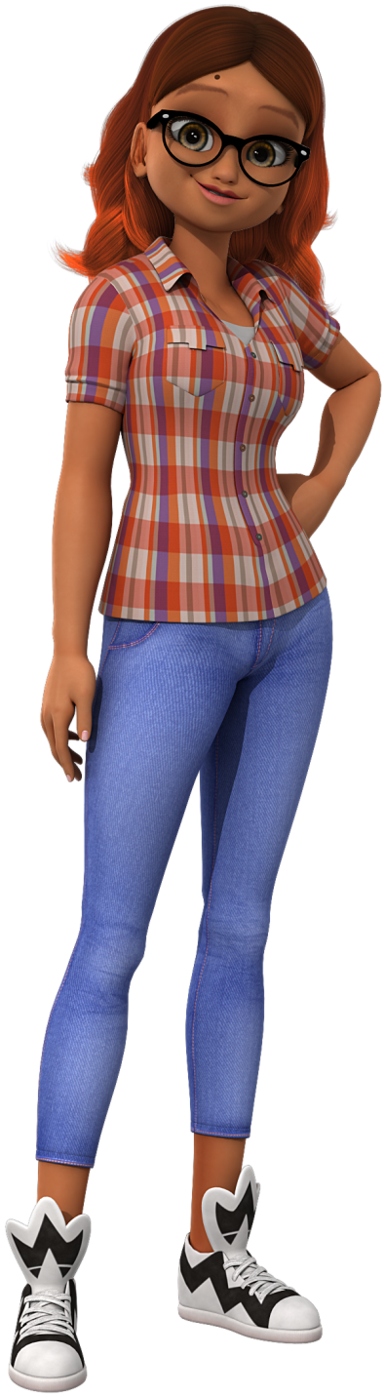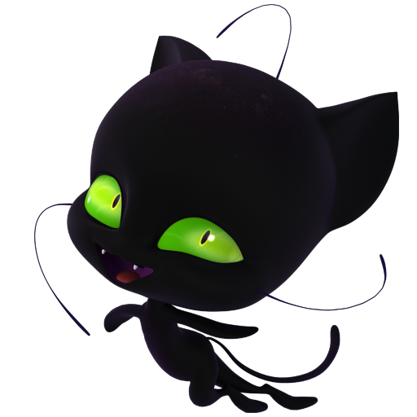

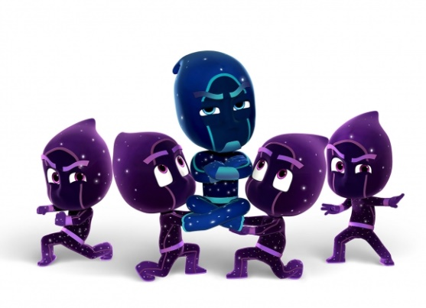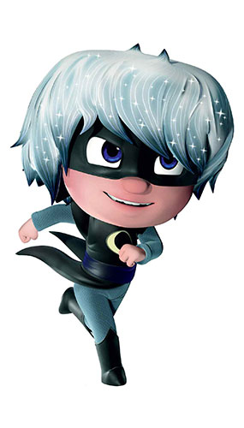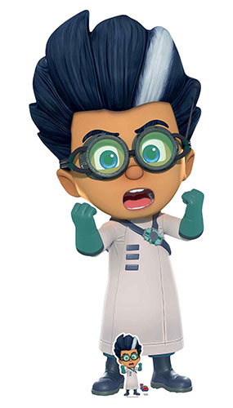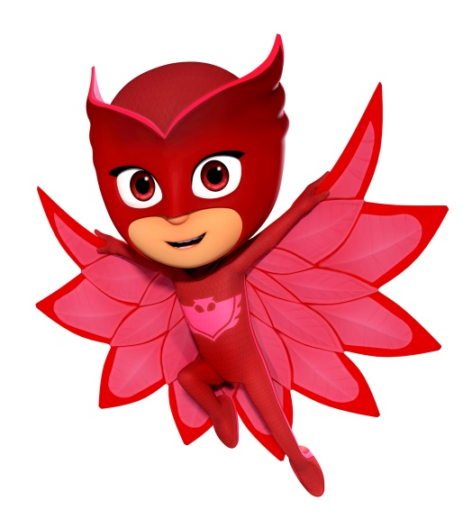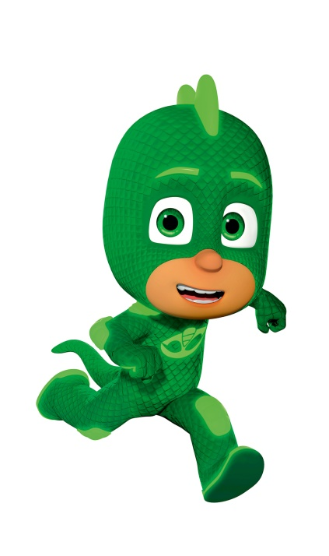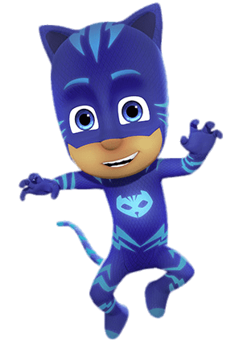

PYJAMASQUE

NINJAKA

PYJAMASQUE

SORCELINE

PYJAMASQUE

ROMEO

PYJAMASQUE

BIBOU

PYJAMASQUE

GLUGLU

PYJAMASQUE

YOYO

POKEMON

SALAMECHE

POKEMON

PIKACHU

CARAPUCE

POKEMON

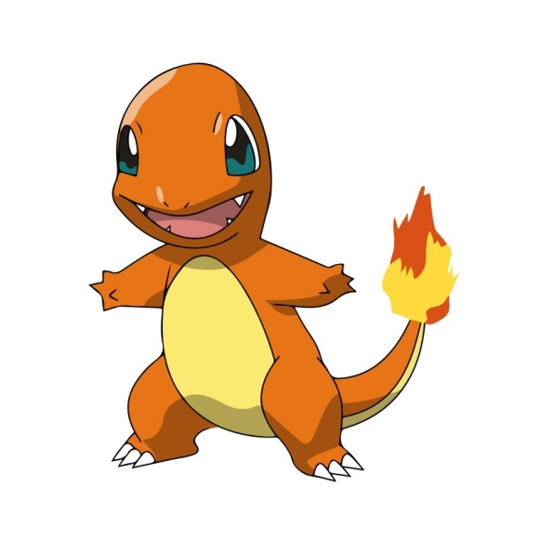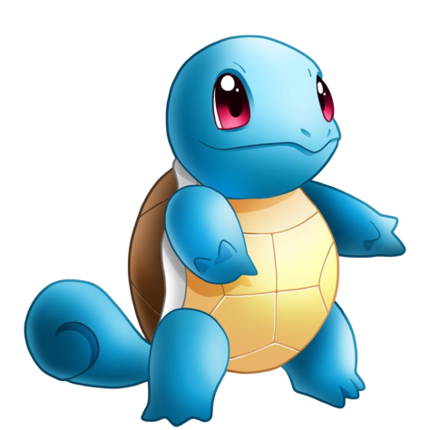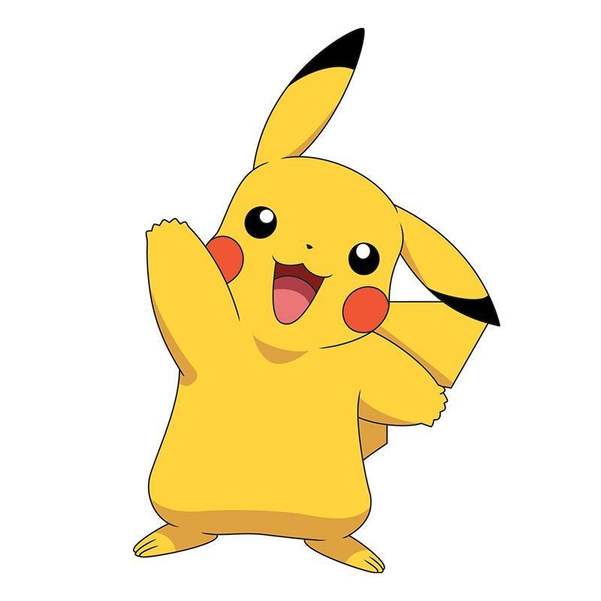

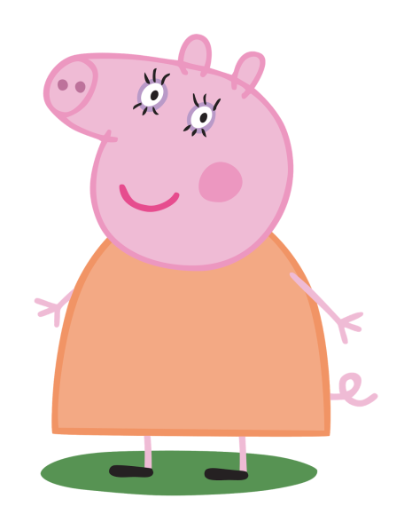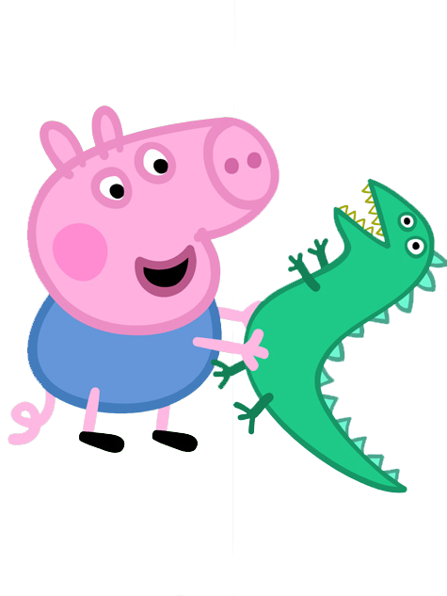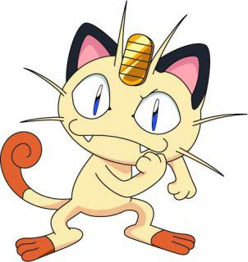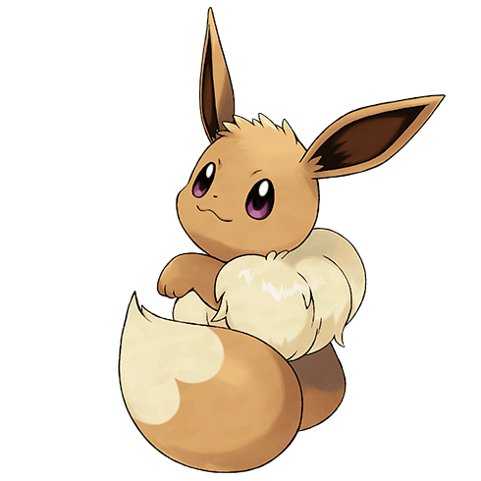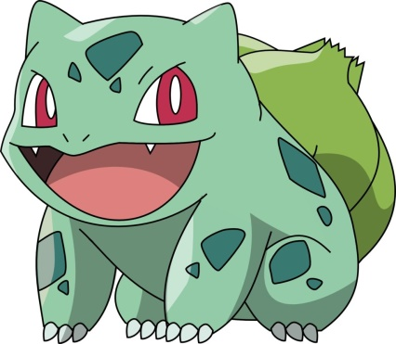

PEPPA PIG

MAMAN PIG

PEPPA PIG

GEORGE

PEPPA

PEPPA PIG

POKEMON

MIAOUS

POKEMON

EVOLI

POKEMON

BULBIZAR

PEPPA PIG

MAMI PIG

PEPPA PIG

PAPI PIG

PEPPA PIG

PAPA PIG

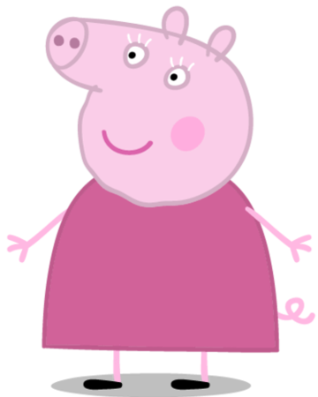

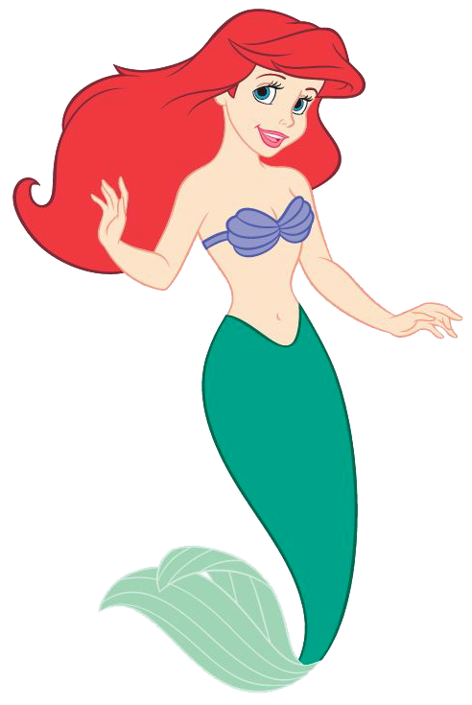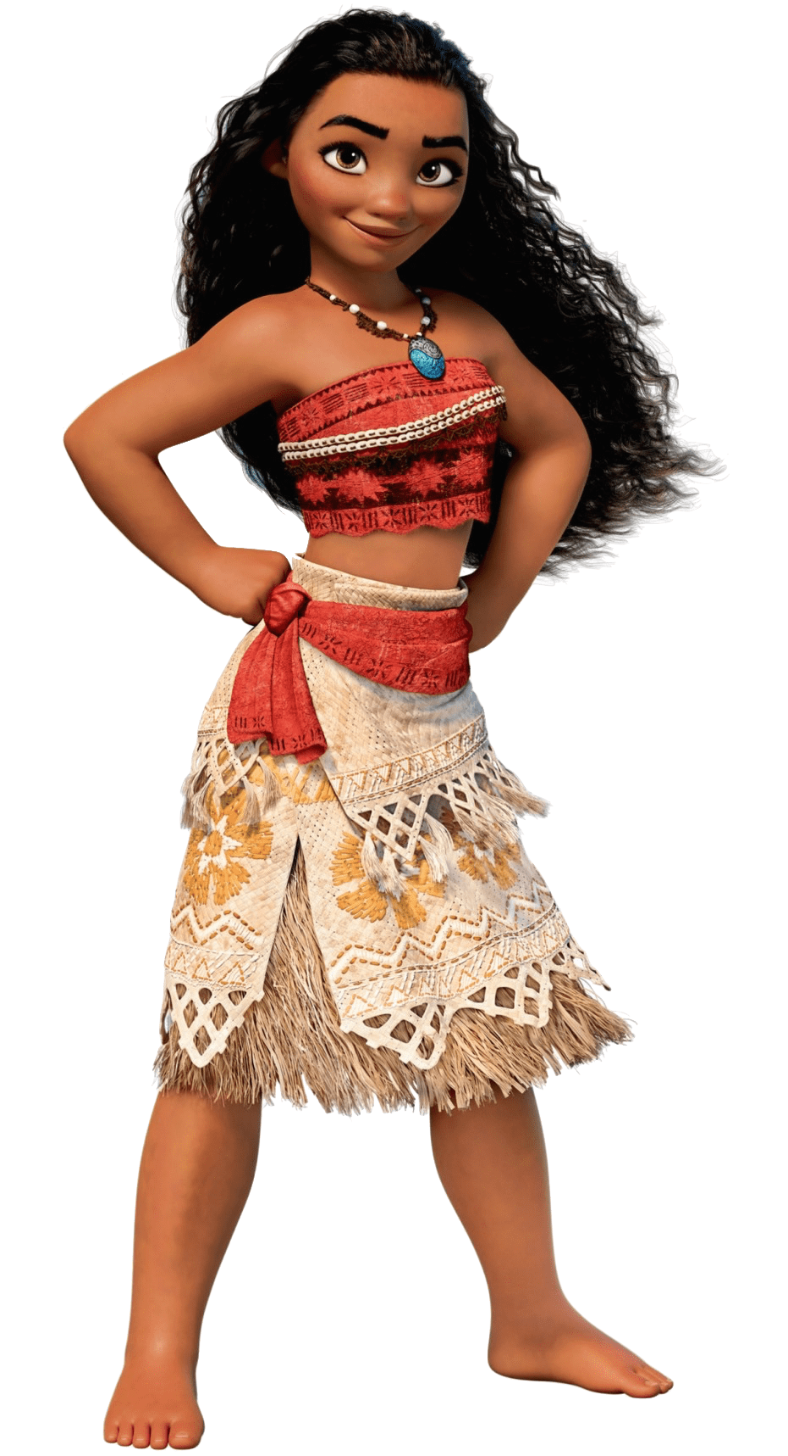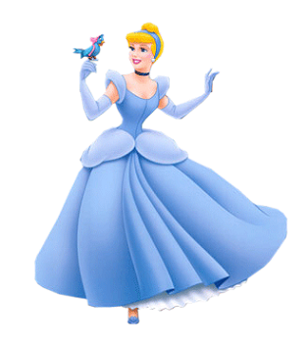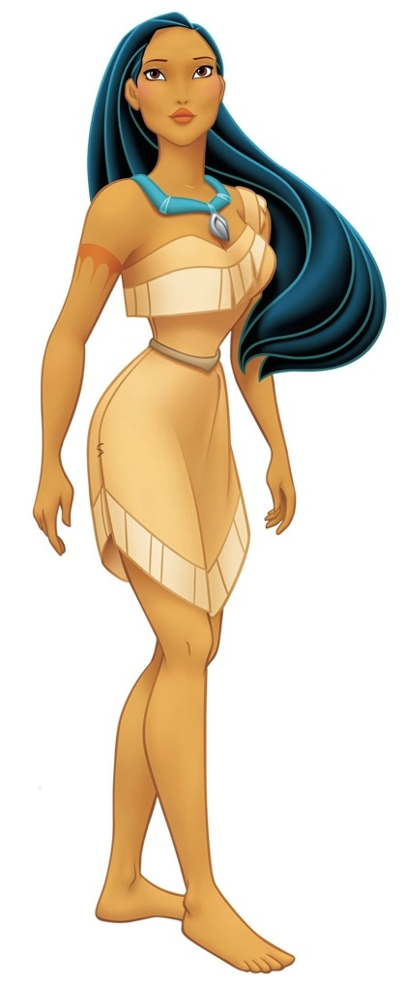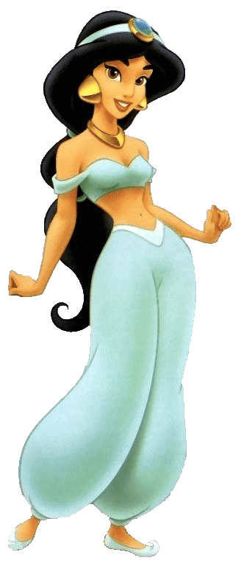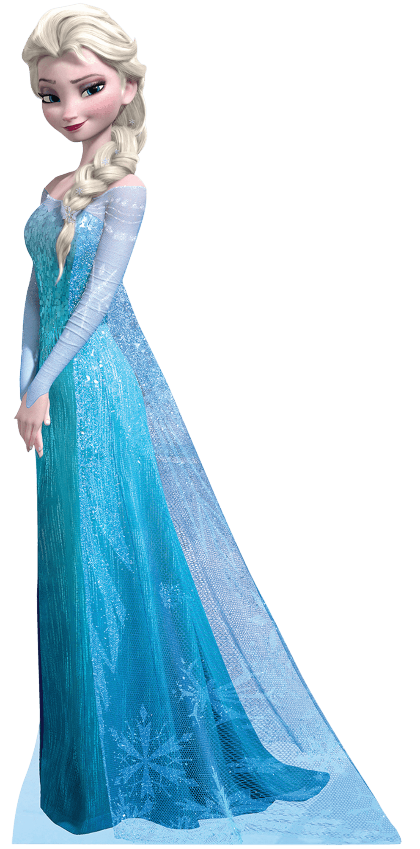

PRINCESSE

ARIEL

PRINCESSE

VAIANA

PRINCESSE

CENDRILLON

PRINCESSE

POCAHONTAS

PRINCESSE

ELSA

JASMINE

PRINCESSE

44 CHATS

PILOU

44 CHATS

MILADY

44 CHATS

ECLAIR

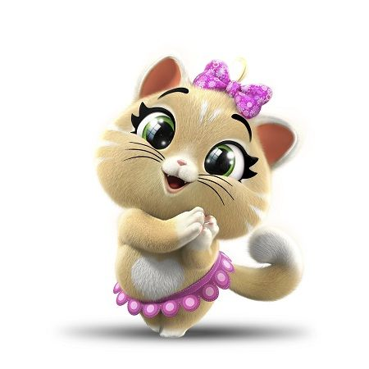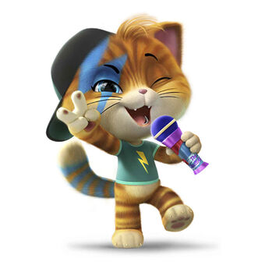

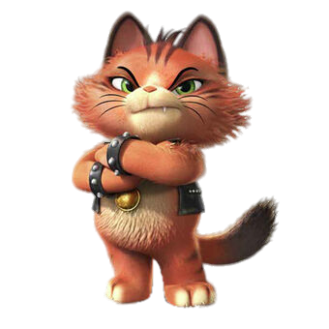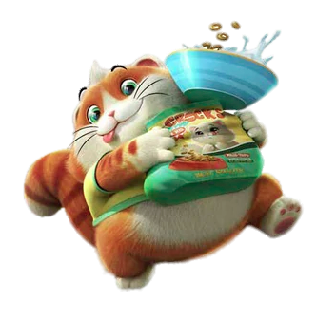

NOS HEROS  
PREFERES

7 FAMILLES

44 CHATS

MAMIE LINA

44 CHATS

BOSS

44 CHATS

BOULETTE