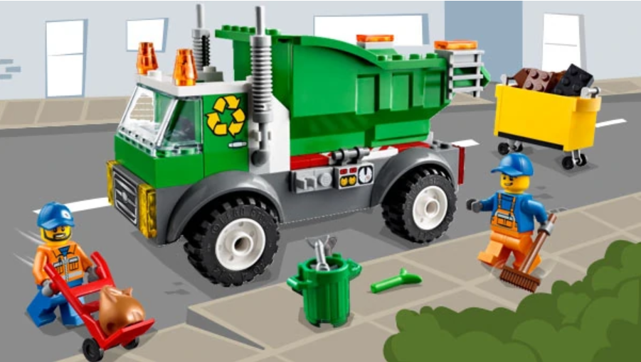

UN GRAND
MERCI
😊
Designed/Certified By Cosmos59-2020

