First Name : ……………………. Class : 1st , 2nd, 3rd

Last Name : ……………………..

1. **Name the following images : monkey, Lion ,cow**

C:\Program Files (x86)\Microsoft Office\MEDIA\CAGCAT10\j0149627.wmf …………………………

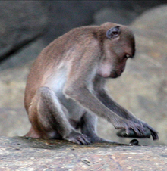 …………………………..

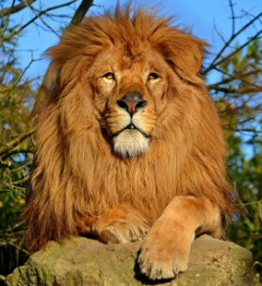 ………………………….

1. **Link the image with the appropriate word :**

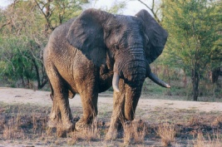 . .crab

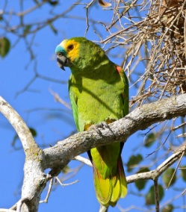 . .flamingo

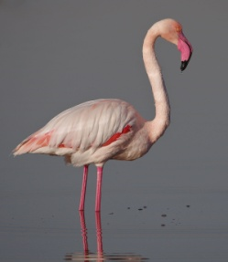 . .parrot

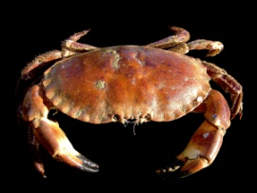 . .elephant

1. **Answer the following questions :**
2. What is your name? ………………………………………………………….
3. How old are you? ………………………………………………………….
4. How many brothers and sisters do you have?

………………………………………………………………………………………………

1. What is your favorite color? …………………………………………………
2. What is your favorite food? …………………………………………………
3. What is your best friend name? ……………………………………………