Label the pictures : Tower of London - British museum - Big Ben - Tower bridge - London eye - Buckingham palace - Trafalgar square
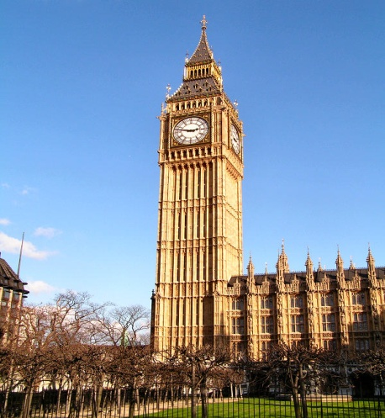
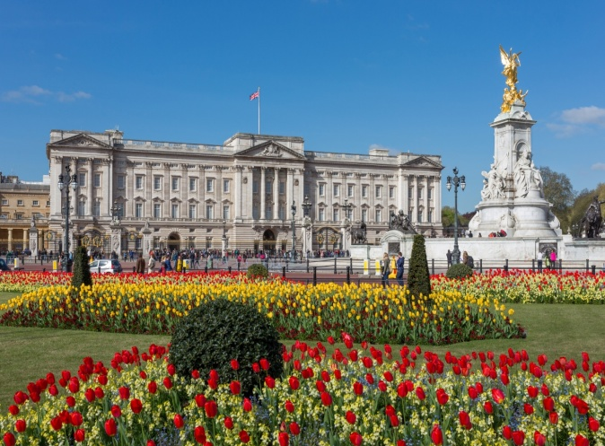
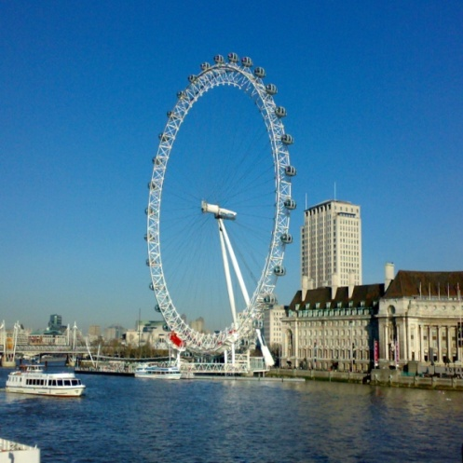

……………………….. …………………………… ……………………………….

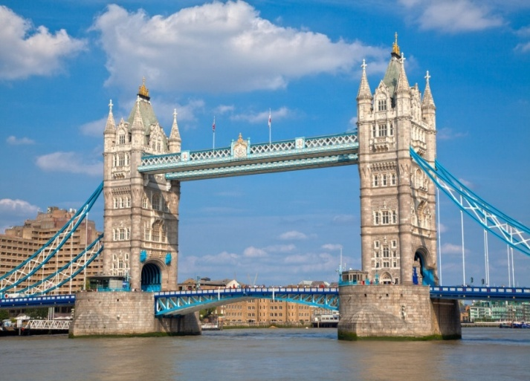
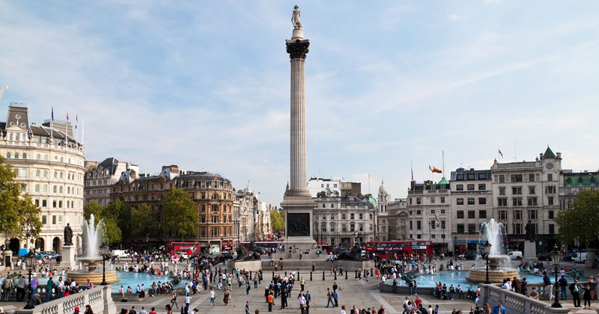

……………………………. ………………………………..
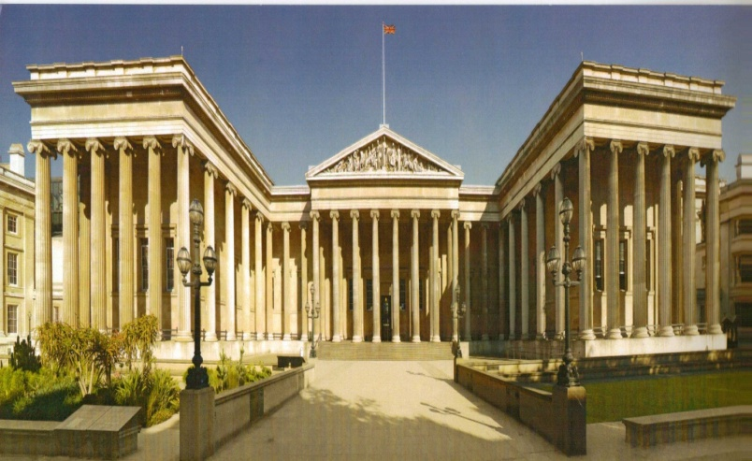
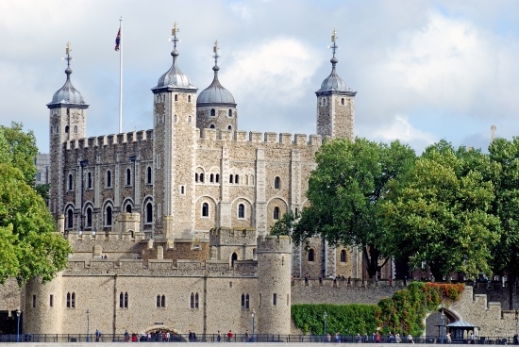

…………………………………….. ………………………………………

Nelson's Column is a monument in Trafalgar Square in central London built to commemorate Admiral Horatio Nelson, who died at the Battle of Trafalgar in 1805.
Trafalgar Square is a public space and tourist attraction in central London, built around the area formerly known as Charing Cross. It is situated in the City of Westminster. At its centre is Nelson's Column, which is guarded by four lion statues at its base
The London Eye is a giant wheel on the South Bank of the River Thames in London. Also known as the Millennium Wheel .The entire structure is 135 metres (443 ft) tall and the wheel has a diameter of 120 metres (394 ft). It offered the highest public viewing point in London

Big Ben is the nickname for the Great Bell of the clock at the north end of the Palace of Westminster in London,^{[1]} and often extended to refer to the clock and the clock tower

the Tower of London, is a historic castle located on the north bank of the River Thames in central London. It was founded towards the end of 1066 as part of the Norman Conquest of England. The White Tower, was built by William the Conqueror in 1078, and was a resented symbol of oppression, inflicted upon London by the new ruling elite. The castle was used as a prison from 1100 until 1952 .

The Camden markets are a number of adjoining large retail markets in Camden Town. Among products sold on the stalls are crafts, clothing, bric-a-brac, and fast food. It is the fourth-most popular visitor attraction in London, attracting approximately 100,000 people each weekend.^{[1]}

Buckingham palace : Located in the City of Westminster.
Buckingham Palace has 775 rooms. These include 19 State rooms, 52 Royal and guest bedrooms, 188 staff bedrooms, 92 offices and 78 bathrooms.
More than 50,000 people visit the Palace each year

