How to refresh 8th Gen mini PC BIOS

Part.1

Please download BIOS from following link:

<https://we.tl/t-PjGO1EKfgw>

  Now get the BIOS rar files released like:

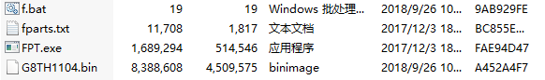

Please prepare one USB drive.(Note: Please use empty USB disk driver when making DOS booting, otherwise the data will get lost when formatting USB disk.) download USBoot\_english.rar from following link:

[https://mega.nz/#!V8oBTTRb!-3YVa8KxeJWCMr5oUStgNFkpssSESezvsFih\_2aZabI](https://mega.nz/" \l "!V8oBTTRb!-3YVa8KxeJWCMr5oUStgNFkpssSESezvsFih_2aZabI)

release the rar, got file run exe program by administrator rights:

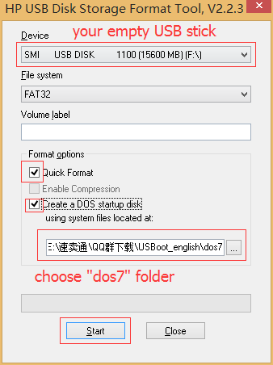

Remark: the DOS system is from “dos7”, then click “ Start” to start. wait until it finished the USB booting DOS is ready.

Part.2

1. Copy below BIOS files to the root of the USB disk (the same USB disk as part 1).



1. Insert the USB Flash Disk on the Mini PC and Start the PC, Press “ F11” or "ESC" continually to enter the following image, Select your USB drive to boot , Press “ Enter”.

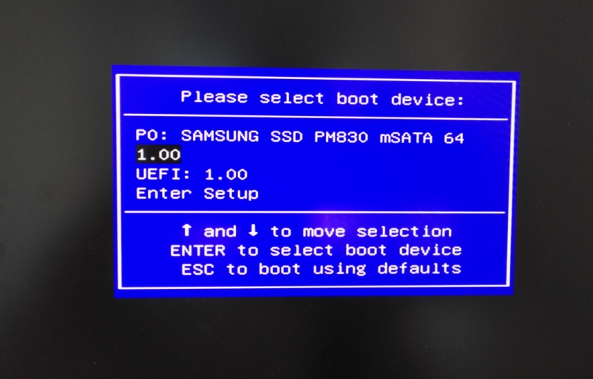

1. You will enter the following image, input "f", and press "Enter" to process refresh:

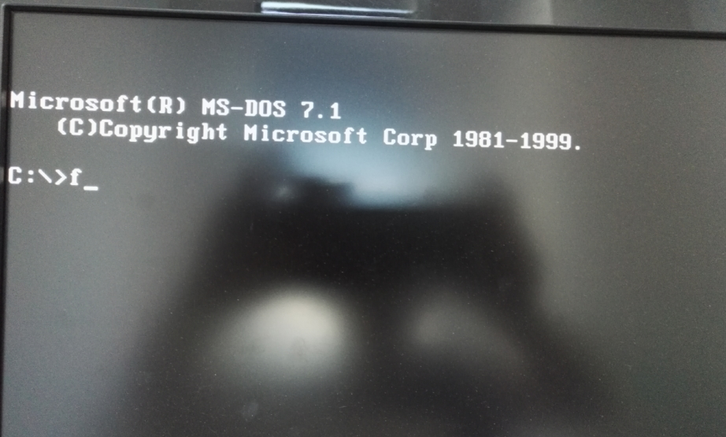

1. It is upgrading BIOS, don’t power off.

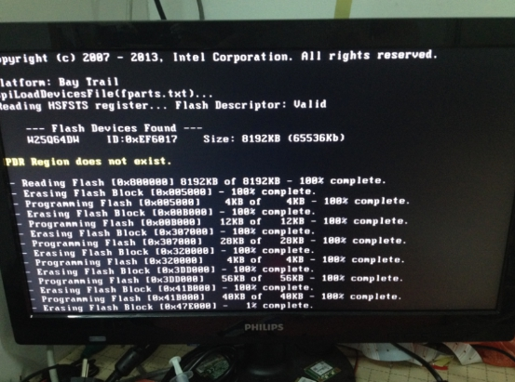

1. It will finish after a few seconds.

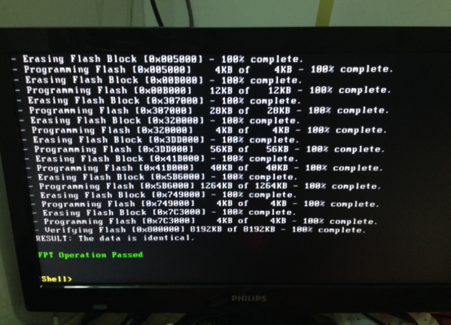

1. After the process is finished, re-start the Mini PC, then BIOS refreshing was finished.