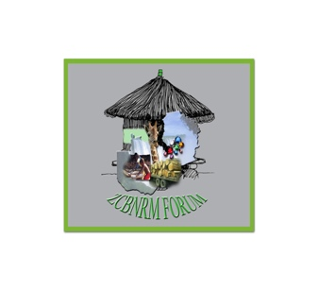

**ZAMBIA COMMUNITY- BASED NATURAL RESOURCES MANAGEMENT FORUM**

C/o WWF Zambia Office, Long Acres P O Box 50551 RW Lusaka.

Phone: +260 97 8482164/+260 96 2201003

To

The Director of National Parks and Wildlife (DNPW)

Chilanga, Zambia

Dear Sir,

**RE: Authority to conduct research on IWT for the LeAP project in Zambia**

Reference is hereby made to the above mentioned subject matter.

It is with pleasure that the Zambia Community-Based Natural Resources Management Forum (ZCBNRM Forum) is informing you on its collaboration with the International Institute for Environment and Development (IIED) in the UK.

The aim of this collaboration is conduct *the Learning and Action Platform for Community Engagement against IWT* project (LeAP). This project addresses site-level poaching of high-value species in Zambia. In the longer term the improvements in evidence, capacity and voice will lead to increased opportunities to participate in, and benefit from, the anti-IWT initiatives implemented by governments, donors and NGOs. It will also lead to the avoidance of negative impacts on poor people from IWT projects – such as loss of access to resources, human rights abuses – and actively engage and support them in enforcement conservation and sustainable use, including through equitable benefit sharing from the use and conservation of wildlife.

The Zambia CBNRM Forum is implementing the programme in Zambia. A major activity of this programme is the data collection on IWT and poaching via communities’ perception surveys and policies surveys. The Forum engaged Mr Charles Kaponda for the purpose of this research. We kindly request for your approval on the collection of these data in the country.

Yours sincerely,

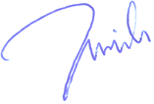

Dr Rodgers Lubilo

ZCBNRM Forum Chairman