1- Addresse source : 192.168.0.1
2- Non, il utilise pas la couche transport
3- protocole de couche IP utilisé est ICMP
4- message envoyée : Echo request
5- message retournée : Echo response
B tracert:
1- Non$
2- ICMP
3 - Tracert is a Windows based command-line tool that you can use to trace the path that an Internet Protocol (IP) packet takes to its destination from a source. Tracert will determine the path taken to a destination. It does this by sending Internet Control Message Protocol (ICMP) Echo Request messages to the destination. When sending traffic to the destination, it will incrementally increase the Time to Live (TTL) field values to aid in finding the path taken to that destination address. The path is outlined from this process.
4 - TTL = 64

C- WWW
1- TCP
2- [SYN, ACK] = [0,1]
[SYN, ACK] = [0,1]
[SYN, ACK] = [1,1]
[SYN, ACK] = [1,1]
3- HTTP
4- port source : 56026, port dest : 80
5 requete de type GET
6- webserver version : APACHE2

D - FTP
1- TCP
2- port : 21
3- port : 20
4
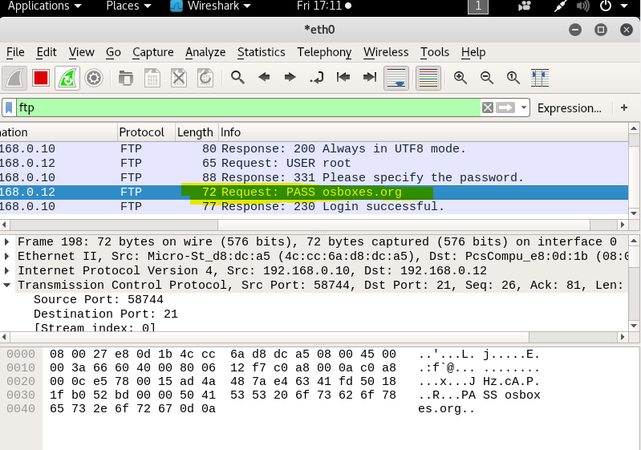

Activité II
1- on scan la plage d'addresses de ces machines
2- nmap -sS 192.168.1.0/24
3- Xmas scan retourne le flag TCP RST/ACK, et le scan SYN retourne RST

