How to use router hdd case
1.Change Hard Disk Format
(1).Insert hard disk.
(2).Connect case and computer by USB cable.
(3).Press switch button on the device(there is a notice if device is connect well with computer)
(4).Change hard disk format as NTFS
right-click on My Computer =>Select Manage=>select Disk Management.unallocated disk can be found in disk management.
(5)After above step,you can see the hard disk detail on"My Computer".
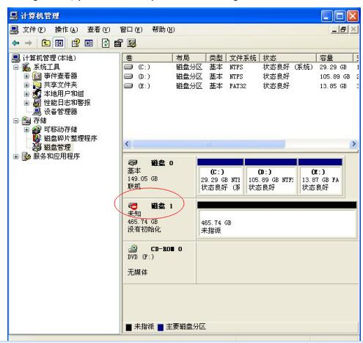
2.Connect Router HDD case
(1).Connect charger power supply.
(2).Short press switch button,wait about 2 minutes to open WIFI.
(3).Search wifi name start by kimax***** on your computer or mobile phone,connect it with default password 12345678 or without password.
Note
1.For HD03WF, In order to avoid data read error,pls don’t use SD Card and TF card simultaneously.
2.Indicator's color will be different from the actual color as light pipe blending.
3:When use the device,insert hard drive in slot first.then Connect computer with USB cable.last plug in the power supply.
4.If your hard drive is new one, Computer will prompt you to format,just follow the notice. If no prompt,right-click on My Computer =>Select Manage=>
select Disk Management.unallocated disk can be found in disk management.

3.Setting Router HDD
(1).After above step,pls open 192.168.169.1 on browse with default password:kimax
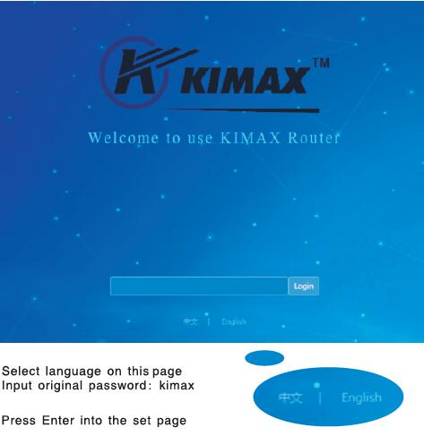
- .Start to setting the router,detail see as user manual shows from page 14 to page 18.
Note:
- How to change administrator password detail see as user manual page 19.
2.How to updated KIMAX-1.3.5 firmware
Pls check the router model on 192.168.169.1,and choose right firmware to your router
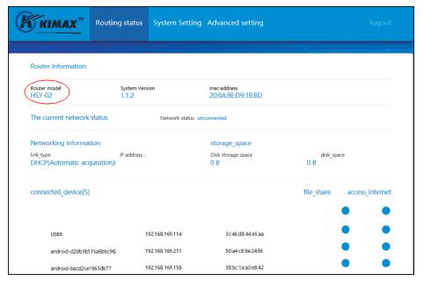
For model HSY-02
紧急修复复位失效专用固件KIMAX-HSY-02专用-0ae7373cf15d86aba945d844157b51e6-bug-fixed-R
For model kimax-H1
KIMAX-H1专用-1.4.0-16-582a8464a39563ee79dd504638cb56ff-R
Pls notice:You can see detail update way on instruction book from page 19 to page 21.And To update the firmware need more than 5minutes,pls keep power supply is work well when device is under updating,shutdown will cause irreparable crash,and router will be will damaged.

4.How to browse HDD on Computer
Wireless connect way
Detail see as user manual shows from page 22 to page 24.
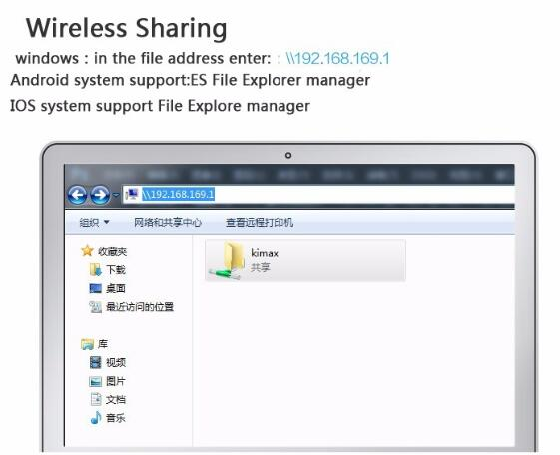
Wired connect way
Connect device with computer by USB 3.0 cable,then you can browse hdd in my computer
Note:
- If you hdd is new one,need to initialized and formatted first,detail way see as above write.
2 if the case is no battery capacity,you should charge it first)

5.How to browse HDD by phone
(1) Install APP in your phone first.
Android APPIOS APP
You can download latest APP
for Android phone:insert ki disk on Android market
for iphone phone:insert ki disk on App store
(2) You should register APP to create account with your phone number.
(3)How to use APP
a.Seach wifi start by kimax***** on your phone,connect it with default password 12345678 or without password.
b.Log in the APP with account number and password as you register one.Then you can visit HDD in your phone (Detail see as user manual shows from page 22 to page 24)
