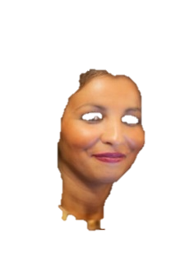

Madame Dupont

EXPERIENCES PROFESSIONNELLES
PPPPPPPPPPPPPPPPPPPPPPPPPPPPPPPPPPPPPPPPPPPPPPPPPPPPPPPPPPPPPPPPPPPPPPPPP

PPPPPPPP

DIVERS

PPPPPPPPPPPPPPPPPPPPPPPPPPPPPPPPPPPPPPPPPPPPPPPPPPPPP

