
PARTICIPATION BULLETIN
WORKSHOP
STARTER TEACHERS
DECEMBER 11th -2018
AT ASL VENTURE
To return before NOVEMBER 30th
at : aslangues@gmail.com
Name :
Surname :
City :
Position :
Email :
Téléphone :

School Access map
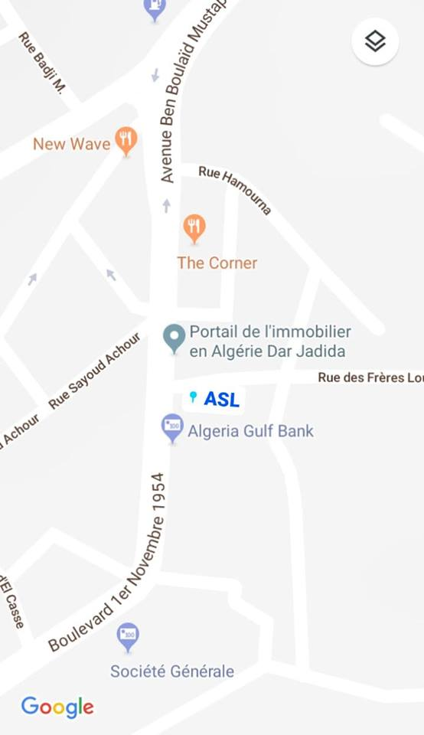

CONTENT :
- Classroom management and teacher language
- Lesson planning
- Planning a sequence of lessons
- Teaching exam classes
- Exploiting authentic material


COFFEE BREAK
LUNCH
AUTHENTIC DOCUMENTATION
PRICE : 6000 DZD

