How to attach celluloid arms or legs

1. | 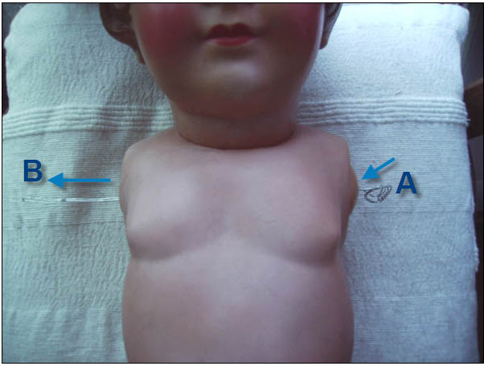 | Insert a folded wire from A to B .
2. | 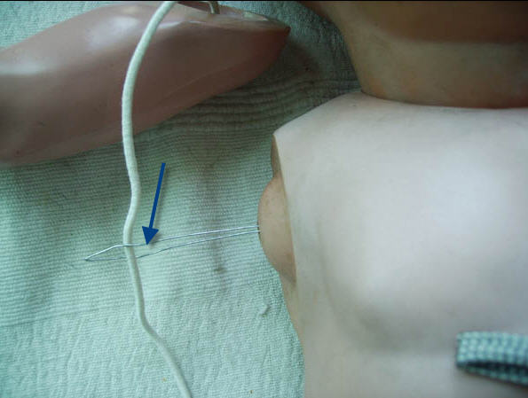 | Pull apart the end of the folded wire to insert rubber band coming out of right arm (up to 3 inches from end). Twist the end to hold rubberband.
3. | 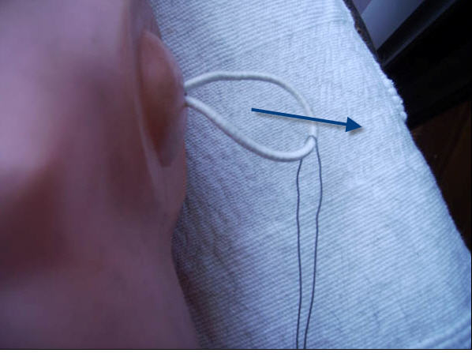 | Carefully slide the wire to the right to pull out rubber band on the other side of the torso
4. | 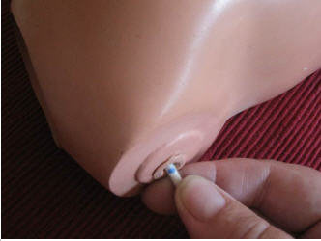 | Mark the rubber on the place where it comes out (do not stretch !)
5. | 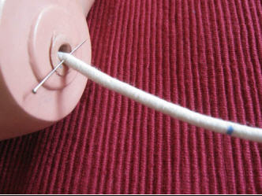 | Carefully stretch the rubber as far as possible (3 to 4 inches away from mark) and lock it with a pin
6. | 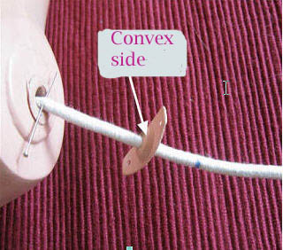 | Slip the anchor onto the rubber with the rounded (convex) side facing the pin (so the concave, hollow side is outside to receive the rubber knot)
7. | 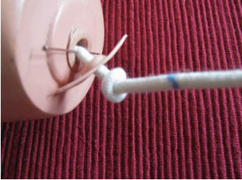 | Make a knot approximately ¾ inch from mark ( knot as tight as possible)
8. | 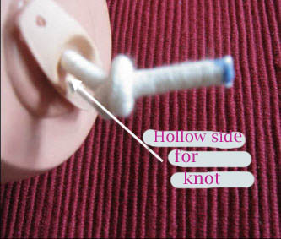 | Cut rubber on the mark
9. | 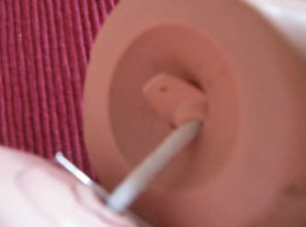 | Take the left arm. Carefully insert anchor in the opening of the gate (first the knot and then the anchor)  Do not force: if the anchor is too wide, gently scrape the sides of the anchor with a knife.
10. | 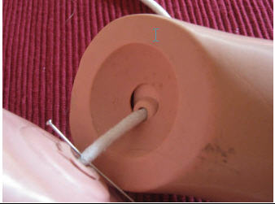 | When the anchor is totally inside, slowly remove the pin holding the arm ( inserting two fingers between torso and arm) to avoid the arm to bang and break!  Remember celluloid is very fragile!!  Good luck!  pom48

