Hello, (I translated into English)
I installed your mail, I did not have any serious problem, except to send messages, indeed, being on the page "Mail":

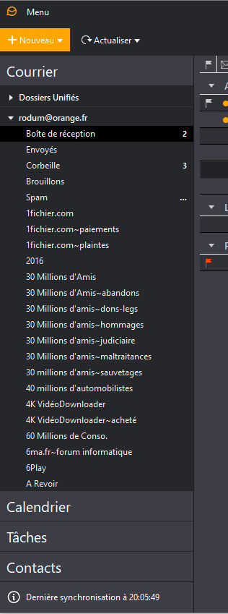
I click on + New, this window opens (I do not copy the whole windows for a saving of place):
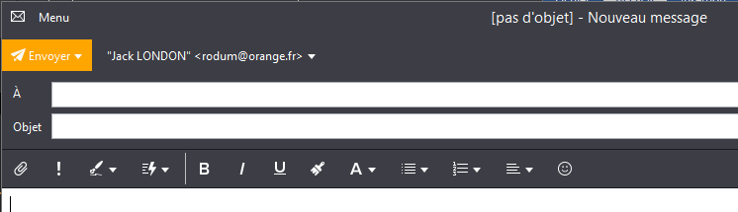
and when I click on the To top left, I have this window:
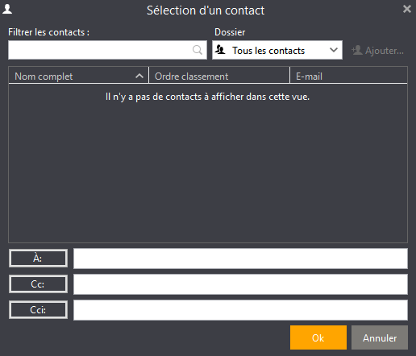
in which there are no contacts to choose from, yet the contacts are well recorded in the mail:
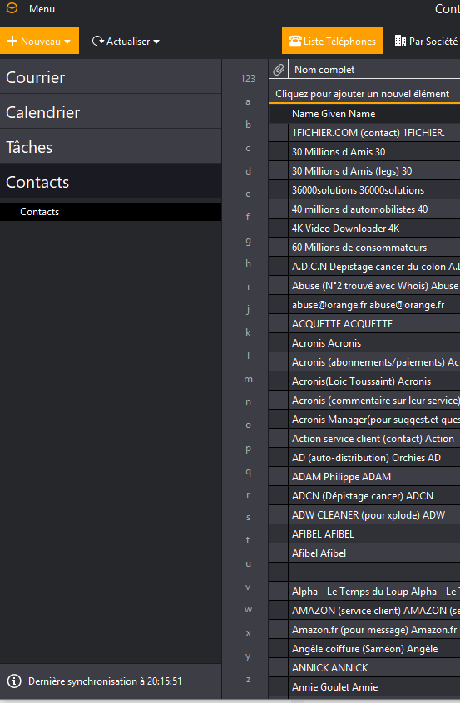
I searched everywhere, but I can not find a solution, what can you tell me about this problem, thank you.

