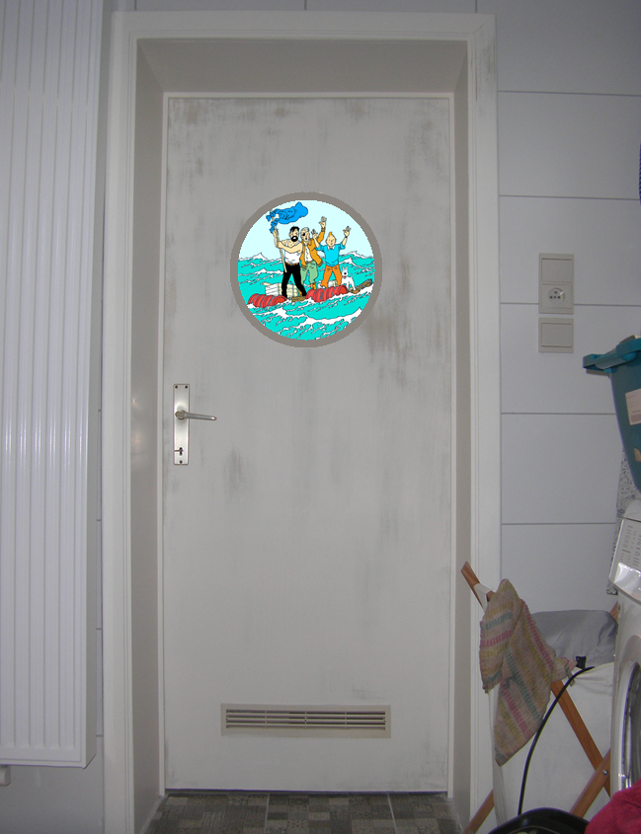

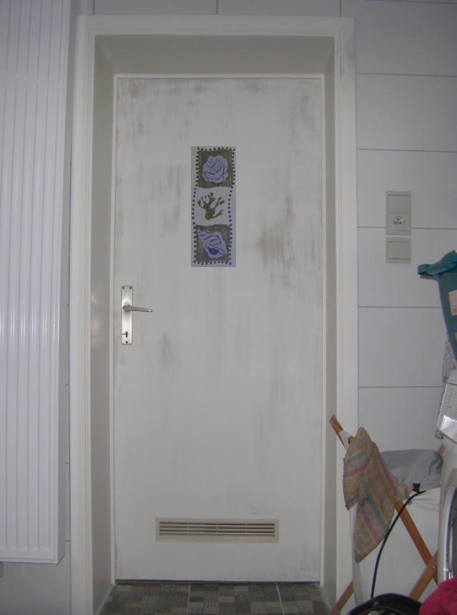[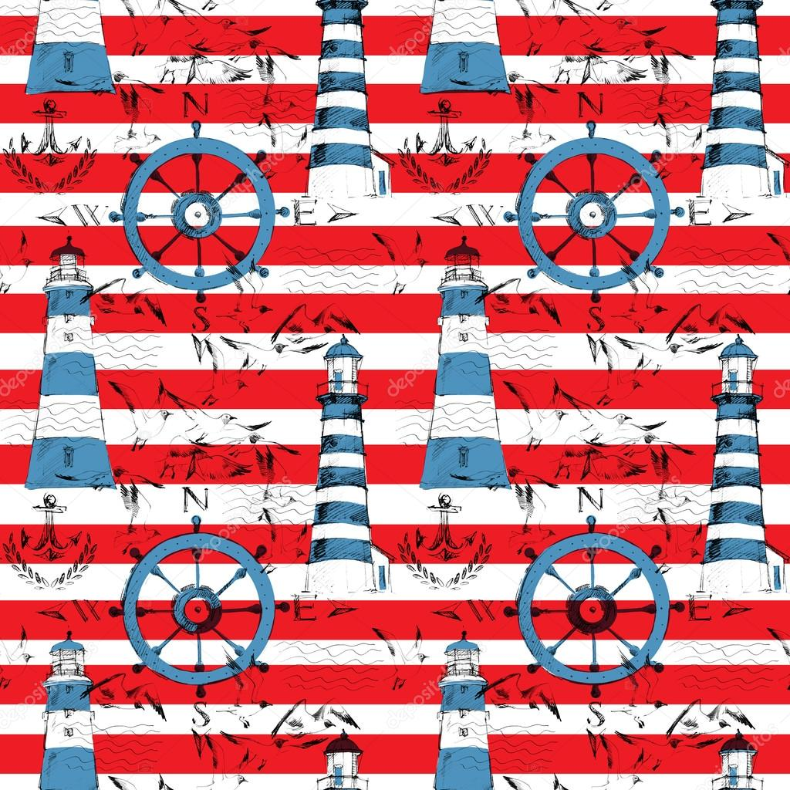](https://www.google.be/url?sa=i&rct=j&q=&esrc=s&source=images&cd=&cad=rja&uact=8&ved=2ahUKEwiGlKKKo-nbAhWmsaQKHaALALUQjRx6BAgBEAU&url=https://fr.depositphotos.com/108612576/stock-photo-seamless-pattern-with-lighthouses-sea.html&psig=AOvVaw15h0BjjMps9QIaFyDRFli3&ust=1529825707488272)