1
Why are Morpho blue?
1.1. Introduction
Their large size and their often brilliant blue wings put butterflies from the Morpho genus among some of the most spectacular insects in South America. Often mentioned in the accounts of explorers in the 19th century (see [FRU12]), they have been prominent in curiosity cabinets and natural history displays and are still today the subject of much commerce. One would logically expect the biology of such sought-after species to be well known and understood, but this is not the case [NEI 08]. Understanding of the origins and evolution of the iridescent blue color is very limited. Why are Morpho (often) blue?
The question of cause in biology can be tackled on three levels: structural, historical and functional [GOU 02]. (1) A structural answer explains the phenotype by its physical or biochemical properties, thus answering the question of ‘how’. It also covers the genetic and developmental origin of the observed phenotype by describing in detail its development during the growth of the individual. This proximate explanation of the phenotype has a temporal dimension, the short time for development to occur, and concerns not only the phenotype itself, but also the structures and processes that generate it. This approach can notably detect if different structures are capable of producing the same phenotype. (2) The evolution of the phenotype (and of its genetic and developmental bases) can also be placed in
its phylogenetic (historical) context. The study of phenotypic variation on a macro-evolutionary scale makes it possible to test the influence of evolutionary processes and of a wide array of factors on the evolution of phenotypes, while also taking into account the extent to which different species are related, that is to say the overlap of evolutionary history between species. (3) Finally, we can try to detect which evolutionary pressures influence the emergence, maintain or loss of the phenotype. Ecological or behavioral (and also biomechanical) studies allow us to determine in particular the role of selection, natural or sexual, in the evolution of the phenotype (functional answer). In practice, these approaches are often somewhat combined: evo-devo is often simply developmental genetics compared between related species, thus bringing together the structural and historical approaches; in much the same way, functional morphology combines the study of physical (structural) properties and ecology. So the comparative method makes it possible to test adaptive hypotheses in a phylogenetic framework. However, it is still rare for these three approaches to be fully integrated [KLI 06]. In this review, we will give an overview of the state-of-art of the nature and evolution of Morpho coloration across these three levels of analysis. We will identify the unanswered questions of most interest and propose possible avenues of research to answer them.
Are Morpho really blue? In the present case we are interested in the color of the wings of adult butterflies (we will therefore put aside the egg, caterpillar and chrysalis stages, none of which — at least in those species of which these stages are known — shows any blue coloration [RAM 14; BEN 16]). Although iridescent blue is rightly associated with Morpho, it is not present throughout the genus. In fact, there are several dark species, predominantly brown, sometimes a greyish ochre, or even with a large wing proportion of orange-ochre, as in the giant M. hecuba (figure 1B). There are also three white-winged species, such as M. polyphemus (see figure 1C and the phylogeny in figure 2). Sometimes, for instance in M. telemachus (figure 1A), the blue is not widespread, only very weakly iridescent and much duller. In typically blue species the coverage of this color varies from one species to another, always fringed by a black part around its edges and often at the base of the wings (see figure 1 DEFHI). Even in those species most famous for their iridescent blue, females are often brown or orange (in M. rhetenor, for example, figure 1F and 1G). If the question ‘why are Morpho blue?’ is undeniably interesting, the subsequent question ‘Why are certain Morpho not blue?’ is just as interesting, and makes it possible to investigate the factors involved in the acquisition and/or loss of this coloration. Finally, butterfly wings have two sides, dorsal and ventral, and the latter, excluding very rare cases of developmental aberration, is never blue: all species (see figure 1HIJK) have a brownish ventral side (except the three white species), with eyespots varying in size, color and number— these famous marks that look like a vertebrate’s eye. The evolutionary origin of this more subtle coloration and of the presence of these eyespots will be briefly discussed.
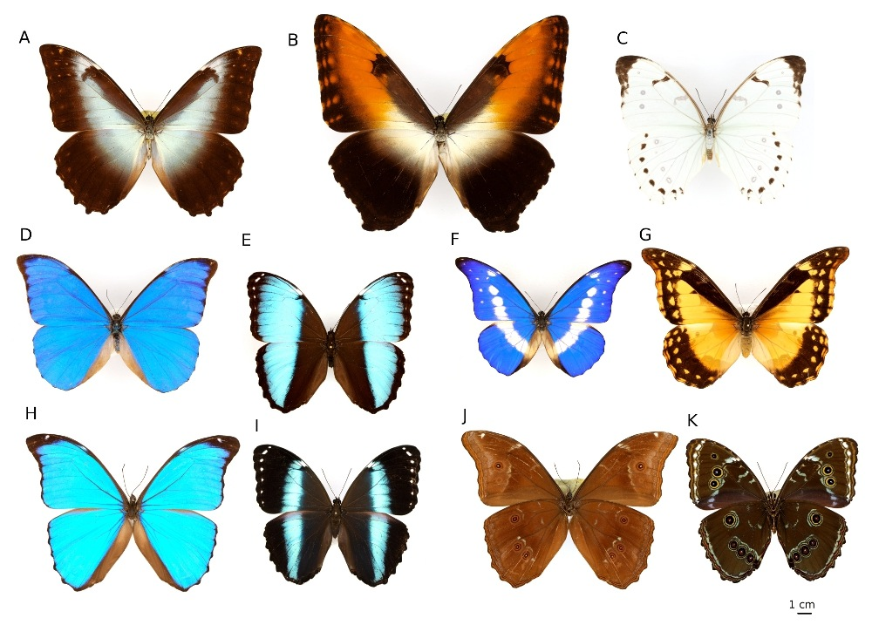
Figure 1 - Diversity of colors in Morphos. A Male Morpho telemachus; B Male Morpho hecuba, C Male Morpho polyphemus, D Male Morpho anaxibia, E; Male Morpho helenor papirius; F Male Morpho rhetenor; G Female Morpho rhetenor; H Male Morpho menelaus; I Male Morpho helenor helenor; J Male Morpho menelaus (ventral side); K Male Morpho achilles (ventral side).
1.2. A structural answer: the iridescent blue in Morpho is a physical color
Here we aim to identify the structures and physical properties of wings that are responsible for blue iridescence, and the genetic and cellular mechanisms involved in their development. To approach this problem we must first define precisely what we mean by ‘iridescent blue’ and identify the visual properties we want to explain. We can thus define several parameters to describe visual appearance; these can be measured thanks to a spectrophotometer and compared between individuals or species: (see box 1). (1) Hue. Why do the wings of various Morpho species reflect light at wavelengths between 450 and 490 nm - corresponding to blue? In general, blue in animals is rarely caused by pigmentation - blue pigments are more complex, unstable and energetically costly than other pigments (e.g. [BUL 04]; see [BAG 07] and [UMB 13] for review). In fact, the origin of the blue in Morpho is not pigmentary but structural, that is to say linked to properties of the scales’ surface (we will later see how pigmentation still plays a role). (2) Brightness. Some Morpho are light while others are darker. (3) Glossiness. While some Morpho are noticeably glossy (e.g. M. cypris), others are matter (e.g. M. anaxibia). (4) Saturation. For a similar hue, certain Morpho show a more intense, saturated blue. (5) Iridescence. If a Morpho is manipulated, and the angle from which it is illuminated and/or observed is varied, its color changes, going from blue to violet, or even to green and orange. Iridescence is defined as the change in color with the angle of illumination or observation (see box 2 for a description of the physical origin of iridescence). The dominant wavelength being blue, Morpho wings are thus generally seen as iridescent blue.
The initial question of the origin of blue in Morpho therefore becomes more specific through the different parameters describing the visual impression generated, such as hue, brightness, glossiness, saturation and iridescence (see boxes 1 and 2). We have to explain the physical origin of these different visual properties, but also what makes them vary between species: what structural differences explain these different properties?
Box 1: different parameters of color
Different parameters of color can be illustrated using a reflectance spectrum, which gives the amount of reflected light as a function of the wavelength (figure E1).
Hue- color in the common meaning of the term (blue, green, yellow, red). It often corresponds to the maximum value in the reflectance spectrum of the object
Brightness- average reflectance (average proportion of reflected light), corresponding to the level of grayness of a color (i.e. grey-spotted space under the curve or line in figure E1).
Saturation (or Chroma)- characterized by the color’s purity. It is linked to the spectral breadth of the object’s peaks of reflection or transmission: the broader the spectrum, the less pure the color, and vice versa (see yellow arrow on figure E1). It goes from 1 for a monochromatic light (laser) to 0 for a white color.
Iridescence- change of hue as a result of change of angle of observation and/or illumination (.i.e. here, shift in reflectance peak quantified by the purple arrow on figure (E1). The physical origins of iridescence are shown in box 2.
Glossiness cannot be quantified with one reflectance spectrum alone and requires more complex methods of study. It corresponds to reflection in a particular direction (anisotropy). Matte surfaces, on the other hand, reflect light in all directions (isotropy).

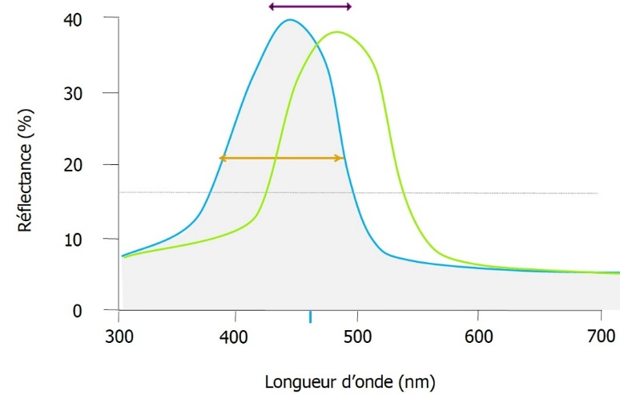
Figure E1 -.Reflectance spectra as a function of wavelength, illustrating how different parameters of color can be computed: the position in wavelength of the main peak defines hue (here, blue, between 450 and 490 nm), peak width at half height (yellow arrow) defines saturation, the surface under the curve, or the average reflectance (dotted) defines brightness, and a change in curve position (moving from the blue curve to the green curve: purple arrow) as a function of the angle of lighting or observation defines iridescence.

Box 2: Iridescence
Iridescence (also called goniochromism) is a color change of an object as a result of the angle of observation and/or illumination (Figure E2a).
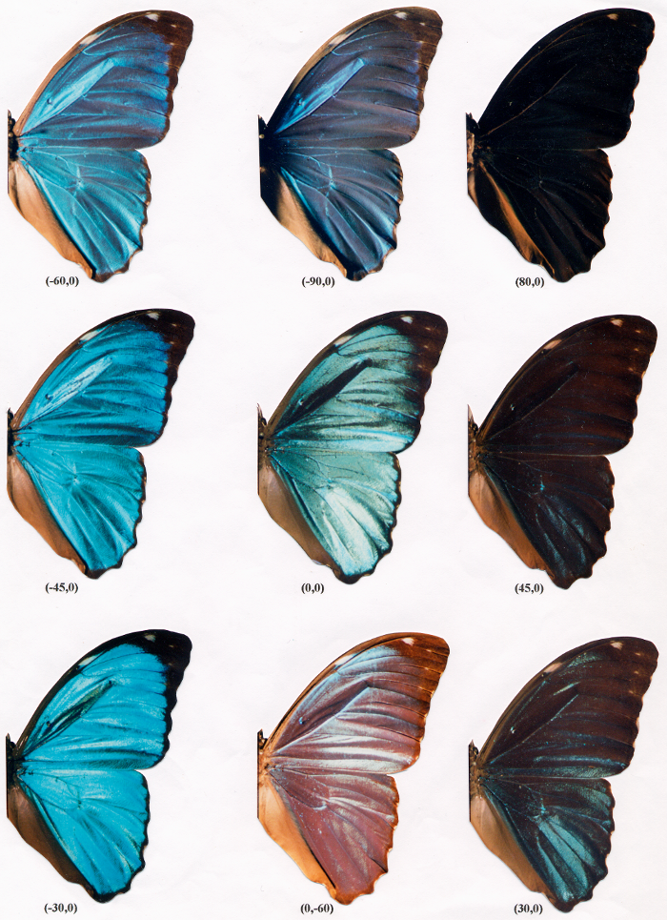
Figure E2a - Iridescence of Morpho menelaus. Here, the angle of observation is fixed (perpendicular to the wing) and only the angle of lighting is varied. The values in brackets indicate respectively height and azimuth.

Iridescence is caused by two distinct mechanisms that work in tandem in Morpho:
1-Thin-film interference - This is the most widespread phenomenon in nature. It results from the reflection of light on both sides of a thin transparent film. When these two waves are in phase, their amplitudes add up. They cancel each other out when they are out of phase. A simple trigonometric calculation tells us this happens when:
kλ = 2necosθ_{r}

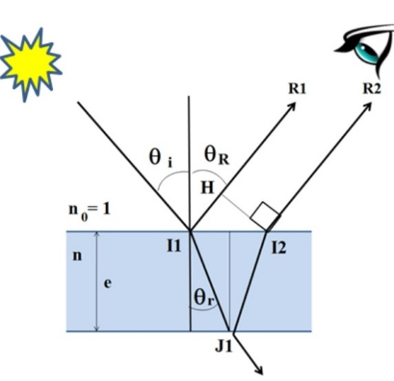
where k is an integer, λ the wavelength, e the film thickness, n its refraction index and θ_{r} the angle of refraction (see figure E2b). As the cosine is a decreasing function between 0 and π/2, wavelength λ decreases as the angle of incidence increases and the color seen shifts toward blue (‘blue shift’). In Morpho, this iridescence by interference takes place mostly on the basal scales, on the level of the corrugated lamellae (figure E2d on right). It is important to note that thin film interferences are a phenomenon of reflection: the angles of illumination and observation must be varied simultaneously and by the same value.

Figure E2b- Thin film interference. According to Descartes, θ_{i} and θ_{R} are equal; to observe iridescence, the angle of observation must be changed as the angle of incidence of the light varies.
2-Diffraction by grating - a grating is a set of objects (lines, gaps, etc.) regularly arranged. Each of these objects diffracts incident light and only certain wavelengths are in phase, and therefore visible, in certain directions. Calculations show us that this occurs when:
nkλ = sini + sini’

where k is an integer, n the number of objects per meter (the opposite of the spacing of grating a), i the light’s angle of incidence and i’ that of observation (see figure E2c). We now have a sine law, a function that increases between 0 and π/2, that shows us red hues are observed at larger angles than blue ones (‘red shift’), contrary to interference. This phenomenon occurs in Morpho on the level of the striations that run along the length of the scales (Figure E2d) and act as a diffracting pattern. We should also note that in this case iridescence is only observed by changing the angle of observation.
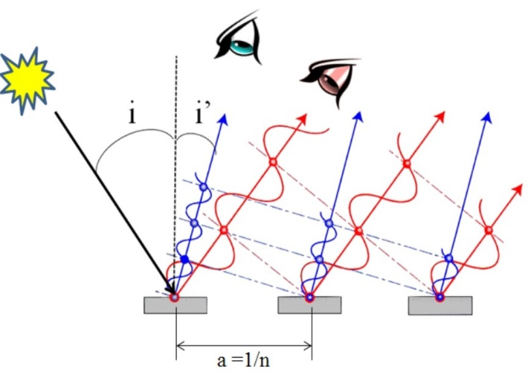
Figure E2c - Diffraction by a grating of spacing a. Here we have only shown an order of 1 (k=1), the same phenomenon occurs at larger angles (k = 2, 3…).
The iridescence observed in Morpho is therefore complex, since it combines these two antagonistic effects. Each scale acts as a striation pattern which spacing, in the range of 1 µm, depends on the species, and causes a color shift towards red (Figure E2d, left). But each striation is made of corrugated lamellae roughly 100nm thick that produce the color blue, but also a shift towards blue when the angle of incidence and observation increases.

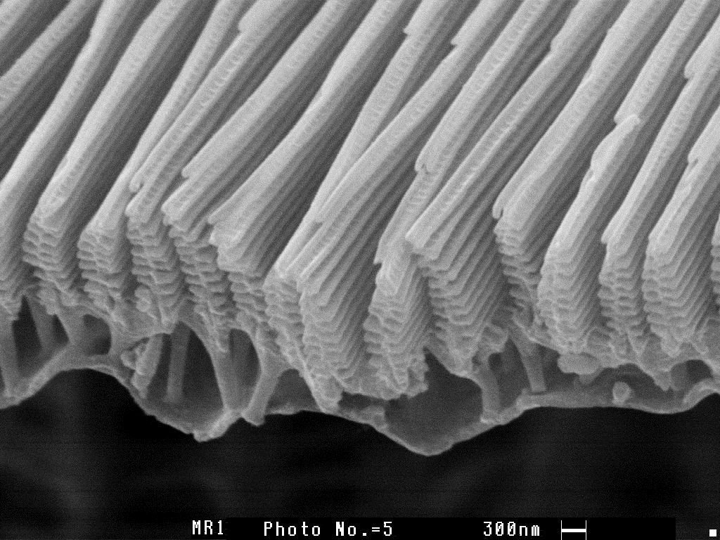
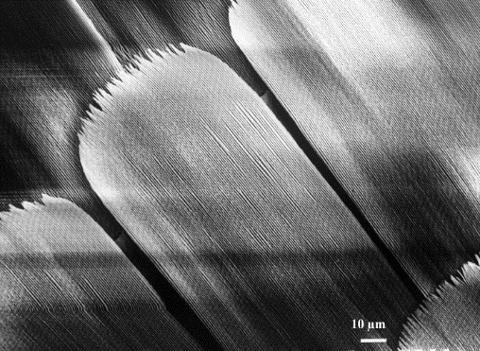

Figure E2d - On the left, basal scale of Morpho menelaus showing the striation pattern, with a spacing of around 1µm. On the right, corrugated lamellae (known as ‘christmas trees’, see also figure 3) producing blue interferences.

Scale structure
Butterfly wings, like that of other insects, are made of two cellular layers on top of one another, the dorsal layer and the ventral layer. What is particular to butterflies (and by definition to all Lepidoptera) is that ventral and dorsal sides present two layers of scales that more or less overlap, called cover scales and basal scales (e.g. [NIJ 91]). The relative size of these scales and the degree of overlap of these two layers are variable between species of Morpho and can influence the visual properties of their wings [BER 10]. Unlike other iridescent butterflies, the structure of basal scales, and not that of cover scales, produce most of photonic phenomena in Morpho species (e.g. [ING 08]): thus the light passes through a layer of transparent scales before reaching the iridescent scales (and passes through it again after reflection). The understanding of the optic properties of Morpho’s wings has been made possible by the technical progress of microscopy, which has allowed us to identify the micro- and nano-structures responsible for them (e.g. [GHI 72]; see [YOS 04; ING 08; BER 10], for historical descriptions).
Scales are marked longitudinally, from the root to the apex, by microscopic parallel striations (at least on the main part of the scale; Figures E2d and 2A-B). These striations are made of corrugated lamellae of chitin, of varying quantity depending on species (but of constant quantity within each species), slightly tilted from scale surface. Striations combined to lamellae three-dimensional organization (figure 2) are responsible for scale photonic properties, notably iridescence [ING 08; BER 10] (see box 2). In particular, lamellae corrugation amplifies the amount of light reflected, which becomes stronger (the color becomes more saturated) as lamellae number increases [BER 10; GIR 16]. Thus, intensely colored species such as M. rhetenor and M. cypris show striations made of 10 to 12 corrugated lamellae, while striations in M. helenor, which displays a less striking blue, are made of only 3 or 4 corrugated lamellae[GIR 16]. This corrugation is also the cause of the blue coloration, through an effect of interference (see box 2 and figure 2D). In fact, each lamella partly reflects the light that reaches it surface: each successive ray of reflected light interferes, sometimes positively (which increases the amplitude of certain wavelengths, here those in the blue range), sometimes negatively (which reduces the amplitude of other wavelengths). Distance between lamellae (in ‘Christmas tree’ organisation, see figures E2d and 2C)), plays a large part in determining the wavelength reflected (and therefore the hue).

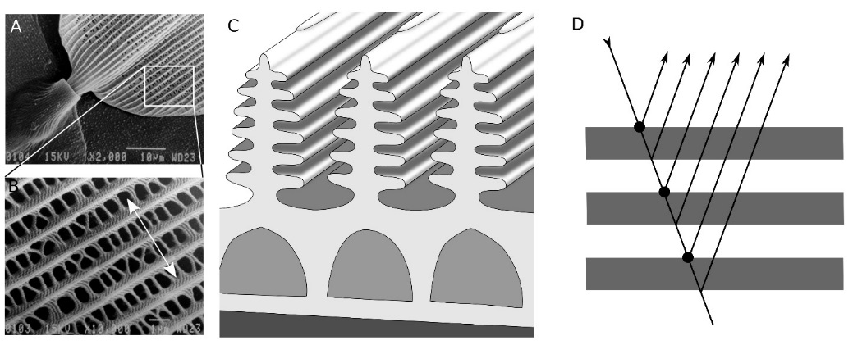
Figure 2 - Micro- and nano-structure of scales responsible for blue iridescence. A: View in electronic microscopy of scale base showing the pedicel. The longitudinal striations covering the scale are clearly visible. B: detailed view of striations under strongest magnification (electronic microscopy). The double ended arrow indicates the plane of the cross-section corresponding to figure C. C: schematic representation of perpendicular cross-section of a Morpho scale. The overlap of chitin lamellae results in this ‘Christmas tree’ organisation (see also figure E2d). D: illustration of the phenomenon of reflection/positive interference, linked to the superposition of lamellae separated by air. A and B from [BER 10].

As well as their peculiar physical structure, basal scales contain pigments. Their dark pigmentation (melanin) reduces unwanted light reflection and thus increases color saturation [ING 08; BER 10, GIR 16]. This pigmentation is absent in the two most basal species of the Morpho phylogeny, M. marcus and M. eugenia, in the three white species (M. polyphemus, M. epistrophus and M. iphitus) and in species from the sulkowskyi cladus, apart from M. absoloni (i.e. M. aega, M. portis, M. aurora, M. rhodopteron, M. zephyritis, M. lympharis and M. sulkowskyi) (see figure 2; [BER 10]). This absence of melanin contributes to the generally less intensely blue appearance of these species.
Glossiness diversity of Morpho species (comparing for example the very glossy M. rhetenor or M. sulkowskyi to the matter M. helenor or M. menelaus) is influenced by cover scales [VUK 99; YOS 04]. In the glossiest species, cover scales are either reduced or provide little coverage, while they are more developed in other species, where they may act as an ‘optic filter’, reducing wing glossiness while producing more diffuse reflected light [YOS 04] (see box 1). Scale shape can also play a role: in M. anaxibia, a species of a deep but quite matt blue, scales are convex, which reduces glossiness [BER 10].
Two species, M. eugenia and M. marcus - the most basal species of the group - show optical properties that stem from fundamentally different causes than other species of Morpho. In these two species, scale striations are made of only one chitin lamella: iridescence is therefore not produced by the corrugation of lamellae themselves [BER 10]. These two different organizations have very little influence on hue but directly affect the spatial distribution of reflected waves. Distance between scales is far greater than the length of the wave packet, or coherence length, which is of circa 1µm for solar light. This prevents any coherent effect, in particular diffraction by the striation pattern. We can therefore suppose that iridescence appeared in Morpho twice independently, early during their diversification.
There is another way of producing blue colors in nature: fluorescence (see [LAG 15] for review). By a non-linear process, high-energy radiations (generally UV) are absorbed by fluorescent molecules, and re-emitted at a lower energy (longer wavelengths), usually as blue or green. M. sulkowskyi deserves particular scrutiny in this regard (e.g. [KUM 94]). It is the only species of the Morpho genus to show noteworthy fluorescence. In this species, basal scales lack the melanins that absorb ultra-violet rays and limit fluorescence. Instead, they contain purines that fluoresce. The emission spectrum shows a blue peak at 480 nm. The output, while remaining relatively weak, adds a noticeable base of blue to this otherwise very pale species [VAN 11a,b].
A final optic property of Morpho wings is polarization. In the wave model, light is an electromagnetic wave where electric and magnetic fields are crosswise, that is to say perpendicular to the direction of propagation. Natural light is unpolarized. Fields oscillate in all directions perpendicular to the light-ray. Various devices called polarizers select one direction of oscillation. Any wave that has undergone an oblique reflection, for example on foliage or on water surface is partially polarized. This is also the case for light reflected by the scales of certain Morpho, as a result of raised striations of lamellae [VUK 99; BER 10]. Imperceptible to the human eye, this effect is interestingly visible to various insects (e.g. [KEL 99]), such as butterflies. Kelber [KEL 01] has shown that butterflies use polarization, combined with color information, to choose their site of oviposition (see also [DOU 07] for a discussion on the biological role of polarization). The ecological importance of polarization for Morpho is unknown.
Scale development
If the structural origin of Morpho coloration has been relatively well identified, the genetic and developmental origin of the structures involved are less well known. Colors of butterflies are however the subject of numerous research programs, notably in evo-devo (e.g. [ALL 08]; BEL 02; HEL 2012; JOR 11; LEP 14; NAD 16]). However, most genetic and developmental studies are interested in pigment synthesis as well as the positioning of color patterns and contain little or no information on scale structure and development (e.g. [BEL 02; NAD 16]). Yet, it has been suggested that these two aspects, pigmentation and structure, are linked (e.g. [GIL 88]). There is therefore little work available on the development of butterfly scales [OVE 66; GHI 2; GHI 76; GAL 98; CHO 12; DIN 14].
It has been shown that scales are homologous with the sensory bristles of other insects (notably of Drosophile; [GAL 98]), the development of which is well studied (e.g. [SIM 90; SKE 91]). Galant et al. [GAL 98] have shown that, in the Precis coenia (Nymphalidae) butterfly, scales are formed at the start of pupation by two waves of cellular division: the first, followed by massive apoptosis, organizes the cells in successive rows along the proximo-distal axis of the wing; the surviving cells undergo a second wave of division which in the case of each dividing cell gives rise to one cell that produces the scale and one cell producing the pedicel of the scale (‘socket cell’, figure 3A). The similarity with sensorial bristle development can be seen at a morphological scale and even more so in the genetic mechanisms involved (notably the expression pattern of the achaete scute homologous gene, a gene playing a central role in the differentiation of bristles in drosophila (see [GAR 09], for review). These similarities support the hypothesis that scales are modified sensorial bristles, co-opted by Lepidoptera in the development of colored scales [GAL 98]. The scale itself is formed from skeletal cellular material; microtubules undergo special growth at the end of wing development, and form fiber bundles which are particularly important to the formation of striations on scale surface [OVE 66]. In a recent study, Dinwiddie et al. [DIN 14] showed that actin filaments play an important role in scale morphogenesis, and in particular in the development of dorsal striations that cause most of the optic phenomena discussed. The cells that produce scales are polyploid, and the ploidy level is, at least in Manduca sexta (Sphingidae), corelated to scale size [CHO 12].
Certain aspects of the three-dimensional structure of Morpho scales described here, in particular the corrugated lamellae in ‘Christmas tree’ organization, are also present in other butterfly species, but on the cover scales and not the basal scales (see [VUK 00]). This is the case for numerous Pieridae species (e.g. the genera Eurema, Colias or Gonepteryx; [GHI 76; WIL 11]). These are not blue, but they show nonetheless a significant component of physical color in the ultra-violet range (e.g. [GHI 76: WIL 11]). Likewise, the three-dimensional structure of scale striations in Trogonoptera brookiana (Papilionidae) is very similar to that of Morpho [WIL 16].
Iridescence may be adaptive in different contexts, but can also evolve in a neutral way from non-iridescent scales of simple structure. In an artificial selection experiment on Bicyclus anynana (Nymphalidae), Wasik et al. [WAS 14] showed that it was in fact possible to obtain individuals with partially iridescent wings in the violet range, from brown-winged ancestors after only six generations of artificial selection. This study highlights the presence of genetic variation of this trait in this species. Several species in the genus Bicyclus show violet iridescent scales, the evolution of which seems to have occurred independently, and by different means (iridescence of basal scales or cover scales according to the species). Wasik et al. [WAS 14] therefore suggest that the adaptive evolution of structural colors may be easier than that of pigmentary colors: unlike the latter, which often require diet changes to obtain new pigment(s), changes involved in the evolution of structural colors are of a quantitative nature, occurring by modulation of the quantity of chitin secreted by wing cells. Finally, Ghiradella and Radigan [GIR 76] suggest that self-organizing processes in intra-cellular structures could play an important role in the development of butterfly scales, which could explain that few genetic changes are necessary to modify their structure, and therefore their color.
1.3. Historical answer: Evolutionary origin of blue color in Morpho
Morpho are part of the Satyrinae sub-family, where they form, along with Antirrhea and Caerois, the Morphini tribe [DEV 85, PEN 06], the sister tribe of the Brassolini (including the renowned butterflies from the Caligo genus) [FRE 04; WAH 09). The Antirrhea and Caerois do not have the spectacular iridescence of some Morpho, but they do quite often show zones of violet-blue iridescence (personal observation; see [DAB 84]). These butterflies fly in the understory, mostly in shadow (never in environments fully exposed to sunlight), and most often at ground level [DEV 85]. Their ecology seems quite different from that of Morpho, which comprise high-flying species, flying in or above the canopy, and species flying mainly in the understory [MIC 11; DEV 10; CHA 16]). The Morpho genus comprises 30 species, for which numerous sub-species have been described (e.g. [LAM 04; BLA 07; BLA 12]). Their phylogeny has been the subject of much work in recent years [PEN 02; CAS 10 ; CAS 12; PEN 12; BLA 13; CHA 16] and is now well established (figure 2 modified according to [CHA 16]).

Color variation in the genus Morpho
The most basal lineage of the genus comprises two species, Morpho marcus and M. eugenia, which both show an iridescent blue color in males, while females are brown-black with a yellow band across the two wings (figure 2). These two species are described as flying mainly in the understory [PEN 02; CHA 16]. The rest of the genus is then divided into two clades, a clade with canopy-flying large species with lengthened triangular hindwings, a trait suspected to be an adaptation to gliding in open spaces [DEV 10; CHA 16], the second clade being generally associated with flight in the understory. The ‘canopy clade’ is split in two, firstly a group of large to very large butterflies which flight pattern is typically gliding, and in which the iridescence characteristic of the genus is either reduced or absent (the ‘telemachus’ group; see figure 1, M. telemachus and M. hecuba; see also figure 2), secondly a group of three species, M. anaxibia, M. cypris and M. rhetenor, all of which are blue, and the latter two highly iridescent. These three species are sexually dimorphic in color: in M. anaxibia females, the blue covers less surface than in males; in M. rhetenor females, the dorsal side is ocre-orange with brown-black patterning (figure 1 FG); the same is true of M. cypris, a species in which there are, however, females with the brilliant blue characteristic of males on one part of their wings.

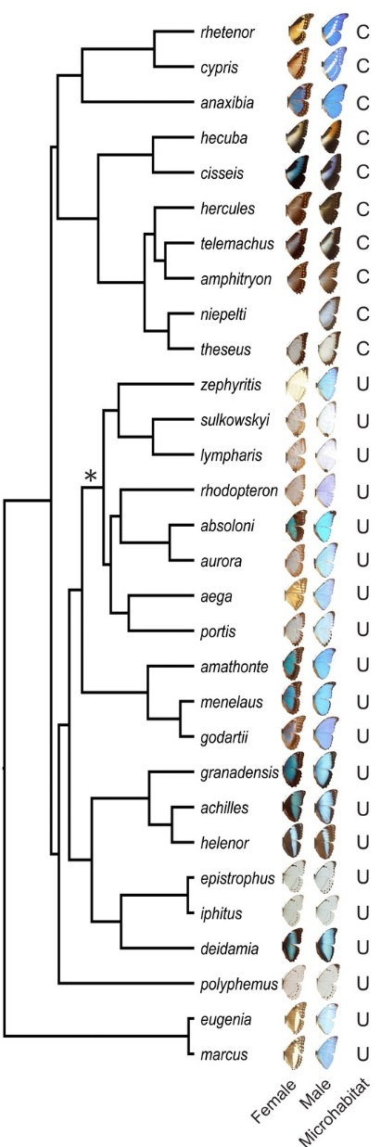
Figure 3 - Phylogeny of the genus Morpho, showing the right wings of males and females. U = Understory and C = Canopy. Figure modified according to [CHA 16].

In the 'understory clade', color diversity is also large. A white species, M. polyphemus, forms the base of the clade, which is divided into two sub-clades. The first sub-clade itself contains two groups, one made of three relatively large blue species, M. amathonte, M. menelaus and M. godartii, all three of which are fairly dimorphic, the females showing brown-black edges with clear marks (and therefore a smaller blue area than in males). The second group contains eight small species, often very glossy, but whose hue is a pale blue, and even slips into white in certain species, such as M. sulkowskyi. Two species in this group show particularly remarkable sexual dimorphism: M. aega, the females of which are polymorphic, one form an ocre-orange color with brown-black patterning, another with a large covering of iridescent blue, and a third intermediary form, and M. zephyritis the females of which are ivory with a very weak iridescence, while the males are a particularly glossy blue. Morpho absoloni, the males of which are also a rather intense glossy blue, are unique, differing from other species of the clade as the females have large brown-black edges, and blue proximal wing parts. The second understory sub-clade contains the type species of the genus, Morpho achilles, and is divided into two groups, one comprising M. achilles, M. helenor and M. granadensis, three species characterized by two black parts, proximal and distal, which width shows geographical variations. Hence, the blue patch between the black parts can be reduced to a very narrow band (see figure 1EI), or it can almost completely cover the wings. The second group contains three species, of which two are white (M. iphitus and M. epistrophus), and resemble the basal species M. polyphemus very closely. The third species of this group is M. deidamia, which dorsal side looks quite similar to that of M. helenor, M. achilles and M. granadensis, with geographical variations, while the ventral side shows a more complex pattern. This second understory sub-clade is characterized by a very limited color dimorphism, and a fairly consistent, yet definitively less glossy and less iridescent blue than in more striking species such as M. rhetenor [BER 10]. This description of color variation on the scale of the genus is inevitably schematic, and does not take into account the numerous variations, notably on an intra-specific scale (i.e. the existence of various sub-species and geographical variants). It underlines the inter- and intra-specific diversity (sexual dimorphism) of coloration in Morpho, in the clades that live in the understory as well as in the canopy, suggesting a complex evolutionary history of coloration in this genus.
What we can take, however, from this brief description, as well as from looking at the phylogeny (Figure 3), is an idea of the importance of phylogeny in determining coloration. In other words, phylogenetically close species seem, in general, to be more similar in terms of coloration (this is called phylogenetic signal). This amounts to the null hypothesis of neutral morphological divergence along the branches of the phylogeny (the brownian model; e.g. [GAR 94]). In answer to the initial question, 'why are Morpho blue?', this model would answer 'because they inherit their blue color, or the absence of it, from their ancestors', without suggesting any particular adaptive mechanism. But does phylogenetic history suffice to explain the precise distribution of color in this genus? In particular, the evolution toward a very clear, even white, color, is intriguing. This has occurred several times, likely independently: other than the white species, species belonging to different clades (M. theseus, M. godartii, M. aurora, M. helenor) contain very pale or white sub-species. These colorations may have been favored by ecological factors. Likewise, some species show a marked blue coloration, in contrast to their closest relatives (e.g. M. absoloni vs. M. aurora or M. zephyritis vs. M. sulkowskyi), which suggests natural selection may play a role in the evolution of this color. These hypotheses must be explicitly tested, either experimentally, or in a comparative framework. Finally, the evolutionary origin of iridescence itself is yet to be explored. The study of wing structures responsible for iridescence and the study of their diversity among Morpho species wouldallow us to identify phenomena of convergence. This could also shed light on the ecological implications of this trait and on selective pressures affecting its evolution (see [BER 10] and [GIR 16] for comparative analysis of some of the species of the genus).
1.4. Functional response: The role of selection in the evolution of Morpho color

The above analysis demonstrates that answering the question ‘why are Morpho blue?’ also implicates the identification of the selective processes involved in the evolution of this color and its diversification.
Color diversity in animals is often discussed in terms of signals received by predators and/or sexual partners or competitors (e.g. [GOM 07]). Butterfly coloration is therefore generally considered first and foremost as a visual signal, both on an inter- and intra-specific level (see for example [END 78; SIL 84; NIJ 91], for general reference). Other selective pressures may act on coloration: butterfly wing scales are also involved in thermoregulation and hydrophobia.
Thermoregulation
In butterflies, muscles involved in flight must reach a fairly high temperature to work properly, making flight possible (e..g. [KIN 85]). Thermoregulation is therefore particularly important for these insects. Coloration, because of its light-absorbing qualities, plays an important role in thermoregulation (e.g. [WAS 75; KIN 85]). But this role is generally limited to the base of the wings, suggesting that apical patterns have little to do with thermoregulation ([WAS 75]; see [KIN 85, 87, 95] for a discussion on Pieridae). All variations in color patterning can therefore probably not be explained by their effects on body temperature. The possibility that iridescence may have a particular effect on thermoregulation is quite controversial [DOU 09], certain authors suggesting that high reflectivity tends to reduce the capacity for thermic absorption (e.g. [KOO 00]), others claiming on the other hand that scale structure and organization allow heat to be more effectively directed toward the veins and the hemolymph (e.g., [TAD 98]; see [WAS 75] for further discussion on hemolymph role in thermoregulation). Data gathered about Morpho wings suggest that their high reflectivity has little effect on their absorption capacity [BER 10]. If it seems unlikely that blue iridescence in Morpho has evolved primarily in response to selective pressures linked to thermoregulation, it is nonetheless within the realms of possibility that the thermic effects of iridescence have played a role in its evolution. This hypothesis should be tested with greater accuracy by comparing the distribution of thermic absorption throughout the phylogeny in tandem with coloration distribution (see [BER 10]). Moreover, literature on thermoregulation is for the most part focused on species in temperate climates [KIN 85], and tropical butterflies are therefore not at all understood in the context of thermoregulation.
Hydrophobia
When it rains, butterflies hide under cover, generally on a tree-trunk or under a leaf. In humid tropical climates, it is definitively more difficult to avoid getting wet than in temperate climates. The scales covering butterfly wings in much the same way as roof tiles generally create a very hydrophobic surface (e.g. [WAG 96]). Zheng et al. have shown that in Morpho the existence of raised, overlapping chitin lamellae (figure 3) increases hydrophobia to an extreme degree (see also [BER 10]). In addition, this super-hydrophobia is combined with directional adhesion, whereby water droplets are prevented from rolling toward the body and instead easily roll off wing outer edges [ZHE 07]. It is thus conceivable that the evolution of Morpho scale nanostructure has been influenced not only by their photonic properties, but also by natural selection favoring more hydrophobic morphologies. Nonetheless, we must bear in mind that Morpho do not usually fly in wet weather. Conversely, they stay under vegetation with their wings closed, where only the non-iridescent ventral side of their wings may be exposed to the rain.
Signalling to predators: a confusing effect?
When it comes to coloration as a visual signal, it is difficult to identify the relative importance of the various visual parameters such as hue, iridescence, brightness, glossiness and saturation, all of which are in reality combined. Analysis of their covariation— or, on the other hand, their potential independence— would be very informative. Unless otherwise mentioned, we will consider these parameters in synthesis in the following discussion.
Morpho are relatively fast-flying butterflies often considered difficult to capture— at least by human predators ([YOU 71; PIN 96, 16]; personal observation). Their coloration may play a role in making their capture even more difficult, as a result of the marked but intermittent signalling emitted by their wings, irregular and ever-changing in nature as they beat rapidly in flight, hiding and exposing successively the glossy dorsal side and the darker ventral side. The irregular flashes of changing colors (i.e. a dark-light contrast, as well as variation in glossiness and iridescence), combined with a complex flight pattern and escape manoeuvres, make it difficult to locate the butterfly and to predict its flight trajectory. The intense, iridescent and glossy blue may therefore produce sensorial confusion in the predator (see [STE 07] for a general discussion on the sensorial effects of coloration on predators). The hypothesis that iridescence may have an anti-predator role ([ROB 96, HIN 73]; see for review [MEA 09]; see [CLE 66] for particular mention of butterflies) has seen little to no experimental testing (see, however, [HIK 15]), and remains completely unexplored in Morpho (see [NEI 08] for discussion). Color evolution in Morpho would therefore seem to hinge both on light environment and on predator cognitive capacities. In addition, gliding, which seems favored in canopy [DEV 10; CHA 16], would limit the frequency of 'anti-predator flashes', which could explain why iridescent blue is less important in certain canopy species. In any case, these considerations highlight the strong link between flight evolution and evolution of color patterning.
Box 3 - Aposematism
Besides camouflage, which is a form of signalling limiting detection by predators, the often striking colors of butterflies may indicate potential predators that attack would be costly, for example in the case of toxic butterflies (e.g. [END 88; SHE 08]). This is called an aposematic signal, which confers to those individuals carrying it protection against predators which learn, at their own expense, to avoid them. Avoidance by predators favors aposematism, and can lead to convergence on the same aposematic signalling in different toxic species that are exposed to the same predators (Müllerian mimicry). Indeed, toxic species mimicking a signal already known by predators benefit from the protection associated with this signal and reduce even further the individual risk of predation which is spread over a larger number of individuals. Furthermore, non-toxic species can also evolve such aposematic signals, thus benefiting from the aposematic protection associated without entailing the metabolic costs associated with the production of chemical defences (Batesian mimicry: see for example [MAL 99] for review).
The toxicity of butterflies is not the only factor incurring a potential cost for predators. The attack in itself is obviously costly in terms of energy, especially when the butterfly is difficult to capture— for instance if it flies fast or erratically. The energetic cost will be relatively higher for prey with lower calory content. From the butterfly’s point of view, toxicity and difficulty of capture are two traits that limit the risk of being caught by predators.

Signalling to predators: an aposematic blue?
The blue seen in Morpho could equally, beyond its direct contribution to making them difficult to locate, act as a signal to predators, in particular birds, of fast and/or erratic flight.
In much the same way as the bright colors of toxic butterflies (see Box 3), this color may inform predators about the cost of an attack, but this time in relation to the difficulty of capture rather than to the toxicity [YOU 71; PIN 96; SRY 99; PIN 16]. This hypothesis has been supported by experimental data: Pinheiro (1996) exposed butterflies to a predator —a Jacamar, an insectivorous bird specialized in catching butterflies— and showed that Morpho are very rarely attacked, and in the event of an attack, are very rarely caught. This conclusion is nonetheless contradicted by field observations concerning M. rhetenor ([NEI 08] pp.218) and M. menelaus ([GAY 16], pp.16-17). Data in this area are generally quite rare and the correlation between the blue signal intensity and protection from attack has never been formally tested.
It has also been suggested that this escape aposematism could, like toxicity aposematism, be behind mimetic evolution (‘evasive mimicry’; [VAN 59]). In other words, if the visual signal associated with difficulty of capture provides a selective advantage by discouraging attack, convergence toward the same signal could take place among fast species (Müllerian escape mimicry). On the other hand, species less difficult to capture could benefit from being similar in appearance to faster species (Batesian escape mimicry). Mallet and Singer [MAL 87] discuss this hypothesis and suggest it could be valid, particularly when the energy benefits of capture are low, such as with big butterflies with a ‘thick, indigestible cuticle and solid wings’, as well as with very small butterflies (low in nutrition), in particular Lycaenidae. This hypothesis has been criticized, mainly because of the lack of robust empirical data, but also on theoretical grounds: Brower [BRO 95] suggests that, unlike toxicity (unpleasant signal), the stimulus that would associate color with failure to catch the prey (frustration signal) would not be strong enough to warrant longterm memorizing by the predator, making the evolution of escape mimicry, Batesian or Müllerian, unlikely. Ruxton et al. [RUX 05] have modelled the evolution of Batesian and Müllerian escape mimicry. Their findings suggest such an evolution is possible in both cases, as long as an attack is costly for the predator, there is abundant alternative prey, and escape is costly for the butterfly.
However, these hypotheses of Morpho color as signalling difficulty of capture, and the subsequent hypotheses of the possible evolution of escape mimicry, have never been empirically tested. It is nonetheless interesting to note that in Morpho, even in the largest species, the body is relatively small and likely poorly profitable as a prey.

Sexual selection
The coloration of Morpho is widely considered to be a form of signalling in intra-specific communication (e.g. [VUK 99]), either toward individuals of the opposite sex in the context of mate choice, or toward individuals of the same sex in the context of intra-sexual competition (e.g. [SIL 84]). This hypothesis is not specific to Morpho: the coloration of butterflies has generally been interpreted in this context (e.g. [END 78; KEM 11]), and notably by Darwin and Wallace ([KOT 80]); see [SIL 84] for further discussion. This is the case above all in species where there is a strong sexual dimorphism in color, males being generally more colored, which suggests either sexual selection, or ecological differences between sexes associated with different natural selective pressures [ALL 11]. Iridescence in particular has been the subject of much attention, because it allows for directional signalling. The polarization of reflected light has also been suggested as a way of producing easily detectable signals in situations where there is little light, for example in the understory (e.g. [DOU 07]). It has been shown in the neo-tropical butterfly Heliconius cydno (Nymphalidae), that the polarized iridescent blue of the wings is involved in signalling in sexual encounters [SWE 03]. What about Morpho?
Gomez and Théry [GOM 07] have shown that light, yellow, white or blue signals create a strong visual contrast (for birds but also more generally for any tetrachromatic system), making it easier to communicate in the understory. They also suggest that a dark saturated blue is more visible in the canopy. These results are in accordance with the distribution of brightness of blue between canopy and understory species: indeed, the three blue canopy species (M. anaxibia, M. rhetenor and M. cypris) show an intense blue that is generally darker than that of understory species (see figure 2), reinforcing the idea of coloration as a visual signal. In blue species, there is also a more or less marked sexual dimorphism in color, where the males always have a more intense blue that covers more of the wing relative to females ([CHA 16]; see figure 2; NB: these differences are not quantified, and there is no quantitative data allowing us to compare iridescence and glossiness between sexes). This dimorphism is at a peak in M. rhetenor, M. cypris and M. aega. In the latter two, females are polymorphic, the predominant morph being an ocre-orange color. It is of interest that color dimorphism is particularly low in non-blue species, which suggests sexual selection plays a role in the evolution of this blue. Certain species of Morpho are often said to be territorial, patrolling in regular fashion a specific area from which they ‘chase’ other males fairly aggressively (e.g. M. amathonte [YOU 73]). This territoriality should however be considered with care, as it is generally impossible to follow butterflies in the forest, which limits our understanding of their actual movements and forays into open areas (rivers, paths and forest borders). In some species (e.g. M. helenor) on the other hand, it is not uncommon to observe several males feeding on the same fruit. Nonetheless, in all blue species males are attracted by the lure of metallic blue, which suggests either a territorial behaviour, or more simply, an inability to discriminate from a distance the lure from a female (in species showing little dimorphism) or from a potential competitor. Sex-ratio is unknown for most species, but females are much more rarely observed than males, which may indicate a sex-ratio biased in favor of males (difficult to explain from an evolutionary standpoint) or simply a behavioural difference, males being more visible due to their patrols in open parts of the forest, while females remain in the close vicinity of host plants to lay (but again, our understanding of behaviour is very limited).
The hypothesis of sexual selection by females to explain the evolution of iridescence and sexual dimorphism of coloration has been put forward for some species with iridescent males (e.g. [CON 07]), and validated in experiments (notably for Hypolimnas bolina (Nymphalidae), Eurema hecabe (Pieridae) [KEM 07a,b; KEM14], and Bicyclus anynana (Nymphalidae) [ROB 05]). To be demonstrated in Morpho, this hypothesis must establish that females choose males differently according to their color, which must therefore be more than a mere signal of species or sex recognition [KEM 11]. Sexually selected traits are generally costly and condition-dependent (that is to say dependent on individual health condition, which is in turn linked with genetic quality (see [HIL 11] for discussion); e.g. [ALL 11]). We currently have no data on the condition-dependence of coloration in Morpho. Kinoshita et al. [KIN 02] have shown that the irregularity of lamella corrugation formations comprising the striations limits iridescence. High regularity in this area could therefore be important for generating highly iridescent coloration patterns. Indeed, it is imaginable that maintaining such a high regularity is energetically costly during the course of development (see [DOU 09] for review). Variations in the quality of iridescence between males of the same species could thus be linked to variations in their general health (their condition). In turn, iridescence could then be used by females as a mate choice criterion, and their preference could hence evolve through the selective advantage associated with paternal genetic quality transmitted to their offspring.

Different natural selection between sexes?
It is also possible that color dimorphism between sexes is linked to different natural selective pressures. This hypothesis is fairly consistent with Wallace’s views on sexual dimorphism [KOT 80], which he thought resulted from the appearance of a trait in both sexes followed by its elimination by selection in the most cryptic sex (here, females). We have recently shown [CHA 16] in Morpho that sexual dimorphism of wing shape was associated with color dimorphism. This association could come from different selective pressures between sexes, females, due to being more cryptic and generally heavier, adopting a different flight pattern from males. In particular, females could fly less than males, thereby being less subject to predation pressure from birds. Conversely, flight performance could be more intensely selected for in males, likely depending on their visual detectability. This hypothesis goes against Darwin’s, focused on sexual selection [KOT 80], here blue being sexually selected by females as an honestsignal (i.e. character costly to maintain and signalling the good genetic quality of its carrier). But these two points of view are not exclusive (see [ALL 11] for detailed discussion). In Morpho, coloration, if indicative of flight performance and capacity to escape predators, could be directly used as a mate choice criterion by females. On the other hand, coloration could offer no advantage against predators, but on the contrary a handicap, providing females with an indirect criterion of quality.
And the lack of blue?
Understanding the evolution of glossy iridescent blue can also be improved by identifying selective pressures that allow for the maintenance of different colorations. Firstly, the ventral face of Morpho is not blue but brown-beige and has eyespots, the number and size of which vary between species (figure 1). This dorso-ventral contrast strongly suggests that the two faces are subject to different selective pressures —indeed, opposite pressures. If the evolution of high conspicuousness may be favored on the dorsal face by predator behaviour, selective pressures on the ventral face seem to promote camouflage. When butterflies are at rest, shaded by foliage with folded wings, the coloration of their ventral side makes them very difficult to spot. Eyespots, more or less visible and marked depending on the species, could divert predator attacks away from most vital parts (see [STE 05] and [MON 15] on the role of eyespots in other species). It has also been suggested that eyespots may play a role in mate choice (e.g. [STE 05]). These hypotheses have never been tested in Morpho.
So what about non-blue species? In the case of the ‘telemachus’ group, one should notice that males in these species fly at great heights, at the very top of the trees, and descend very rarely to the ground [MIC 11; DEV 10; PEN 12; CHA 16]. It is therefore tempting to suppose that selective pressures that would favor iridescent blue individuals would no longer be relevant above the canopy, or would be counterbalanced by deleterious effects (see above for discussion on luminous flashes emitted by escape flight, probably less effective in gliding scenarios). Moreover, a number of ecological parameters change with height —such as habitat openness, increased sunlight, or the nature and number of predators— which can influence the selective value of a phenotype. Three species said to be ‘canopy butterflies’ have however intense and iridescent blue color (M. cypris, M. rhetenor and M. anaxibia), which shows that the canopy/understory dichotomy cannot exclusively explain the presence or absence of blue.
In the case of the three white Morpho species, which do not belong to one sole clade, their close resemblance suggests some sort of convergence, but the ecological factors involved are unknown; they are unlikely linked to flight height since M. polyphemus flies high, even at canopy level [YOU 72]. As regards the two palest species of the ‘sulkowskyi’ group, M. sulkowskyi and M. lympharis, males have wings with virtually no melanin. They fly in fairly open environments and often above the vegetation; highly conspicuous, they appear a pale yellow color. These two species are found at high altitudes, most often around 2000-2500m. This association between loss of melanin and high altitude is quite surprising, given the importance of melanin in thermoregulation, at least in species living in temperate climates, and given that species generally have more melanin when they live at higher altitudes (e.g. [KIN 85]).
Finally, in some species, females show no blue coloration: as previously discussed, this situation could result from a difference of ecological context between sexes, females being selected for their cryptic colors (Wallace’s hypothesis). It has been suggested that the ocre-orange colors associated with the brown-black patterning in the females of certain species (M. rhetenor, M. cypris and M. aega) could indicate cases of Batesian mimicry, where the models to be imitated may be toxic species from the Danainae family [GAY 16]. However, the mimicry is not very accurate, and female M. rhetenor and M. cypris are much larger than their supposed models, which would contradict this hypothesis.

1.5. Conclusions and open questions

The resounding message of this review is that despite their iconic status, Morpho remain relatively unknown, especially for the evolution of their coloration. While their phylogeny is well established, and the nano-structural basis of their color fully identified, the ecological and genetic factors of these traits are almost entirely unexplored. The hypotheses commonly called upon to explain the evolution of the iridescent blue color, whether in terms of sexual selection or escape from predators, have never been explicitly tested. These gaps leave us with a number of open questions: are non-blue species subject to different selective pressures (thermoregulation, hydrophobia, predation, communication)? Do they fly more slowly or simply in a different way than their blue relatives? Are there, within each species, differences in flight behaviour between sexes? In the hypothesis regarding the importance of blue as a sexual signal, do Morpho show evidence of particular visual receptors? Are they sensitive to polarized light? All these questions require experiments to be carried out that would allow us to study flight modalities and numerous behavioural traits. But they point above all, despite more than a century of collecting, toward the lack of understanding of the ecology of Morpho.

Acknowledgements
We thank Jim Mallet for his advices on references and Peter Vukusik for the copy of one of his articles.

Bibliography
[ALL 08 ] Allen, C.E., Beldade, P., Zwaan, B.J. and Brakefield, P.M.Differences in the selection response of serially repeated color pattern characters: standing variation, development, and evolution. BMC Evolutionary Biology, 8(1), 2008, p.94.
Allen, C.E., Zwaan, B.J. and Brakefield, P.M., 2011. Evolution of sexual dimorphism in the Lepidoptera. Annual review of entomology, 56, pp.445-464.
Bagnara, J. T., Fernandez, P. J., & Fujii, R. 2007. On the blue coloration of vertebrates. Pigment Cell Research, 20(1), 14-26.
Beldade, P., Koops, K. and Brakefield, P.M., 2002. Developmental constraints versus flexibility in morphological evolution. Nature, 416(6883), pp.844-847.
Bénéluz, F., 2016. Stades premiers. In : Gayman, J.M. (coord.), Les Morpho. Distribution, diversification, comportement. Lépidoptéristes de France, Paris : 177-203.
Berthier, S., 2007. Iridescences: the physical colors of insects. Springer Science & Business Media.
Berthier, S., 2010. Photonique des Morphos. Springer Science & Business Media.
Berthier, S., Charron, E. and Boulenguez, J., 2006. Morphological structure and optical properties of the wings of Morphidae. Insect Science, 13(2), pp.145-158.
Berthier, S., Charron, E. and Da Silva, A., 2003. Determination of the cuticle index of the scales of the iridescent butterfly Morpho menelaus. Optics communications, 228(4), pp.349-356.
Blandin, P. and Purser, B., 2013. Evolution and diversification of Neotropical butterflies: insights from the biogeography and phylogeny of the genus Morpho Fabricius, 1807 (Nymphalidae: Morphinae), with a review of the geodynamics of South America. Tropical Lepidoptera Research, 23(2), pp.62-85.
Blandin, P., 2007. The Systematics of the Genus Morpho Fabricius, 1807. Hillside Books, Canterbury: 277 p.
Breuker, C.J., Debat, V. and Klingenberg, C.P., 2006. Functional evo-devo. Trends in Ecology & Evolution, 21(9), pp.488-492.
Brower, A.V., 1995. Locomotor mimicry in butterflies? A critical review of the evidence. Philosophical Transactions of the Royal Society of London B: Biological Sciences, 347(1322), pp.413-425.
Bulina, M.E., Lukyanov, K.A., Yampolsky, I.V., Chudakov, D.M., Staroverov, D.B., Shcheglov, A.S., Gurskaya, N.G. and Lukyanov, S., 2004. New class of blue animal pigments based on Frizzled and Kringle protein domains. Journal of Biological Chemistry, 279(42), pp.43367-43370.
Cassildé, C., Blandin, P. and Silvain, J.F., 2012, January. Phylogeny of the genus Morpho Fabricius 1807: insights from two mitochondrial genes (Lepidoptera: Nymphalidae). In Annales de la Société entomologique de France (Vol. 48, No. 1-2, pp. 173-188). Taylor & Francis Group.
Chai, P. 1988. Wing coloration of free-flying Neotropical butterflies as a signal learned by a specialized avian predator. Biotropica: 20-30.
Chazot, N., Panara, S., Zilbermann, N., Blandin, P., Le Poul, Y., Cornette, R., Elias, M. and Debat, V., 2016. Morpho morphometrics: Shared ancestry and selection drive the evolution of wing size and shape in Morpho butterflies. Evolution, 70(1), pp.181-194.
Cho, E.H. and Nijhout, H.F., 2013. Development of polyploidy of scale-building cells in the wings of Manduca sexta. Arthropod structure & development, 42(1), pp.37-46.
Clench, H.K., 1966. Behavioral thermoregulation in butterflies. Ecology, 47(6), pp.1021-1034.
Costanzo K and Monteiro A. 2007. The use of chemical and visual cues in female choice in the butterfly Bicyclus anynana. Proc. R. Soc. Lond. B 274:845–51
D’Abrera, B., 1984. Butterflies of the Neotropical Region. Part II. Danaidae, Ithomiidae, Heliconidae & Morphidae. Ferny Creek, Victoria, Hill House : xii + 173-384.
DeVries, P.J., Kitching, I.J. and Vane-Wright, R.I., 1985. The systematic position of Antirrhea and Caerois, with comments on the classification of the Nymphalidae (Lepidoptera). Systematic Entomology, 10(1), pp.11-32.
DeVries, P.J., Penz, C.M. and Hill, R.I., 2010. Vertical distribution, flight behaviour and evolution of wing morphology in Morpho butterflies. Journal of Animal Ecology, 79(5), pp.1077-1085.
Dinwiddie, A., Null, R., Pizzano, M., Chuong, L., Krup, A. L., Tan, H. E., & Patel, N. H. 2014. Dynamics of F-actin prefigure the structure of butterfly wing scales. Developmental biology, 392(2), 404-418.
Doucet, S.M. and Meadows, M.G., 2009. Iridescence: a functional perspective. Journal of The Royal Society Interface, 6(Suppl 2), pp.S115-S132.
Douglas, J.M., Cronin, T.W., Chiou, T.H. and Dominy, N.J., 2007. Light habitats and the role of polarized iridescence in the sensory ecology of neotropical nymphalid butterflies (Lepidoptera: Nymphalidae). Journal of Experimental Biology, 210(5), pp.788-799.
Endler, J.A. and Greenwood, J.J.D., 1988. Frequency-dependent predation, crypsis and aposematic coloration. Philosophical Transactions of the Royal Society of London B: Biological Sciences, 319(1196), pp.505-523.
Endler, J.A., 1978. A predator’s view of animal color patterns. In Evolutionary biology (pp. 319-364). Springer US.
Freitas, A. V. L., & Brown, K. S., 2004. Phylogeny of the Nymphalidae (Lepidoptera). Systematic biology, 53(3), 363-383.
Fruhstorfer, H.,1912. 6. Familie: Morphidae West. In: Seitz, A. (Ed.), Die Gross- Schmetterlinge der Erde. Stuttgart, Alfred Kernen. 5: 333-344.
García-Bellido, A., & de Celis, J. F. 2009. The complex tale of the achaete–scute complex: a paradigmatic case in the analysis of gene organization and function during development. Genetics, 182(3), 631-639.
Galant, R., Skeath, J.B., Paddock, S., Lewis, D.L. and Carroll, S.B., 1998. Expression pattern of a butterfly achaete-scute homolog reveals the homology of butterfly wing scales and insect sensory bristles. Current Biology, 8(14), pp.807-813.
Garland Jr, T. and Losos, J.B., 1994. Ecological morphology of locomotor performance in squamate reptiles. Ecological morphology: integrative organismal biology, pp.240-302.
Gayman J.-M., Merlier F., Ouvaroff J., Bénéluz, F., Lacomme, D. and B. Purser. 2016. Les Morpho. Distribution, diversification, comportement. Association des Lépidoptéristes de France.
Ghiradella, H., Aneshansley, D., Eisner, T., Silberglied, R. E., & Hinton, H. E. 1972. Ultraviolet reflection of a male butterfly: interference color caused by thin-layer elaboration of wing scales. Science, 178(4066), 1214-1217.
Ghiradella, H. and Radigan, W., 1976. Development of butterfly scales. II. Struts, lattices and surface tension. Journal of morphology, 150(2), pp.279-297.
Ghiradella, H., 1989. Structure and development of iridescent butterfly scales: lattices and laminae. Journal of Morphology, 202(1), pp.69-88.
Gilbert, L.E., Forrest, H.S., Schultz, T.D. and Harvey, D.J., 1988. Correlations of ultrastructure and pigmentation suggest how genes control development of wing scales of Heliconius butterflies. J. Res. Lepid, 26, pp.141-160.
Giraldo, M.A., Yoshioka, S., Liu, C. and Stavenga, D.G., 2016. Coloration mechanisms and phylogeny of Morpho butterflies. Journal of Experimental Biology, 219(24), pp.3936-3944.
Gomez, D., & Théry, M., 2007. Simultaneous crypsis and conspicuousness in color patterns: comparative analysis of a neotropical rainforest bird community. The american naturalist, 169(S1), S42-S61.
Gould, S.J., 2002. The structure of evolutionary theory. Harvard University Press.
Heliconius Genome Consortium. 2012. Butterfly genome reveals promiscuous exchange of mimicry adaptations among species. Nature 487:94-98. doi: 10.1038/nature11041
Hill, G. E. 2011. Condition‐dependent traits as signals of the functionality of vital cellular processes. Ecology Letters, 14(7), 625-634.
Hinton, H.E., 1973. Natural deception. Illusion in nature and art. Duckworth, London, pp.97-159.
Ingram, A.L. and Parker, A.R., 2008. A review of the diversity and evolution of photonic structures in butterflies, incorporating the work of John Huxley (The Natural History Museum, London from 1961 to 1990). Philosophical Transactions of the Royal Society of London B: Biological Sciences, 363(1502), pp.2465-2480.
Joron M, L Frezal, RT Jones, N Chamberlain, SF Lee, CR Haag, A Whibley, M Becuwe, SW Baxter, L Ferguson, PA Wilkinson, C Salazar, C Davidson, R Clark, MA Quail, H Beasley, R Glithero, C Lloyd, S Sims, M Jones, J Rogers, C Jiggins, and RH ffrench-Constant. 2011. Chromosomal rearrangements maintain a polymorphic supergene controlling butterfly mimicry. Nature 477:203-206. doi: 10.1038/nature10341
Kemp DJ. 2007. Female butterflies prefer males bearing bright iridescent ornamentation. Proc. R. Soc. Lond. B 274:1043–47
Kemp DJ. 2007. Female mating biases for bright UV iridescence in a butterfly Eurema hecabe (Pieridae). Behav. Ecol. 19:1–8
Kemp, D.J. and Rutowski, R.L., 2011. The role of coloration in mate choice and sexual interactions in butterflies. Advances in the Study of Behavior, 43(5).
Kemp, D.J., Jones, D., Macedonia, J.M. and Krockenberger, A.K., 2014. Female mating preferences and male signal variation in iridescent Hypolimnas butterflies. Animal Behaviour, 87, pp.221-229.
Kingsolver, J.G., 1985. Thermoregulatory significance of wing melanization in Pieris butterflies (Lepidoptera: Pieridae): physics, posture, and pattern. Oecologia, 66(4), pp.546-553.
Kinoshita, S., Yoshioka, S. and Kawagoe, K., 2002. Mechanisms of structural colour in the Morpho butterfly: cooperation of regularity and irregularity in an iridescent scale. Proceedings of the Royal Society of London B: Biological Sciences, 269(1499), pp.1417-1421.
Koon, D.W. and Crawford, A.B., 2000. Insect thin films as sun blocks, not solar collectors. Applied optics, 39(15), pp.2496-2498.
Kottler, M.J., 1980. Darwin, Wallace, and the origin of sexual dimorphism. Proceedings of the American Philosophical Society, 124(3), pp.203-226.
Kumazawa, K., Tanaka, S., Negita, K., & Tabata, H. 1994. Fluorescence from wing of Morpho sulkowskyi butterfly. Japanese journal of applied physics, 33(4R), 2119.
Lagorio, M. G., Cordon, G. B., & Iriel, A. 2015. Reviewing the relevance of fluorescence in biological systems. Photochemical & Photobiological Sciences, 14(9), 1538-1559.
Lamas G. 2004. Tribe Morphini, pp. 12-201. in: Lamas G. (ed.), Checklist: part 4a, Hesperioidea - Papilonoidea. in: Heppner JB (ed.), Atlas of neotropical lepidoptera, gainesville, Association for Tropical lepidoptera/Scientific publishers. vol. 5a.
Le Poul Y, Whibley A, Chouteau M, Prunier F, Llaurens V, & Joron M. 2014. Evolution of dominance mechanisms at a butterfly mimicry supergene. Nature Communications 5:5644. doi:10.1038/ncomms6644
Mallet, J. and Joron, M., 1999. Evolution of diversity in warning color and mimicry: polymorphisms, shifting balance, and speciation. Annual Review of Ecology and Systematics, 30(1), pp.201-233.
Mallet, J. and Singer, M.C., 1987. Individual selection, kin selection, and the shifting balance in the evolution of warning colours: the evidence from butterflies. Biological Journal of the Linnean Society, 32(4), pp.337-350.
Mejdoubi, A., Andraud, C., Berthier, S., Lafait, J., Boulenguez, J. and Richalot, E., 2013. Finite element modeling of the radiative properties of Morpho butterfly wing scales. Physical Review E, 87(2), p.022705.
Michael, O. 1911. Lebensweise und Gewohnheiten der Morpho des Amazonasgebietes. Fauna Exotica 1:10–17.
Nadeau NJ, Pardo-Diaz C, Whibley A, Supple MA, Saenko SV, Wallbank RWR, Wu GC, Maroja L, Ferguson L, Hanly JJ, Hines H, Salazar C, Merrill RM, Dowling AJ, ffrench-Constant RH, Llaurens V, Joron M, McMillan OW, and Jiggins C (2016). The gene cortex controls mimicry and crypsis in butterflies and moths. Nature 534:106–110. doi:10.1038/nature17961
Nattier, R., Capdevielle‐Dulac, C., Cassildé, C., Couloux, A., Cruaud, C., Lachaume, G., Lamas, G., Silvain, J.F. and Blandin, P., 2016. Phylogeny and diversification of the cloud forest Morpho sulkowskyi group (Lepidoptera, Nymphalidae) in the evolving Andes. Zoologica Scripta.
Neild, A.F.E., 2008. The Butterflies of Venezuela. Part 2 : Nymphalidae II (Acraeinae, Libytheinae, Nymphalinae, Ithomiinae, Morphinae). Meridian Publications, London : 275 pp.
Nijhout, H. F., 1991. The development and evolution of butterfly wing patterns. Smithsonian series in comparative evolutionary biology (USA).
Olson, V.A. and Owens, I.P., 1998. Costly sexual signals: are carotenoids rare, risky or required?. Trends in Ecology & Evolution, 13(12), pp.510-514.
Overton, J., 1966. Microtubules and microfibrils in morphogenesis of the scale cells of Ephestia kühniella. The Journal of cell biology, 29(2), pp.293-305.
Peña, C., Wahlberg, N., Weingartner, E., Kodandaramaiah, U., Nylin, S., Freitas, A.V. and Brower, A.V., 2006. Higher level phylogeny of Satyrinae butterflies (Lepidoptera: Nymphalidae) based on DNA sequence data. Molecular phylogenetics and evolution, 40(1), pp.29-49.
Penz, C.M. and DeVries, P.J., 2002. Phylogenetic analysis of Morpho butterflies (Nymphalidae, Morphinae): implications for classification and natural history. American Museum Novitates, pp.1-33.
Penz, C.M., DeVries, P.J. and Wahlberg, N., 2012. Diversification of Morpho butterflies (Lepidoptera, Nymphalidae): a re‐evaluation of morphological characters and new insight from DNA sequence data. Systematic Entomology, 37(4), pp.670-685.
Pike, T.W., 2015. Interference coloration as an anti-predator defence. Biology letters, 11(4), p. 20150159.
Pinheiro, C.E., 1996. Palatablility and escaping ability in Neotropical butterflies: tests with wild kingbirds (Tyrannus melancholicus, Tyrannidae). Biological Journal of the Linnean Society, 59(4), pp.351-365.
Pinheiro, C.E.G., Freitas, A.V.L., Campos, V.C., DeVries, P.J. and Penz, C.M., 2016. Both Palatable and Unpalatable Butterflies Use Bright Colors to Signal Difficulty of Capture to Predators. Neotropical entomology, 45(2), pp.107-113.
Potyrailo, R.A., Ghiradella, H., Vertiatchikh, A., Dovidenko, K., Cournoyer, J.R. and Olson, E., 2007. Morpho butterfly wing scales demonstrate highly selective vapour response. Nature Photonics, 1(2), pp.123-128.
Prudic, K.L., Stoehr, A.M., Wasik, B.R. and Monteiro, A., 2015, January. Eyespots deflect predator attack increasing fitness and promoting the evolution of phenotypic plasticity. In Proc. R. Soc. B (Vol. 282, No. 1798, p. 20141531). The Royal Society.
Ramírez Garcia, C., Gallusser, S., Lachaume, G. & Blandin, P., 2014. The ecology and life cycle of the Amazonian Morpho cisseis phanodemus Hewitson, 1869, with a comparative review of early stages in the genus Morpho (Lepidoptera : Nymphalidae : Morphinae). Tropical Lepidoptera Research, 24(2) : 67-80.
Revell, L.J., 2012. phytools: an R package for phylogenetic comparative biology (and other things). Methods in Ecology and Evolution, 3(2), pp.217-223.
Robertson, K.A. and Monteiro, A., 2005. Female Bicyclus anynana butterflies choose males on the basis of their dorsal UV-reflective eyespot pupils. Proceedings of the Royal Society of London B: Biological Sciences, 272(1572), pp.1541-1546.
Robinson, M.H., 1969. Defenses against visually hunting predators. Evol. Biol, 3(22), pp.5-59.
Ruxton, G. D., Speed, M., & Sherratt, T. N. (2004). Evasive mimicry: when (if ever) could mimicry based on difficulty of capture evolve? Proceedings of the Royal Society of London B: Biological Sciences, 271(1553), 2135-2142.
Saranathan, V., Osuji, C.O., Mochrie, S.G., Noh, H., Narayanan, S., Sandy, A., Dufresne, E.R. and Prum, R.O., 2010. Structure, function, and self-assembly of single network gyroid (I4132) photonic crystals in butterfly wing scales. Proceedings of the National Academy of Sciences, 107(26), pp.11676-11681.
Schneider, C.A., Rasband, W.S., Eliceiri, K.W., 2012. NIH Image to ImageJ: 25 years of image analysis. Nature Methods 9, 671-675
Siddique, R. H.; Diewald, S.; Leuthold, J.; Hölscher, H., 2013. Theoretical and experimental analysis of the structural pattern responsible for the iridescence of Morpho butterflies. Optics Express. 21 (12): 14351–14361.
Silberglied, R.E., 1984. Visual communication and sexual selection among butterflies. In Symposia of the Royal Entomological Society of London.
Simpson, P., 1990. Lateral inhibition and the development of the sensory bristles of the adult peripheral nervous system of Drosophila. Development, 109(3), pp.509-519.
Skeath, J.B. and Carroll, S.B., 1991. Regulation of achaete-scute gene expression and sensory organ pattern formation in the Drosophila wing. Genes & Development, 5(6), pp.984-995.
Stevens, M., 2007. Predator perception and the interrelation between different forms of protective coloration. Proceedings of the Royal Society of London B: Biological Sciences, 274(1617), pp.1457-1464.
Tada, H., Mann, S.E., Miaoulis, I.N. and Wong, P.Y., 1999. Effects of a butterfly scale microstructure on the iridescent color observed at different angles. Optics Express, 5(4), pp.87-92.
Umbers, K.D., 2013. On the perception, production and function of blue colouration in animals. Journal of Zoology, 289(4), pp.229-242.
Van Hooijdonk, E., Barthou, C., Vigneron, J.P. and Berthier, S., 2011a. Detailed experimental analysis of the structural fluorescence in the butterfly Morpho sulkowskyi (Nymphalidae). Journal of nanophotonics, 5(1), pp.053525-053525.
Van Hooijdonk E., C. Barthou, J.P. Vigneron, S. Berthier. 2011b. Structural iridescence in the butterfly Morpho sulkowskyi (Nymphalidae). Proc. of SPIE, 80940.
Van Someren, V.G.L., & Jackson, T.H.E. 1959. Some comments on protective resemblance amongst African Lepidoptera (Rhopalocera). Journal of the Lepidopterists' Society 13:121-150.
Vukusic, P. and Sambles, J.R., 2003. Photonic structures in biology. Nature, 424(6950), pp.852-855.
Vukusic, P., Sambles, J.R. and Ghiradella, H., 2000. Optical classification of microstructure in butterfly wing-scales. Photonics Sci. News, 6(1), pp.61-66.
Vukusic, P., Sambles, J.R., Lawrence, C.R. and Wootton, R.J., 1999. Quantified interference and diffraction in single Morpho butterfly scales. Proceedings of the Royal Society of London B: Biological Sciences, 266(1427), pp.1403-1411.
Wagner, T., Neinhuis, C., & Barthlott, W. (1996). Wettability and contaminability of insect wings as a function of their surface sculptures. Acta Zoologica, 77(3), 213-225.
Wasik, B.R., Liew, S.F., Lilien, D.A., Dinwiddie, A.J., Noh, H., Cao, H. and Monteiro, A., 2014. Artificial selection for structural color on butterfly wings and comparison with natural evolution. Proceedings of the National Academy of Sciences, 111(33), pp.12109-12114.
Wasserthal, L.T., 1975. The role of butterfly wings in regulation of body temperature. Journal of Insect Physiology, 21(12), pp.1921-1930.
Wilts, B. D., Giraldo, M. A., & Stavenga, D. G. (2016). Unique wing scale photonics of male Rajah Brooke’s birdwing butterflies. Frontiers in Zoology, 13(1), 36.
Wilts, B.D., Pirih, P. and Stavenga, D.G., (2011) Spectral reflectance properties of iridescent pierid butterfly wings. Journal of Comparative Physiology A, 197(6), pp.693-702.
Yoshioka, S. and Kinoshita, S., 2004. Wavelength–selective and anisotropic light–diffusing scale on the wing of the Morpho butterfly. Proceedings of the Royal Society of London B: Biological Sciences, 271(1539), pp.581-587.
Yoshioka, S. and Kinoshita, S., 2006. Structural or pigmentary? Origin of the distinctive white stripe on the blue wing of a Morpho butterfly. Proceedings of the Royal Society of London B: Biological Sciences, 273(1583), pp.129-134.
Young, A.M. and Muyshondt, A., 1972. Biology of Morpho polyphemus (Lepidoptera: Morphidae) in El Salvador. Journal of the New York Entomological Society, pp.18-42.
Young, A.M., 1971. Wing coloration and reflectance in Morpho butterflies as related to reproductive behavior and escape from avian predators. Oecologia, 7(3), pp.209-222.
Young, A.M., 1973. Studies on comparative ecology and ethology in adult populations of several species of Morpho butterflies (Lepidoptera: Morphidae). Studies on Neotropical Fauna and Environment, 8(1), pp.17-50.
Wahlberg, N., Leneveu, J., Kodandaramaiah, U., Peña, C., Nylin, S., Freitas, A. V., & Brower, A. V. 2009. Nymphalid butterflies diversify following near demise at the Cretaceous/Tertiary boundary. Proceedings of the Royal Society of London B: Biological Sciences, 276(1677), 4295-4302.
Zheng, Y., Gao, X., & Jiang, L., 2007. Directional adhesion of superhydrophobic butterfly wings. Soft Matter, 3(2), 178-182.

Vincent Debatª, Serge Berthier^{b}, Patrick Blandinª, Nicolas Chazot^{c}, Marianne Eliasª, Doris Gomez^{d}, Violaine Llaurensª ª Institut de Systématique, Evolution, Biodiversité, ISYEB, UMR 7205 CNRS MNHN UPMC EPHE, Muséum national d'Histoire naturelle, Sorbonne Universités, CP 50, 45 rue Buffon, 75005 Paris, France, debat@mnhn.fr ^{b} Université Paris Diderot. Institut des Nanosciences de Paris (INSP - Université Pierre et Marie Curie), UNESCO-UNISA chair in Nanotechnology, Cap Town, South Africa. ^{c} Department of Biology, University of Lund, 223 62 Lund, Sweden ^{d} Centre d’Écologie Fonctionnelle et Évolutive, UMR CNRS 5175, 1919 route de Mende, 34090 Montpellier, France

