Florine Campo 1DA Droit/Groupe 2
2017-2018 | session de janvier
Portfolio

- "Couple who faked holiday sickness are jailed"
- "meet the women fighting gender bias in law"
- "I have become my daughter’s stalker"
- "Mum wasn’t treated like a prisoner, but like a human being"
- "Man loses damages claim against IVF clinic over 'forged' consent"
There are 6009 words in these articles.

Couple who faked holiday sickness are jailed
Pair claimed they fell ill twice in Mallorca but Thomas Cook took out landmark private prosecution after social media posts described happy times.
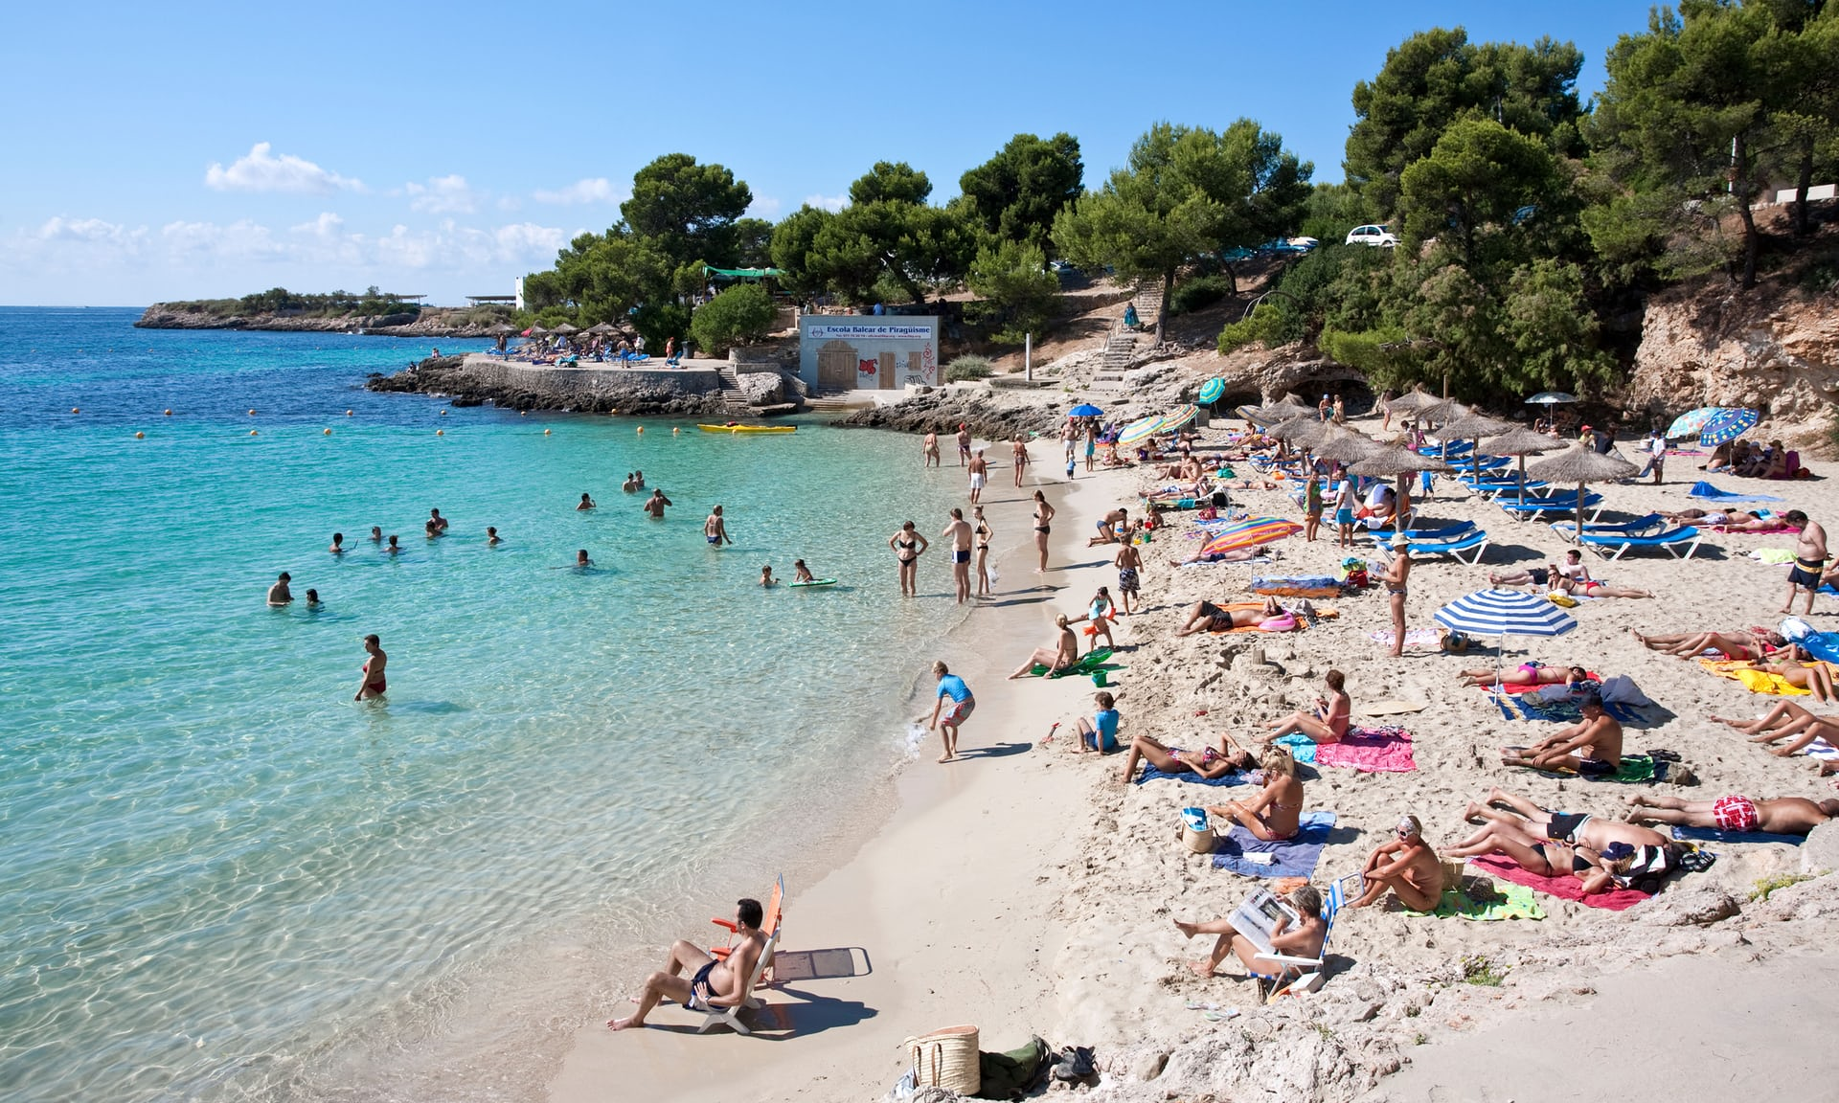
A reference picture © Alamy
The government has stepped up attempts to eliminate fake holiday sickness scams, as a middle-aged British couple who had boasted on social media about having “sun, laughter and fun” on their holidays were jailed after making false insurance claims.
Deborah Briton and her partner Paul Roberts tried to claim £20,000 compensation by stating they and their two children had fallen ill on holidays to Mallorca in 2015 and 2016, Liverpool crown court was told.
Briton, 53, sobbed as she was sentenced to nine months in prison after admitting four counts of fraud in the private prosecution, brought by the holiday company Thomas Cook. Roberts, 43, was jailed for 15 months.
The convictions came on the same day that the government announced a call for evidence from travel operators as part of a crackdown on holiday sickness frauds that have plagued holiday firms operating in Spain. The Association of British Travel Agents (Abta) said it welcomed the latest move in attempts to quash a fraud that is “tarnishing British holidaymakers’ reputation abroad” and costing Spanish hoteliers millions of pounds.
“It is crucial that the government brings in new rules that control legal costs on holiday sickness claims as soon as possible, and we welcome the chance to be able to submit further evidence from our members to help crack down on these bogus claims,” said Abta.
In June ministers pledged action to try to halt the the flood of spurious claims for food poisoning, which have risen by 500% since 2013. Partly fuelled by organised claims touts, they have sparked an angry backlash from Spanish hoteliers, and led the foreign secretary, Boris Johnson, to declare that the digestive systems of British people had “become the most delicate in the world”.
Liverpool crown court was told that the pair, from Wallasey, Wirral, tried to claim nearly £20,000 for the fake gastric illnesses and would have also cost the holiday firm a further £28,000 in legal expenses had their claims been successful.
Judge David Aubrey QC said their claims had been a “complete and utter sham”.
“They were bogus from start to finish, you were both asserting on your behalfs and on behalf of your two children that on two separate holidays you had suffered illness. They were totally and utterly fake,” said Aubrey.
He said: “Those who may be tempted in the future to make a dishonest claim in relation to fake holiday sickness, if they are investigated and brought to justice, whatever the circumstances of an individual, he or she must expect to receive an immediate custodial sentence.”
After the holiday in June 2015 Briton had written on social media: “Safely home after two weeks of sun, laughter, fun and tears. Met up with all our lovely holiday friends who made our holiday fab.”
A post after returning from the second holiday in July 2016 read: “Back home after a fantastic holiday, my favourite so far.”
But in August that year they contacted David Norman Solicitors to make the claims. An intimated letter of claim which was read to the court said: “Our client’s holiday was ruined due to their symptoms as they were ill for the entire remainder of the trip. They were unable to enjoy the holiday.”
Sam Brown, prosecuting, said: “Both defendants knew that in issuing this claim he or she would be lying in order to support it.”
Briton was later contacted by a travel rep from the hotel, who asked about the claims. In a message, the mother-of-four told her the claims were due to “Paul with his dodgy dealings”.
Charles Lander, defending Roberts, said: “It was an idea the defendant formed from speaking to others in a pub. He stupidly believed those others who told him he wouldn’t be detected. How wrong he was.”
Foreign secretary Boris Johnson said: “These claims make it more expensive for Brits to go abroad. They should not have to shoulder the inevitable rising costs of bogus accusations made by a small minority.
“The recent rise in false claims against tour operators, partly fuelled by unscrupulous touts, tarnishes the UK’s reputation overseas. It is also hugely unfair to those who genuinely do become ill, who risk becoming victims of unjustified suspicion. This is the first step in fighting the scam holiday claim epidemic.”
Following the hearing, a Thomas Cook spokesman said: “The sentences handed down today demonstrate how serious the issue of fraudulent illness claims has become. This is a particularly sobering case, but reflects what is going on across the UK travel industry, so we had to take a stand to protect our holidays and our customers from the minority who cheat the system.”

English | French
To step up | Intensifier
The attempts | Les efforts ou tentatives
The fake holiday sickness scams | Les fraudes de faux congés de maladie
False insurance claims | De fausses déclarations d'assurance
To state | Déclarer
Brought by (past participle) | Apporté par
A count | Un chef d'accusation
The convictions | Les condamnations
A call for evidence | Un appel à la preuve
The travel operators | Les voyagistes
English | French
To plague | affliger
To quash | Annuler
Bogus (adjective) | Fausses
To pledge | S'engager
To submit | Présenter
The flood of spurious claims | Le déluge de déclarations fallacieuses
The touts | Les racoleurs, voyous
To spark | Déclencher
A backlash | Un contrecoup
A utter sham | Un flagrant subterfuge
To assert | Affirmer quelque chose
On behalf of (preposition) | Au nom de
A custodial sentence | Une peine de détention
The remainder | Le reste
To issue | Émettre, formuler
The issue | La question
A travel rep | Un représentant de voyage
His dodgy dealings | Ses relations douteuses
To shoulder | Endosser, supporter quelque chose
The tour operators | Les agences de voyage
The hearing | L'audience
To hand down | Transmettre, ici prononcer
Sobering (adjective) | Préoccupant
To take a stand | Prendre position

PS: This article holds 857 words.

Meet the women fighting gender bias in law
Female lawyers are breaking the glass ceiling by setting up their own firms and making the profession fairer and more flexible.
© Funke Abimbola
When Funke Abimbola graduated 20 years ago, it took 150 phone calls to secure her first job in law. “I thought that would be it – once I was in, it would be fine,” she says. Her career progressed well to begin with, until, aged 28, she had her first child. The response when she returned from maternity leave nearly made her abandon the profession.
“It was one of the lowest periods of my life,” she says. “I was the first person in the firm’s history to ask to work flexibly and they weren’t set up for [it]. I felt helpless. I thought the moment I was more senior and able to do something about that, I was going to.”
My degree couldn't prepare me for the harsh realities of work in law
It’s a struggle many women in law face, which is reflected in the low number of female lawyers in leadership positions. Despite the fact that women account for 61% of law graduates, only 28% of private practice partners are female. The numbers are similarly troubling at judicial level. England and Wales have among the lowest proportion of female judges in Europe, and a 2010 Law Society review found that the lack of flexible work opportunities was a significant obstacle to women progressing up the career ladder. The gender pay gap in law is 30%, compared with a UK-wide average of 19%.
But there are signs of change. Magic Circle firm Linklaters recently launched a flexible working pilot scheme in Germany, and more than a third of UK legal firms and practices have signed up to the Law Society’s diversity and inclusion charter, which includes a commitment to flexible working. To improve diversity more broadly, a new Lawyer Portal aims to help students aged 14 and over find opportunities, regardless of their background.
Lady Justice Heather Hallett, the first female vice-president of the Queen’s Bench division and chair of the Judges’ Council diversity committee, says the law sector has “changed considerably for the better” for women.
“I hope there is no glass ceiling,” she adds, “but I am not sure that all those involved in selection processes appreciate the difficulties that a woman (particularly one with caring responsibilities) may face.”

She says greater recognition that sexism and discriminatory practices are unacceptable is needed across all organisations, as well as the “genuine commitment of those in senior positions to improve diversity and social inclusion”.
“There are some men who, having seen dramatic changes since the 1970s, question whether there are still any problems today,” she says. “I can assure them there are.”
Some women are setting up their own law firms to drive a new way of working. Sarah Goulbourne co-founded Gunnercooke in 2010 and was inundated with applications from senior female lawyers, many of whom were considering a career change. The firm now has 200 lawyers across the country, 60% of whom are female. All are self-employed and work flexibly from home.
“One of the things we’ve been told by our clients is how much happier our lawyers are,” Goulbourne says. “Those [working in traditional] models are under so much pressure and strain.”
It’s a sentiment Janvi Patel and Denise Nurse agree with. Both had worked in private practice before moving to work in-house (Patel for Nortel Networks and Nurse for BSkyB). They realised there was a disconnect between what corporate in-house teams wanted (flexible legal advice that was available quickly from solicitors who understood they were part of a broader picture) and the private sector’s bill-by-hours model, which quickly became expensive. The pair set up Halebury in 2007 to address this gap. They now have a team of 35 lawyers and recently won a rising star in law award.
“What we did is focus on the relationship [between client and lawyer], as opposed to all the other bells and whistles,” Patel says. “And there’s a level of flexibility that comes with that. We don’t worry about how many hours you work and targets – it’s about what you bring to the table.”
Patel believes it’s vital to show the next generation that things are changing. She has also found lawyers and clients are pushing firms to champion diversity.
“I have seen amazing general counsels saying if there aren’t enough women or diversity, it’s not going to be looked on favourably. That is huge.”
One of those general counsels is Abimbola. She didn’t quit law when the going got tough and was awarded an MBE this year for her services to diversity in the legal profession. Now company secretary for the UK and Ireland at Roche, diversity is a key requirement when she looks to retain private practice firms. “There were a lot of firms who weren’t even shortlisted when I did my request for proposals a couple of years ago,” she says. “The arrogance was unbelievable. But one of them did reach out to me to years later and said, ‘What can we do? We’re losing business’.”
Her advice to female graduates entering law now is simple: “It’s about being brave enough to ask for what you need.”
But she says the legal profession also needs to evolve to appeal more to young people. “The men coming through now are no longer prepared to do the long hours either.”

English | French
A struggle | Une lutte
Among (preposition) | Parmi
The career ladder | L’échelle des carrières
A commitment | Un engagement
The Judges’ Council diversity committee | Le comité sur la diversité du Conseil des juges
No glass ceiling | Pas de "barrière invisible"
An application | Une candidature
The pressure and the strain | La pression et la tension
A private practice | Un Cabinet Privé
The corporate in-house teams | Les équipes internes de l'entreprise
A broad picture | Une vision plus large
The other bells and whistles | Les autres "tralalas"
The general counsel | L'avocat général
Tough (adjective) | Difficile
A key requirement | Une exigence essentielle
The company secretary | Le secrétaire général
To reach out to sb./sth. | Atteindre qqn./qqch.
To shortlist | Préselectionner
To appeal | Attirer
To address something | Résoudre quelque chose

PS: This article holds 665 words.

‘I have become my daughter’s stalker’

She has gone to university and, desperate for crumbs about her life, I track her on social media – her every move, her friends, even her tutors.
A reference picture © Alamy

I wake up, switch on my phone, go straight to Snapchat and touch my daughter’s name. There on Snap Map, in a city 60 miles from mine, I see where she is right now – what road, what building. Even if she is still asleep and hasn’t used her phone yet, I can glean whether last night was a late one, where she was, what she did – was she cramming or clubbing?

Next, I might open my weather app – and see what it is like where she is. When I sit down to work, I now waste time on Twitter first: her college, her university library, her tutors all have accounts, so I check in, hoping for crumbs, for clues about her day. Then there is Instagram. If she hasn’t posted anything new, I can always scan her old posts for new “likes”, then follow those links to the accounts of her new friends. I can read their banter, size them up. It is compulsive, relentless, draining … and deeply dubious.

My 18-year-old daughter, Lucy, left home for university this autumn and I have become her stalker. I barely recognise myself. I have survived for years without social media. I am not on Facebook or Twitter, I don’t blog, I have no online presence. This summer, though, when Lucy went InterRailing, my children signed me up to Instagram and Snapchat so that I could follow her travels. To my horror (and delight), I discovered I could click on Lucy’s name and see exactly where she was on a map of Europe – which city, which street and, from that, which hostel, which club, which coffee house. I could Google the venue, visit the website, read reviews on TripAdvisor, imagine her there … It was fascinating, if borderline unhinged. When she returned, I forgot all about it. Eight weeks later, she really left.

When Lucy lived at home, my parenting was pretty chilled. Although she regularly went out until the early hours, I don’t recall waiting up or being unable to sleep while she was gone. I didn’t quiz her on her whereabouts or what she had been doing. There weren’t many rules – that I recall.

What mattered was our connection. I knew her life. I could see Lucy was happy, or at least OK. Conversations happened naturally, over the kitchen table or up in her room (until she would say, in the nicest way possible: “OK, Mum, can you go now?”). I knew – without registering – what kind of thing she was eating, wearing, reading or watching on Netflix. Over the years, I’d meet her friends, learn bits and pieces, build a picture. Of course, there must have been plenty she kept private, but I was fine with that because I could see she was fine, too.

And then she was gone. I knew it was coming, of course. There was plenty of time to prepare mentally, but I hadn’t grasped how “gone” she would be. Her room is cold and still (and, for the first time, in perfect order). There is no one in her place at family meals – it still feels wrong.

When I work at home, I can’t hear her jamming on the piano or pottering in the kitchen or procrastinating in her bedroom. When there is a key in the door, it is never hers.

She is away, building something new, of her own, and I don’t want to bother her or bombard her with questions – so into this void steps modern technology. When I left home for university 30 years ago, my parents would have loved to know the detail of my days. Instead, they made do with a Sunday night call to the payphone outside my flat. Now the avenues of information are endless.

Everything is out there. Each university, hall of residence, faculty, tutor, society and sports team can be found on Instagram, Twitter and Facebook. Daily menus are online. Bar nights, club nights, comedy nights. Library induction days. Internship opportunities. It’s all listed somewhere.

Each friend Lucy makes is instantly Google-able. Even my 84-year-old mother, on learning the name of a boy Lucy met in fresher’s week, managed to find him online, ascertain his A-level results, his love of theatre and the fact that his grandfather died in summer.

A friend whose daughter has also just started university sent me an email the other day headed: “They can run but they can’t hide.” She had scanned the tweets of her daughter’s university Labour club and struck gold – a photo of her girl sitting on a sofa at the first meeting. A dad I know told me that his son’s university newspaper has become his paper of choice and that he is even reading books from his son’s reading list, perhaps to live vicariously through him, perhaps just to feel somehow connected. (He also admits tracking his son on Snapchat, so he knows where he spent the night.)

Parenting expert Elizabeth Hartley-Brewer is horrified, but not surprised. “I remember, 25 years ago, seeing parents walking past the primary school at playtime, hovering at the railings to catch a glimpse of their children to see how they played and who with,” she says. “This is exactly the same.”

She even admits to doing it a bit herself. “My daughter is 30; she’s not on Snapchat, but I can go on WhatsApp in the morning and see whether she stayed up late – and from that I have an idea if she was at home or at her boyfriend’s,” she says.

“If she’s on holiday, I can look on her Facebook page to see what pictures she has uploaded, to see the places she’s visiting, her drinking cocktails or whatever.” However, she doesn’t approve of my 24/7 stalking.

“Parents have access to so much information now, we have so many options, but they don’t get rid of anxiety, they create more,” she warns – something I can verify, having lost hours discovering nothing of value and often only raising questions (Why is Lucy still up at 5.30am when she told me she’s exhausted? And who is that odd young man liking her Instagram posts?) One thing is certain. It doesn’t make me miss her any less.

Hartley-Brewer suggests, in this early period, speaking to Lucy more often on the phone the old-fashioned way (we have spoken only once so far as I don’t want to hound her) and going cold turkey on everything else. “When I went to university, I was delighted to be independent,” says Hartley-Brewer. “If I’d thought my parents were trying to find out everything about me, I’d have been horrified.”

Lucy probably wouldn’t be horrified – maybe more amused and a little sad on my behalf. She is immersed in her own world now and I’m in the old one, watching from afar, hoping for the odd glimpse. I know it is pointless. She has gone. Yes, she will be back – but, for the first time, she has a chunk of life entirely to herself that is really none of my business. And that chunk will grow and grow.

In a few weeks, maybe a term, I will adjust to that and lose interest in her tutor’s tweets on the sonnet form. This stalking will be a distant memory and I will wonder how I ever found the time. I even plan to ask Lucy to block me from her Snap Map because I really don’t want to know where she is all day.

I’ll let go. Just not quite yet.

English | French
To glean (sth.) | Grappiller quelque chose
To cram | Étudier intensivement
To club | Sortir en boite
To waste time | Gaspiller son temps
The banter | Le badinage
To size up | Mesurer
Relentless (adjective) | Incessant, constant
Dubious (adjective) | Contestable
Barely (adverb) | À peine
The delight | La joie
The venue | Le lieu
The borderline | La frontière
To unhinge | déséquilibrer
The parenting | Le rôle de parent
Chilled (past participle) | détendu
The whereabouts | La localisation
To matter | Compter, importer
The connection | Le lien, la relation
To grasp | Saisir, comprendre
Still (adjective) | Immobile, calme
To jam | improviser
To pot | Faire de la poterie
English | French
On behalf of (preposition) | Au nom de
Into the void | Dans ce vide
Endless (adjective) | Sans fin
Fresh (adective) | Nouveau
To ascertain (sth.) | Vérifier quelque chose
To get rid of (sb./sth.) | Se débarrasser de qqn ou quelque chose
A cold turkey | Un sevrage brutal
To hound (sb.) | Harceler quelqu'un
To immerse (sb./sth.) | Immerger qqn ou quelque chose
Afar (adverb) | De loin, au loin
A glimpse | Un aperçu
Pointless (adjective) | Inutile, vain
A chunk | Une partie
A term | Ici: un trimestre
To adjust to something | S'habituer à quelque chose
A distant memory | Un lointain souvenir
To let go | Lâcher prise

PS: This article holds 1378 words.
'Mum wasn’t treated like a prisoner, but like a human being'

Visiting Mum project helps reduce distress caused to children and their mothers by incarceration, but funding has run out.
A reference picture © Reuters Blogs

When Elsa’s mum, Janet, was jailed for 10-and-a-half months last year, her daughter’s life changed in an instant.

“Not having Mum there was the most awful thing,” says Elsa, now 15. “I felt like a huge part of my life was completely gone. Mum takes me to school, picks me up, takes me out, treats me. It’s not like my dad doesn’t do that, but it’s not the same relationship as you have with your mum.”
For Janet, one of the most painful aspects of her sentence was the knowledge that her children would have to visit her in jail.
“They’d never been anywhere like that and I thought I would be a huge embarrassment to them,” she says. Because Wales has no women’s prison, the journey to visit her would take an hour, across the border to Eastwood Park prison in Gloucestershire where all female prisoners from south Wales are sent. For some children in the west of Wales, it can be a six-hour round trip. On public transport, getting there and back in a day might be impossible.
“I was completely distraught,” says Elsa, remembering her reaction to the prospect of visiting a prison. “I thought it would be awful, really scary. Most terrifying to me was [not knowing] how she lived there. Where was she sleeping? Was she getting enough food?”
It’s these kind of fears that the Visiting Mum project aims to allay. Run by the Prison Advice and Care Trust (Pact) and volunteering charity Sova, the project is funded by the Big Lottery Innovation Fund and helps children from south Wales visit their mothers at Eastwood Park, with the aim of reducing the emotional distress caused to children and their mothers by incarceration. Given that the relationship between mental health and offending is well known, another aim is to reduce reoffending when women are released.
In 2010, the Prison Reform Trust estimated that more than 17,240 children were separated from their mother through imprisonment. Despite the Welsh government’s adoption of the United Nations Convention on the Rights of the Child, there is no national strategy in Wales for the children of prisoners, which means they receive little support. It’s hardly surprising: no data is routinely collected by local authorities about the children of prisoners in England or Wales, so nobody knows who they are.
Dr Alyson Rees of Cardiff University recently published an overwhelmingly positive evaluation of the Visiting Mum scheme. She says that while mothers are imprisoned, children often have to live with relatives or friends and so may be in a different geographical area and have to move schools.
“It’s a stigmatising thing to have a mother in prison,” says Rees. Only an adult can book a visit and as relationships between mothers and carers can become strained, this isn’t always as simple as it may seem. For children, the barriers to contact with a mother serving a custodial sentence can be very high.
An alternative to ‘ordinary’ visits
As well as solving some of the practical problems facing families by providing a volunteer to drive children, the Visiting Mum scheme also helps children explore their concerns about the prison environment. If the family wishes, their dedicated volunteer will spend time explaining what to expect as children go through security and will show pictures of the scenes they’ll encounter. Eastwood Park’s governor agreed that special visiting arrangements could be made each month for children seeing their mothers.
“On an ‘ordinary’ visit, which is just an hour, there can be 30 families in a room,” explains Sova volunteer Lynda Camilleri. “It’s noisy. The mum isn’t allowed to leave her chair, but children don’t want to sit down and chat because they’re kids, and there’s nothing the mum can do. She can’t go and paint or play with them, she can’t make a cup of tea or food for them. It’s important for kids to see their mum being a mum, but that can’t happen.”

Under the Visiting Mum scheme, instead of several guards patrolling a packed visiting hall, there’s just one – the entire hall is given over to the family.
“We set up the room. There’s a play area and we’ll do arts and crafts, games, [put out] breakfast things – brioche and croissants and tea and coffee. Mum can move around,” says Charlotte Parsons, families engagement manager for Pact at Eastwood Park.
Camilleri, who has accompanied one set of children who hadn’t seen their mother for a whole year, says that having two full hours of quality time means that the vital parent-child bond, that could have been badly damaged, has a far better chance of being sustained through the mother’s sentence. “Even little things like taking a toddler to the toilet, she can do: that’s just not allowed on a normal visit.”
For Elsa, who experienced ordinary visits too, the difference was stark. “There would be loads of other people there, it would be loud, and it was horrible to see her in a way that we had to do stuff for her, like make a cup of tea,” she explains. “We could sit next to her, hold her hand, but we weren’t allowed to go too close. With the [Visiting Mum] visits, which were so much more free, I could give her a hug whenever I wanted. It was lovely.”
The scheme has been running for three years, and 167 children have been able to see their mother in a family friendly way because of it. Mothers who would have lost their relationship with their children have been able to nurture that bond.
Her Majesty’s Inspectorate of Prisons praised the scheme as “excellent” in its inspection last year. It costs £168,000 a year to run, covering two full-time workers, who carry out casework and parenting-relationship programmes, and a volunteer co-ordinator. Pact also produces information packs for teachers and social workers and runs events for professionals. But the funding has finished and no more has yet been found.
“I’m sad,” says Parsons. “Today we had a lady [arrive] from Caerphilly. She wants to see her children and it would have been brilliant, but we’re not taking new referrals.”
The impact of the scheme is obvious in the way Elsa recalls what two hours of private family time meant to her while her mum was in prison.
“I really, really needed her. And this project helped me feel as if she was actually there for me. I had more phone calls with her and I felt safe, which I was really happy about. I don’t think, if it had been just normal visits, that I’d have felt that safe. And she wasn’t treated like a prisoner, but like a human being.”
English | French

PS: This article holds 1597 words.
Man loses damages claim against IVF clinic over 'forged' consent
Judge rules IVF Hammersmith failed to ensure consent from both parties, but rejects claim as parents cannot be compensated for birth of healthy child.
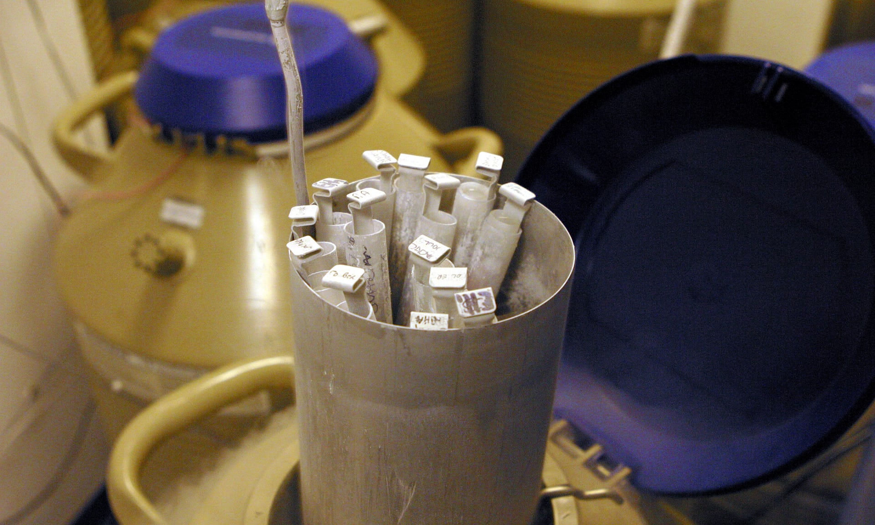 A reference image © Tina Stallard/Getty Images
A wealthy businessman has failed in his attempt to recover damages from a private IVF clinic, despite a court ruling that his former partner forged his signature to conceive their daughter by the procedure.
In a potentially far-reaching judgment at the high court in London on Friday, Mr Justice Jay ruled that IVF Hammersmith had failed in its obligation to ensure consent from both parties before carrying out the procedure, but found the clinic did not have to meet the costs of caring for the man’s daughter although he allowed the father to appeal.
Passing judgment at the high court in London, Jay wrote: “Although [the father] has lost this case, my judgment must be seen as a complete personal and moral vindication … The same, of course, cannot be said for [the mother].”
But Jay said the claim had failed due to public policy, which stipulates that parents cannot be compensated for the birth of a healthy child.
The man, who is in his 50s, said IVF Hammersmith should be liable for “hundreds of thousands of pounds” needed to care for his daughter, who is six, including a private education, nannies, her wedding, university education, skiing trips, refurbishing her bedroom and a Land Rover Discovery used to transport the girl and his eight-year-old son.
In a statement following the ruling, he said the case had “never been about money; it is about justice.” He wanted to draw attention to the “catastrophic failings of the Human Fertility and Embryology Authority (HFEA), and the unacceptable conduct of fertility clinics, which have grown into multimillion-pound businesses on the back of sharp practices”, he added. The HFEA said it would not be commenting on the case.
The judge found the company had breached its contract in accepting a document that purported to give the man’s consent to using a frozen egg fertilised by his sperm, five months after he said he and his partner had parted ways after a “volatile and rancorous” relationship. The clinic said at no point had it been informed of the couple’s separation.
Although the judge did not find the company liable for damages, he did state concerns about the way consent was obtained by clinics during this period. The fact the clinic had changed the way it obtained consent demonstrated “that more robust procedures were not beyond the bounds of practical possibility”.
The case has significant ramifications for parents seeking IVF and the clinics they turn to, setting a precedent in terms of the circumstances under which parents of “unwanted” children can claim damages. It comes after a man who had a failed vasectomy was unsuccessful in his bid to sue for negligence after fathering two daughters.
In the IVF case, the father said he was devastated when his former partner, a teacher, emailed him a year after their breakup on Valentine’s Day 2011, writing: “By the way, I’m pregnant.”
The mother, who is in her 40s, denied forging the signature and says her former partner did give his approval.
A six-day trial in July was told the father’s signature on the “consent to thaw” form had been forged after someone “traced” his real signature. Dr Audrey Giles, a handwriting expert, told the court she was “99% sure” the document had been falsified.
In his ruling, the judge said the girl’s mother, known only as R, had lied while given evidence and accused her of “mendacious embellishment”, adding: “I have to say that some of her evidence was made up as she went along.”
The man and his then girlfriend attended the clinic in 2008 and signed an “agreement for cryopreservation”. They conceived a son by IVF in 2008.
The couple then returned to the clinic in 2010 to discuss thawing a frozen embryo. The man later said the relationship was already broken beyond repair at this point and he had only attended to “avoid another shouting match”. The judge found he “persuaded himself that the purpose of the consultation with [the consultant] was not to discuss the use of the frozen embryos in the context of R having another baby”.
Giving evidence, the father, who has since remarried, told the court he was devastated when he heard his former partner was pregnant.
“I said that’s clever – why would you do that? I’m truly amazed by what you have done,” he said. “I phoned the clinic on 15 February 2011 to reveal all. I wanted to know what had gone on. I was in a terrible state.
“My response was: ‘Oh my God, how could this happen?’ I’d never agreed to get her pregnant. My head was exploding. It turned my head upside down. I just couldn’t function. It was just so overwhelming.”
The father, who cannot be named for legal reasons, has previously said that although he loves his daughter, her birth has placed an unwelcome financial burden on him.
During the trial he said the child was “unwanted” but would be treated like any of his other children. Describing how he felt about the situation, he said: “It’s very difficult to comprehend the situation. You have a beautiful girl who, when she’s in our midst, all she does is remind us of pain. She’s a beautiful girl who doesn’t feel like she’s part of our family. She feels like an alien in our home despite the fact that she’s a beautiful girl.”
The case has already changed procedures in many IVF clinics, many of which now insist on the signing of contracts in clinics or Skype calls to witness the signing of contracts if parents are abroad. It could have a further impact on the regulation of IVF treatment and how frozen embryos can be used years after they are initially stored.
Jude Fleming, the chief operating officer for IVF Hammersmith, said the clinic was pleased the judge had ruled in its favour and dismissed the claim for damages.
The clinic has changed its practices so that if both parties are not available for the signing of the forms, written consent is followed up with a phone call. She added: “It’s very sad for the people involved, the patients, the children and the staff that were involved in this treatment.”
James Lawford Davies, a partner at Hempsons who represented the clinic, said the court had found that the signature had been properly checked, and was only found to be fraudulent using “sophisticated machinery”.
He added: “Clinics cannot presume that all their patients might be dishonest, but the case highlights the importance of having systems in place to ensure that both partners continue to agree to pursue treatment together, right up until the moment of transfer.”
Praful Nargund, the chief executive of ABC IVF, a private London clinic, said industry leaders were considering whether further steps could be taken to safeguard the consent procedure. “The most crucial appointment, the embryo transfer, which is the point of no return, clinics will be looking at this very carefully,” he said, adding that ideally the father should attend this appointment, but clinics would need to decide whether this was necessary on a case by case basis.
“The core message here is clinics are not sleuths trying to decide if a patient is a patient or not,” he added. “We see both people in person and take reasonable steps to identify them using a passport or driving licence. We inform them at the outset that if there is any change in consent that they inform us straight away.”
The father plans to appeal against the decision regarding damages in the supreme court.
English | French

PS: This article holds 1512 words.

Bibliography
Legal texts
BRIGNALL Miles, "Couple who faked holiday sickness are jailed", in The Gardian, https://www.theguardian.com/law/2017/oct/13/couple-who-faked-holiday-sickness-claims-are-jailed, released on 13 October 2017 and consulted on 24 October 2017.
SHEPPARD Emma, "Meet the women fighting gender bias in law", in The Gardian, https://www.theguardian.com/law/2017/jul/12/meet-the-women-fighting-gender-bias-in-law, released on 12 July 2017 and consulted on 24 October 2017.
Text about stalking

Anonymous, "I have become my daughter’s stalker", https://www.theguardian.com/lifeandstyle/2017/nov/04/i-have-become-my-daughters-stalker, released on 4 November 2017 and consulted on 12 November 2017.
Text about prison environment
Louise TICKLE, "Mum wasn’t treated like a prisoner, but like a human being", in The Gardian, https://www.theguardian.com/lifeandstyle/2017/nov/04/i-have-become-my-daughters-stalker, released on 23 October 2017 and consulted on 12 November 2017.
Text about a medical clinic
TOPPING Alexandra and DEVLIN Hannah, "Man loses damages claim against IVF clinic over 'forged' consent", in The Gardian, https://www.theguardian.com/society/2017/oct/06/man-loses-damages-claim-against-ivf-clinic-over-forged-consent, released on 6 October 2017 and consulted on 12 November 2017.

BRIGNALL Miles, "Couple who faked holiday sickness are jailed", https://www.theguardian.com/law/2017/oct/13/couple-who-faked-holiday-sickness-claims-are-jailed, released on 13 October 2017 and consulted on 24 October 2017.
SHEPPARD Emma "Meet the women fighting gender bias in law", in The Gardian, https://www.theguardian.com/law/2017/jul/12/meet-the-women-fighting-gender-bias-in-law, released on 12 July 2017 and consulted on 24 October 2017.
Anonymous, "I have become my daughter’s stalker", https://www.theguardian.com/lifeandstyle/2017/nov/04/i-have-become-my-daughters-stalker, released on 4 November 2017 and consulted on 12 November 2017.
TICKLE Louise, "Mum wasn’t treated like a prisoner, but like a human being'", https://www.theguardian.com/lifeandstyle/2017/nov/04/i-have-become-my-daughters-stalker, released on 23 October 2017 and consulted on 12 November 2017.
TOPPING Alexandra and DEVLIN Hannah, "Man loses damages claim against IVF clinic over 'forged' consent", https://www.theguardian.com/society/2017/oct/06/man-loses-damages-claim-against-ivf-clinic-over-forged-consent, released on 6 October 2017 and consulted on 12 November 2017.

