PARTICIPATION BULLETIN
WORKSHOPS
CLASSROOM METHODOLOGY
DECEMBER 24th-25TH, 2017
LE MAJESTIC HOTEL ANNABA
To return before December 1ST
at : aslangues@gmail.com
Name :
Surname :
City :
Position :
Email :
Téléphone :

HOTEL Access map
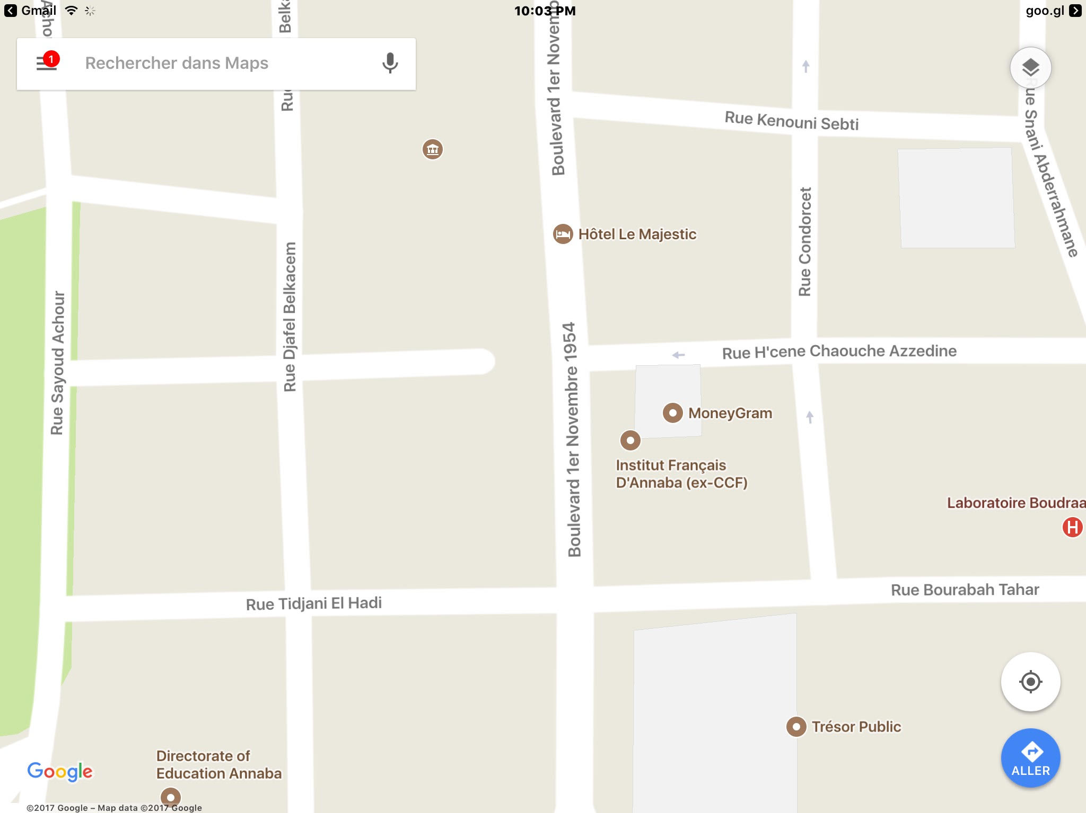
payment by bank transfer :

BOUHARIS MOHAMED ASL
BANQUE: Société générale Algérie ALN /RIB: 021 00301 1 130019023 87

WHERE TO SPEND THE NIGHT DURING YOUR STAY

We have selected for you during your stay the best hotels with the most convenient prices.
We could help with booking. Just send us an email when selecting the most suitable hotel for you.

- Complexe Touristique Sabri http://www.hotel-sabri.com/
- Hôtel Rym El Djamil http://www.xn--htel-rymeldjamil-nvb.com/
- Hôtel Emir Téléphone : 038 45 17 80
- Hôtel El Mouna Téléphone : 038 86 57 70

CONTENT :
- Classroom management and teacher language
- Providing feedback and correction techniques
- Teaching receptive skills: Reading and listening DAY ONE
- Oral fl uency and speaking skills
- Developing learners’ writing skills
- Teaching vocabulary

- Teaching grammar
- Lesson planning
- Planning a sequence of lessons DAY TWO
- Teaching exam classes
- Exploiting authentic material
- Promoting learner autonomy

