**What happened to Brussels ?**

**The big socio-biological decline 1965-2015.**

Baptiste Dumoulin, August 2016

**Abstract:**

Brussels saw the wealth of its inhabitants reduced dramatically in 50 years. The wealth index in the Belgian capital declines from 139 in early 1970 to 79 in 2015 (the wealth index is simply the ratio of revenues in a given place in Belgian compare to the Belgian mean, the wealth index is 100 for Belgium, by definition), meaning that the relative prosperity of the Brussels region has lost 43% in 50 years.

The purpose of this analysis is to show the close link between the increase in the north-african population in the Brussels population and the progressive wealth reduction. This inverse relationship is mediated by the lowest genotypic intelligence of North African and African populations compared to European or East Asian.  
 **Brussels is the capital of Belgium. It has 19 municipalities.**

**The southern municipalities (Uccle, Watermael-Boitsfort, Auderghem, Woluwe-Saint-Pierre, Woluwe-Saint-Lambert) are the most wealth while the northern municipalities (especially Saint-Josse-ten-Node, Molenbeek- Saint-Jean, Schaerbeek, Anderlecht and Koekelberg) are less wealth with the lowest social scores of all the country.**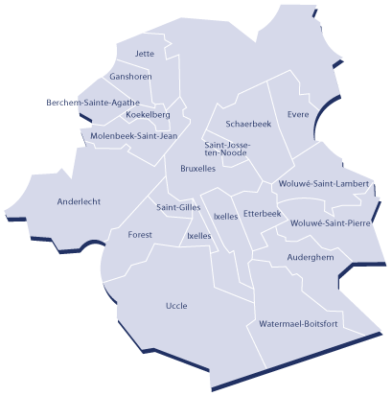

It is difficult to get an ethnic composition of the different communes of Brussels, particularly the proportion of North Africans. An imperfect estimate comes from the study of Jan Hertogen (KU Leuven, 2016) on the Muslim presence in Belgium. These data are shown in Column 2 of Table 1. This is a surrogate for the estimation of the North African population of Brussels.

 In 1955, the official census has 4,000 North Africans in Belgium (0.05%).

The non-European immigration really begins in the 1960s, following

signed by the Belgian State of immigration agreements with Morocco (1964), Turkey (1964), Tunisia (1969) and Algeria (1970). Although the Belgian government decides an immigration stop in 1974 (opposite the oil crisis), this population will continue to increase (births, family reunification).   
Moreover, thanks to laws that facilitate the naturalization, the number of North Africans will increase especially from the 1990s.  
  
Maghreb arriving focused from the start in the cities and especially in the north of Brussels.

Column 1 of the table shows the 19 Brussels communes, in descending order of North African population (%) in these municipalities.

Saint-Josse-ten-Node (SJTN) has the highest proportion of North Africans (45%) followed by Sint-Jans-Molenbeek (41.2%), Schaerbeek (37.3%), Brussels city (31%), Anderlecht (30.2%), Koekelberg (28.4%) and Saint Gilles (24.4%)

At the other end, common Watermael-Boitfort (4.6%), Woluwe-Saint-Pierre (4.7%), Uccle (6.6%) Auderghem (6.7%) and Woluwe-Saint- Lambert (7.7%) have the fewest Maghreb.

|  |  |  |  |  |  |  |
| --- | --- | --- | --- | --- | --- | --- |
| Municipality | North-african population (%) | Wealth index (2013) | Mean waves, compared with the national mean (%) | Share of households in demand for social housing, 2012 (%) | Unemployment rate, 2012  (%) | Median income, 2012  (euros) |
| Saint-Josse-ten-Noode | 45 | 50 | -50 | 5,25 | 34,9 | 14579 |
| Molenbeek-Saint-Jean | 41,2 | 59,2 | -40,8 | 7,82 | 30,92 | 16568 |
| Schaerbeek | 37,3 | 65,8 | -34,2 | 5,06 | 26,43 | 17159 |
| Bruxelles-ville | 31 | 71 | -29 | 5,56 | 25,33 | 17080 |
| Anderlecht | 30,2 | 66,7 | -33,3 | 9,61 | 25,78 | 17244 |
| Koekelberg | 28,4 | 72,8 | -27,2 | 5,4 | 24,06 | 18069 |
| Saint-Gilles | 24,4 | 68,9 | -31,1 | 5,1 | 26,98 | 16028 |
| Forest | 23,1 | 82,4 | -17,6 | 4,71 | 23,82 | 18555 |
| Evere | 17,9 | 78,3 | -21,7 | 2,47 | 21,02 | 20096 |
| Jette | 17,3 | 86,6 | -13,4 | 2,7 | 19,81 | 19977 |
| Ganshoren | 16,5 | 87,2 | -12,8 | 2,6 | 19,69 | 19900 |
| Berchem-Sainte-Agathe | 15,8 | 89,4 | -10,6 | 2,86 | 18,68 | 20566 |
| Ixelles | 14,8 | 88,5 | -11,5 | 2,3 | 21,12 | 18161 |
| Etterbeek | 12,8 | 80,8 | -19,2 | 1,73 | 19,8 | 19423 |
| Woluwe-Saint-Lambert | 7,7 | 96,1 | -3,9 | 0,79 | 13,12 | 22858 |
| Auderghem | 6,7 | 104,3 | +4,3 | 0,74 | 13,15 | 23543 |
| Uccle | 6,6 | 111,6 | +11,6 | 0,9 | 14,27 | 21523 |
| Woluwe-Saint-Pierre | 4,7 | 111,5 | +11,5 | 0,47 | 11 | 24822 |
| Watermael-Boitsfort | 4,6 | 112,8 | +12,8 | 0,6 | 13,76 | 22624 |

**The 19 municipalities of Brussels classified in descending order of the proportion of North Africans.  
  
  
  
  
Tableau 1**

|  |  |  |  |  |  |
| --- | --- | --- | --- | --- | --- |
| Municipality | North-african population (%) | 18-64 beneficiaries of social integration income, 2012 (%) | Total population of the municipality (2014) | Juvenile delinquency in the total population under 18 years (%) | Delinquency in the total population 18-25 years (%) |
| Saint-Josse-ten-Noode | 45 | 7,16 | 27447 | 8,3 | 10,5 |
| Molenbeek-Saint-Jean | 41,2 | 6,97 | 94854 | 6,7 | 10,7 |
| Schaerbeek | 37,3 | 4,95 | 131604 | 5,6 | 8,5 |
| Bruxelles-ville | 31 | 4,3 | 170407 | 7,1 | 9,9 |
| Anderlecht | 30,2 | 4,50 | 115178 | 5,6 | 10 |
| Koekelberg | 28,4 | 2,94 | 21317 | 7,2 | 8,9 |
| Saint-Gilles | 24,4 | 4,68 | 50460 | 5,9 | 8,3 |
| Forest | 23,1 | 3,03 | 54524 | 4,9 | 7,8 |
| Evere | 17,9 | 4,2 | 37957 | 5 | 7,8 |
| Jette | 17,3 | 2,67 | 50237 | 4,3 | 7,3 |
| Ganshoren | 16,5 | 1,26 | 23836 | 4,9 | 7,2 |
| Berchem-Sainte-Agathe | 15,8 | 2,01 | 23690 | 4,8 | 7,6 |
| Ixelles | 14,8 | 2,55 | 83332 | 4,9 | 5,9 |
| Etterbeek | 12,8 | 3,71 | 46427 | 4,6 | 5,8 |
| Woluwe-Saint-Lambert | 7,7 | 1,96 | 53318 | 3,3 | 3,8 |
| Auderghem | 6,7 | 2,01 | 32560 | 3,1 | 5,6 |
| Uccle | 6,6 | 1,61 | 81089 | 3,5 | 5,2 |
| Woluwe-Saint-Pierre | 4,7 | 0,81 | 40841 | 2,3 | 3,1 |
| Watermael-Boitsfort | 4,6 | 1,93 | 24408 | 3,6 | 5,5 |

**Tableau 2**

|  |  |  |  |  |  |  |  |
| --- | --- | --- | --- | --- | --- | --- | --- |
| Municipality | North-african population (%) | Proportion with a university degree | Proportion de petit poids de naissance (%) en 1992 | Life expectancy at birth | Children born in a family with no income from work (%) | Population growth | |
| Saint-Josse-ten-Noode | 45 | 4,2 | 6,19 | 78,5 | 52,77 | 24,16 | |
| Molenbeek-Saint-Jean | 41,2 | 3,4 | 7,69 | 78,9 | 36,34 | 20,14 |
| Schaerbeek | 37,3 | 7 | 5,82 | 80 | 36,94 | 15,45 | |
| Bruxelles-ville | 31 | 6,4 | 6,72 | 79,7 | 30,04 | 16,76 | |
| Anderlecht | 30,2 | 3,5 | 6,95 | 79,5 | 34,13 | 20,26 | |
| Koekelberg | 28,4 | 5,4 | 6,44 | 79,2 | 25,47 | 17,88 | |
| Saint-Gilles | 24,4 | 6,3 | 7,64 | 78,9 | 31,06 | 15,01 | |
| Forest | 23,1 | 7,9 | 6,14 | 80,2 | 20,31 | 7,67 | |
| Evere | 17,9 | 4,5 | 5,52 | 79,8 | 26,04 | 10,65 | |
| Jette | 17,3 | 6,1 | 5,42 | 80,5 | 22,56 | 17,75 | |
| Ganshoren | 16,5 | 6,3 | 8,97 | 80,2 | 22,86 | 14,32 | |
| Berchem-Sainte-Agathe | 15,8 | 6,3 | 6,72 | 80,1 | 21,86 | 18,47 | |
| Ixelles | 14,8 | 13,4 | 5,64 | 81,2 | 17,19 | 2,54 | |
| Etterbeek | 12,8 | 10,7 | 6,35 | 79,9 | 16,28 | 11,43 | |
| Woluwe-Saint-Lambert | 7,7 | 14,2 | 4,34 | 82,4 | 9,49 | 8,87 | |
| Auderghem | 6,7 | 12,5 | 6,55 | 80,6 | 10,68 | 7,61 | |
| Uccle | 6,6 | 15 | 5,2 | 80,2 | 11,23 | 3,8 | |
| Woluwe-Saint-Pierre | 4,7 | 18,1 | 2,91 | 82,9 | 8,18 | 2,04 | |
| Watermael-Boitsfort | 4,6 | 14,5 | 5,78 | 80,8 | 10,15 | 2,35 | |

**Tableau 3**

|  |  |  |  |  |  |
| --- | --- | --- | --- | --- | --- |
| CORRELATION | Median income | Unemployment rate, 2012  (%) | Share of households in demand for social housing, 2012 (%) | Part des enfants naissant dans un ménage sans revenu du travail  (%) | Population growth |
| North-african population (%) | -0,90 | +0,96 | +0,86 | +0,95 | +0,81 |

|  |  |  |  |  |  |  |
| --- | --- | --- | --- | --- | --- | --- |
| CORRELATION | 18-64 beneficiaries of social integration income, 2012 (%) | Juvenile delinquency in the total population under 18 years (%) | Delinquency in the total population 18-25 years (%) | Proportion with a university degree (%) | Petits poids de naissance (%) | Life expectancy |
| % maghrébins et nord-africains | +0,89 | +0,91 | +0,92 | -0,8 | +0,44 | -0,75 |

**1. Unemployement rate  
  
  
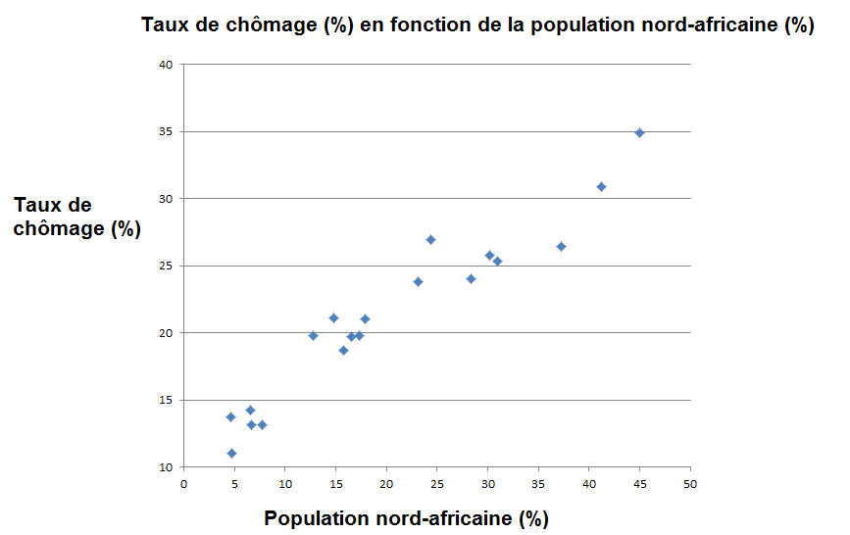  
  
  
The newfound correlation is 0.96.**

**The unemployment rate (2012) in Brussels municipalities are almost directly proportional to the share of North Africans in these municipalities (table above).**

**The municipalities of Saint-Josse-ten-Node and Molenbeek prance leading with unemployment rates, and the North African share, the most important of Brussels (and all of Belgium) while the southeastern towns , Auderghem, WB, WSP and WSL have a proportion of north African roughly 8 times lower and an unemployment rate nearly 3 times lower.  
  
  
  
  
  
  
  
  
  
  
  
2. Median income and general wealth  
  
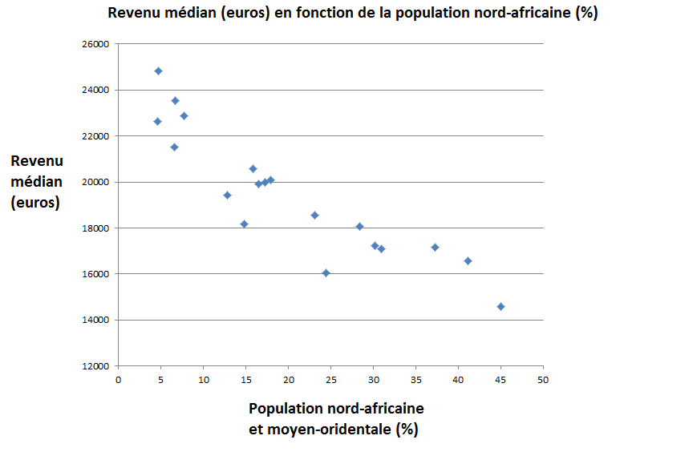**

**The newfound correlation is -0.90.**

**With median incomes of 14579 and 16568, Saint Josse Ten Node and Molenbeek have the lowest median incomes in Brussels (and the whole of Belgium).**

**3. Population growth  
  
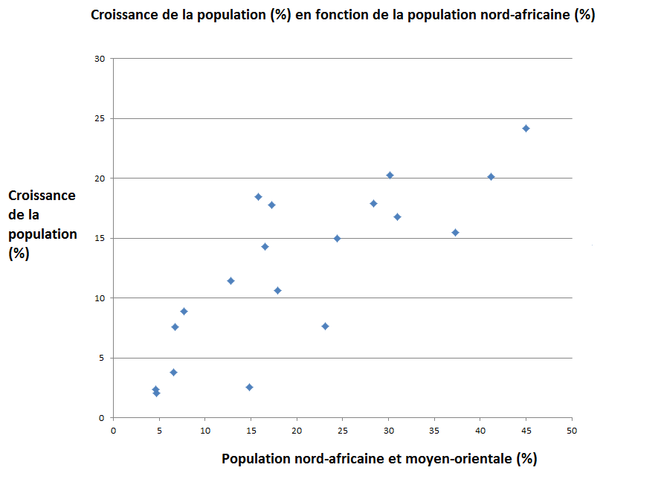  
  
  
The growth of the population is over 10 times higher in the Brussels municipalities with high concentration African Maghreb. A SJTN and Molenbeek, the population growth is 24 to 20%, against just over 2% in the municipalities of WSP and WB.**

**Populations at low Q.I tend to have more children for several reasons:**

**-A High fertility, as a low Q.I are two biological characteristics of an evolutionary strategy r (Rushton, 2000).**

**-The Lowest Q.I less control their birth because they are less able to foresee the consequences of their actions**

**-The Populations low Q.I produce more testosterone (Nyborg) which increases the libido and frequency of intercourse**

**-The Lowest Q.I populations are more religious, which indirectly increases the fertility to the extent that religion generally encouraged to make children**

**4. Share of households in demand of a social housing  
  
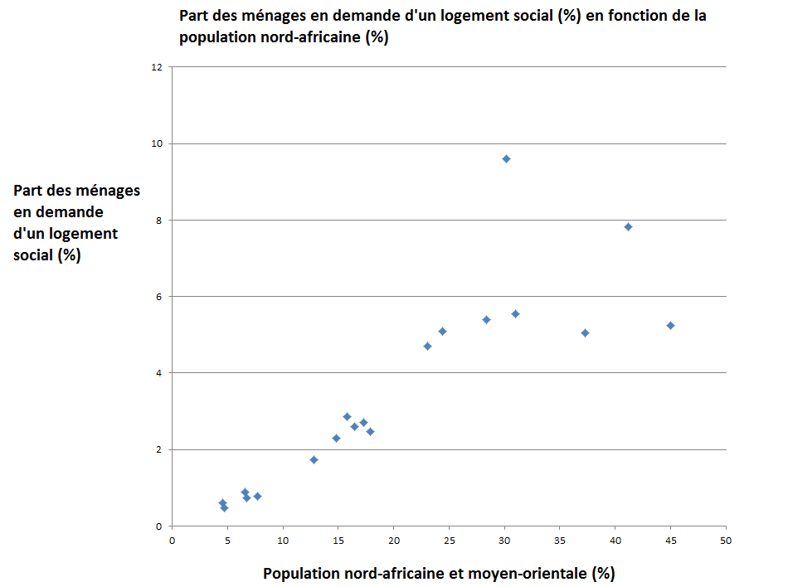**

**5. Share of children born in households without labor income**

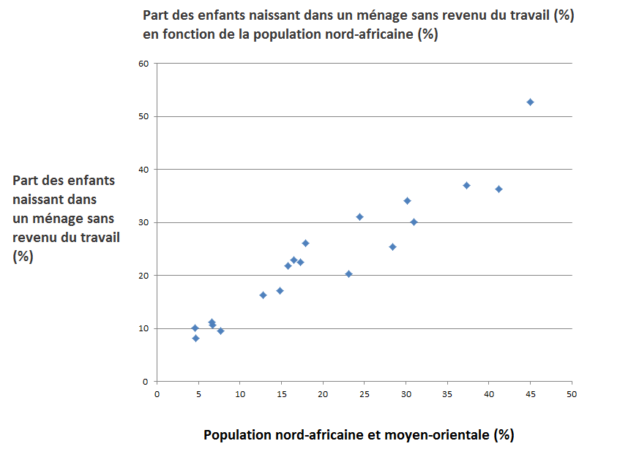

**6. Social Integration Income  
  
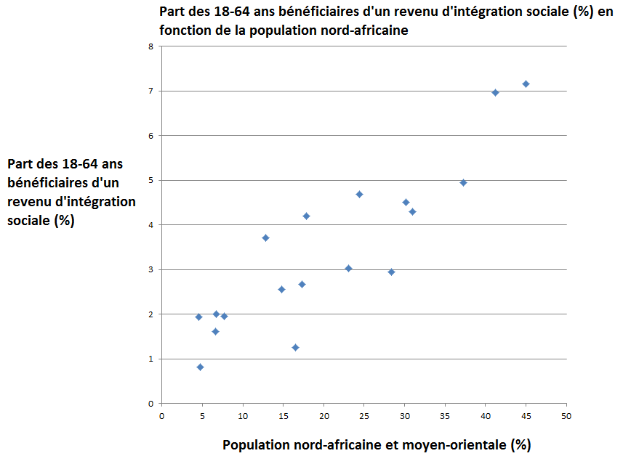  
  
  
  
  
  
  
  
  
  
  
  
  
  
  
  
  
  
  
  
  
  
5. delinquency  
5.1 Delinquency under 18 years  
  
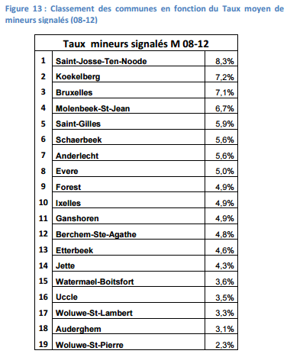**

**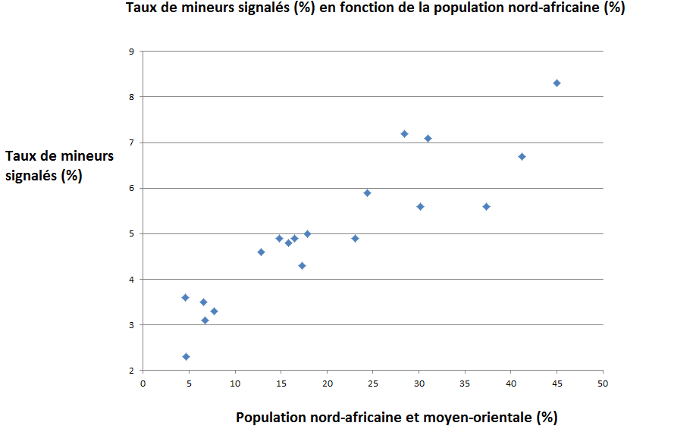  
  
  
  
  
  
  
  
  
  
  
  
  
  
  
  
  
  
  
  
  
  
  
  
  
  
5.2 Delinquency in young adults (18-25 ans)  
  
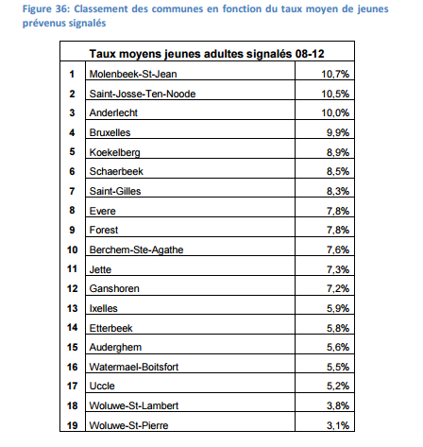**

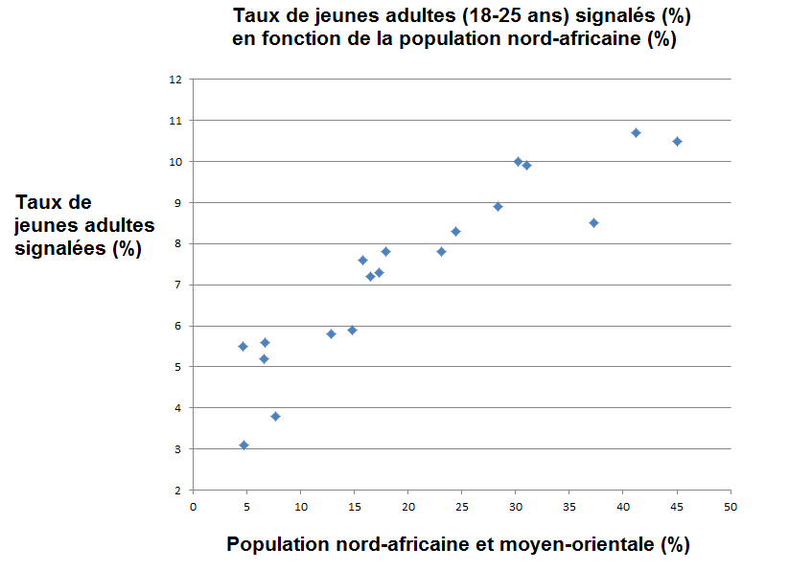

**6. Education**  
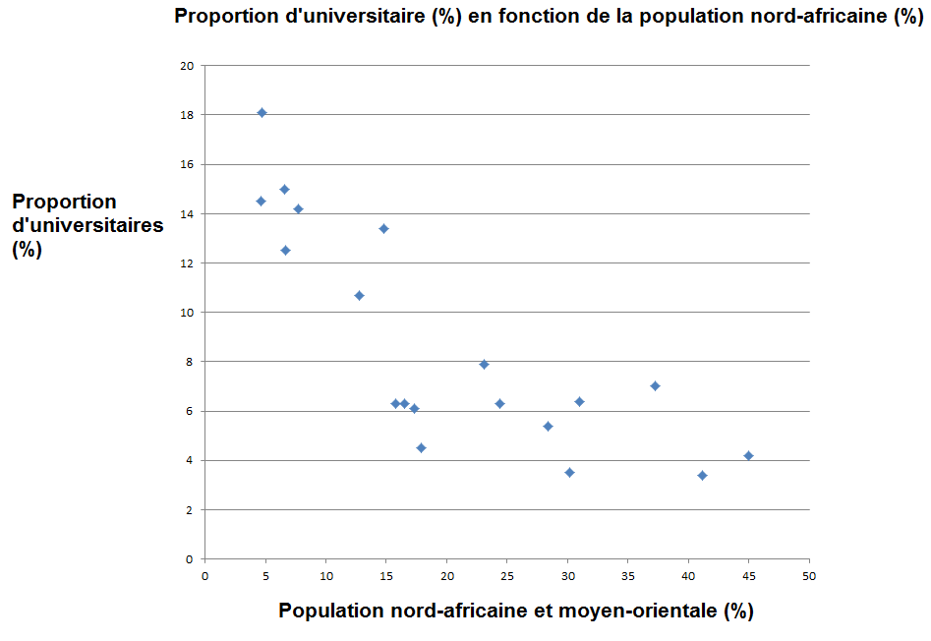

**7. Life expectancy**  
  
  
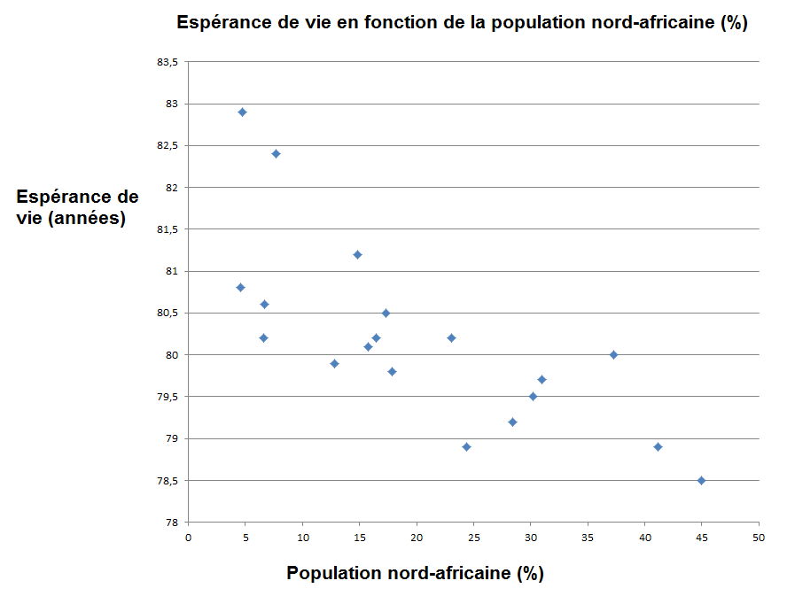

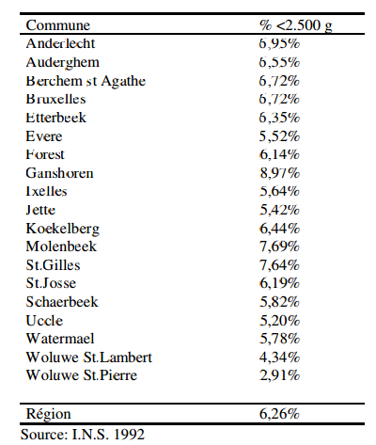  
Belgique 5%  
  
  
  
  
Mean I.Q for the different racial groups in Belgium

|  |  |  |
| --- | --- | --- |
|  | Q.I | % de la population belge |
| Nord-africains et moyen-orientaux | 86,7 | 8,1 |
| Européens | 99 | 85,2 |
| Ashkénazes | 109 | 0,3 |
| Africains | 80-85 | 5,4 |
| Est-asiatiques | 105 | 1 |

Source : OCDE PISA score

**8. Religion**The North African population of Belgium is much more than believing and practicing the European population.

A Brussels in five (20%) said practicing Muslim himself and other 4 percent are "non-practicing Muslims."

As Brussels has about 25% Muslim Arab, this gives a frequency of about a North African 20 unbeliever (5%), compared with 25-30% of non-believers in the European population.

This difference is a consequence of the negative relationship between intelligence and religious inclination. Nyborg analyzed it and found that the correlation between low and fundamentalism Q.I was particularly negative.

1. **Causal criteria Branford Hill**
2. **We have demonstrated that there was a high correlation between the proportion of North Africans in a Brussels commune and a set of problematic social (Crime, low education, low income, high welfare dependency, high religiosity ...).**
3. **However, correlation does not mean causation. The list of criteria for a correlation to be considered causality is (Hill's causality criteria):**
4. **1. Strength of association (relative risk or odds ratio);**
5. **We have previously shown that the correlations found are extremely high.**
6. **2. Consistency (repeat observations in different populations);**
7. **These observations parallel those observed in England, the Netherlands, America, Australia, Africa or Asia.**
8. **3. Specificity (a cause an effect);**
9. **4. Temporal relationship (temporality). The cause must precede effect;**
10. **We established the temporal relationship by tracing the arrival of North African populations in Belgium.**  
      
      
      
      
      
      
      
      
      
      
      
    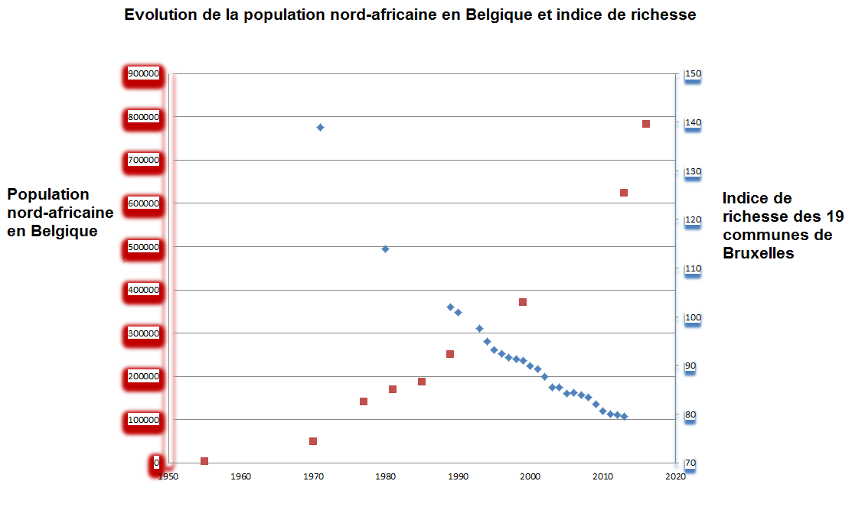

*17. Dose-effect relationship;*

*Correlations times above show a clear dose-response relationship.*

*18. Plausibility (biological plausibility);*

*It is clear and supported by the entire scientific research on the issue.*

*19. Experimental Evidence (animal or human);*

*20. Analogy (possibility of alternative explanations).* **Conclusion**

In Brussels like in any other multi-ethnic entity worldwide, social structure seems driven rigidly by intelligence ("The Bell Curve" for the US case and "The Global Bell Curve" for global data).

Maghrebian populations of Brussels and Belgium have all the characteristics of populations with low IQ: A higher delinquency, low levels of education, high fertility, high unemployment rate, lower life expectancy, high social dependency and low frequency of atheism.

The establishment of a North African population in Belgium, mainly in Brussels but not only, has meant decreased quite substantially average intelligence and consequently the level of development. In 50 years, the wealth index of Brussels was sprayed, from 139 in 1971 to 79 in 2015, continuing decline and almost linear, concomitant with the increase in North African from Brussels. This decline will continue.

The very low social outcomes of the municipalities of Saint-Josse-ten-Node, Molenbeek, Schaerbeek and Anderlecht are all the more surprising that these municipalities are located in the heart of the Brussels region, the economic center of Belgium. Sociologists have speculated that problems arose in the French suburbs of their position eccentric downtown. Presumably he was a (umpteenth) ad-hoc explanation without validity.

This depletion of Brussels is accompanied by rising inequality and an increase in the Gini index. This kind of society also increases the resentment of African Maghreb that are locked at the bottom of the social ladder by their lower intelligence.

It is on this ground that prosperous Islamic terrorism. "Faith is a low I.Q phenomenon," as demonstrated by Helmuth Nyborg. Molenbeek was recently released its relative anonymity international has been identified as birthplace of many European terrorists.

Brussels is unfortunately not unique in Europe. Mass immigration of North African and African populations, biologically less intelligent and more fruitful, is a dangerous sword of Damocles, heavier each yea, over the future of Europe.

**Références**  
  
Lynn R. (2006) « Race differences in intelligence ».  
  
Lynn R. (2009) « The global bell curve. Intelligence, race and inequality worldwide   
  
Monitoring des quartiers, service public régional de Bruxelles. <https://monitoringdesquartiers.brussels/>  
  
Hertogen J. (2016) Quantification des musulmans en Belgique.  
  
Mahieu V., Ravier I. et Vanneste C. (2015) « Vers une image chiffrée de la délinquance enregistrée des jeunes en Région de Bruxelles-Capitale » Recherche réalisée à la demande de l’observatoire bruxellois de la prévention et de la sécurité.  
<https://nicc.fgov.be/upload/publicaties/rapport_40-obps-201506.pdf>  
  
Boutsen M. (1997) « Etude de la situation des enfants à Bruxelles »   
<http://www.grandirabruxelles.be/Publications/rapports/11_97/11_97.PDF>  
  
Le Vif l’express (2015) Espérance de vie dans votre commune. Données sur base d’une étude de l’ULB et le Kuleuven.   
<http://www.levif.be/actualite/belgique/decouvrez-l-esperance-de-vie-dans-votre-commune/article-normal-408285.html>  
  
Statistiques fiscales revenus 2015 IBSA  
<http://ibsa.brussels/fichiers/chiffres/2.1_revenus_depenses_menages_statistique_fiscale.xls>  
  
Touzri A. (2007) « Les minorités issues de l’immigration et les dispositifs de revitalisation urbaine dans la commune bruxelloise de Molenbeek-Saint-Jean »   
<https://books.google.be/books?id=FJSxs97zXC4C&pg=PA131&lpg=PA131&dq=indice+de+richesse+bruxelles+appauvrissement&source=bl&ots=k00_mg3HFz&sig=ATrKLAyax46rNWyxOyzh9dzc7e0&hl=fr&sa=X&ved=0ahUKEwii7vTf4L_OAhUML8AKHRI4DboQ6AEIUzAI#v=onepage&q=indice%20de%20richesse%20bruxelles%20appauvrissement&f=false>  
  
**Torrekens C. (2007) « Concentration des populations musulmanes et structuration de l’associatif musulman à Bruxelles »**[**http://www.brusselsstudies.be/medias/publications/FR_35_BS4FR.pdf**](http://www.brusselsstudies.be/medias/publications/FR_35_BS4FR.pdf) **Vloeberg E. et Corijn E. (2012) « Où va Bruxelles ? »**[**http://www.lasso.be/documents/presentatie_waarheen_met_brussel.pdf**](http://www.lasso.be/documents/presentatie_waarheen_met_brussel.pdf) **Cossée de Maulde G. (2010) « Musulmans dans la société belge. Pour un vivre ensemble »**[**http://www.centreavec.be/site/musulmans-dans-la-soci%C3%A9t%C3%A9-belge-pour-un-vivre-ensembl**](http://www.centreavec.be/site/musulmans-dans-la-soci%C3%A9t%C3%A9-belge-pour-un-vivre-ensembl) **Torrekens C. (2005) « L’islam dans la capitale européenne : vers l’émergence d’un islam européen ? », Emigrations et Voyages, vol 1, 1er semestre, pp 47-69.**[**http://www.ulb.ac.be/socio/germe/documentsenligne/islamcapitaleeurop%E9enne.pdf**](http://www.ulb.ac.be/socio/germe/documentsenligne/islamcapitaleeurop%E9enne.pdf) **Nielsen J. (2004 3ème edition) “Muslims is western Europe”**[**https://books.google.be/books?hl=fr&lr=&id=nge6HYH1SsIC&oi=fnd&pg=PR7&dq=muslims+brussels&ots=JXYPeK-NMh&sig=hAyFsePykjSGYqY0DrWxg_Kt6QY#v=onepage&q=muslims%20brussels&f=false**](https://books.google.be/books?hl=fr&lr=&id=nge6HYH1SsIC&oi=fnd&pg=PR7&dq=muslims+brussels&ots=JXYPeK-NMh&sig=hAyFsePykjSGYqY0DrWxg_Kt6QY#v=onepage&q=muslims%20brussels&f=false) **Sailer S. (2015) Why Does Belgium Have Such Angry Muslims?**[**http://www.unz.com/isteve/why-does-belgium-have-such-angry-muslims/**](http://www.unz.com/isteve/why-does-belgium-have-such-angry-muslims/)

**Religion**

[**http://www.lesoir.be/1106186/article/actualite/belgique/2016-01-28/75-des-francophones-revendiquent-une-identite-religieuse**](http://www.lesoir.be/1106186/article/actualite/belgique/2016-01-28/75-des-francophones-revendiquent-une-identite-religieuse)