Vehicle Blackbox DVR

User's Manual
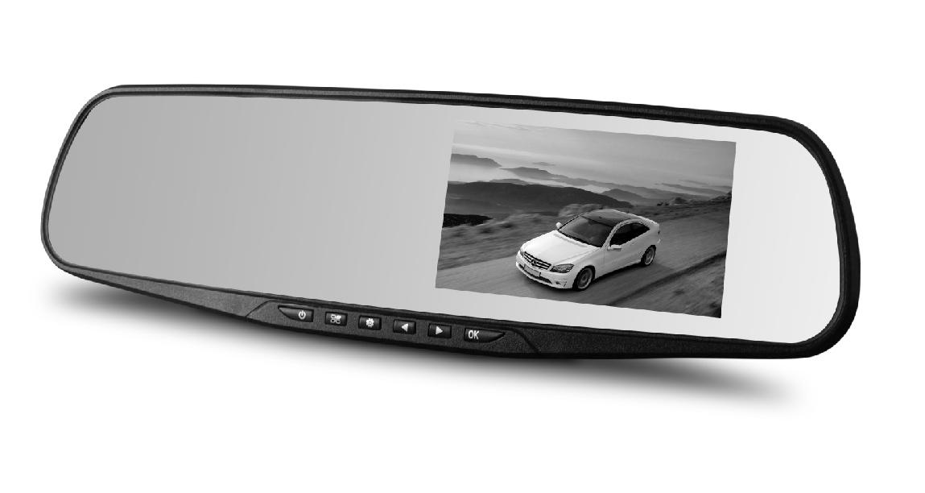

For ongoing product improvement, this manual is subject to modification without prior notice.

MODEL: LD353

Foreword

Thank you for purchasing, this product is for today's lifestyle. It is designed to provide hard evidence of a situation. It can be applied to meeting records, monitoring evidence, location shooting, video and other evidence where proof is required.

This product combines the industry-leading HDR high dynamic camera, WDR wide dynamic camera never missing second. It has seamless looping video, ultra-wide-angle shooting, ultra-high-definition camera, real-time playback, motion detection, lane deviation shift and so on much latest technology in one. Unique and stylish, streamlined design to today's needs. This manual will detail how to install and operate.

Please read before use and keep it with you. We hope this product will meet your needs.

Specifications may vary due to upgrades, updates and other reasons, please prevail in kind, without notice. Manufactures reserved the right to directly change technology without prior notice.

Infringement of copyright/Privacy Notice

Please note this product is for personal use. Its use must not violate national or international copyright/Privacy laws. That is the recorded image for personal use only and may not freely publicly spread; in addition the use of video performances, exhibitions, or commercial activities recorded by this product, in some case may infringe someone else's copyright or legal rights.

Installation Instructions

Installation of this product should be close to the mirror to get the best view. Make sure the lens is within the scope of the windshield wipers to ensure good vision. Even in the rainy conditions, effects are good. Do not touch the lens with your fingers, because the oil from your fingers may be left on the lens, resulting in that recording or photography is not clear, so please periodically clean the lens.


1

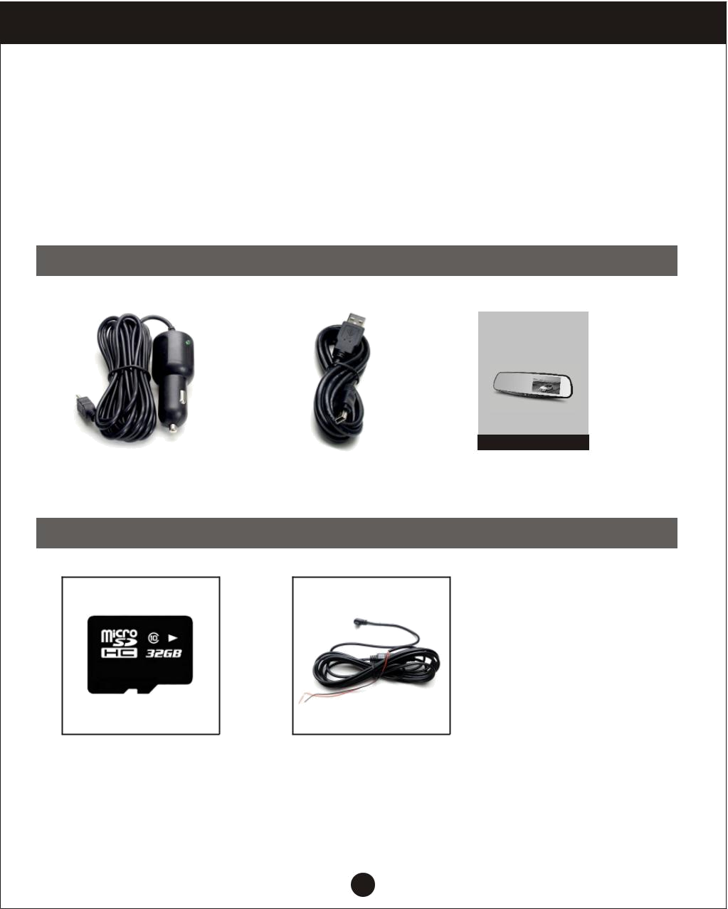
Precautions

Use original factory standard charger

Not dismantle the machine, to avoid affecting the warranty. Modify the power line, please find construction professionals.

Accessories Check

The following is a list of standard and optional list. If there are any missing or damaged items, please contact your dealer immediately.

Standard

 |  |  |  |  | Vehicle Blackbox DVR
 |  |  |  |  | User's Manual
 |  |  |  |  | For ongoing product improvement, this manual is subject to modification without prior notice.
 |  |  |  |  | MODEL: LD353
Car charger cable |  | USB Cable |  |  | User's manual

Optional

High-speed microSD card Modification buck line

2

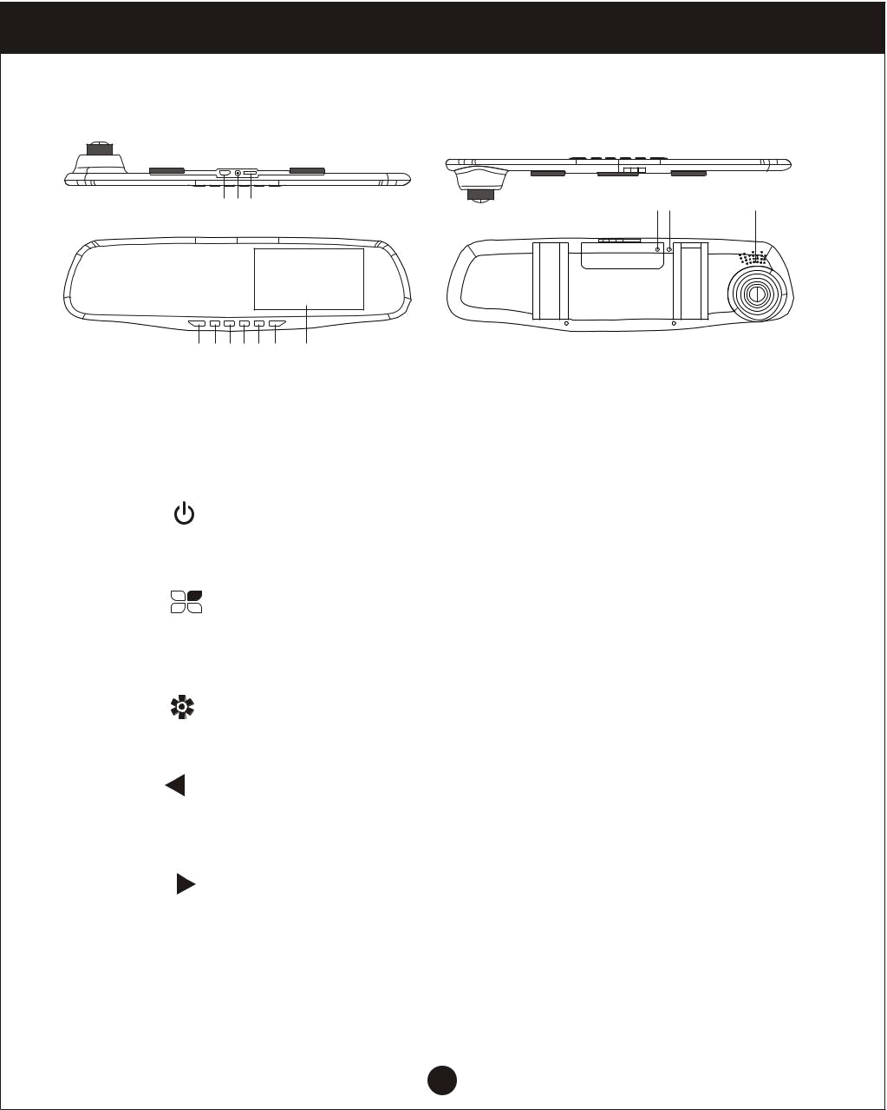
Product Overview

The structure of FIG

8 9 10

1112 13

1 2 3 4 5 6 7

Host keys and interface description

Number | Icon | Name | Operating instructions
1 |  | Switch button | Turn on or turn off the system
 |  | Menu Key/ | Under the standby mode, press the menu key
 |  | Menu Key/ | to bring up the feature set;
2 |  | Emergency | Quickly press the camera button on the unit
 |  | button | showing current state of the video file locking,
 |  |  | covering not be recycled;
3 |  | Mode | For inter camera mode key / camera /playback
3 |  | Mode | switch
4 |  | Down keys | In the menu options, select the function key
4 |  | Down keys | down; standby or video, night vision lights turn
 |  |  | on or off
 |  | On the turn | Menu options, select the function keys up;
5 |  | On the turn | standby or recording status, open or closed
5 |  | key | standby or recording status, open or closed
 |  | key | recordings

3

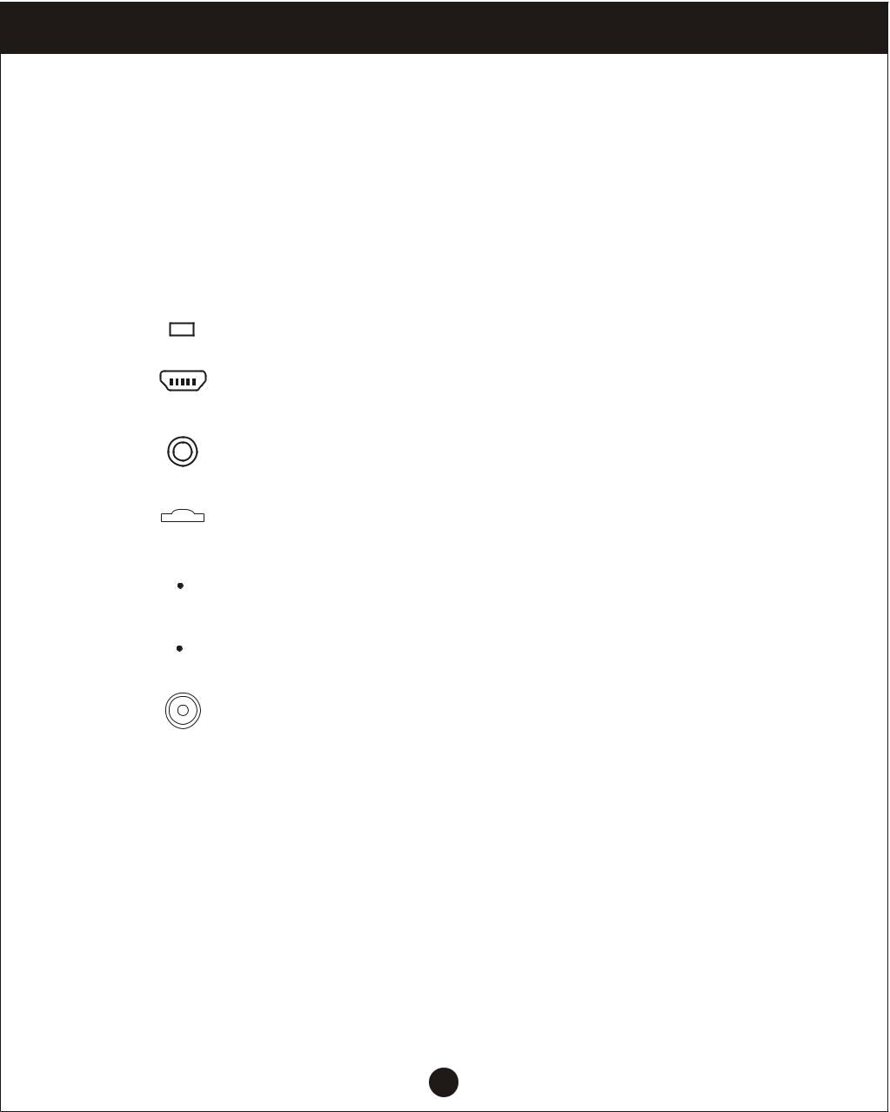
Product Overview

Host keys and interface description

Number | Icon |  |  | Name | Operating instructions
 |  |  |  |  | Camera/camera/confirm the short press to start
6 |  | OK |  | Ok button | the camera down key, camera mode, press
 |  |  |  |  | again to stop recording;
 |  |  |  |  | Short press to camera mode to take picture;
 |  |  |  |  | the menu mode to confirm the key
7 |  |  |  | Display | 4.3 inch TFT with HD display screen
8 |  |  |  | USB Port | For connecting a PC to transfer data;
8 |  |  |  | USB Port | Power connector, supplies power
9 |  |  |  | AV input port | AV cable is used to connect the video output
9 |  |  |  | AV input port | to AV equipment
10 |  |  |  | MicroSD | MicroSD memory card slot, install the correct
10 |  |  |  | card slot | direct direction tips
11 |  |  |  | Reset button | System restart the reset button
12 |  |  |  | Microphone | Recording receiving port
13 |  |  |  | Shot | Image acquisition

4

Memory Installation

1. Insert a memory card

Insert the memory card on the device memory card correctly in accordance with the direction of the gap prompt, press the card until a click is heard. Use a high-speed card (CLASS6 above).

Note: The first time you use your new card with this unit to format the card to.

- Remove the memory card: press the memory card out of the slot

Note: When the device is in the boot state, do not remove or insert a memory

card in order to avoid damaging the memory card.

- Bundle the Vehicle DVR to the current rearview mirror on your car with using provided velcro tape, and make sure it is tied solid


5

Memory Installation

4. Connect the power

Please use the original factory standard charger, the boot device as well as the built-in battery. The end of the car charger is connected to the device's USB port and the other end of the card charger is plugged into the car port, car engine once launched the device automatically boot.
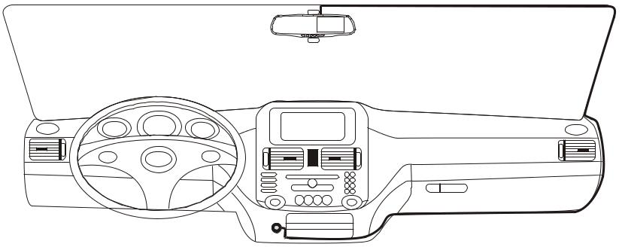

5. The device on/off

- Auto on/off: Once when the car is ignited, the DVR will boot accordingly. Then, when you turn on the DVR, the camera starts to work.

When the car stalled, the DVR will automatically save the record and turn off power in 15 seconds.

  - Manual on/off: manual boot then press the button host, shut down by the host of the same length keys.

6

Initial user settings

Set the date and time:

- Because the machine has switched the camera's automatic functions, you need to press the OK button click, the device enters the standby state.

- Then press the M button twice, at <time/date>by pressing or to select <date/time>, then press the ok button to enter the setting.

- By press the or keys to adjust the value, press the OK button to enter another field. Until the completion date and time settings, press M to exit.

Recorder Recording Operations

- When the car engine is started, the device is automatically turned on and start recording. When the engine stalled, then it will automatically stop recording.
Or press the OK button. Way manually stop recording.

Note: some vehicles powered car charger interface is often when the engine stalled, the power supply will continue to work. If you encounter such a situation, take the following steps: Open the manual way on/of the device, or the car charger from a car cigarette lighter port unplugged.

- Other types of camera: Press the OK button, then start recording; press the OK button again, then stop recording.

Note: (1)1,2,3,4,5,10 minutes every camera, it will save time, please refer to the circulation camera menu.(2)The equipment will be saved in the camera memory card, if a memory card is full, the oldest file is automatically overwritten memory card.

3. Emergency camera

Note: if you start a gravity sensor, and detect a collision, the device will automatically lock the current record video will not be overwritten.

7

Recorder camera operate

- Short press M to switch to camera mode, camera icon in the upper left corner of the screen display.

- Press the OK button to take pictures, take pictures of the screen flashes once to indicate camera complete. Video/photo playback operations.

  - As in the camera mode, you need to press the OK button to stop the recording.

  - Press the M button to switch to playback mode, the upper left corner of the screen to display the playback icon.

- Press or key up or down to select the file.

- Press the OK button to play the selected video file; short press again to pause playback.

Menu setting operating

- If you are recording, need to press the OK button to stop recording.

- Long press the M key to bring up the setup menu, twice on the menu page.

- By a short press or key, you can cycle up and down to select items in each set.

- Select the setting you want to change, press the OK button to enter the changes through short.

- After setting short press M key to exit standby mode.

8

Special features

1. Gravity sensor function

When the gravity acceleration starts, the machine will automatically save the video when the incident occurred and will not delete the file.

Gravity sensor can be adjusted in the menu high-medium-low-off, the factory default is medium.

2. Parking mode feature

After stop mode is turned on, when the vehicle stalled, tachograph will enter into dormant status. When car body feels vibration from outside, tachograph will open the camera to do record. After the vibration gone, the DVR automatically shuts down after a record 10-15 seconds. When the body is detected again after the shock, again start camera function.

Parking for guarding video camera 1080p 15 frames/sec, and the file is automatically locked.

Note: the parking guard function must only work in the case of tachgraph automatic shutdown, manual startup or shutdown, the parking guard does not work.

3. Motion detection function

If the motion detection feature turns on, quickly press OK to start recording.

The camera automatically switches to a 10 second, motion detection standby mode. If the recorder in front of the screen still, not moving object, the machine automatically enters stop recording state. When detecting an object moves, the recorder start recording, the recorder screen jumps to the video, the red recording light starts blinking. Default: motion detection off.

4. USB mode

Connect the USB cable to the computer, theUSB menu will appear with the following options;

- Memory

In this mode, the video file can be accessed.

- Camera

Select this mode will bring up the USB video device, can be real-time network camera or video chat as a PC camera.

9

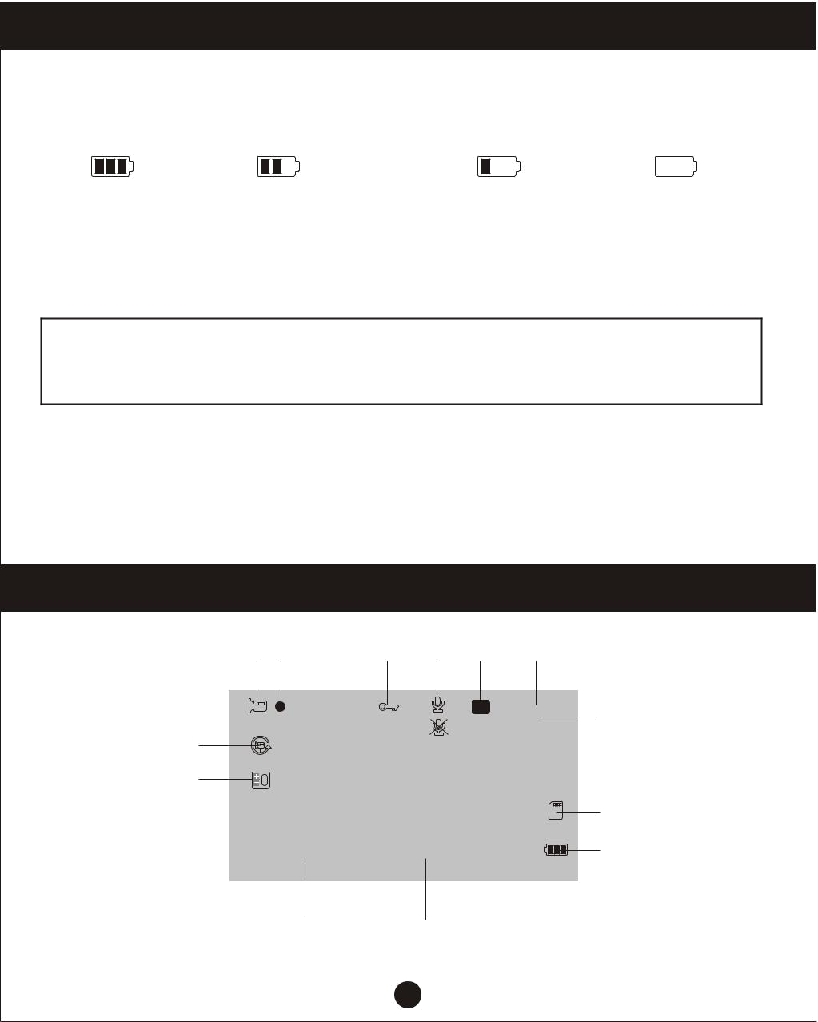
Special features

5. The battery instructions

Battery level indicator, refer to diagram:

Full charged Lower power consumption Low power consumption Lack of electricity

After switching on the car power, the red charging indicator lights up in charge of the process, the whole charging time is approximately 180 minutes, the red charging indicator light will automatically turn off after charging is completed.

Note: This equipment is to follow cars with state work long hours, stopping only for the built-in battery shutdown designed to save the file, so the limited length of battery life, in daily use, please link to the vehicle power supply.

6. Reset

If during use, the machine abnormal or crash situation, you can press the RESET button to reset the machine operating system shell through the hole touch through tiny needles.

Definition video interface icon

1 | 2 | 3 | 4 | 5 | 6
 |  |  |  | P | 00:15:30 | 7
 |  |  |  |  | 1080P HD | 7
10
11
 |  |  |  |  |  | 8
 | 2014/01/01 |  | 00:00:01 |  |  | 9
 | 13 |  | 12

10

Menu setting operating

-  : Camera icon indicates camera mode.

- : Flashing red indicates that the device in the camera work.

3. : Video file icon to open the lock.

When the G-sensor gravity sensor starts, the key icon appears on the screen, indicating that the current videos is locked video; in short video status button, you can quickly lock for shooting video.

4.  : Open icon recording function.

 : Recording function close icon.

- P : Indicating that the parking mode feature is turned on.

- 00:15:30: White font-memory cards remaining recording time / red font-current
segment recording time.

7.1080P HD: Indicates recording status at this time select the resolution for 1080P HD / 720P /480P can select in the menu “Resolution”, after which select the appropriate resolution, the screen will display the appropriate resolution to this position;

-  : Memory card icon is display.

- : Icon displayed after inserting a memory card.

- : Cycle time icon imaging segment, the middle number indicates the

cycle recording time.

Menu options are: 1 minute / 2 minutes / 3 minutes / 5 minutes / 10 minutes.

11.  : EV exposure compensation icon indicates the currently selected exposure parameters.
12. 00:00:01: Time display shows the current standard time; before using it for initial setup.

13. 2014/01/01: Date display, showing the current standard dates before using it for initial setup.

11

Settings Menu

Menu Options | Explanation | Available options
Resolution | Set the video resolution | 1080P HD, 1080P, 720P,WVGA, VGA
 | When setting up each | 1 minute, 2 minutes, 3 minutes, 5
Loop recording | When setting up each | minutes, 10 minutes, off, if you choose
Loop recording | video file length | to close the case, the card will not
 |  | automatically cycle full coverage
Exposure | Underexposed, dim | +0.0, -1/3, -2/3, -10, -4/3, -5/3, -2.0,
Exposure | the screen, you need | +0.0, -1/3, -2/3, -10, -4/3, -5/3, -2.0,
compensation | the screen, you need | +2.0,+5/3, +4/3, +10, +2/3, -1/3-
compensation | to fill light | +2.0,+5/3, +4/3, +10, +2/3, -1/3-
 | In standby mode, when
Motions | the screen has moved | On, Off
Detection | to the detection of | On, Off
 | automatic video
Recording | Recording function is | On, Off
Audio | turned on or off | On, Off
Date Label | Camera video | On, Off
Date Label | watermark date | On, Off
G-sensor | Collision generated | High, medium, low,off
G-sensor | video never be covered | High, medium, low,off
Lane shift | When the vehicle travel | Function switch, models, sensitivity,
Lane shift | lane shift will alarm | area selection, start speed
 | After parking stall, body
 | if you receive external
Stop mode | vibration generated by | On, Off
Stop mode | the tachograph will | On, Off
 | automatically turn the
 | camera
Date / Time | Date and time | You can set the year, month, day
Date / Time | Date and time | hour minute, second

12

Settings Menu

Menu Options | Explanation | Available options
Automatic | No automatic shutdown | 1 minute, 3 minutes
shutdown | operating state | 1 minute, 3 minutes
 | Recorder automatically | 10 seconds, 30 seconds, 1 minute
Screen Saver | turns off the display | 10 seconds, 30 seconds, 1 minute
 | work
Beep | During operation, the | On, Off
Beep | key is with sound | On, Off
Language | Language operation | Traditional, Simplified Chinese,
Language | Language operation | Russian, Japanese, French, Italian,
Settings | menu | Russian, Japanese, French, Italian,
Settings | menu | German, Spanish, English, Korean
TV mode | Connected TV system | NTSC, PAL
Light frequency | Lights flicker frequency | 50HZ, 60HZ
Fill light | Use in low-light | On, Off
Fill light | environments | On, Off
Format | You can delete memory | SD card
Format | card data above | SD card
Default setting | Restore factory settings | Cancel, OK
Version | Software version | Version number
Version | shipped | Version number

13


Product Specifications

Product name | HD tachograph
Product features | Extremely wide angle of 170 degrees,
Product features | 1080P full HD
G-sensor | Built-in ( under the car accident case of
G-sensor | emergency save, not to be deleted)
LCD screen size | 4.3inch high-resolution LCD screen
Shot | A+ grade high-resolution 170 degree
Shot | ultra-wide-angle lens
Language | Russian, English, Chinese, Japanese, etc
File format | MJPEG AVI
Video resolution | 1920X1080P, 1280X720P
Recording video format | Audio, AAC
Color effects | Standard
Continuous loop recording | Seamless loop recording, no leakage seconds
Truck switch machine | Support auto ignition on, turn off shutdown
Motion detection function | Support
Division date | Support
Vector Media | Support built-in memory ( Total amount:1024MB)
Camera mode | 1200M
Photo format | JPEG
Memory card | MicroSD card (Max support 32GB)
Micphone | Support
Built-in stereo | Support
IR | Support
Video format | PAL / NTSC
Current frequency | 50Hz / 60Hz
USB functionality | 1: USB disk, 2: PC camera
Power interface | 5V 1A
Battery | Built-in 200mAh

14

Troubleshooting

Under normal operating conditions, such as abnormal products, please refer to the solution:

Unable to boot:

Check the recorder and car charger connected correctly, if you manually turned on, check the battery level is too low needs recharging. As a result of procedural questions by pressing the RESET button to restore to factory settings.

When the camera automatically stops recording, or do not cycle the camera.

Due to the huge high-definition video data, it is possible because the memory card reader could not keep pace.

Make sure the gravity sensor function is closed, and memory is formatted.

Each time the camera and set the cycle is not the same.

Check to see if motion detection function, because the camera motion detection state length of time, depending on the screen there is no movement.

Please check whether the stolen camera, finger print.

Please clean the Lens before using the camera. It is important to keep the lens clean.

Camera effects and lighting conditions will affect the quality of the video.

Images have streaks interference.

This is due to the wrong setting “light frequency” produced under the fluorescent lights, the domestic flat rate “50Hz”.

When the machine briefly press the “RESET” the reset button to restore restart.

15

