122

2016

Janvier

|  |  |
| --- | --- |
| 1  Ven | Jour de l’An |
| 08 12 16 20 24 |
| 2  Sam |  |
| 08 12 16 20 24 |
| 3  Dim |  |
| 08 12 16 20 24 |
| 4  Lun |  |
| 08 12 16 20 24 |
| 5  Mar |  |
| 08 12 16 20 24 |
| 6  Mer |  |
| 08 12 16 20 24 |
| 7  Jeu |  |
| 08 12 16 20 24 |
| 8  Ven |  |
| 08 12 16 20 24 |
| 9  Sam |  |
| 08 12 16 20 24 |
| 10  Dim |  |
| 08 12 16 20 24 |
| 11  Lun |  |
| 08 12 16 20 24 |
| 12  Mar | Martine |
| 08 12 16 20 24 |
| 13  Mer |  |
| 08 12 16 20 24 |
| 14  Jeu |  |
| 08 12 16 20 24 |
| 15  Ven |  |
| 08 12 16 20 24 |
| 16  Sam |  |
| 08 12 16 20 24 |

|  |  |
| --- | --- |
| 17  Dim |  |
| 08 12 16 20 24 |
| 18  Lun |  |
| 08 12 16 20 24 |
| 19  Mar |  |
| 08 12 16 20 24 |
| 20  Mer |  |
| 08 12 16 20 24 |
| 21  Jeu |  |
| 08 12 16 20 24 |
| 22  Ven | Maryse |
| 08 12 16 20 24 |
| 23  Sam |  |
| 08 12 16 20 24 |
| 24  Dim |  |
| 08 12 16 20 24 |
| 25  Lun |  |
| 08 12 16 20 24 |
| 26  Mar | Scrapinette 91 |
| 08 12 16 20 24 |
| 27  Mer |  |
| 08 12 16 20 24 |
| 28  Jeu |  |
| 08 12 16 20 24 |
| 29  Ven |  |
| 08 12 16 20 24 |
| 30  Sam |  |
| 08 12 16 20 24 |
| 31  Dim |  |
| 08 12 16 20 24 |
| 1/2  Lun |  |
| 08 12 16 20 24 |



Agenda quotidien

2

2016

Février

|  |  |
| --- | --- |
| 1  Lun |  |
| 08 12 16 20 24 |
| 2  Mar |  |
| 08 12 16 20 24 |
| 3  Mer |  |
| 08 12 16 20 24 |
| 4  Jeu |  |
| 08 12 16 20 24 |
| 5  Ven |  |
| 08 12 16 20 24 |
| 6  Sam |  |
| 08 12 16 20 24 |
| 7  Dim |  |
| 08 12 16 20 24 |
| 8  Lun |  |
| 08 12 16 20 24 |
| 9  Mar | Cattt |
| 08 12 16 20 24 |
| 10  Mer |  |
| 08 12 16 20 24 |
| 11  Jeu |  |
| 08 12 16 20 24 |
| 12  Ven |  |
| 08 12 16 20 24 |
| 13  Sam |  |
| 08 12 16 20 24 |
| 14  Dim |  |
| 08 12 16 20 24 |
| 15  Lun |  |
| 08 12 16 20 24 |
| 16  Mar |  |
| 08 12 16 20 24 |

|  |  |
| --- | --- |
| 17  Mer |  |
| 08 12 16 20 24 |
| 18  Jeu | Thérèse |
| 08 12 16 20 24 |
| 19  Ven |  |
| 08 12 16 20 24 |
| 20  Sam |  |
| 08 12 16 20 24 |
| 21  Dim |  |
| 08 12 16 20 24 |
| 22  Lun |  |
| 08 12 16 20 24 |
| 23  Mar |  |
| 08 12 16 20 24 |
| 24  Mer |  |
| 08 12 16 20 24 |
| 25  Jeu |  |
| 08 12 16 20 24 |
| 26  Ven |  |
| 08 12 16 20 24 |
| 27  Sam |  |
| 08 12 16 20 24 |
| 28  Dim |  |
| 08 12 16 20 24 |
| 29  Lun |  |
| 08 12 16 20 24 |
| 1/3  Mar |  |
| 08 12 16 20 24 |
| 2  Mer |  |
| 08 12 16 20 24 |
| 3  Jeu |  |
| 08 12 16 20 24 |

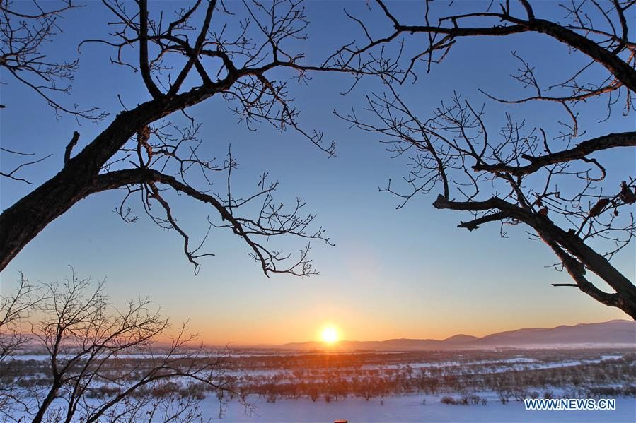

Agenda quotidien

3

2016

Mars

|  |  |
| --- | --- |
| 1  Mar |  |
| 08 12 16 20 24 |
| 2  Mer |  |
| 08 12 16 20 24 |
| 3  Jeu |  |
| 08 12 16 20 24 |
| 4  Ven |  |
| 08 12 16 20 24 |
| 5  Sam |  |
| 08 12 16 20 24 |
| 6  Dim |  |
| 08 12 16 20 24 |
| 7  Lun |  |
| 08 12 16 20 24 |
| 8  Mar |  |
| 08 12 16 20 24 |
| 9  Mer |  |
| 08 12 16 20 24 |
| 10  Jeu |  |
| 08 12 16 20 24 |
| 11  Ven |  |
| 08 12 16 20 24 |
| 12  Sam |  |
| 08 12 16 20 24 |
| 13  Dim |  |
| 08 12 16 20 24 |
| 14  Lun |  |
| 08 12 16 20 24 |
| 15  Mar |  |
| 08 12 16 20 24 |
| 16  Mer |  |
| 08 12 16 20 24 |

|  |  |
| --- | --- |
| 17  Jeu |  |
| 08 12 16 20 24 |
| 18  Ven |  |
| 08 12 16 20 24 |
| 19  Sam | Micheline |
| 08 12 16 20 24 |
| 20  Dim |  |
| 08 12 16 20 24 |
| 21  Lun |  |
| 08 12 16 20 24 |
| 22  Mar |  |
| 08 12 16 20 24 |
| 23  Mer |  |
| 08 12 16 20 24 |
| 24  Jeu |  |
| 08 12 16 20 24 |
| 25  Ven |  |
| 08 12 16 20 24 |
| 26  Sam |  |
| 08 12 16 20 24 |
| 27  Dim | Pâques |
| 08 12 16 20 24 |
| 28  Lun | Lundi de Pâques |
| 08 12 16 20 24 |
| 29  Mar |  |
| 08 12 16 20 24 |
| 30  Mer |  |
| 08 12 16 20 24 |
| 31  Jeu |  |
| 08 12 16 20 24 |
| 1/4  Ven |  |
| 08 12 16 20 24 |

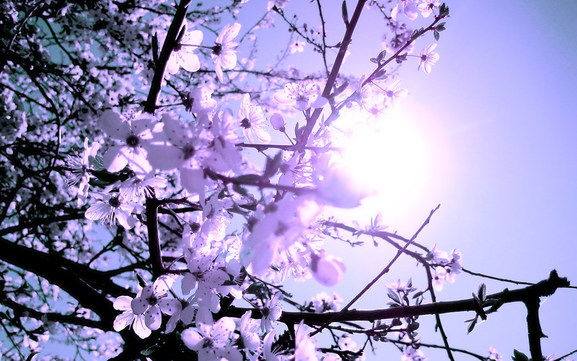

Agenda quotidien

4

2016

Avril

|  |  |
| --- | --- |
| 1  Ven |  |
| 08 12 16 20 24 |
| 2  Sam |  |
| 08 12 16 20 24 |
| 3  Dim |  |
| 08 12 16 20 24 |
| 4  Lun |  |
| 08 12 16 20 24 |
| 5  Mar |  |
| 08 12 16 20 24 |
| 6  Mer |  |
| 08 12 16 20 24 |
| 7  Jeu |  |
| 08 12 16 20 24 |
| 8  Ven |  |
| 08 12 16 20 24 |
| 9  Sam |  |
| 08 12 16 20 24 |
| 10  Dim |  |
| 08 12 16 20 24 |
| 11  Lun |  |
| 08 12 16 20 24 |
| 12  Mar |  |
| 08 12 16 20 24 |
| 13  Mer |  |
| 08 12 16 20 24 |
| 14  Jeu |  |
| 08 12 16 20 24 |
| 15  Ven |  |
| 08 12 16 20 24 |
| 16  Sam | Gisèle |
| 08 12 16 20 24 |

|  |  |
| --- | --- |
| 17  Dim | Gwenaëlle |
| 08 12 16 20 24 |
| 18  Lun | Kiaras |
| 08 12 16 20 24 |
| 19  Mar |  |
| 08 12 16 20 24 |
| 20  Mer |  |
| 08 12 16 20 24 |
| 21  Jeu |  |
| 08 12 16 20 24 |
| 22  Ven |  |
| 08 12 16 20 24 |
| 23  Sam |  |
| 08 12 16 20 24 |
| 24  Dim |  |
| 08 12 16 20 24 |
| 25  Lun |  |
| 08 12 16 20 24 |
| 26  Mar |  |
| 08 12 16 20 24 |
| 27  Mer |  |
| 08 12 16 20 24 |
| 28  Jeu |  |
| 08 12 16 20 24 |
| 29  Ven |  |
| 08 12 16 20 24 |
| 30  Sam |  |
| 08 12 16 20 24 |
| 31  Dim |  |
| 08 12 16 20 24 |
| 1/5  Lun |  |
| 08 12 16 20 24 |



Agenda quotidien

5

2016

Mai

|  |  |
| --- | --- |
| 1  Dim | Fête du Travail |
| 08 12 16 20 24 |
| 2  Lun | Mady |
| 08 12 16 20 24 |
| 3  Mar | Lydia |
| 08 12 16 20 24 |
| 4  Mer |  |
| 08 12 16 20 24 |
| 5  Jeu | Ascension |
| 08 12 16 20 24 |
| 6  Ven |  |
| 08 12 16 20 24 |
| 7  Sam |  |
| 08 12 16 20 24 |
| 8  Dim | Victoire 1945 |
| 08 12 16 20 24 |
| 9  Lun |  |
| 08 12 16 20 24 |
| 10  Mar |  |
| 08 12 16 20 24 |
| 11  Mer |  |
| 08 12 16 20 24 |
| 12  Jeu |  |
| 08 12 16 20 24 |
| 13  Ven |  |
| 08 12 16 20 24 |
| 14  Sam |  |
| 08 12 16 20 24 |
| 15  Dim | Pentecôte |
| 08 12 16 20 24 |
| 16  Lun | Lundi de Pentecôte |
| 08 12 16 20 24 |

|  |  |
| --- | --- |
| 17  Mar |  |
| 08 12 16 20 24 |
| 18  Mer |  |
| 08 12 16 20 24 |
| 19  Jeu |  |
| 08 12 16 20 24 |
| 20  Ven |  |
| 08 12 16 20 24 |
| 21  Sam |  |
| 08 12 16 20 24 |
| 22  Dim |  |
| 08 12 16 20 24 |
| 23  Lun |  |
| 08 12 16 20 24 |
| 24  Mar |  |
| 08 12 16 20 24 |
| 25  Mer |  |
| 08 12 16 20 24 |
| 26  Jeu |  |
| 08 12 16 20 24 |
| 27  Ven |  |
| 08 12 16 20 24 |
| 28  Sam |  |
| 08 12 16 20 24 |
| 29  Dim |  |
| 08 12 16 20 24 |
| 30  Lun |  |
| 08 12 16 20 24 |
| 31  Mar |  |
| 08 12 16 20 24 |
| 1/6  Mer |  |
| 08 12 16 20 24 |



Agenda quotidien



6

2016

Juin

|  |  |
| --- | --- |
| 1  Mer |  |
| 08 12 16 20 24 |
| 2  Jeu |  |
| 08 12 16 20 24 |
| 3  Ven |  |
| 08 12 16 20 24 |
| 4  Sam |  |
| 08 12 16 20 24 |
| 5  Dim |  |
| 08 12 16 20 24 |
| 6  Lun |  |
| 08 12 16 20 24 |
| 7  Mar |  |
| 08 12 16 20 24 |
| 8  Mer |  |
| 08 12 16 20 24 |
| 9  Jeu |  |
| 08 12 16 20 24 |
| 10  Ven |  |
| 08 12 16 20 24 |
| 11  Sam |  |
| 08 12 16 20 24 |
| 12  Dim |  |
| 08 12 16 20 24 |
| 13  Lun |  |
| 08 12 16 20 24 |
| 14  Mar |  |
| 08 12 16 20 24 |
| 15  Mer |  |
| 08 12 16 20 24 |
| 16  Jeu |  |
| 08 12 16 20 24 |

|  |  |
| --- | --- |
| 17  Ven |  |
| 08 12 16 20 24 |
| 18  Sam |  |
| 08 12 16 20 24 |
| 19  Dim |  |
| 08 12 16 20 24 |
| 20  Lun |  |
| 08 12 16 20 24 |
| 21  Mar |  |
| 08 12 16 20 24 |
| 22  Mer |  |
| 08 12 16 20 24 |
| 23  Jeu | Isadef |
| 08 12 16 20 24 |
| 24  Ven |  |
| 08 12 16 20 24 |
| 25  Sam |  |
| 08 12 16 20 24 |
| 26  Dim |  |
| 08 12 16 20 24 |
| 27  Lun |  |
| 08 12 16 20 24 |
| 28  Mar |  |
| 08 12 16 20 24 |
| 29  Mer |  |
| 08 12 16 20 24 |
| 30  Jeu |  |
| 08 12 16 20 24 |
| 1/7  Ven |  |
| 08 12 16 20 24 |
| 2  Sam |  |
| 08 12 16 20 24 |

Agenda quotidien



7

2016

Juillet

|  |  |
| --- | --- |
| 1  Ven |  |
| 08 12 16 20 24 |
| 2  Sam |  |
| 08 12 16 20 24 |
| 3  Dim |  |
| 08 12 16 20 24 |
| 4  Lun |  |
| 08 12 16 20 24 |
| 5  Mar |  |
| 08 12 16 20 24 |
| 6  Mer |  |
| 08 12 16 20 24 |
| 7  Jeu |  |
| 08 12 16 20 24 |
| 8  Ven |  |
| 08 12 16 20 24 |
| 9  Sam |  |
| 08 12 16 20 24 |
| 10  Dim |  |
| 08 12 16 20 24 |
| 11  Lun |  |
| 08 12 16 20 24 |
| 12  Mar |  |
| 08 12 16 20 24 |
| 13  Mer |  |
| 08 12 16 20 24 |
| 14  Jeu | Fête Nationale |
| 08 12 16 20 24 |
| 15  Ven |  |
| 08 12 16 20 24 |
| 16  Sam |  |
| 08 12 16 20 24 |

|  |  |
| --- | --- |
| 17  Dim |  |
| 08 12 16 20 24 |
| 18  Lun |  |
| 08 12 16 20 24 |
| 19  Mar |  |
| 08 12 16 20 24 |
| 20  Mer |  |
| 08 12 16 20 24 |
| 21  Jeu |  |
| 08 12 16 20 24 |
| 22  Ven |  |
| 08 12 16 20 24 |
| 23  Sam |  |
| 08 12 16 20 24 |
| 24  Dim |  |
| 08 12 16 20 24 |
| 25  Lun |  |
| 08 12 16 20 24 |
| 26  Mar |  |
| 08 12 16 20 24 |
| 27  Mer |  |
| 08 12 16 20 24 |
| 28  Jeu |  |
| 08 12 16 20 24 |
| 29  Ven |  |
| 08 12 16 20 24 |
| 30  Sam |  |
| 08 12 16 20 24 |
| 31  Dim |  |
| 08 12 16 20 24 |
| 1/8  Lun |  |
| 08 12 16 20 24 |

Agenda quotidien

822

2016

Août

|  |  |
| --- | --- |
| 1  Lun |  |
| 08 12 16 20 24 |
| 2  Mar |  |
| 08 12 16 20 24 |
| 3  Mer | Marianne |
| 08 12 16 20 24 |
| 4  Jeu |  |
| 08 12 16 20 24 |
| 5  Ven | Petite Souris |
| 08 12 16 20 24 |
| 6  Sam |  |
| 08 12 16 20 24 |
| 7  Dim | Khyna |
| 08 12 16 20 24 |
| 8  Lun | Mamichouette |
| 08 12 16 20 24 |
| 9  Mar |  |
| 08 12 16 20 24 |
| 10  Mer |  |
| 08 12 16 20 24 |
| 11  Jeu |  |
| 08 12 16 20 24 |
| 12  Ven |  |
| 08 12 16 20 24 |
| 13  Sam |  |
| 08 12 16 20 24 |
| 14  Dim |  |
| 08 12 16 20 24 |
| 15  Lun | Assomption |
| 08 12 16 20 24 |
| 16  Mar |  |
| 08 12 16 20 24 |

|  |  |
| --- | --- |
| 17  Mer |  |
| 08 12 16 20 24 |
| 18  Jeu | Chriscou |
| 08 12 16 20 24 |
| 19  Ven |  |
| 08 12 16 20 24 |
| 20  Sam |  |
| 08 12 16 20 24 |
| 21  Dim |  |
| 08 12 16 20 24 |
| 22  Lun |  |
| 08 12 16 20 24 |
| 23  Mar |  |
| 08 12 16 20 24 |
| 24  Mer |  |
| 08 12 16 20 24 |
| 25  Jeu |  |
| 08 12 16 20 24 |
| 26  Ven |  |
| 08 12 16 20 24 |
| 27  Sam |  |
| 08 12 16 20 24 |
| 28  Dim | Kirel |
| 08 12 16 20 24 |
| 29  Lun |  |
| 08 12 16 20 24 |
| 30  Mar |  |
| 08 12 16 20 24 |
| 31  Mer |  |
| 08 12 16 20 24 |
| 1/9  Jeu |  |
| 08 12 16 20 24 |

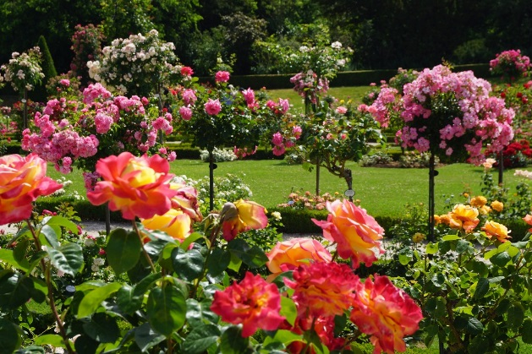

Agenda quotidien

9

2016

Septembre

|  |  |
| --- | --- |
| 1  Jeu |  |
| 08 12 16 20 24 |
| 2  Ven |  |
| 08 12 16 20 24 |
| 3  Sam |  |
| 08 12 16 20 24 |
| 4  Dim |  |
| 08 12 16 20 24 |
| 5  Lun |  |
| 08 12 16 20 24 |
| 6  Mar |  |
| 08 12 16 20 24 |
| 7  Mer |  |
| 08 12 16 20 24 |
| 8  Jeu |  |
| 08 12 16 20 24 |
| 9  Ven |  |
| 08 12 16 20 24 |
| 10  Sam | La fée Féérique |
| 08 12 16 20 24 |
| 11  Dim |  |
| 08 12 16 20 24 |
| 12  Lun |  |
| 08 12 16 20 24 |
| 13  Mar |  |
| 08 12 16 20 24 |
| 14  Mer |  |
| 08 12 16 20 24 |
| 15  Jeu |  |
| 08 12 16 20 24 |
| 16  Ven |  |
| 08 12 16 20 24 |

|  |  |
| --- | --- |
| 17  Sam |  |
| 08 12 16 20 24 |
| 18  Dim |  |
| 08 12 16 20 24 |
| 19  Lun |  |
| 08 12 16 20 24 |
| 20  Mar |  |
| 08 12 16 20 24 |
| 21  Mer |  |
| 08 12 16 20 24 |
| 22  Jeu |  |
| 08 12 16 20 24 |
| 23  Ven |  |
| 08 12 16 20 24 |
| 24  Sam |  |
| 08 12 16 20 24 |
| 25  Dim |  |
| 08 12 16 20 24 |
| 26  Lun |  |
| 08 12 16 20 24 |
| 27  Mar |  |
| 08 12 16 20 24 |
| 28  Mer |  |
| 08 12 16 20 24 |
| 29  Jeu |  |
| 08 12 16 20 24 |
| 30  Ven |  |
| 08 12 16 20 24 |
| 1/10  Sam |  |
| 08 12 16 20 24 |
| 2  Dim |  |
| 08 12 16 20 24 |



Agenda quotidien

Octobre

1022

2016

|  |  |
| --- | --- |
| 1  Sam |  |
| 08 12 16 20 24 |
| 2  Dim |  |
| 08 12 16 20 24 |
| 3  Lun |  |
| 08 12 16 20 24 |
| 4  Mar |  |
| 08 12 16 20 24 |
| 5  Mer |  |
| 08 12 16 20 24 |
| 6  Jeu |  |
| 08 12 16 20 24 |
| 7  Ven |  |
| 08 12 16 20 24 |
| 8  Sam |  |
| 08 12 16 20 24 |
| 9  Dim |  |
| 08 12 16 20 24 |
| 10  Lun |  |
| 08 12 16 20 24 |
| 11  Mar |  |
| 08 12 16 20 24 |
| 12  Mer |  |
| 08 12 16 20 24 |
| 13  Jeu |  |
| 08 12 16 20 24 |
| 14  Ven |  |
| 08 12 16 20 24 |
| 15  Sam |  |
| 08 12 16 20 24 |
| 16  Dim |  |
| 08 12 16 20 24 |

|  |  |
| --- | --- |
| 17  Lun |  |
| 08 12 16 20 24 |
| 18  Mar |  |
| 08 12 16 20 24 |
| 19  Mer |  |
| 08 12 16 20 24 |
| 20  Jeu |  |
| 08 12 16 20 24 |
| 21  Ven |  |
| 08 12 16 20 24 |
| 22  Sam |  |
| 08 12 16 20 24 |
| 23  Dim |  |
| 08 12 16 20 24 |
| 24  Lun |  |
| 08 12 16 20 24 |
| 25  Mar |  |
| 08 12 16 20 24 |
| 26  Mer |  |
| 08 12 16 20 24 |
| 27  Jeu |  |
| 08 12 16 20 24 |
| 28  Ven |  |
| 08 12 16 20 24 |
| 29  Sam |  |
| 08 12 16 20 24 |
| 30  Dim |  |
| 08 12 16 20 24 |
| 31  Lun | Jakeline |
| 08 12 16 20 24 |
| 1/11  Mar |  |
| 08 12 16 20 24 |



Agenda quotidien

Novembre

1122

2016

|  |  |
| --- | --- |
| 1  Mar |  |
| 08 12 16 20 24 |
| 2  Mer |  |
| 08 12 16 20 24 |
| 3  Jeu |  |
| 08 12 16 20 24 |
| 4  Ven |  |
| 08 12 16 20 24 |
| 5  Sam |  |
| 08 12 16 20 24 |
| 6  Dim |  |
| 08 12 16 20 24 |
| 7  Lun |  |
| 08 12 16 20 24 |
| 8  Mar | Soperle |
| 08 12 16 20 24 |
| 9  Mer |  |
| 08 12 16 20 24 |
| 10  Jeu |  |
| 08 12 16 20 24 |
| 11  Ven | Armistice 1918 |
| 08 12 16 20 24 |
| 12  Sam |  |
| 08 12 16 20 24 |
| 13  Dim |  |
| 08 12 16 20 24 |
| 14  Lun |  |
| 08 12 16 20 24 |
| 15  Mar |  |
| 08 12 16 20 24 |
| 16  Mer |  |
| 08 12 16 20 24 |

|  |  |
| --- | --- |
| 17  Jeu |  |
| 08 12 16 20 24 |
| 18  Ven |  |
| 08 12 16 20 24 |
| 19  Sam |  |
| 08 12 16 20 24 |
| 20  Dim |  |
| 08 12 16 20 24 |
| 21  Lun |  |
| 08 12 16 20 24 |
| 22  Mar |  |
| 08 12 16 20 24 |
| 23  Mer |  |
| 08 12 16 20 24 |
| 24  Jeu |  |
| 08 12 16 20 24 |
| 25  Ven |  |
| 08 12 16 20 24 |
| 26  Sam |  |
| 08 12 16 20 24 |
| 27  Dim |  |
| 08 12 16 20 24 |
| 28  Lun |  |
| 08 12 16 20 24 |
| 29  Mar |  |
| 08 12 16 20 24 |
| 30  Mer |  |
| 08 12 16 20 24 |
| 1/12  Jeu |  |
| 08 12 16 20 24 |
| 2  Ven |  |
| 08 12 16 20 24 |



Agenda quotidien

Décembre

1222

2016

|  |  |
| --- | --- |
| 1  Jeu |  |
| 08 12 16 20 24 |
| 2  Ven |  |
| 08 12 16 20 24 |
| 3  Sam |  |
| 08 12 16 20 24 |
| 4  Dim |  |
| 08 12 16 20 24 |
| 5  Lun |  |
| 08 12 16 20 24 |
| 6  Mar |  |
| 08 12 16 20 24 |
| 7  Mer |  |
| 08 12 16 20 24 |
| 8  Jeu |  |
| 08 12 16 20 24 |
| 9  Ven | Marina |
| 08 12 16 20 24 |
| 10  Sam |  |
| 08 12 16 20 24 |
| 11  Dim |  |
| 08 12 16 20 24 |
| 12  Lun |  |
| 08 12 16 20 24 |
| 13  Mar |  |
| 08 12 16 20 24 |
| 14  Mer |  |
| 08 12 16 20 24 |
| 15  Jeu |  |
| 08 12 16 20 24 |
| 16  Ven |  |
| 08 12 16 20 24 |

|  |  |
| --- | --- |
| 17  Sam |  |
| 08 12 16 20 24 |
| 18  Dim | Cricri |
| 08 12 16 20 24 |
| 19  Lun |  |
| 08 12 16 20 24 |
| 20  Mar |  |
| 08 12 16 20 24 |
| 21  Mer |  |
| 08 12 16 20 24 |
| 22  Jeu |  |
| 08 12 16 20 24 |
| 23  Ven |  |
| 08 12 16 20 24 |
| 24  Sam |  |
| 08 12 16 20 24 |
| 25  Dim | Noël |
| 08 12 16 20 24 |
| 26  Lun |  |
| 08 12 16 20 24 |
| 27  Mar |  |
| 08 12 16 20 24 |
| 28  Mer |  |
| 08 12 16 20 24 |
| 29  Jeu |  |
| 08 12 16 20 24 |
| 30  Ven |  |
| 08 12 16 20 24 |
| 31  Sam |  |
| 08 12 16 20 24 |
| 1/1  Dim |  |
| 08 12 16 20 24 |



Agenda quotidien