Animations saccadées dans PowerPoint

Jerky Animations in PowerPoint 2010 and 2013
Par Geetesh Bajaj
http://blog.indezine.com/2013/07/jerky-animations-in-powerpoint-2010-and.html
Monday, July 15, 2013
posted by Geetesh on 9:30 AM IST
Do your animations appear a little jerky in PowerPoint 2010 or 2013 compared to how they played in PowerPoint 2007? There could be any number of reasons why the animations may not play smoothly -- you may have too many applications using resources in the background or your graphics system may not be able to cope up.
However, when the same animations play well on PowerPoint 2007 -- and do not on 2010 and 2013 (sometimes, even on the same computer) -- then this easy trick may help!
- First of all, run PowerPoint 2010 or 2013 -- and at least in the latter version, press the Esc key to create a blank presentation -- otherwise PowerPoint 2013 won't let you access the File menu! Now select the File menu and then choose Options in the resultant Backstage view.
- This will bring up the PowerPoint Options dialog box -- choose the Advanced tab within the sidebar (highlighted in red in Figure 1, below). Scroll down the right pane until you see a section called Display. If you are on PowerPoint 2010, check the option called Disable hardware graphics acceleration (highlighted in blue in Figure 1, below). If you are on PowerPoint 2013, also check the option called Disable Slide Show hardware graphics acceleration. If this option is (or options are) already checked, leave them alone. Click the OK button to apply these changes.
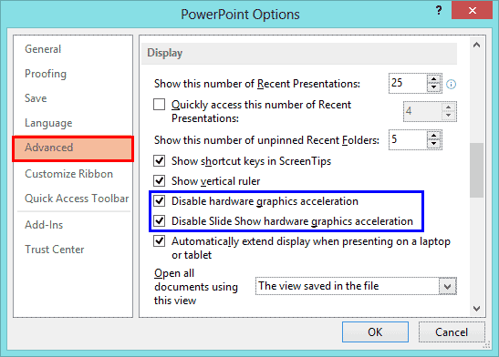
Figure 1: PowerPoint Options
You can now close all instances of PowerPoint.
- Now you need to run the Registry Editor and make a small edit. Do remember that it's wise to backup your Registry before you make any edits -- also if you are not comfortable with editing your Registry -- then ignore this step altogether. Whatever you do, remember that anything you are doing is at your own risk!
Do not want to make this change through the Registry? Chirag Dalal of the Office One site has created a free SpriteClipping utility that will make this change for you! This utility will make the change for both PowerPoint 2010 and/or 2013. However, do ensure that all instances of PowerPoint are shut down before you run this utility. Thank you so much, Chirag!
If you use Chirag's utility, you need not follow the rest of these steps!
To run the Registry Editor in Windows 7 or 8, click the Windows button on your keyboard to access the Start Menu -- now type "Run" without the quotes to bring up an icon for the Run program -- click this icon so that you see the Run dialog box, as shown in Figure 2, below.
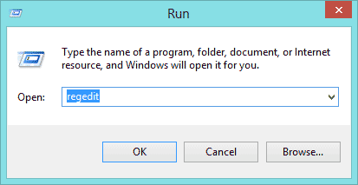
Figure 2: Run dialog box
- Now type in "regedit" without the quotes inside the Run dialog box, and hit the OK button.
- You will see the User Account Control window shown in Figure 3, below -- click the Yes button to go ahead and open the Registry Editor.
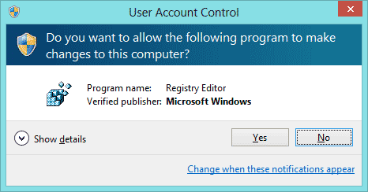
Figure 3: User Account Control
- The Registry Editor now opens -- navigate to the HKEY_CURRENT_USER\Software\Microsoft\Office\15.0\PowerPoint\Options key if you are using PowerPoint 2013, as shown in Figure 4, below.
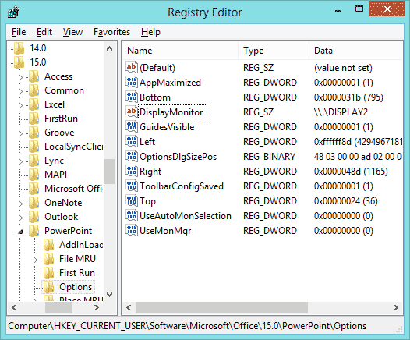
Figure 4: Registry Editor
If you are using PowerPoint 2010, you will navigate to the HKEY_CURRENT_USER\Software\Microsoft\Office\14.0\PowerPoint\Options key.
- Now select Options in the left-pane -- then right-click and you will see a small menu (see Figure 5, below). Select New in this menu to open a sub-menu. Click on the option that says DWORD (32-bit) Value. It's not necessary that your computer provides this option -- in that case, you will see an alternative DWORD Value option -- click on that option.
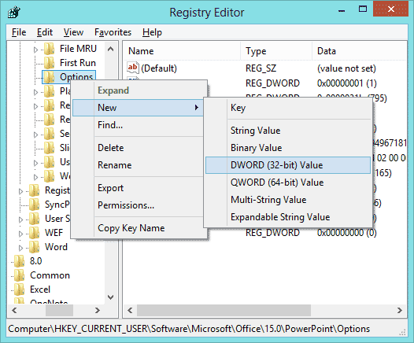
Figure 5: Add a new DWORD Value
- You will see a new DWORD Value called New Value#1, as shown in Figure 6, below. Click on this value, and type over it to replace the value with DisableSpriteClipping, as shown in Figure 7, below.
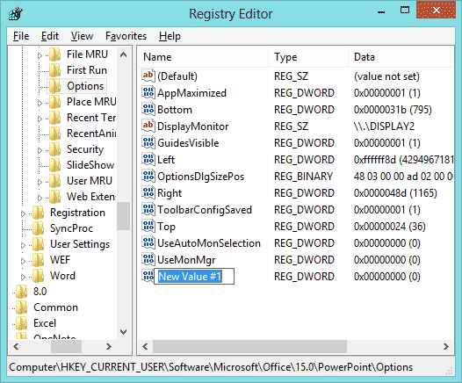
Figure 6: Replace existing text...
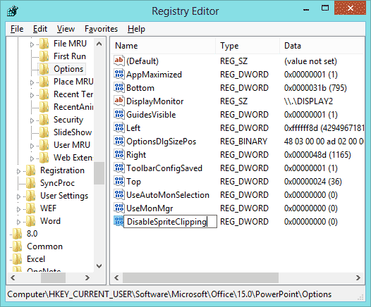
Figure 7: ..with a new DWORD Value
- Double click this value to bring up an Edit dialog as shown in Figure 8. Change the Value data to 1. Exit the Registry Editor.
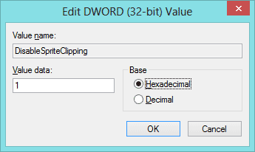
Figure 8: Edit DWORD Value
Animations in your presentation should now be smoother!

