

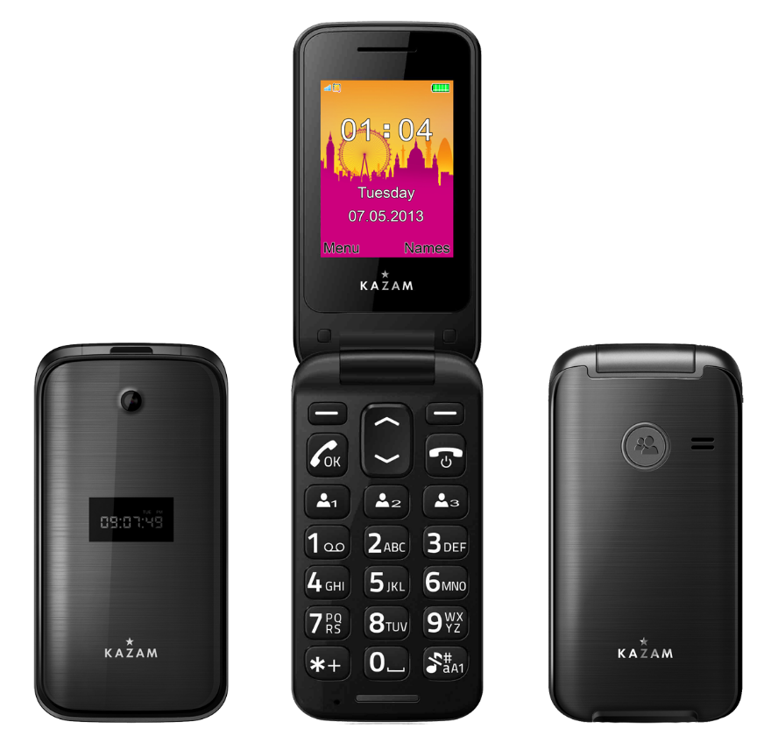

**Life C6**

User Manual

**ALL RIGHTS RESERVED**

Copyright © KAZAM Licensing Limited (2014)

©2014. All rights are reserved. No part of this document can be reproduced without permission. All trademarks and brand names mentioned in this publication are property of their respective owners.

Licenses issued by the Copyright Licensing Agency or any other reproduction rights organisation do not apply. The product described in this manual may contain copyrighted software of KAZAM Licensing Limited and/or its licensors. Customer shall not in any manner reproduce, distribute, modify, decompile, disassemble, decrypt, extract, reverse engineer, lease, assign or sublicense the said software unless such restrictions are prohibited by applicable laws or such actions are approved in writing by the respective copyright holders. If any unauthorised acts are carried out in relation to this copyright work, a civil claim for damages may be made and/or a criminal prosecution may result.

# **Trademarks and Permissions**

KAZAM is a trademark or registered trademark of KAZAM Licensing Limited. Android is a trademark of Google Inc. Other trademarks, products, services and company names mentioned in this manual are the property of their respective owners.

While all the efforts have been made to ensure the accuracy of contents in this manual, we presume no responsibility for errors or omissions or statements of any kind, whether such errors are omissions or statements resulting from negligence, accidents, or any other cause. We operate a policy of continuous development and reserve the right to make changes, modifications and improvements to the device, device features/specifications or any of its parts without prior notice.

Your device may have preinstalled bookmarks and links for third party internet sites and may allow you to access third party sites. These are no affiliated with us, and we do not endorse or assume liability for them. If you access such sites, take precautions for security or content.

The limited warranty does not cover user manuals or any third party software, settings, content, data or links, whether included/downloaded in the product, whether included during installment, assembly, shipping or any other time in the delivery chain or otherwise and in any way acquired by you. To the extent permitted by applicable law(s), we do not warrant that any our software will meet your requirements, will work in combination with any hardware or software applications provided by a third party, that the operations of the software will be uninterrupted or error free or that any defects in the software are correctable or will be corrected.

* Some features of this product and its accessories described herein rely on the software installed, capacities and settings of the local network, and therefore may not be active or may be limited by local network, and therefore may not be activated or may be limited by local network operators or network service provides. Thus the descriptions herein may not match exactly the product or its accessories you purchased. KAZAM reserves the right to change of modify any information or specifications contained in this manual without prior notice and without liability.

**SAFETY PRECAUTIONS**

Please read the following safety guidelines before using the device.

|  |  |
| --- | --- |
|  | Please read all safety precautions. Not following them may be dangerous or illegal. |
|  | Do not place your phone and accessories in containers with strong electromagnetic fields. |
|  | Obey all traffic laws. Do not use hand-held while driving. |
|  | Switch off when instructed in hospitals and medical facilities. Follow all regulations and rules enforced. |
|  | Do not use the phones at a refueling station. Do not use near fuel or chemicals. |
|  | Switch off when instructed in aircraft and airports. Follow all regulations and rules enforced. |
|  | Keep the phone and all of its parts, including accessories, out of the reach of children. |
|  | Use only approved batteries and chargers. The power adaptor does not have its own power switch, to stop charging remove the charger from the socket. The socket of the power outlet must be near the equipment and be easily accessible. |
|  | Only qualified personnel should service the phone. Faulty service may be dangerous and may invalidate any warranty applicable to the device. |
|  | To avoid possible hearing damage, do not listen at high volume for longer periods. |

**Note**:

* Do not place magnetic storage media near your phone. Radiation from the phone may erase the information stored on them.
* Mobile phones can interfere with the functioning of medical devices such as hearing aids or pacemakers. People having active medical implants should keep their cell phone at least 15 cm away from the implant.
* Do not dismantle the device or accessories otherwise, manufacturer is not liable to pay for damages as the device and accessories are not covered by warranty.
* Use only original batteries and charging devices.
* Please back up your important data timely and keep them properly. The company is not liable for any failure to call or loss of data due to mis-operation, poor signal or power cut, etc.
* All the screens in this manual are for reference only, and some contents actually displayed may depend upon the pre-setting of the service provider, network operator or the SIM card. If any functions referred to in this manual are different from those of your device, please follow your device.
* Do not put use it in a place with flammable gas such as a petrol pumps. The temperature recommended for using the device is 0-40℃. Do not touch the charger, power cable or socket with wet hands. This may cause an electric shock.
* If your phone or any of its accessories do not function normally, then please visit your nearest authorized service facility. The qualified personnel will assist you, and if necessary, will arrange for the service.

**TABLE OF CONTENTS**

**ALL RIGHTS RESERVED 1**

**TRADEMARKS AND PERMISSIONS**

**SAFETY PRECAUTIONS 3**

**TABLE OF CONTENTS 5**

1. **UNDERSTANDING YOUR DEVICE 6**
   1. GENERAL INFO 6
   2. DEVICE OVERVIEW 5
2. **GETTING STARTED 7**
   1. INSTALLING CARDS& BATTERY 7
   2. POWERING ON/OFF THE DEVICE 8
3. **BASIC OPERATIONS 9**
   1. CALLING 9
   2. MESSAGING 10
   3. PHONEBOOK 11
4. **CALL HISTORY 12**
5. **SETTINGS 14**
   1. PHONE SETTINGS 14
   2. NETWORK SETTINGS 14
   3. SECURITY SETTINGS 14
   4. CALL SETTINGS 15
   5. CONNECTIVITY 15
   6. RESTORE SETTINGS 15
6. **PROFILES 16**
7. **MULTIMEDIA – Emergency Flow 19**
   1. CAMERA 19
   2. IMAGE VIEWER 19
   3. VIDEO RECORDER 19
   4. VIDEO PLAYER 20
   5. AUDIO PLAYER 20
   6. SOUND RECORDER 20
   7. FM RADIO 20
8. **EXTRAS 20**
9. **SPECIFICATIONS 21**

Enviromental Concern/Information **22**

EU Declaration of Conformity (CE) 24

SAR 25

**1.UNDERSTANDING YOUR DEVICE**

**1.1 GENERAL INFO**

KAZAM Life C5 has a 2.4” QVGA screen with 320*240 resolution. It has a fixed focus front camera, an 800mAh battery and expandable memory. It supports MMS, SMS and Bluetooth.

**1.2 DEVICE OVERVIEW**

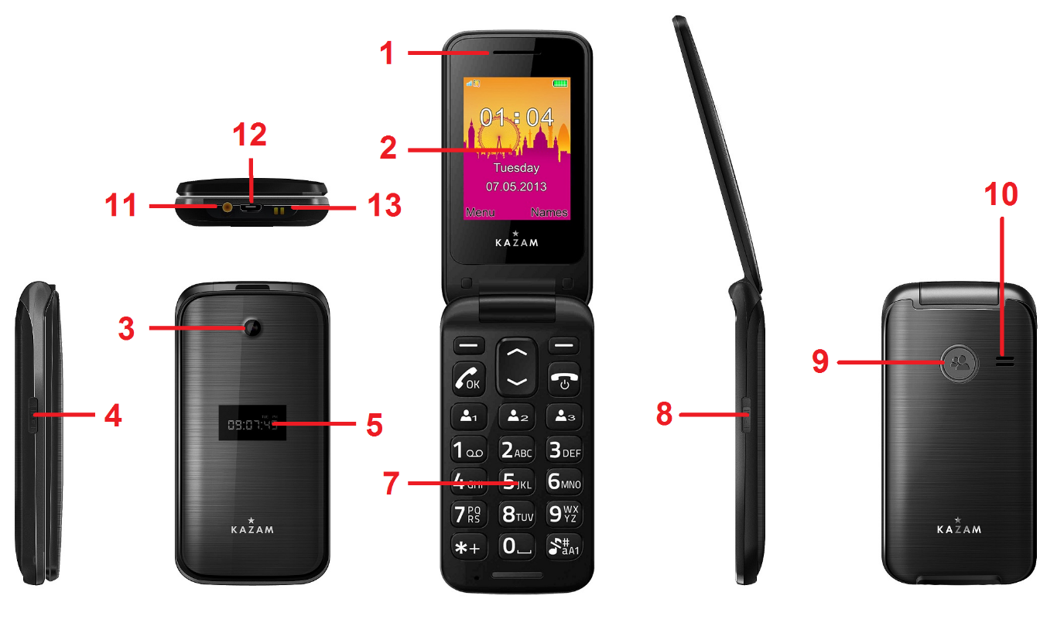

|  |  |
| --- | --- |
| **Position of keys:** |  |
| **1. Earpiece** | **2. Display** |
| **3. Camera** | **4. Torch key** |
| **5. External Display** | **6. Mic** |
| **7. Keypad** | **8. Camera key** |
| **9. SOS Key** | **10. Speaker** |
| **11. Cradle charging connector** | **12. Charging socket** |
| **13. Torch** |  |

**2. GETTING STARTED**

**2.1 INSTALLING SIM CARDS & BATTERY**

Please switch off your device before removing the battery, inserting a SIM or memory card.

**Installing Battery**

To install the battery please follow the steps below:-

* Remove the back cover of the device.
* Hold the device with the front facing downwards.
* Insert the battery ensuring it is the correct way round.
* Replace the battery cover until it clicks into place.

**Charging the Battery**

The device prompts a warning tone and message indicating insufficient battery when the battery power is low. Please follow the instructions below to charge your device:-

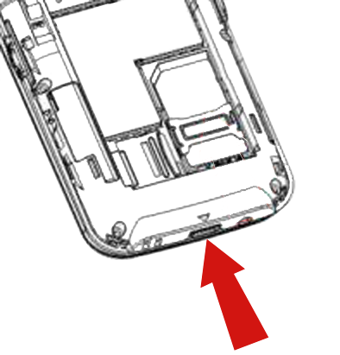

* Plug the connector of the charger into the micro USB port on the device.
* Plug the charger into a standard AC wall outlet.



Charging…….

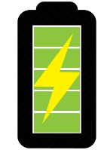

Fully Charged…….

It is recommended to fully charge the battery before using the device for the first time.

**Installing SIM Card**

In order to install you SIM card, follow the steps below:-

* 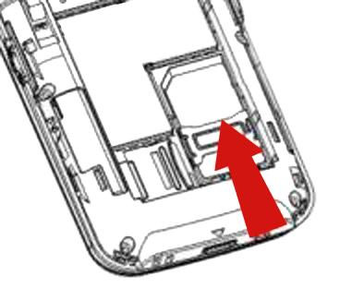Remove the back cover of the device
* Hold the device with the front facing downwards
* Remove the battery
* Slide the SIM card into the dock shown on image
* Insert the battery
* Replace the battery cover until it clicks into place

**Installing Memory Card**

Your device supports micro SD card, which is a multimedia memory card used to increase the memory of the device. The micro SD card is small and should be installed carefully to avoid any kind of damage. Please follow the steps below to install the memory card in the device:

* 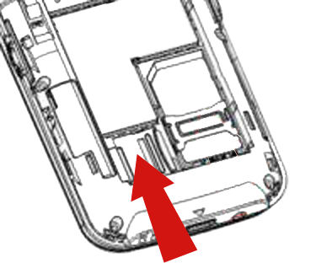Remove the back cover of the device.
* Hold the device with the front facing downwards.
* Remove the battery
* Slot the micro SD card into the device, see image
* Replace the battery.
* Replace the battery cover until it clicks into place.

**2.2 POWERING ON/OFF THE DEVICE**

**Turning On the Device**

After installing the SIM card and charging the battery, you are now ready to turn on your device.

* Press and hold the Power Key to turn on the device.

**Turning Off the Device**

* Press and hold the Power Key for 3 seconds.

**3. BASIC OPERATIONS**

**3.1 CALLING**

**Making Calls**

If the icon network strength icon is visible in the information bar at the top of the screen, then you can make or receive calls. To make a call, follow the steps below:

* Direct dial

In standby mode, press the corresponding numeric keys to enter the phone number that you want to dial, including necessary area codes. Short Press the Right soft key [Clear] to delete.

* International call

To make an international call, long press * key until the prefix symbol "＋" of international call displays in screen.

* Dialling from contact list

Enter the Phonebook via the menu, use the Up/Down Navigator keys to scroll to the desired contact, or press the first letter of the name of the desired contact for quick search.

* Dialling from call history

Enter the Call centre (press the Dial key-ok from standby or via the menu), use the Up/Down navigator keys to scroll to the desired contact, press the dial key can direct dial.

**Answer/Reject an Incoming Call**

When you receive an incoming call, details of the contact name/number are displayed.

Press the call key or left soft key to answer the incoming call.

Press the power key once to reject the call.

In call options menu:-

* Swap –Switch between active calls
* Conference – Multi-call options. The availability of this option depends on your service provider.
* End single call - End the current call.
* End all calls- End all active calls
* New call – Launches the dialler and a new call can be initiated
* Phonebook – Launched phonebook interface
* Messages – Launches messaging menu
* Sound recorder -Record the current call.

Note- Recording of the call, in some countries is illegal. Therefore, when you record calls, should seek prior approval from the other party.

**3.2 MESSAGING**

Your device is capable of sending and receiving of SMS (Short Message Service) and MMS (Multimedia Message Service).

**Creating an SMS**

* From the main menu, select ‘Messages’ – ‘Write message’- ‘Text message’
* Select ‘Options’ – ‘Send to’ to enter a number or select a recipient contact
* Once recipient is specified, select ‘Options’ – ‘Send’ to send the message.

**Creating an MMS**

Your device comes preloaded with MMS settings for most operators. Additional settings can be added by accessing:

* *Settings -> Connectivity -> Data Accounts -> Options ->Add PS Account*

A multimedia message or MMS can contain letters, pictures, audio files or video files. To create and send a MMS follow the steps below:-

* From the main menu, select ‘Messages’ – ‘Write message’- ‘Multimedia message’
* Select ‘Options’ – ‘Send to’ to enter a number or select a recipient contact
* Select ‘Options’ to display MMS options where sounds, images and videos can be attached to the message.
* Once recipient is specified, select ‘Options’ – ‘Send’ to send the message.

**Inbox**

Received SMS and MMS messages are accessed here.

To open received messages highlight the message and select the centre key.

In message list, press the OK key to read the selected message or press the left soft key [Options] to launch the following menu:

* View: view the current message
* Reply by SMS: Reply SMS to the message sender directly.
* Reply by MMS: Reply MMS to the message sender directly.
* Call Sender: Select to call the sender number.
* Forward: forward the current message to other number.
* Delete: Delete the highlighted message.
* Delete all: Delete all messages in inbox.
* Save to phonebook: Save the information in the sender number to the phonebook.

**3.3 PHONEBOOK**

Contact details (name and number) are stored in the phonebook. You can save information such as name and phone number.

**To add a Contact**

* From the home screen press the right soft key [Names] or select ‘Phonebook’ from the main menu.
* Select the ‘Add new contact’ option
* Select ‘To SIM’ or ‘To Phone’.
* Enter contact information (Name and number)
* Select ‘Options’ – ‘Save’ to save the newly added contact.

**Contact options**

* Call: Call the selected contact
* View: View the selected contact
* Send text message: Send SMS to the selected contact
* Send multimedia message: Send MMS to the selected contact
* Edit: You can edit the details of the highlighted contact
* Delete: Delete the highlighted contact
* Copy: Copy the highlighted contact to “SIM” or “phone”

**Phonebook settings**

* *Speed dial - Contacts can be assigned to numbered shortcuts.*

*Use the OK key at ‘Enable speed dial’ option to turn speed dial function on or off. Select ‘Set number’, scroll to a key number (8 available, from 2 to 9), press the OK key and select ‘Edit’, scroll to the desired number to set as speed dial number for the key and press the OK key.*

* *When a number is assigned to a speed dial and the function is enabled, you can simply press and hold the corresponding numeric key on idle screen to dial the assigned contact automatically.*
* *Memory status: View the used memory of the SIM card and phone’s phone book. The capacity of SIM card depends on different SIM card.*
* *Copy contacts: Contacts can be copied between SIM and Phone memories*
* *Move contacts: Contacts can be moved between SIM and Phone memories*
* *Delete all contacts: Select to delete the contacts from SIM or the phone memory.*

***Call history:***

**4. CALL settings**

* *All received calls, dialled numbers and missed calls as well as their call time are recorded in the call history section of your phone.*
* *Call history can be accessed by pressing the Green key from standby or accessed through the ‘Call History’ item through the main menu.*

*If accessed through the menu item, the submenus are as follows:-*

* *Dialled calls*
* *Missed calls*
* *Received calls*
* *All calls*
* *Delete call logs*

*Missed/dialled/Received*

*In the missed, dialled and received calls lists the following actions are applicable:*

* *Green key – Make a call to the highlighted number/contact*
* *Centre key [OK]- View the details of highlighted call record*
* *Left soft key to launch the options menu as displayed below*

*View: View the details of current call record.*

*Call: call current record.*

*Send text message: send SMS to the select number*

*Save to phonebook: Store the number as a phonebook entry.*

*Delete: Delete the current call record.*

*Delete call logs: You can select dialled calls/Missed calls/Received calls/All calls to delete.*

***Call Settings:***

* ***Call waiting***

You can choose to Activate, Deactivate or Query status of this feature.

If activated, you will be notified when a call in received whilst another call is ongoing.

* ***Call divert***

This feature allows you to divert to your phone calls to your voice mailbox or another phone number you specify. This function needs the support of network operator.

* ***Call barring***

Barring restrictions can be set on incoming and outgoing calls. This function needs the support of network operator, please contact the network operator for further information.

* ***Advanced settings***

Auto redial

You can enable or disable this feature. If the feature is turned on then is a call is not successful then it will be automatically redialled up to 10 times.

Call time reminder

When set, an in call beep will sound after the selected time period. This can be after a specified number of seconds or you can select a time period after which the beep will sound.

Answer mode

Any key –When set, any key will answer incoming calls with the exception of the right soft key and the end key.

Auto answer when headset -When set, incoming calls will automatically be answered if a headset is inserted.

**5. SETTINGS**

**5.1 Profile**

The phone provides you with four profiles: general, silent, meeting, outdoor. The profiles tailor the phone settings according to different environments by using a range of different tones and alerts. These profiles can be personalised according to your requirements.

**5.2 PHONE SETTINGS**

* ***Time and date***

*Set home city: You can choose a home city from the list to set as the phone home time zone.( London defaulted)*

*Set time/date: Under this you can set the phone to the current date and time. The phone allows you to set the date range of calendar 2000 to 2030.*

*Set format: Under this you can set the time and date display format*

* ***Language***

*Under this you can choose the language that the phone menus are displayed in.*

* **Pref. input method**

*You can choose between ABC, abc or numeric as the default input method.*

* ***Display***

*Wallpaper: The standby image displayed for background wallpaper.*

*You can choose from the built-in wallpaper and an image saved on the phone memory or memory card.*

LCD backlight: The backlight brightness and timeout value can be set under this menu item

* ***Flight mode***

Switch between normal and flight mode. When flight mode is active all network and data related functions will be restricted.

**5.3 NETWORK SETTINGS**

Set network related settings such as network selection and the use of GPRS/3G.

Automatic or manual network selection is available to determine the network which is used.

**5.4 SECURITY SETTINGS**

* ***SIM security***

You can set and enable the PIN code and PIN” codes

Note that if the input PIN code wrong three times, the SIM card will automatically lock and unlock and a PUK code will be required to unlock. Please contact your SIM card provider for more details regarding PUK codes.

PIN lock

Under this you can enable or disable PIN password. When this feature is enabled, every time you turn the phone prompts you to enter the PIN password.

Change PIN

If the current PIN password is already activated, you can make changes to the PIN password. First enter the old PIN password twice and then specify the desired, new password for future use.

Change PIN2

PIN2passwordis used to access a particular function (such as setting a fixed number, set the call billing, etc.)

If PIN2 is entered incorrectly 3 times a PUK2 code will be required to unlock.

* ***Phone security***

A phone passcode can be set to avoid unauthorised use of your mobile phone.

Phone lock

Under this you can enable or disable phone password. To do so, the phone password must be entered. **The default code is 0000**.

When this feature is enabled, every time you turn the phone on you are prompted to enter the password.

Change password

You can make changes to the phone password. First enter the old phone password, and then enter the newly selected password twice to confirm.

**5.5 CONNECTIVITY**

* ***Data account***

Preloaded MMS accounts are displayed.

These accounts can be manually edited, deleted and added.

**5.6 RESTORE SETTINGS**

Reset the phone settings to default using this feature. The phone password is required to use this feature.

**Default password is 0000.**

**6. MULTIMEDIA**

**6.1 File manager**

Files saved on the phone or memory card can be viewed and used here.

File manager options:

* Open: Open the file or folder.
* Format: choose to format the file.
* New Folder – Create a new folder in which files can be stored
* Delete – The selected file or folder can be deleted.
* Sort by: can "name", “time” ,"size" , "type" or “none”.

**6.2 CAMERA**

Your phone is fitted with camera which allows you to take photos. You can store the pictures on the phone memory or on the inserted memory card.

* In the multimedia menu, select the camera to launch the camera preview screen.
* Press the OK key(dial key) to take photo, press the right soft key to return, press the left soft key to launch the following options menu:-

**Camera Options**

* Switch to video recorder: Switch to video preview screen.
* Photos: Launches the image viewer list
* Camera settings: Modify settings such as Anti-flicker and Delay timer.
* Image settings: Image quality and image size can be modified
* White balance: Image effect can be set
* Scene mode: Select between automatic and night camera modes
* Storage: Choose the default image saving location as phone memory or memory card.
* Restore default: Camera parameters can be restored back to their default values/

**6.3 IMAGE VIEWER**

This feature is convenient for users to view the photos stored in on the phone or memory card. Press the OK key to open the picture or press the left soft key to open the option menu:

* View: Open the current image to view.
* Image information: Display the current image information.
* Send：Pictures can be sent via ”MMS” or "Bluetooth".
* Use as: Picture can be set as idle screen wallpaper.
* Rename: Change the name of the selected picture.
* Delete：Delete the selected image.
* Storage：Phone or memory card can be set as the default image viewer

**6.4 VIDEO RECORDER**

* In the multimedia menu, select the video recorder to launch the video preview screen
* Press the centre key to start recording
* Press up/down navigation key to adjust the focal distance
* Press the left soft key the launch the options menu
* Switch to camera: Switch to still camera
* Camcorder settings: Anti-flicker settings can be modified.
* Video settings: Can set the video quality
* Storage: You can set phone or memory card as storage location for recorded videos.

**6.5 VIDEO PLAYER**

This feature can be used to play video files stored on the phone memory or inserted memory card.

The supported video formats are 3gp, mp4 and avi files.

In the multimedia menu, select the video player into the video list, press left soft key open the option menu:

* Play：Play the current video file
* Send: Videos can be sent via ”MMS” or "Bluetooth"
* Rename：Change the name of the selected video.
* Delete：Delete the selected video.
* Storage：Phone memory or memory card videos can be displayed by default

**6.6 AUDIO PLAYER**

Audio files saved in the phone or memory card can be played through this menu item.

**6.7 FM RADIO**

You can use your mobile phone to listen to FM radio stations once a supported headset is plugged into the handset. Please press the side key to adjust music volume.

* Ensure headset in inserted
* Launch FM Radio from multimedia menu
* Press middle key to switch radio on and off.
* The up and down navigation keys manually scroll through radio frequencies.
* The left and right navigation keys scroll through radio stations.

Radio options menu

* Channel list – Radio stations names and frequencies can be saved. When in FM Radio pressing the corresponding key will tune into the specified frequency.
* Manual input – Radio frequency can be manually entered.
* Auto search – Automatically searches and saves the found frequencies.

**7. EXTRAS**

**7.1 Emergency Setting**

Emergency alarm function, when you need emergency help, long press back "help" button, it will sent the help message and make calls automatically to phone numbers preset.

* Button status: switch on/off this function( defaulted on)
* SOS numbers: 5 numbers you can preset
* SOS messages: Defaulted message is "Emergency, Need Help!"
* You can find and setup the SOS short numbers under Organizer – Emergency Settings (Alternatively under Settings – Emergency Settings).

**Emergency Flow**

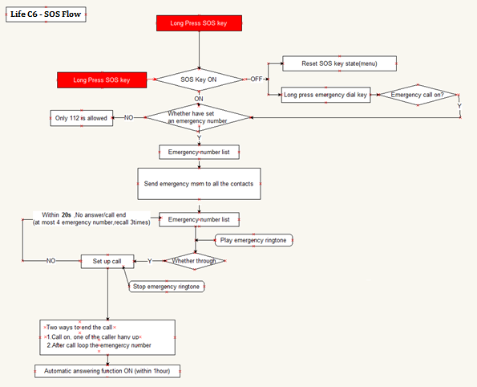

**7.2 Speed dial**

Short-cut call function, you can preset numbers, after done, long press the buttons to make a call.

* Status: choose on/off button
* Set numbers: 1,2,3 short cuts buttons can be preset. Additionally, number 2-9 can be preset also.

**7.3 CALCULATOR**

Calculator helps you perform basic arithmetic functions, such as addition, subtraction, multiplication and division.

* The navigation keys correspond to the arithmetic function displayed in the calculator display.
* Up navigation key- choose Add, divide, Multiply, Subtract
* Down key: choose add, divide, Multiply, Subtract.
* left soft key- equal to
* Right soft key – Clear

**7.4 CALENDAR**

Calendar can be used to check the current date and plan events.

Calendar options

* Jump to date: Jump the selected date.
* Go to today: the date of the input query calendar information
* Go to weekly/monthly view: can set the calendar display mode through week or month.

**7.5 ALARM**

Alarms can be set to sound at the specified time. To add a new alarm follow these steps:-

* Launch the alarm feature through the ‘Extras’ menu.
* Highlight an alarm and select ‘Edit’.
* In the status menu select ‘On’.
* Select time for alarm to sound and repeat value.
* Select ‘Options’ – ‘Save’ and alarm is set.

When an alarm is active a bell icon is displayed at the top of the idle screen and the alarm will be checked in the list.

**8. Bluetooth**

* ***Bluetooth***

You can transfer data, such as images and videos to other devices using Bluetooth. Search for devices and accept/transfer data. The received data is automatically stored in your phone.

Bluetooth options

* Power: Switch Bluetooth on and off
* Visibility: If your device is visible other Bluetooth devices can find the phone; if you select off, other Bluetooth devices can’t find the phone.
* My device: Select to add new equipment and search for Bluetooth devices within range of the signal. After the Bluetooth device is found, you can select the device you wish to connect with.
* My name: Modify the Bluetooth device name that other users can identify your device with.

Services:

This function can be enter and go internet.

**9. SPECIFICATION**

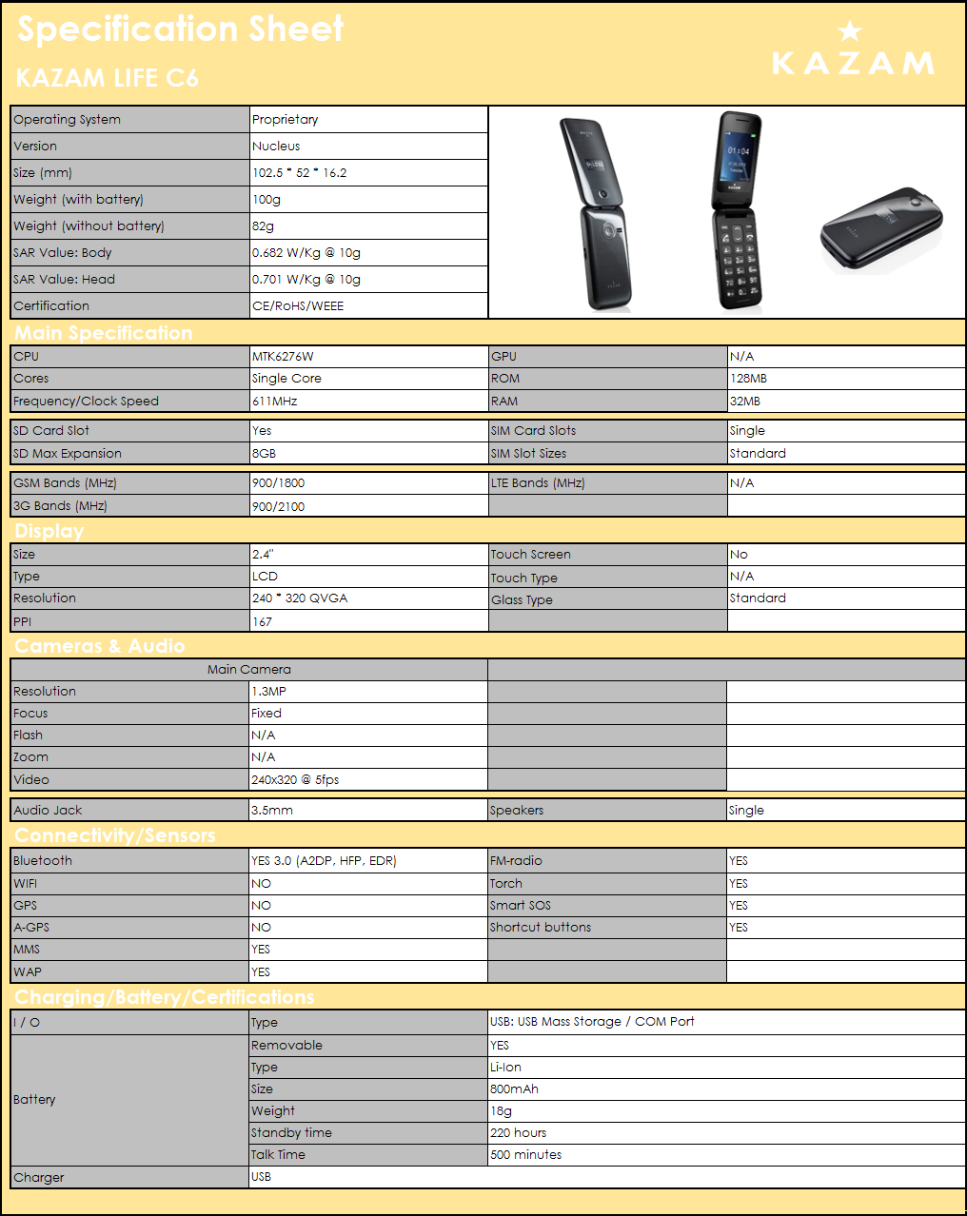

* Standby time and maximum talk time depend upon network strength, and various circumstances/settings.

**ACCESSORIES**

* Use only batteries, chargers, and accessories approved by the manufacturer with this device. Use of any other types will invalidate the warranty and may be dangerous. Check with your dealer for available accessories. You may opt to buy:
* *Extra Battery*

Extra batteries of various capacities are available from our company or through your dealer.

* *USB - Charger Plug, charger cable*

Charger plug: used to connect with the charger cable for charging on wall outlets. Also you can use the charger cable to connect with the other devices such as computers to charge the phone.

Charging time from empty is about 2 to 3 hours. The charging condition is displayed on screen. You can freely use your phone while charging.

* *Earphone*
* A mini, practical, hands-free device; you can use its button to answer and end calls.
* Do not plug or unplug the earphones when connecting dialled or incoming calls.

**ENVIRONMENTAL CONCERN**

Help us save the environment…GO GREEN!

All our endeavours are directed towards providing environmentally aware products to you. The materials used in our devices are recyclable and can be reused to make new products. We strive to make products that are safe for our consumers as well as the environment.

Preserve natural resources for future generations by recycling your mobile phone. Your mobile phone contains some metals which, when recycled properly, can be put back into circulation, decreasing the need for new metal mining.

Recycling reduces the need for raw materials, saves energy, helps mitigate global warming and reduces pollution, therefore preserving natural resources for the future.

Follow some simple steps and contribute towards saving the planet:

DO

* Recycle your handset and its accessories.
* To protect natural resources and to promote re-use of the material, kindly separate batteries from other type of waste.

DONT

* Do not dispose of your mobile and its battery in fire.
* Do not dispose your mobile with the regular waste.
* Do not over charge your handset. Remove the charger when battery is full



This logo signifies that this product and/or its accessories should not be disposed of with other household waste.

**Hazards of improper handling, accidental breakage, damage and /or improper recycling of hazardous elements**, **can result in the following:**

* When burned, cancer-producing dioxins can be released into the air we breathe; If thrown in landfills, leaching into groundwater affecting your local community
* In warm climates, the oxidation of mercury in the environment can be accelerated, leading to the creation of oxidized Hg atoms that are known to be associated with ozone depletion.
* Improper recycling additionally results in data security issues, as private electronic information remains on hard drive, if not properly removed before disposal.

**How to Recycle**

Please get your electronics products recycled only through authorised recyclers, approved by Pollution Control Board. We provide facility of recycling of our products, for details please visit our website or call our customer care. Help us to GO GREEN.

**Constitution of Hazardous Elements in your Device:**

Your device does not contain the following hazardous elements in a proportion higher than the limits provided hereunder: maximum concentration value of 0.1% by weight in homogenous materials for lead, mercury, hexavalent chromium, polybrominated biphenyls and polybrominated diphenyl ethers; and maximum concentration value of 0.01% by weight in homogenous materials for cadmium.

EU Declaration of Conformity for

R&TTE Directive 1999/5/EC

We **Kazam Mobile Limited**

Of **Suite 4B, 43 Berkeley Square, London, W1J 5FJ, United Kingdom**

Declare under our sole responsibility that the product

Product name: **Featurephone**

Trade name: **KAZAM**

Model name: **Life C6**

To which this declaration relates, is in conformity with the following standards

And/or other normative documents.

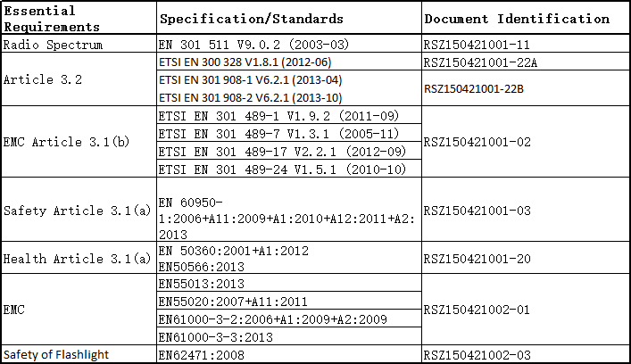

We hereby declare that (all essential radio test suites have been carried out and that) the above named product is in conformity to all the essential requirements

Of Directive 1999/5/EC.

The Conformity assessment procedure referred to in Article 10 and detailed in Annex ［Ⅲ］or ［Ⅳ］of Directive 1999/5/EC has been followed with the involvement of the following Notified Body(ies): **Bay Area Compliance Laboratories**

**1274 Anvilwood Ave.,Sunnyvale,CA 94089 U.S.A** the equipment will also carry the

(Notified Body number) 1313 class 2 equipment identifier

Signature:

2015.05.20

Printed name/title: **Daniel Readman**/Manager

Tel: **+44 (0) 20 7491 6930**

Address: **Suite 4B, 43 Berkeley Square, London, W1J 5FJ, United Kingdom**



**SAR Information**

SAR

This device was tested for typical body-worn operations. To comply with RF exposure requirements, a minimum separation distance of 1.5 cm must be maintained between the user’s body and the handset, including the antenna. Third-party belt-clips, holsters, and similar accessories used by this device should not contain any metallic components. Body-worn accessories that do not meet these requirements may not comply with RF exposure requirements and should be avoided.

Use only the supplied or an approved antenna. Unauthorized antennas, modifications, or attachments could impair call quality, damage the phone, or result in violation of regulations. Do not use the phone with a damaged antenna. If a damaged antenna comes into contact with the skin, a minor burn may result. Please contact your local dealer for replacement antenna.



**Note:**

Use headphones/earphones with care, excessive volume from earphones and headphones can cause hearing loss.

CAUTION: RISK OF EXPLOSION IF BATTERY IS REPLACED BY AN INCORRECT TYPE. DISPOSE OF USED BATTERIES ACCORDING TO THE INSTRUCTIONS.

The product shall only be connected to a USB interface of version USB2.0 or later.

The charging adapter shall be installed near the equipment and shall be easily accessible.

**Charger:**

Model: UT-090E-5005 (EURO) UT-003B-698 (UK)

Input: AC 100-240V 50/60Hz 0.15A

Output: DC5.0V, 500mA

The plug considered as disconnect device of adapter.

Operation temperature：-20 ℃- 40 ℃

The device complies with RF specifications when the device used at 1.5cm form your body.



Kazam Life C6

USER MANUAL

